Department of Physical Education
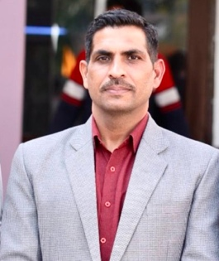 | Name: Dr. Kuldeep Singh  Designation: Associate Professor of Physical Education  College: Indira Gandhi National College, Ladwa (Kurukshetra), Haryana, India  Email: kuldeepskkr@gmail.com  Contact No.: +91 90342 48290  Qualification:  - M.A.Ed. Department of Physical Education, Kurukshetra University  - NET (Dec., 2004) - 3014  - JRF (June 2005) - 359  - M.Phil. (Gold Medallist, Department of Physical Education, Kurukshetra University)  - Ph.D. (Department of Physical Education, Kurukshetra University)  - Teaching Experience: 20 years
MESSAGE FROM DR. KULDEEP SINGH
Associate Professor of Physical Education
Dear Students,
Our true vitality lies in the movement and activity of our body. As long as we remain physically active, we truly experience the essence of life. An idle or inactive body is often compared to a lifeless one. Therefore, staying active is essential—not only for our own well-being but also for leading an independent, fulfilling life.
Engaging in sports and physical activities helps us maintain and improve our physical health. It also enhances our ability to contribute meaningfully to society. A healthy body is one of life’s greatest assets, enabling us to live freely and fully. In contrast, an unhealthy body can feel like a prison to both body and mind. Thus, caring for our physical and mental well-being is a vital responsibility.
Physical education offers more than just fitness—it provides knowledge about the human body, its internal systems, and how to keep it functioning optimally. It cultivates discipline, self-confidence, and a sense of responsibility, all of which are essential for personal and social development.
As recommended by the World Health Organization (WHO), every adult should engage in at least four hours of physical activity per week. I encourage all of you to take part in regular exercise, games, and physical education activities. By doing so, you will not only stay healthy but also lead a more balanced, confident, and successful life.
Warm regards,
Your Teacher
Indira Gandhi National College, Ladwa-Dhanora (Kurukshetra)
Department of Physical Education
The Department of Physical Education plays a vital role in promoting a healthy, drug-free, and active lifestyle among rural youth. Through regular sports and fitness activities, we help students develop physical strength, mental resilience, and discipline, preparing them to face life’s challenges with confidence.
Aligned with the National Education Policy (NEP) 2020, physical education is integrated into the academic calendar, enabling us to groom athletes who actively represent the college in Inter-Collegiate, Inter-University, State, and National level competitions.
Our mission is to foster sportsmanship, leadership, and a strong sense of national responsibility, while ensuring the overall well-being and lifelong fitness of our students.
The Department of Physical Education at Indira Gandhi National College, Ladwa is one of the most active and prominent departments on campus. Our sportspersons regularly participate in various university and national-level tournaments, demonstrating their dedication and commitment to the true values and spirit of sports in life. The details of the activities conducted during the last academic session are mentioned below.

Sports Participation Report (Session 2024–25)
The Department of Physical Education at Indira Gandhi National College, Ladwa actively promoted student participation in various sports during the academic session 2024–25. A total of 67 students participated across 12 different sports disciplines, including 55 male and 12 female players.
Male students took part in sports such as Cricket (16), Volleyball (10), Taekwondo (9), Karate (7), Judo (1), Pistol & Rifle Shooting (4), Wushu (3), and Chess (5). Female students represented the college in Chess (5), Table Tennis (5), Karate (1), and Wrestling (1).
In total, 12 unique sports were played, showcasing a diverse range of athletic involvement on campus. Additionally, during the Annual Athletics Meet held on 4–5 March, 2025, 198 male and 178 female athletes participated, making a total of 262 participants—highlighting the extensive engagement in track and field events.
This data reflects the department’s ongoing commitment to promoting physical education and sporting excellence under the NEP 2020 framework, encouraging holistic development and a competitive spirit among students.

National Sports Day and “Fit India Movement” (29 August, 2024)
On 29 August 2024, Indira Gandhi National College, Ladwa celebrated National Sports Day and the “Fit India Movement” in honor of Major Dhyan Chand’s birth anniversary. The event was organized by the Department of Physical Education and the NCC Unit. Principal Dr. Kushal Pal emphasized physical fitness, meditation, and a healthy lifestyle. Various sports competitions like arm wrestling, tug of war, and running were held. Winners were awarded medals by faculty members. A total of 48 students, 19 NCC cadets, and several teachers participated. The event concluded with the national anthem and distribution of refreshments.
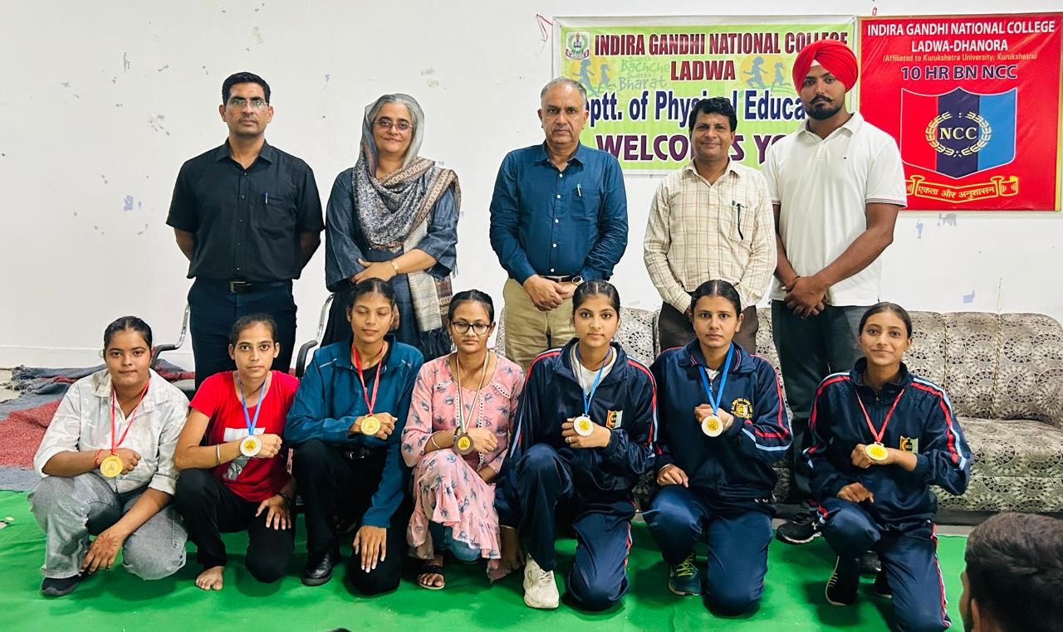 | 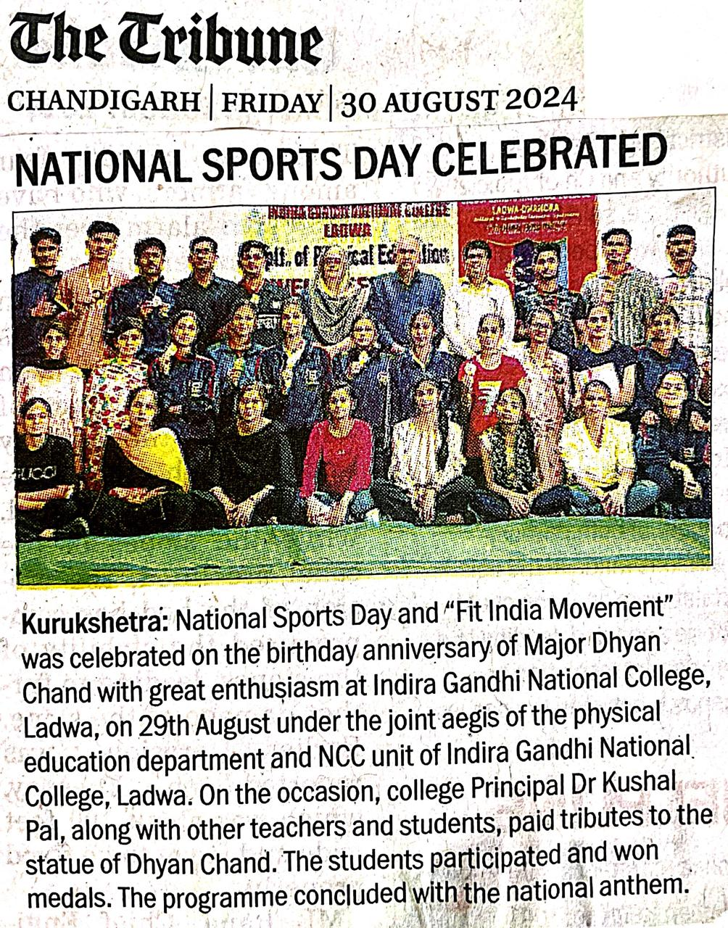
Table-Tennis (Women) Tournament Report (Date: 05-03-2025)
The women’s Table-Tennis team from Indira Gandhi National College, Ladwa-Dhanora participated in the Kurukshetra University Inter-College Table-Tennis Tournament, organised by the Kurukshetra University Sports Department on 05 March, 2025. Four players from under graduate classes participated in the tournament, accompanied by the team manager, Dr Kuldeep Singh (Associate Professor of Physical Education). The competition was held at S.D. College, Ambala/C.
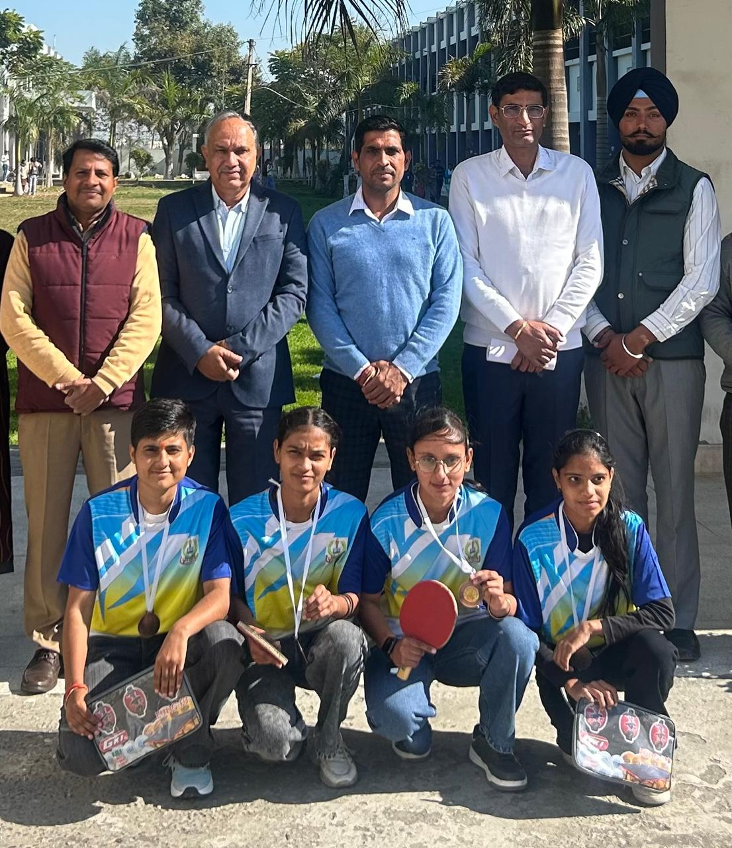
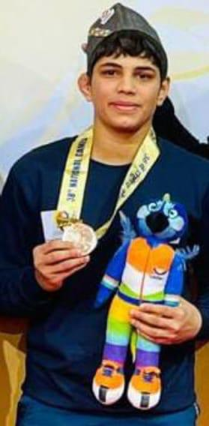 | Tapsya Becomes National Champion in Wrestling  Tapsya, a second-year B.A. student of GN College, Ladwa, won the Gold Medal in the 57 kg category at the 38th National Games held in Uttarakhand, representing Haryana in women’s wrestling. Her victory brought pride to the college, the town of Ladwa, and the state.  In recognition of her outstanding performance, she was recently awarded the prestigious ‘Haryana Bal Kumari’ award, becoming the first student from the college to receive this honor.  Earlier, Tapsya also secured a Gold Medal at the Junior Asian Championship in Racha, Thailand. She continues to prove her talent in senior-level competitions as well.  On this occasion, Principal Dr. Kushal Pal congratulated Tapsya and celebrated her success with the college staff and students. Shri Pawan Garg, President of the College Management Committee, also extended heartfelt wishes, expressing confidence in Tapsya’s future achievements at the international level.
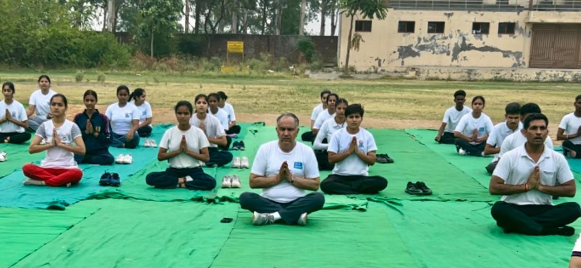 | 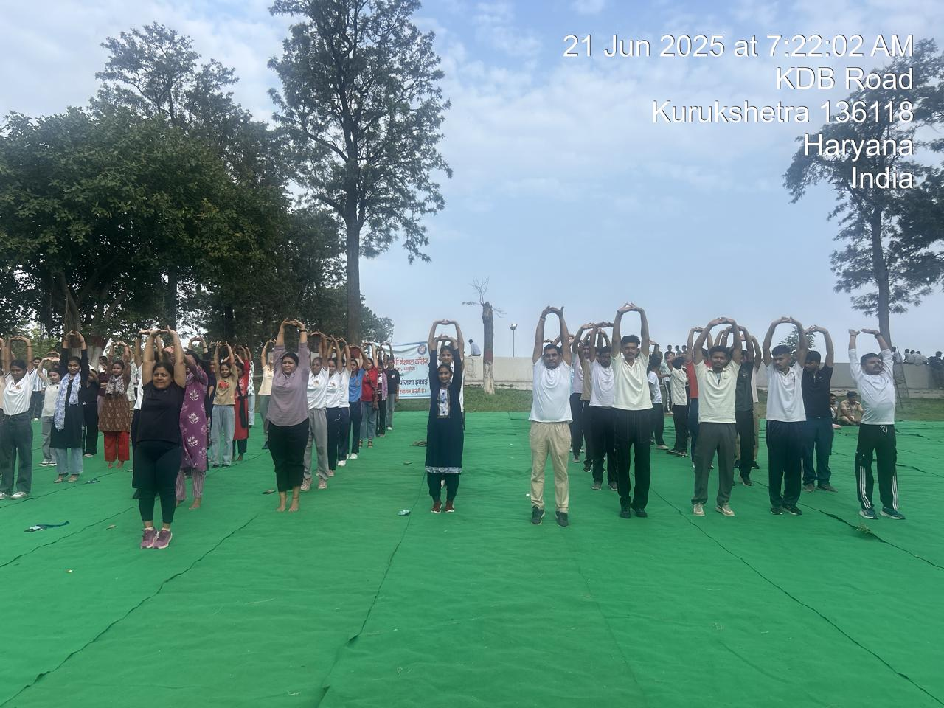

Karate (Men/Women) Tournament Report (Date: 21-11-2024)
The Men’s and Women’s Karate teams of Indira Gandhi National College, Ladwa-Dhanora participated in the Kurukshetra University Inter-College Karate Tournament, organized by the Kurukshetra University Sports Department on 21st November, 2024.
A total of seven players from different classes represented the college in the tournament, accompanied by the team manager, Dr. Kuldeep Singh (Associate Professor of Physical Education). The competition was held at the Multipurpose Hall of Kurukshetra University.
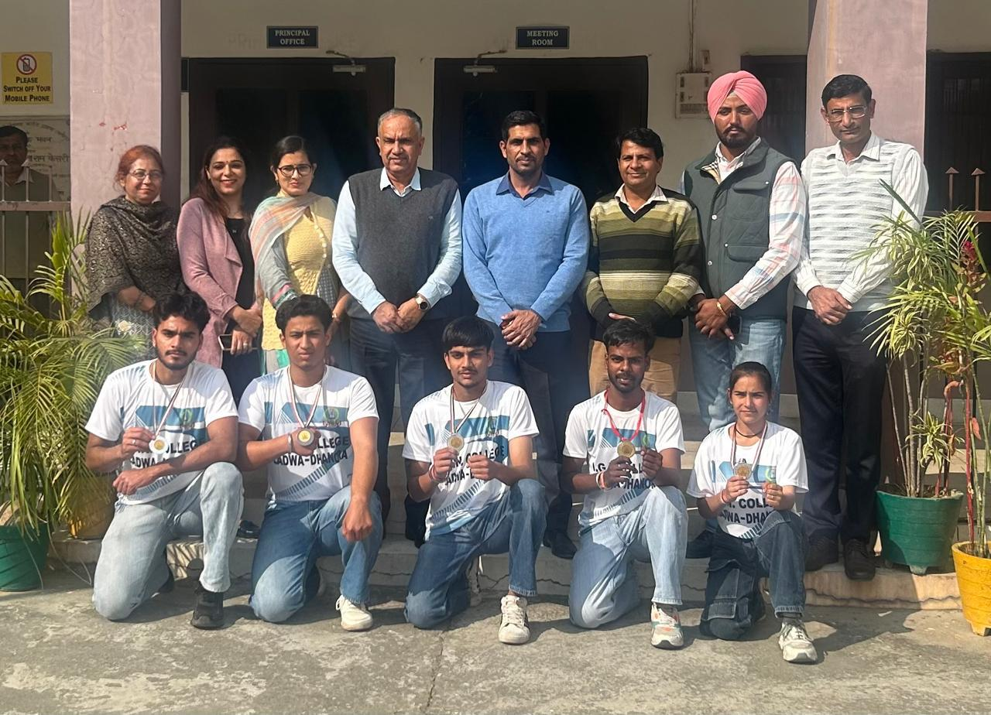

Jai Karan Wins Bronze in North Zone Inter-University Karate
Jai Karan, a first-year B.A. student of Indira Gandhi National College, Ladwa-Dhanora, won the bronze medal in the 55 kg category at the North Zone Inter-University Karate Championship held at Chandigarh University. He was warmly welcomed back to the college by Principal Dr. Kushal Pal, faculty members, staff, and students. Principal Dr. Kushal Pal appreciated Jai Karan's hard work and dedication, stating, “This achievement reflects his consistent efforts and the strong support from his family and the college.” Mr. Pawan Garg, Chairman of the College Management Committee, congratulated Jai Karan, his family, and the college community, expressing confidence that he will continue to bring laurels to the college and the nation in the future.
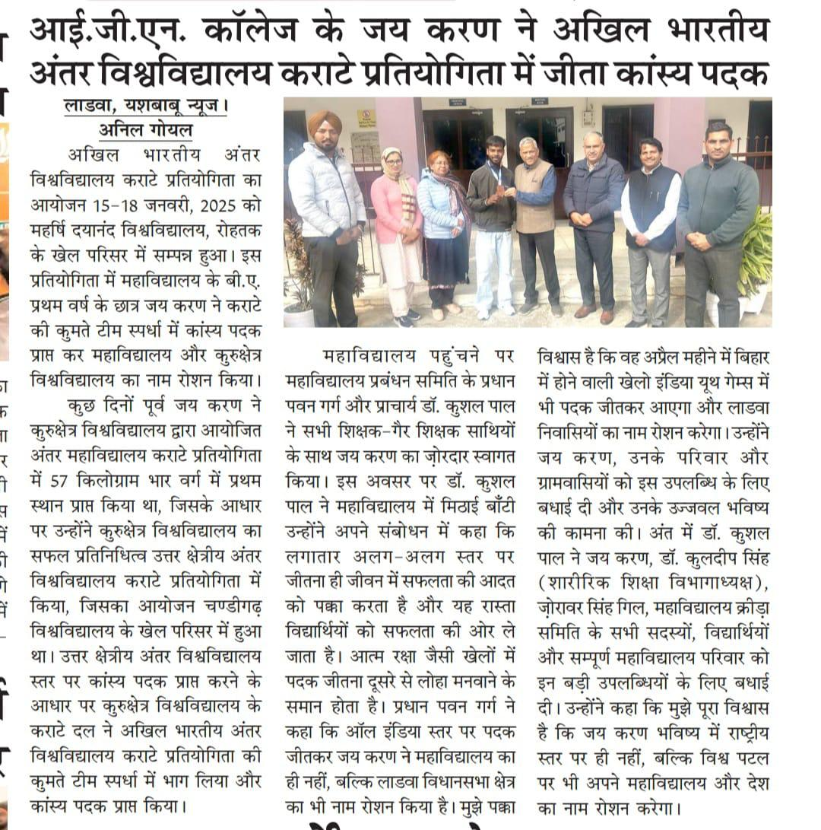
MDC Physical Education students during their practical examination
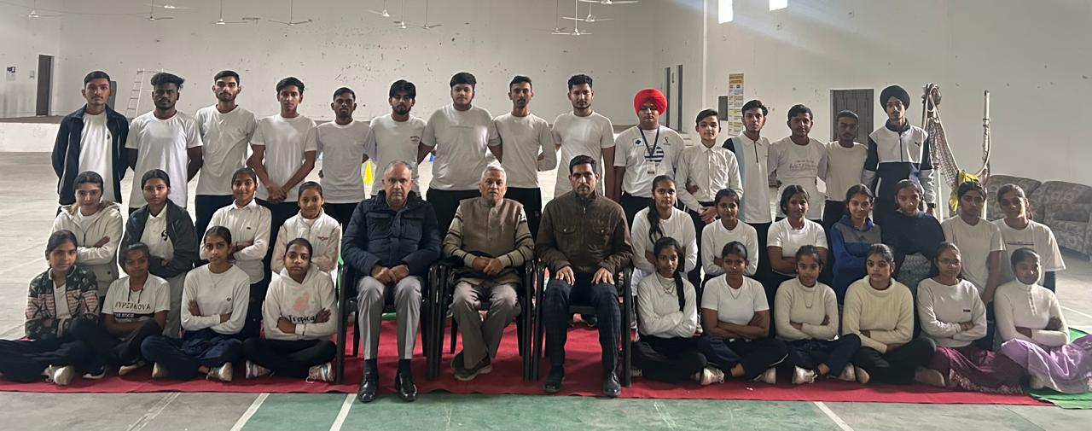
College Organises Inter-College Cricket Matches (24–26 March 2025)
Indira Gandhi National College, Ladwa successfully hosted the Kurukshetra University Inter-College Men’s Zone-A Cricket Matches from 24th to 26th March 2025. In the final match on 26th March, Government College, Bherian (Pehowa) defeated R.K.S.D. College, Kaithal by 113 runs. Bherian scored 249/4 in 20 overs. In reply, Kaithal was restricted to 135 runs. Manish (Bherian) and Parth Vats (Kaithal) took 3 wickets each. College Principal, congratulated both teams and appreciated IGN College, Ladwa for successfully organizing the event. Special thanks were extended to Dr. Kuldeep Singh and the organizing team. make correction
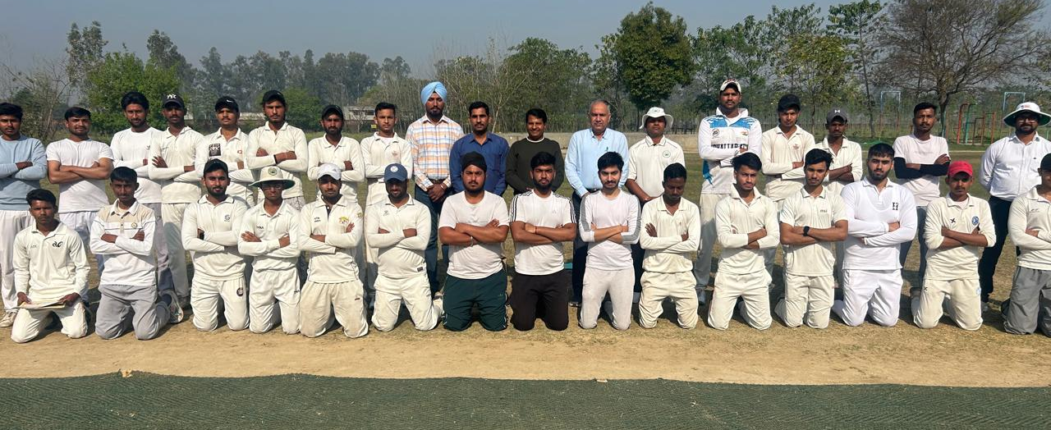
50th Annual Athletic Meet Report (2024–25)
50th Annual Athletic Meet Report (2024–25)
The 50th Annual Athletic Meet of Indira Gandhi National College, Ladwa-Dhanora was held on 4th and 5th March 2025 at the college playground. The event was inaugurated by Chief Guest Sh. Davender Saini (A.C.P., Delhi Police, Anti-Riot Cell). He encouraged students to excel in both academics and sports and formally declared the meet open.
Dr. Kushal Pal, Principal, welcomed the dignitaries and participants. Winners of the 1500-meter race (Men & Women), conducted earlier to avoid event fatigue, were also honored during the opening.
The closing ceremony was led by Dr. Vikram Singh (Associate Professor, I.B. College, Panipat), who shared his sports journey and donated Rs. 10,000 for sports equipment. He also distributed prizes and congratulated Best Male Athlete Mohit and Best Female Athlete Vidhi.
A total of 376 students (198 men and 178 women) from B.A., B.Com., B.Sc., and M.A. classes participated in 29 events, along with traditional tug-of-war competitions, where B.A. II Year men’s and women’s teams won Gold. Daily refreshments were provided to all participants.
The event concluded with the National Anthem, marking a successful and memorable celebration of the college’s sporting spirit.
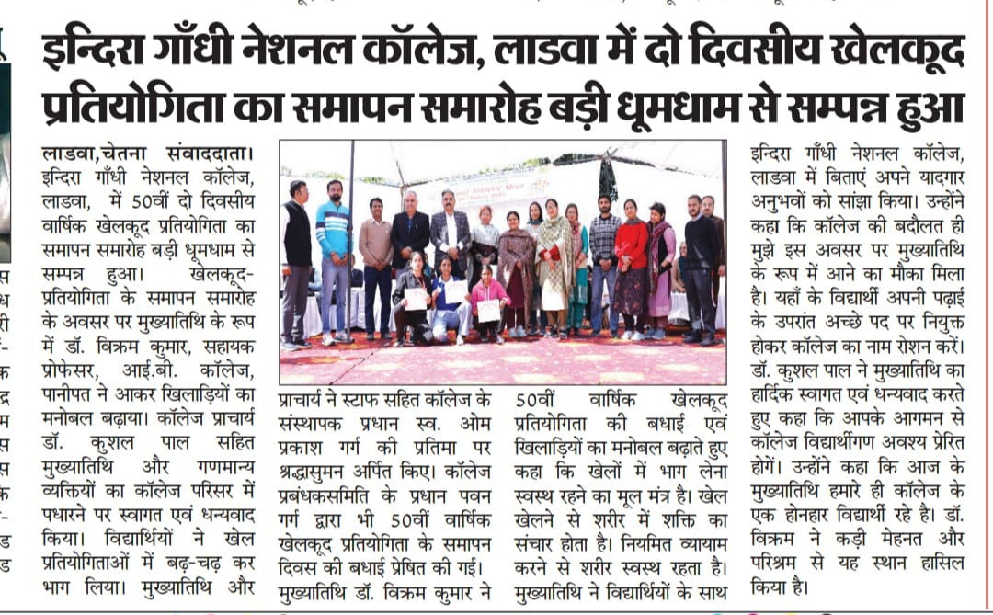

Chess (Women) Tournament Report
Date: 09-04-2025

The women’s Chess team from Indira Gandhi National College, Ladwa-Dhanora participated in the Kurukshetra University Inter-College Chess Tournament, organised by the Kurukshetra University Sports Department from 8 & 9 April, 2025. Four players from under graduate classes participated in the tournament, accompanied by the team manager, Dr Kuldeep Singh (Associate Professor of Physical Education). The competition was held at Kurukshetra University Sports Department.
Results of the Tournament
Date & place of the tournament | Number of players, participated | Match played between | Result
8 & 9 April, 2025  Kurukshetra University Sports Department | 05  Chanchal,Dilpreet,Harbans Kaur, Mehak and Gunjan | I.G.N. College, Ladwa and Govt., College, Panopat | Loose

(Dr Kuldeep Singh) (Dr. Kushal Pal)
Associate professor of Physical Education Principal

Table-Tennis (Women) Tournament Report
Date: 05-03-2025

The women’s Table-Tennis team from Indira Gandhi National College, Ladwa-Dhanora participated in the Kurukshetra University Inter-College Table-Tennis Tournament, organised by the Kurukshetra University Sports Department on 05 March, 2025. Four players from under graduate classes participated in the tournament, accompanied by the team manager, Dr Kuldeep Singh (Associate Professor of Physical Education). The competition was held at S.D. College, Ambala/C.
Results of the Tournament
Date & place of the tournament | Number of players, participated | Match played between | Result
5 March, 2025  S.D. College, Ambala/C | 04 | I.G.N. College, Ladwa and Khalsa College, Karnal | Won
 | Chanchal,Dilpreet,Ruby and Sonia | I.G.N. College, Ladwa and Guru Nanak girls College, Yamuna Nagar | Won
 |  | I.G.N. College, Ladwa and Guru Nanak Khalsa College, Yamuna Nagar | Loose
 |  | I.G.N. College, Ladwa and S.D. College, Ambala/C | Loose
 |  |  | Won Third Place in tournament

(Dr Kuldeep Singh) (Dr. Kushal Pal)
Associate professor of Physical Education Principal

Wushu (Men) Tournament Report
Date: 19-02-2025

The men’s wushu team from Indira Gandhi National College, Ladwa-Dhanora participated in the Kurukshetra University Inter-College Wushu Tournament, organised by the Kurukshetra University Sports Department from 19 February, 2025. Three players from under graduate classes participated in the tournament, accompanied by the team manager, Dr Kuldeep Singh (Associate Professor of Physical Education). The competition was held at Kurukshetra University Sports Complex.
Results of the Tournament
Date & place of the tournament | Number of players, participated | Match played by | Result
19 February, 2025  Kurukshetra University Sports Department | 03 | Samir Khan | Loose
 |  | Ankit | Loose
 |  | Sameer | Loose

(Dr Kuldeep Singh) (Dr. Kushal Pal)
Associate professor of Physical Education Principal

Chess (Men) Tournament Report
Date: 11-02-2025

The men’s Chess team from Indira Gandhi National College, Ladwa-Dhanora participated in the Kurukshetra University Inter-College Chess Tournament, organised by the Kurukshetra University Sports Department from 10 to 11 January, 2025. Six players from under and post graduate classes participated in the tournament, accompanied by the team manager, Dr Kuldeep Singh (Associate Professor of Physical Education). The competition was held at Kurukshetra University Sports Complex.
Results of the Tournament
Date & place of the tournament | Number of players, participated | Match played between | Result
10&11 February, 2025  Kurukshetra University Sports Department | 06 | I.G.N. College, Ladwa and UIET, KUK | Loose  3+1 Draw
 |  | Aniket | Loose
 |  | Ganesh | Loose
 |  | Akhil | Loose
 |  | Bhavishya | Draw

(Dr Kuldeep Singh) (Dr. Kushal Pal)
Associate professor of Physical Education Principal

Shooting (Men) Tournament Report
Date: 08-11-2024

The men’s Shooting team from Indira Gandhi National College, Ladwa-Dhanora participated in the Kurukshetra University Inter-College Shooting Tournament, organised by the Kurukshetra University Sports Department from 6 to 8 December, 2024. Four players from under graduate classes participated in the tournament, accompanied by the team manager, Dr Kuldeep Singh (Associate Professor of Physical Education). The competition was held at Arya College, Panipat.
Results of the Tournament
Date & place of the tournament | Number of players, participated | Name of the Player’s & weight category | Result
6 to 8 Nov., 2024  Arya College, Panipat | 04 | PRINCE KUMAR | No Position
 |  | AATISH MALIK | No Position
 |  | AKSH | No Position
 |  | ZAKIR ABBAS | No Position

(Dr Kuldeep Singh) (Dr. Kushal Pal)
Associate professor of Physical Education Principal

Judo (Men) Tournament Report
Date: 26-11-2024

The men’s judo team from Indira Gandhi National College, Ladwa-Dhanora participated in the Kurukshetra University Inter-College Judo Tournament, organised by the Kurukshetra University Sports Department on 26 November, 2024. Only one player from B.A.-II Years class participated in the tournament, accompanied by the team manager, Dr Kuldeep Singh (Associate Professor of Physical Education). The competition was held at Kurukshetra University Multipurpose Hall.
Results of the Tournament
Date & place of the tournament | Number of players, participated | Name of the Player’s & weight category | Result
26-11-2024  Kurukshetra University Sports Department | 01 | Aarif Khan B.A.-II | Won bronze Medal

(Dr Kuldeep Singh) (Dr. Kushal Pal)
Associate professor of Physical Education Principal

Karate (Men/Women) Tournament Report
Date: 21-11-2024

The Men’s & Women’s Karate teams from Indira Gandhi National College, Ladwa-Dhanora participated in the Kurukshetra University Inter-College Karate Tournament, organised by the Kurukshetra University Sports Department on 21 November, 2024. A total of seven players from different classes participated in the tournament, accompanied by the team manager, Dr Kuldeep Singh (Associate Professor of Physical Education). The competition was held at Kurukshetra University multipurpose Hall.
Results of the Tournament
Date & place of the tournament | Number of players, participated | Name of the Player’s and weight category | Result
21-10-2024  Kurukshetra University Sports Department | 07(01 Women + 06 Men) | ANKIT | Lost
 |  | BHAVISHYA (+84 Kg) | Silver Medal
 |  | ANIKET SHARMA (+60 Kg) | Silver Medal
 |  | KESHAV (-75 Kg) | Lost
 |  | JAI KARAN (-55 Kg) | Gold Medal
 |  | KRISH (-84 Kg) | Bronze Medal
 |  | Prachi (-45 Kg) | Silver Medsl

(Dr. Kushal Pal) (Dr Kuldeep Singh)
Principal Associate professor of Physical Education

Wrestling (Women) Tournament Report
Date: 18-11-2024

The women’s wrestling team from Indira Gandhi National College, Ladwa-Dhanora participated in the Kurukshetra University Inter-College Wrestling Tournament, organised by the Kurukshetra University Sports Department on 18 November, 2024. Only one player from B.A.-II Years class participated in the tournament, accompanied by the team manager, Dr Kuldeep Singh (Associate Professor of Physical Education). The competition was held at Kurukshetra University Multipurpose Hall.
Results of the Tournament
Date & place of the tournament | Number of players, participated | Name of the Player’s & weight category | Result
18-11-2024  Kurukshetra University Sports Department | 01 | Tapsya (59 Kg. weight category) | All 03 bought Won

(Dr. Kushal Pal) (Dr Kuldeep Singh)
Principal Associate professor of Physical Education

Volleyball Tournament (Men) Report
Date: 22-10-2024

The Men’s Volleyball team from Indira Gandhi National College, Ladwa-Dhanora participated in the Kurukshetra University inter-College Volleyball Tournament, organised by the Kurukshetra University Sports Department on 22 October, 2024. A total of seven players from different classes participated in the tournament, accompanied by the team manager, Dr Kuldeep Singh (Associate Professor of Physical Education). The competition was held at Kurukshetra University Indoor Hall.
Results of the Tournament
Date & place of the tournament | Number of players, participated | Match played between | Result
22-10-2024  Kurukshetra University Sports Department | 07 | I.G.N.College,Ladwa and DAV College,Pehowa | Match Won
 |  | I.G.N.College,Ladwa and IIHS, Kurukshetra University,Kurukshetra | 25-19; 24-26  25-22  Match lost

(Dr. Kushal Pal) (Dr Kuldeep Singh)
Principal Associate professor of Physical Education

Taekwondo Tournament (Men) Report
Date: 26-10-2024

The Men’s Taekwondo team from Indira Gandhi National College, Ladwa-Dhanora participated in the Kurukshetra University inter-College Taekwondo Tournament, organised by the Kurukshetra University Sports Department from 25 to 26 October, 2024. A total of eight players from different classes participated in the tournament, accompanied by the team manager, Dr Kuldeep Singh (Associate Professor of Physical Education). The competition was held at Kurukshetra University Indoor Hall.
Results of the Tournament
Date & place of the tournament | Number of players, participated | Player’s Name | Result
25&26-10-2024  Kurukshetra University Sports Department | 08 | Jai Karan (Weight Category= 54Kg) | Bout Lost
 |  | Aniket (Weight Category= 5.8Kg) | Bout lost
 |  | Vansh Saini (Weight Category= 63Kg) | Bout lost
 |  | Ankit (Weight Category= 68Kg) | Second Bout lost
 |  | Keshav (Weight Category= 74Kg) | Bout lost
 |  | Sameer (Weight Category= 80Kg) | Second Bout lost
 |  | Bhavishya (Weight Category= +80Kg) | Won Silver Medal
 |  | Krish (Weight Category= +87Kg) | Bout lost

(Dr. Kushal Pal) (Dr Kuldeep Singh)
Principal Associate professor of Physical Education

University 61st Annual Athletics Meet Report
Date: 08-11-2024

The Men’s & Women’s Athletics teams from Indira Gandhi National College, Ladwa-Dhanora participated in the Kurukshetra University 61st Annual Athletics Meet, organised by the Kurukshetra University Sports Department from 06 to 08 November, 2024. A total of five players from different classes participated in the tournament, accompanied by the team manager, Dr Kuldeep Singh (Associate Professor of Physical Education). The competition was held at Dronacharya Stadium, Kurukshetra.

Results of the Tournament
Date & place of the tournament | Number of players, participated | Player’s Name | Result
25&26-10-2024  Kurukshetra University Sports Department | 05 | Samir (400Mtrs,800 Mtrs, 4 X400 Mixed Relay) | No Medal
 |  | Vansh Saini (400Mtrs,800 Mtrs, 4 X400 Mixed Relay) | No Medal
 |  | Vidhi (Long Jump, 800 Mtrs, 4 X400 Mixed Relay) | No Medal
 |  | Harbansh Kaur (400Mtrs,800 Mtrs,  4 X400 Mixed Relay) | No Medal
 |  | Jaspreet Singh (Shotput) | No Medal

(Dr. Kushal Pal) (Dr Kuldeep Singh)
Principal Associate professor of Physical Education

Department of Physical Education
Name: Dr. Kuldeep Singh
Designation: Associate Professor of Physical Education
College: Indira Gandhi National College, Ladwa (Kurukshetra), Haryana, India
Email: kuldeepskkr@gmail.com
Contact No.: +91 90342 48290
Qualification:
- M.A.Ed. Department of Physical Education, Kurukshetra University
- NET (Dec., 2004) - 3014
- JRF (June 2005) - 359
- M.Phil. (Gold Medallist, Department of Physical Education, Kurukshetra University)
- Ph.D. (Department of Physical Education, Kurukshetra University)
- Teaching Experience: 20 years
MESSAGE FROM LIEUTENAT (DR.) KULDEEP SINGH
ASSOCIATE NCC OFFICER
Discipline, regularity, teamwork, sacrifice, a spirit of sharing, and a commitment to social service are the cornerstones of a successful and meaningful life. These values not only define our character but also shape our aspirations and guide us toward achieving them.
If we aim to rise above the ordinary, we must consciously design our lifestyle around these principles—especially discipline and teamwork. When we consistently practice positive habits, they become part of our daily routine, ultimately turning into necessities. This is the foundation of true self-development.
The two mandatory 10-day Combined Annual Training Camps (CATC), required for the ‘B’ and ‘C’ Certificates in NCC, play a crucial role in nurturing these qualities. These camps train cadets to adapt, grow, and thrive even in challenging conditions—instilling strength, resilience, and a deep sense of national pride.
Through this transformative process, NCC shapes the path of young individuals, preparing them not only for personal achievement but also to become responsible, disciplined citizens. It empowers them to rise above distractions and social evils—such as substance abuse—and to dedicate themselves to the service of the nation.
Let us carry forward the proud legacy of the NCC with purpose, discipline, and unwavering commitment.

Jai Hind! 🇮🇳

