National Cadet Corps (NCC) Army Wing
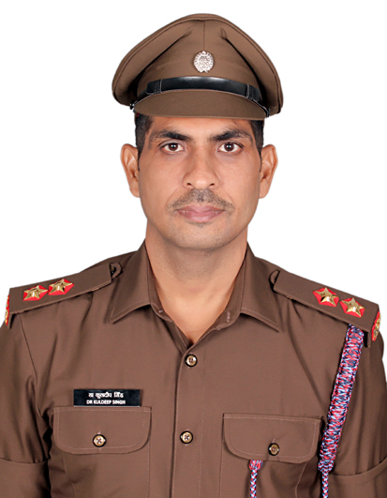 | Associate NCC Officer (ANO)  Lieutenant (Dr.) Kuldeep Singh  ‘A’ Grade & 23 Rank in Pre-Commissioned Cadet Course-172  Unit: 10 HAR BN NCC, Kurukshetra  Group Head Quarter: Ambala  Directorate: PB, HR, HP & CHD  SD/SW Cadets Strength: 53
MESSAGE FROM LIEUTENAT (DR.) KULDEEP SINGH
ASSOCIATE NCC OFFICER
Discipline, regularity, teamwork, sacrifice, a spirit of sharing, and a commitment to social service are the cornerstones of a successful and meaningful life. These values not only define our character but also shape our aspirations and guide us toward achieving them.
If we aim to rise above the ordinary, we must consciously design our lifestyle around these principles—especially discipline and teamwork. When we consistently practice positive habits, they become part of our daily routine, ultimately turning into necessities. This is the foundation of true self-development.
The two mandatory 10-day Combined Annual Training Camps (CATC), required for the ‘B’ and ‘C’ Certificates in NCC, play a crucial role in nurturing these qualities. These camps train cadets to adapt, grow, and thrive even in challenging conditions—instilling strength, resilience, and a deep sense of national pride.
Through this transformative process, NCC shapes the path of young individuals, preparing them not only for personal achievement but also to become responsible, disciplined citizens. It empowers them to rise above distractions and social evils—such as substance abuse—and to dedicate themselves to the service of the nation.
Let us carry forward the proud legacy of the NCC with purpose, discipline, and unwavering commitment.

Jai Hind! 🇮🇳

Indira Gandhi National College, Ladwa-Dhanora (Kurukshetra)
NATIONAL CADET CORPS (NCC) – ARMY WING
The NCC Army Wing at our college plays a vital role in shaping rural youth into disciplined, confident, and patriotic citizens. It instills the values of unity, character, and leadership, preparing students for national service and future responsibilities. Through regular training and activities, NCC inspires courage, discipline, and a strong sense of duty towards the nation.
Our college NCC unit has an SD/SW strength of 53 cadets. Cadets actively participate in prestigious camps such as Army Attachment with Army Units, Army Attachment with Military Hospitals, Civic Action Programs, Thal Sanik Camp, Combined Annual Training Camps, and several other national-level camps—bringing immense pride to our institution. Many of our cadets have also joined the Indian Armed Forces as Agniveer, serving the nation in various ranks and roles.

Aims of NCC:
- To develop character, comradeship, discipline, leadership, a secular outlook, a spirit of adventure, sportsmanship, and the ideals of selfless service among the youth of the country.
- To create a human resource of organized, trained, and motivated youth, capable of providing leadership in all walks of life and ready to serve the nation whenever required.
- To provide a suitable environment that motivates young people to pursue a career in the Armed Forces.

NCC Pledge:
We, the cadets of the National Cadet Corps, do solemnly pledge that we shall always uphold the unity of India. We resolve to be disciplined and responsible citizens of our nation. We shall undertake positive community service in the spirit of selflessness and with concern for our fellow beings.

The NCC Unit of Indira Gandhi National College, Ladwa is one of the most active societies on campus. Our cadets regularly participate in various training camps, awareness drives, and community service initiatives, showcasing dedication and commitment to the values and spirit of the NCC.

National Youth Day Celebration at Indira Gandhi National College, Ladwa (11 Jan.,2025)  National Youth Day was celebrated jointly by the Swami Vivekananda Youth Cell and NCC Unit at Indira Gandhi National College, Ladwa. The event began with floral tributes to Swami Vivekananda and Lal Bahadur Shastri. A lecture on "Empowering Youth, Viksit Bharat" was delivered by Dr. Anurag, who emphasized the role of youth in nation-building and Swami Vivekananda's ideals. Dr. Amit Verma shared insights into Vivekananda's life. A slogan writing competition was held, with Anmol, Palak, and Manpreet winning top positions. The program ended with sapling plantation involving 48 participants. | 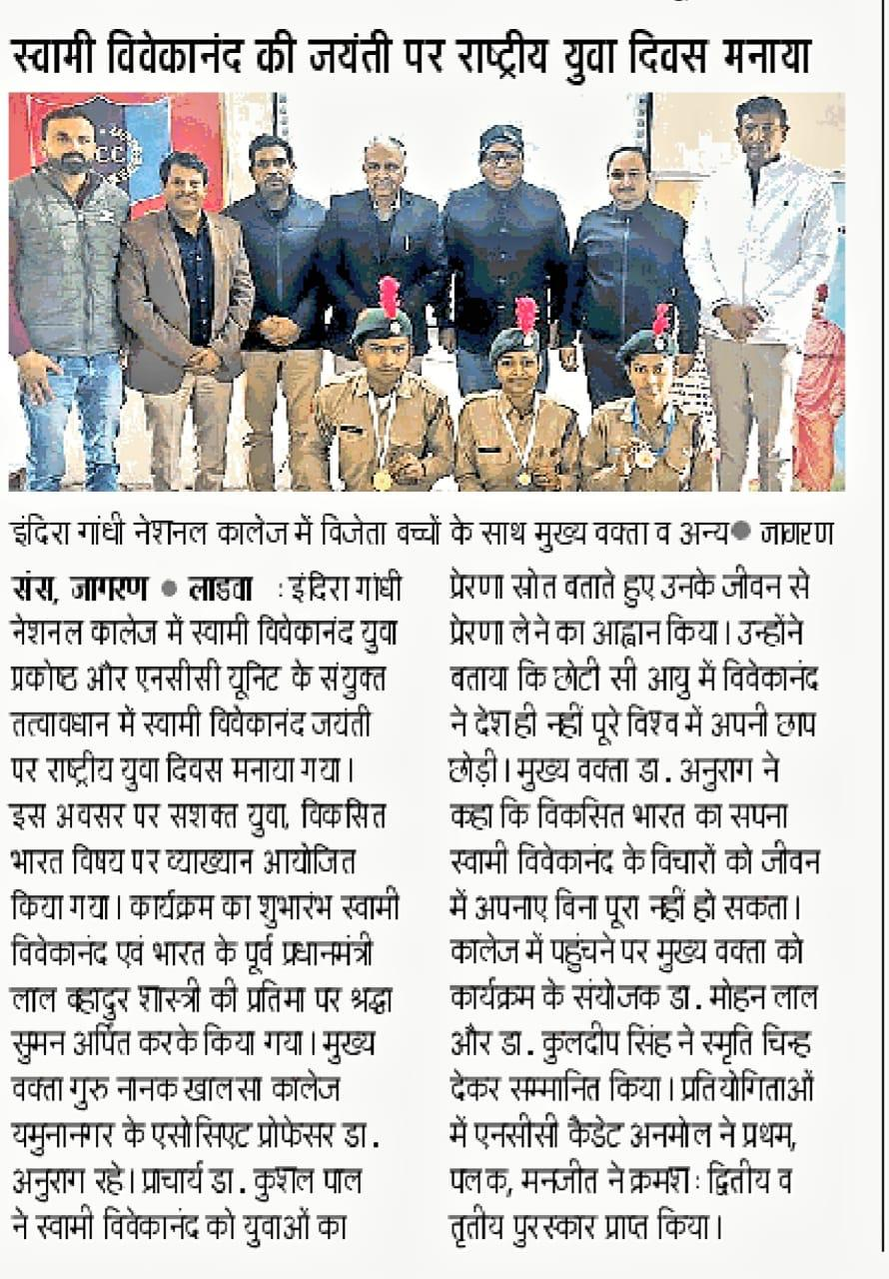
NCC Cadets Participate in the 76th Republic Day Parade (26 January, 2025)
A contingent of NCC cadets from Indira Gandhi National College, Ladwa-Dhanora, proudly participated in the 76th Republic Day Parade held on 26th January 2025 at the New Grain Market, Ladwa. The parade featured 38 cadets from both undergraduate and postgraduate classes, under the guidance of ANO Lieutenant (Dr.) Kuldeep Singh. Cadet Sunny led the SD (Senior Division) troop, while Cadet Pooja led the SW (Senior Wing) troop.
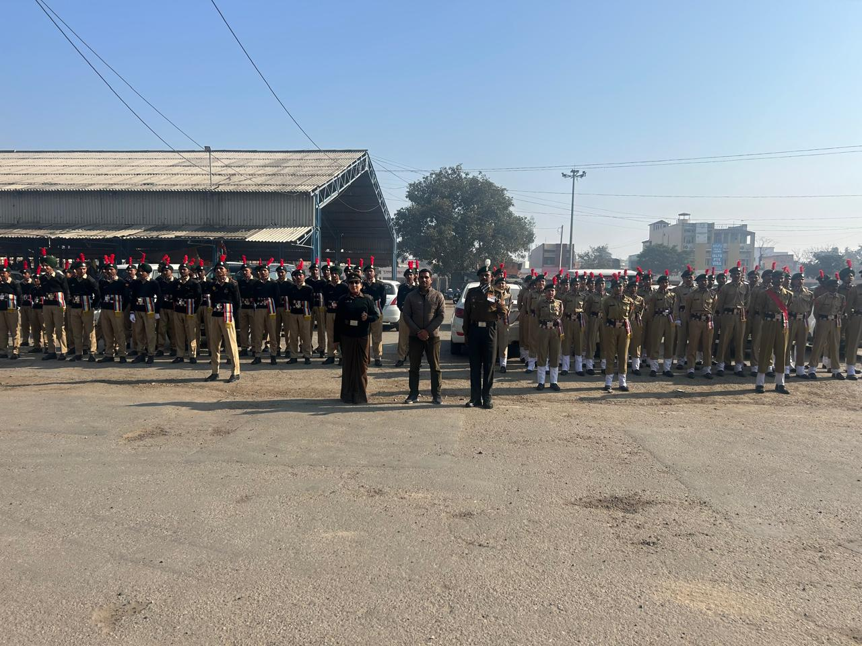
College NCC Cadet Enrolment Process  (30 August, 2024)  The NCC cadet enrolment process at Indira Gandhi National College, Ladwa, was successfully completed on 30th August 2024 by the 10 Haryana Battalion. Out of 44 enthusiastic applicants, 16 cadets were selected. The process was supervised by Principal Dr. Kushal Pal and ANO Lieutenant (Dr.) Kuldeep Singh, along with NCC officers from the battalion. ‘C’ certificates were also awarded to outgoing cadets, with special recognition given to Cadet Manpreet for her outstanding performance in NCC camps. | 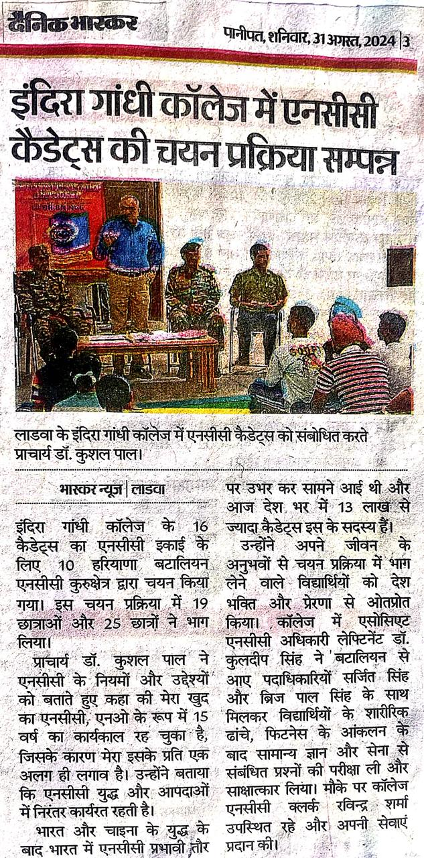
NCC Cadets Celebrate National Sports Day and “Fit India Movement” (29 August, 2024)  On 29 August 2024, Indira Gandhi National College, Ladwa celebrated National Sports Day and the “Fit India Movement” in honor of Major Dhyan Chand’s birth anniversary. The event was organized by the Department of Physical Education and the NCC Unit. Principal Dr. Kushal Pal emphasized physical fitness, meditation, and a healthy lifestyle. Various sports competitions like arm wrestling, tug of war, and running were held. Winners were awarded medals by faculty members. A total of 48 students, 19 NCC cadets, and several teachers participated. The event concluded with the national anthem and distribution of refreshments. | 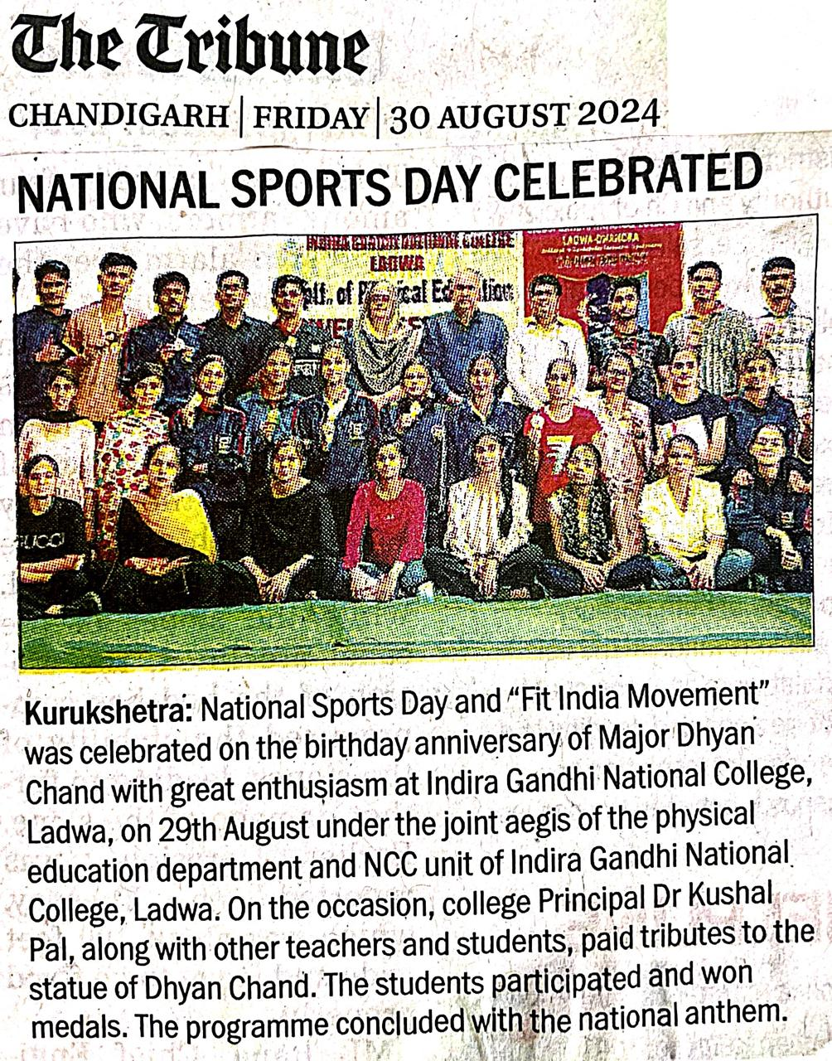
“Tiranga Rally” Organized at Ladwa Main Market (14 August, 2024)
On 14th August 2024, a grand “Tiranga Rally” was organized at Ladwa Main Market by colleges and schools of Ladwa block. A total of 113 NCC cadets participated in the rally, including 21 cadets from Indira Gandhi National College (IGNC), Ladwa; 57 from GSSS, Ladwa; 26 from JNV, Niwarsi; and 9 from Sugni Devi Arya Kanya Senior Secondary School, Ladwa. Cadets, along with CTOs/ANOs from all institutions, took part in the rally under the supervision of Lieutenant (Dr.) Kuldeep Singh.
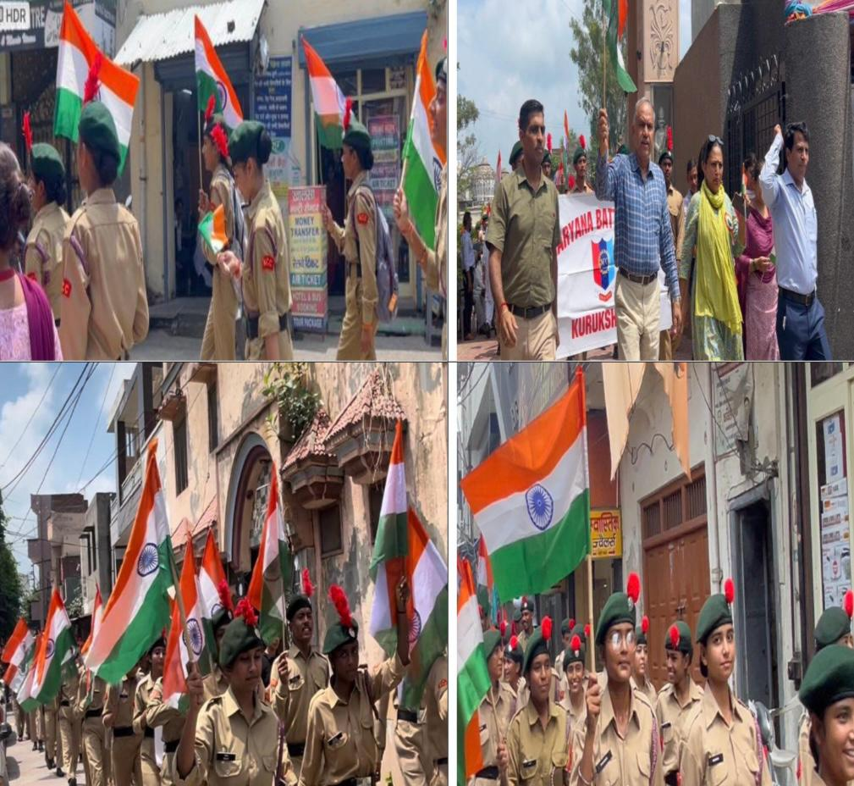
NCC Cadets Participate in the 78th Independence Day Parade (15 Aug., 2024)
A contingent of NCC cadets from Indira Gandhi National College, Ladwa-Dhanora, proudly participated in the 76th Republic Day Parade held on 26th January 2025 at the New Grain Market, Ladwa. The parade featured 38 cadets from both undergraduate and postgraduate classes, under the guidance of ANO Dr. Kuldeep Singh. Cadet Sunny led the SD troop, while Cadet Pooja led the SW troop. The flag-hoisting ceremony was conducted by the Sub-Divisional Magistrate of Ladwa.
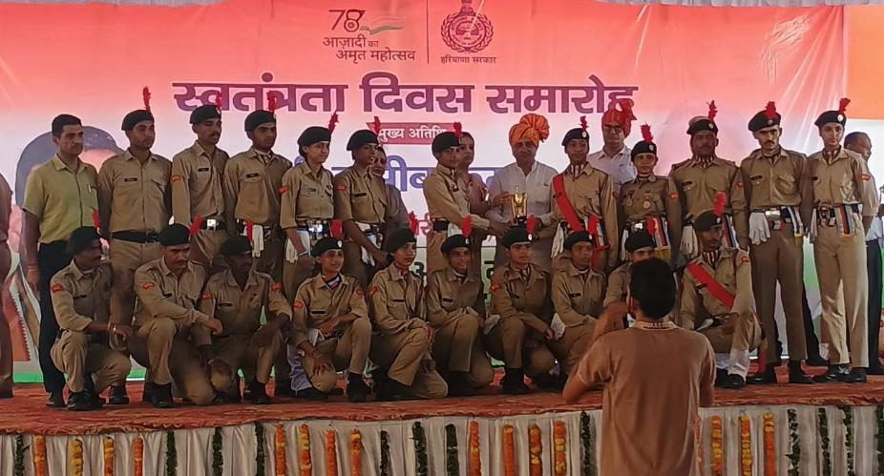
NCC Cadets Participate in National De-Worming Day (04 September, 2024)  NCC cadets from Indira Gandhi National College, Ladwa-Dhanora, actively participated in the National De-Worming Day program held on the college premises. All cadets took the deworming medicine and also distributed it among other students, encouraging regular deworming for better personal health.  The event was organized under the guidance of ANO Dr. Kuldeep Singh. The college Principal extended special thanks to Dr. Kuldeep Singh and all the NCC cadets for making the event a great success. | 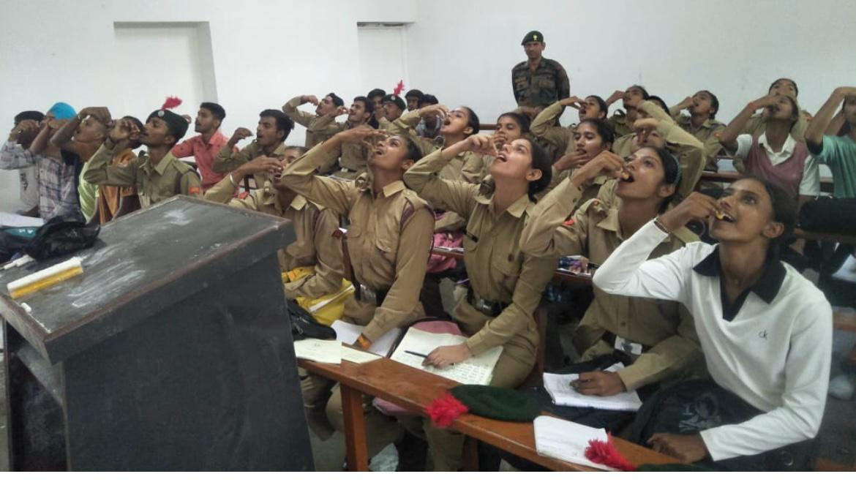
College, Ladwa NCC Army Wing Four cadets and ANO donated blood at a blood donation camp on the college premises on World Health Day, 7th April 2024. | 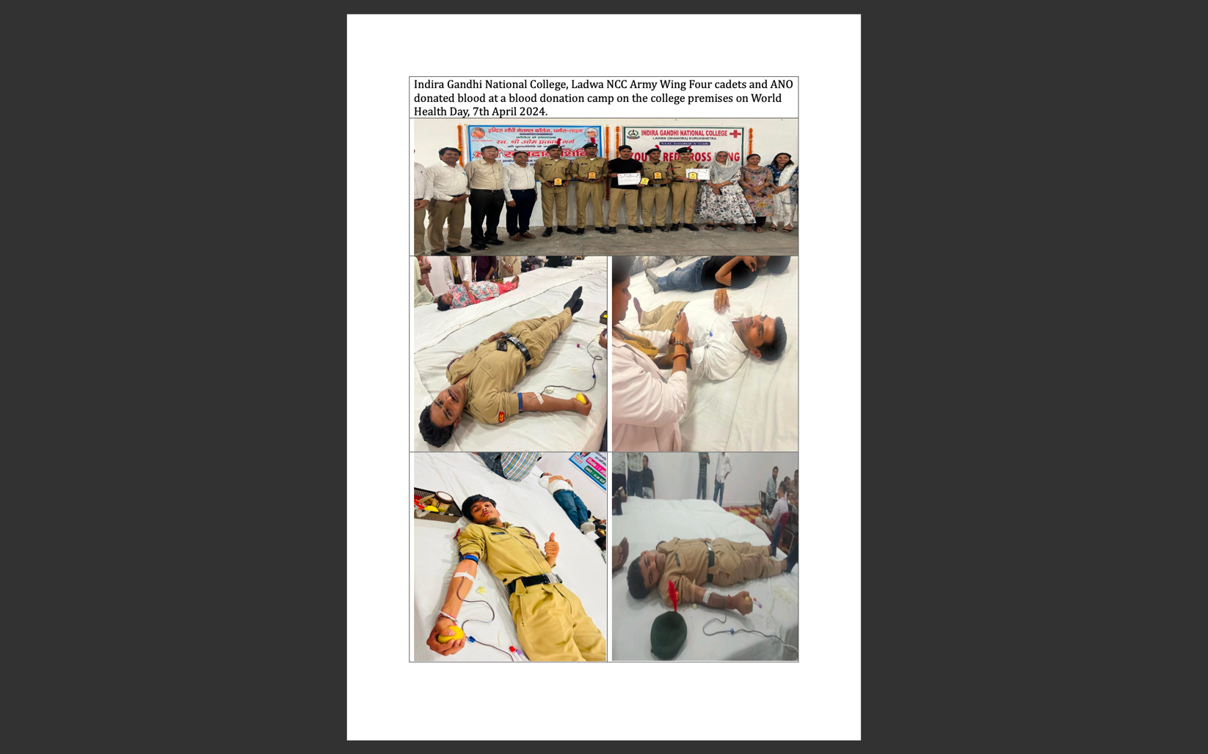
Former Soldiers Deliver a Lecture on the Agnipath Scheme at I.G.N. College, Ladwa  On 17 April 2025, retired soldiers Sardar Surjit Singh and Havildar Baljeet Singh delivered a motivational lecture on the Agnipath Scheme at IGN College, Ladwa. Organized by the NCC unit under Dr. Kuldeep Singh, the event aimed to inform and inspire cadets. Informational booklets were also distributed. | 