**Indira Gandhi National College Ladwa (Dhanora)**

**Snapshots of ICT Tools Used by Teachers**

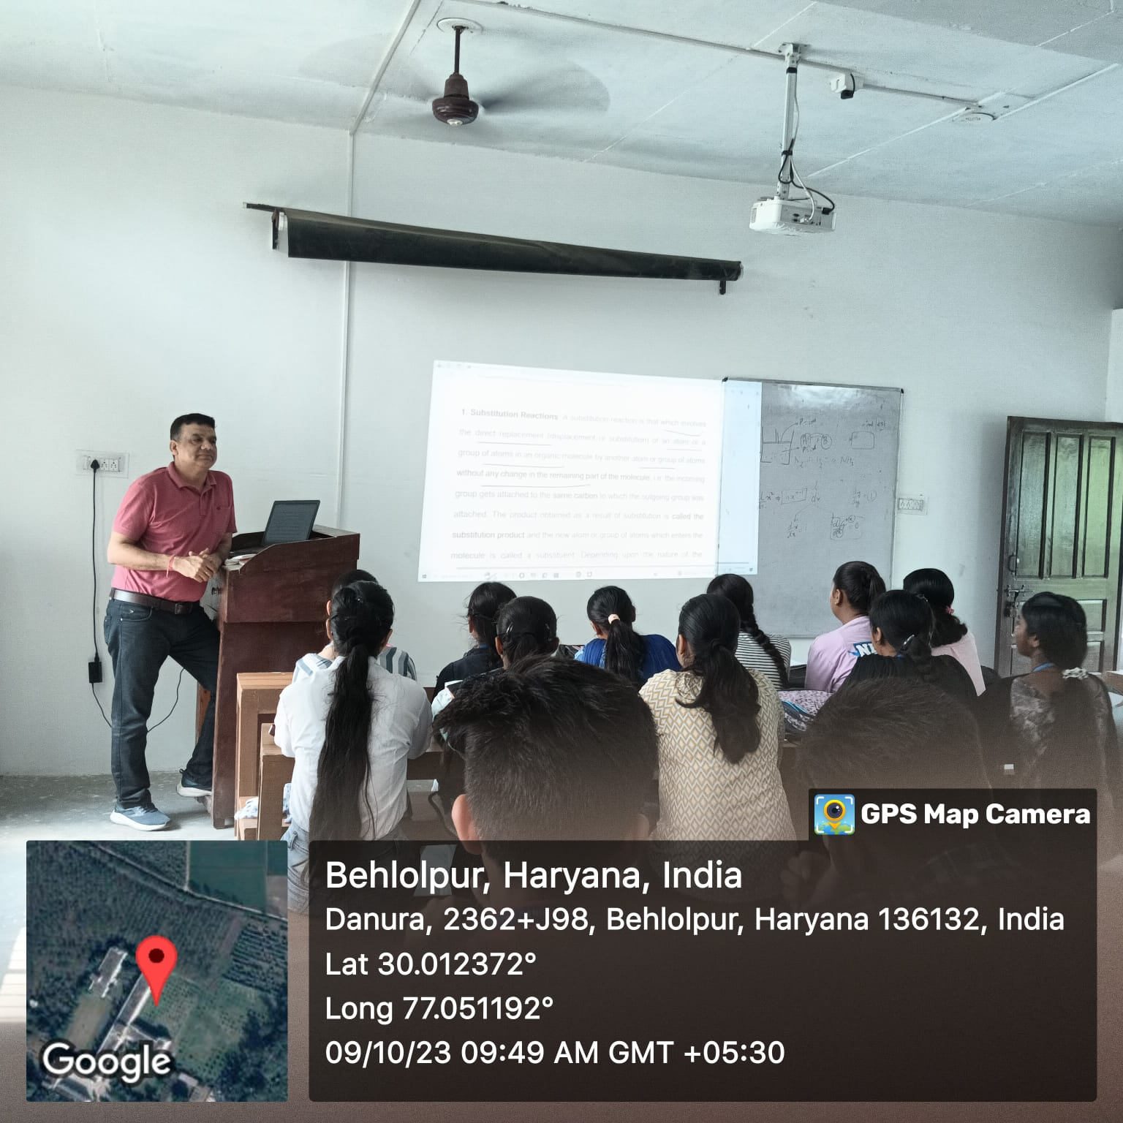

**TEACHING THROUGH POWER POINT PRESENTATION**

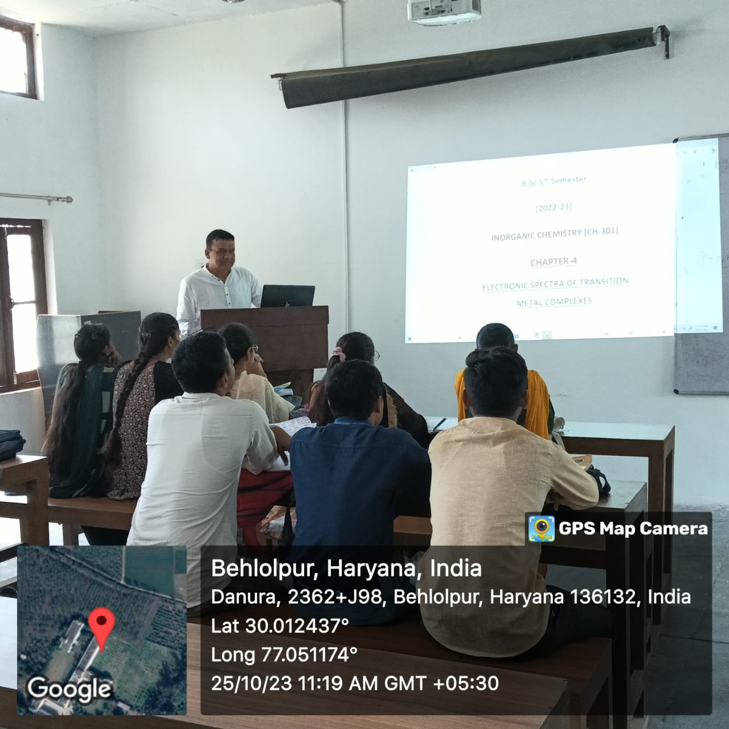

**TEACHING THROUGH POWER POINT PRESENTATION**

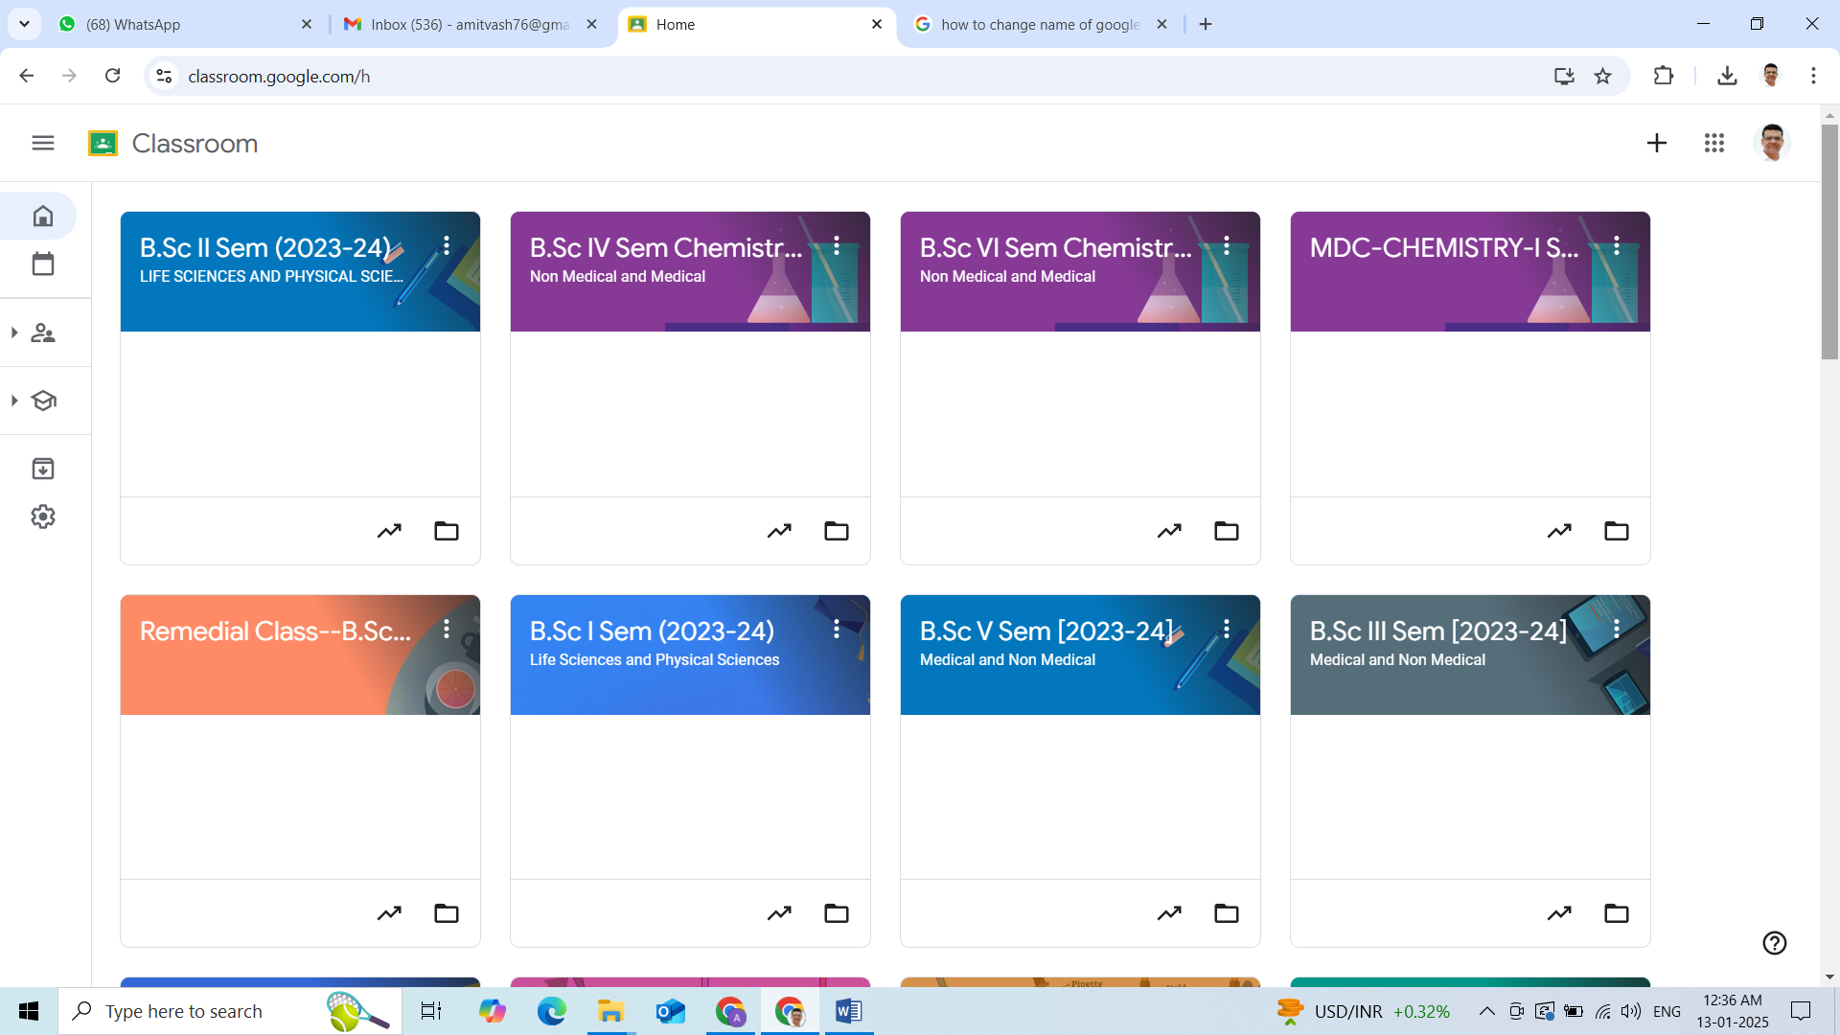

**GOOGLE CLASSROOMS**

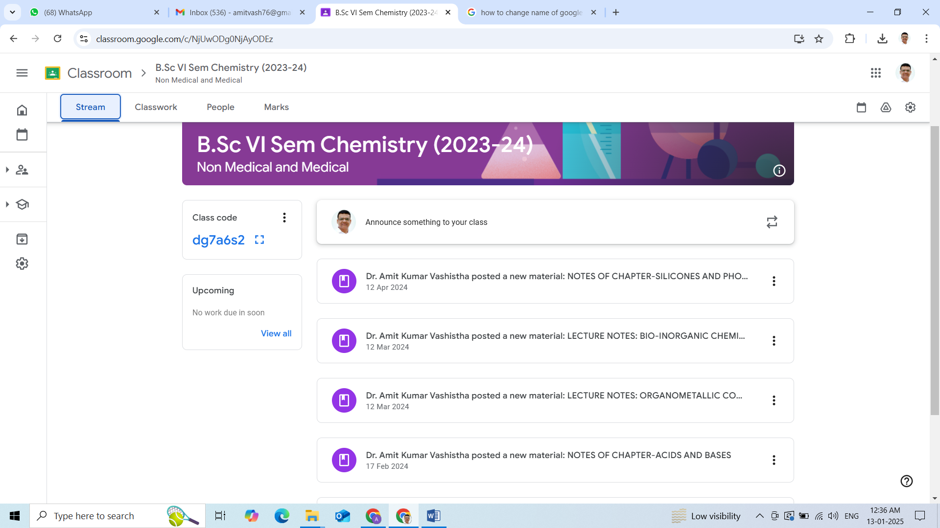

**SHARING OF STUDY MATERIAL ON GOOGLE CLASSROOM**

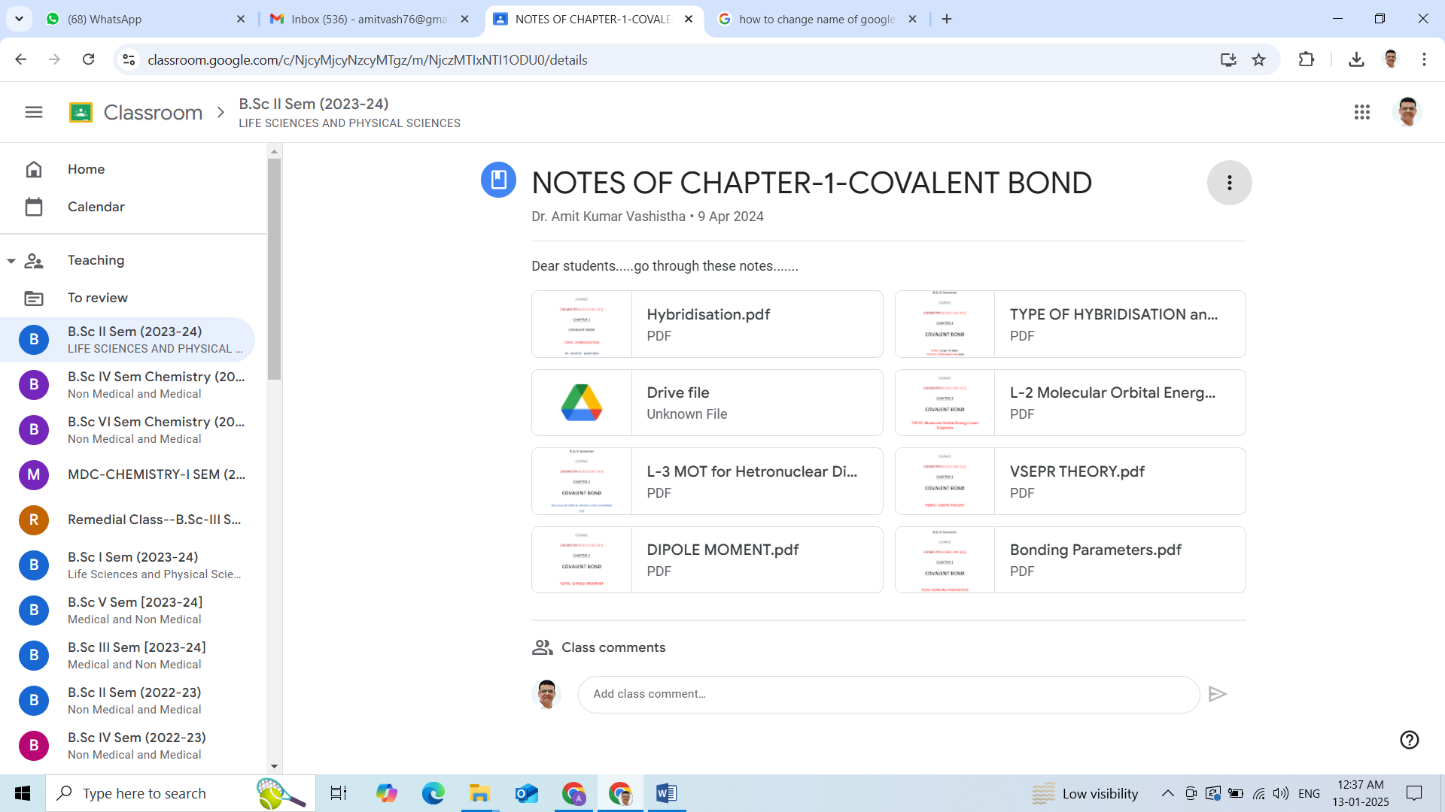

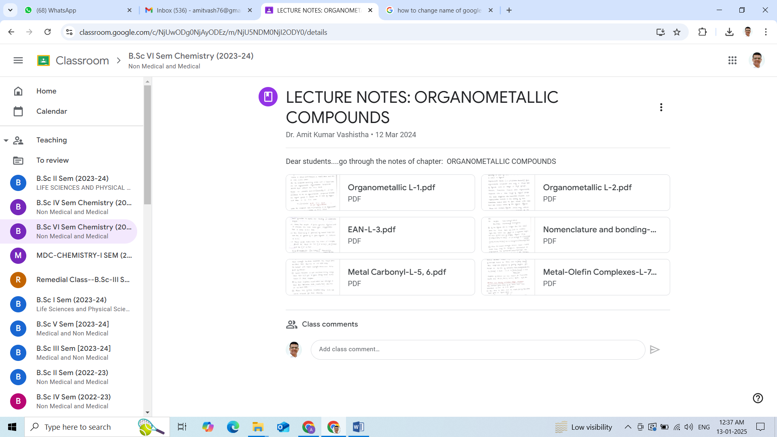

**NOTES SHARED IN GOOGLE CLASSROOM**

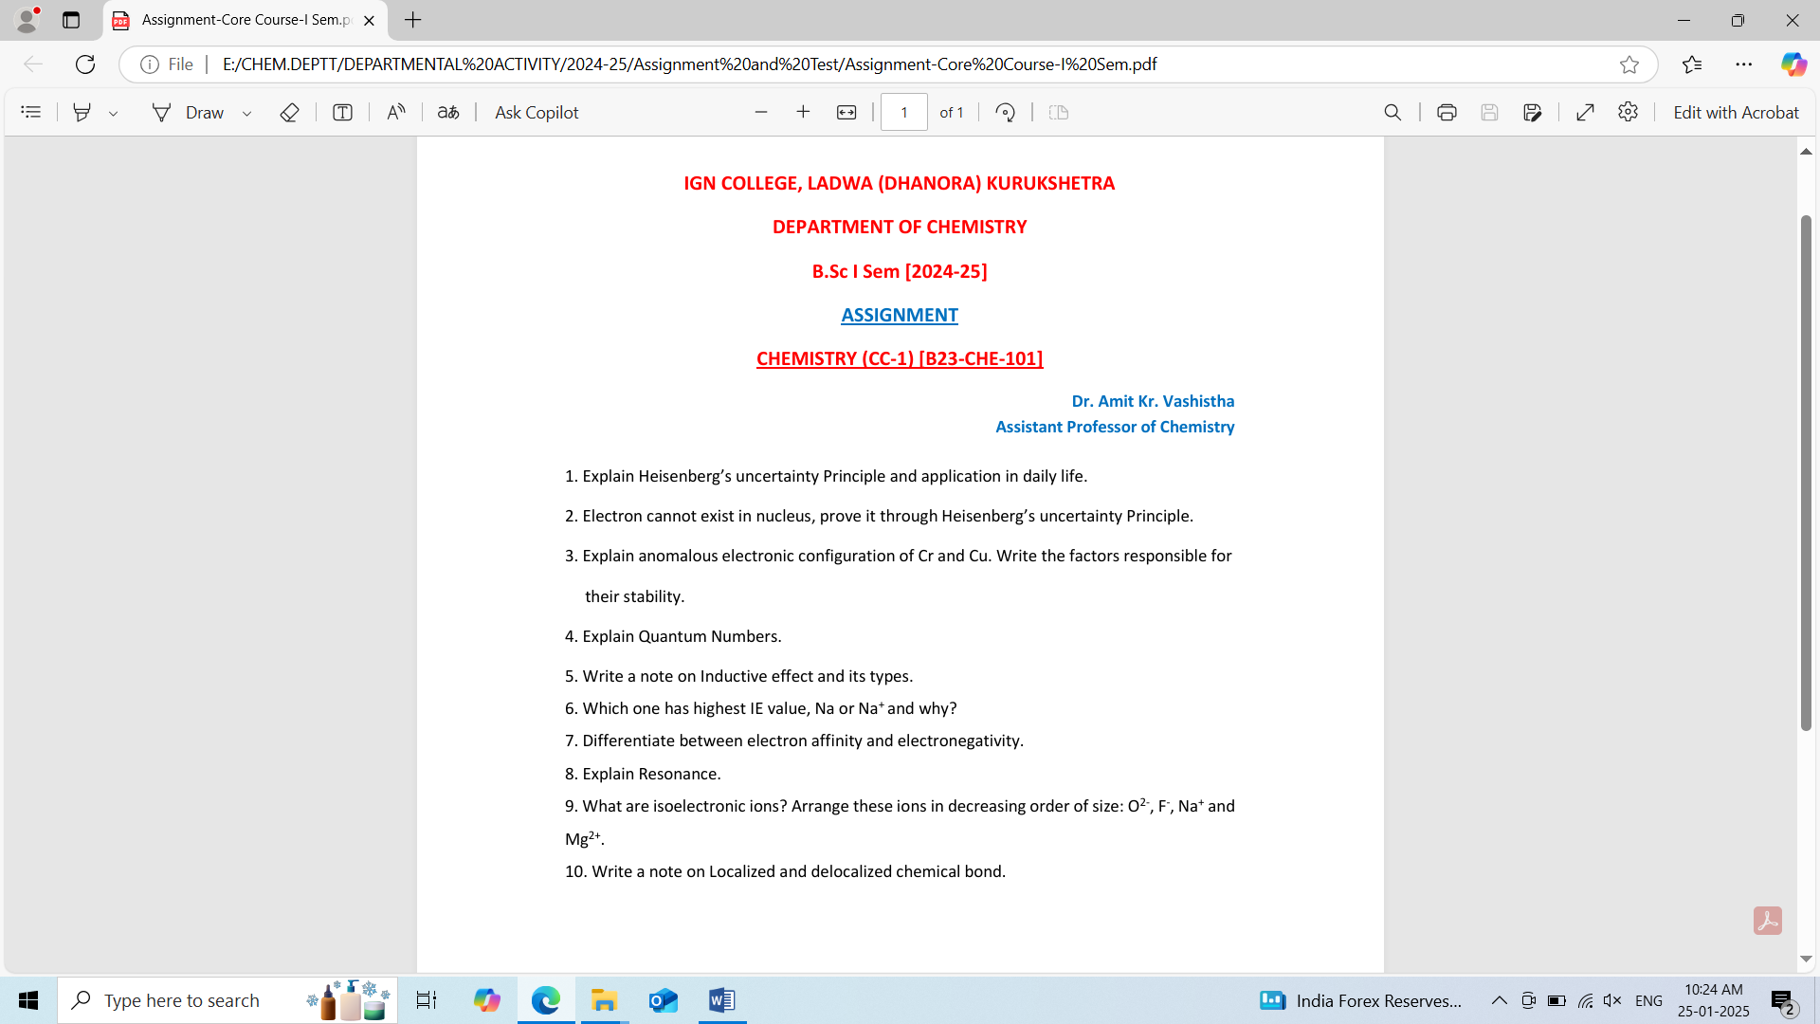

**ASSIGNMENT SHARED WITH THE STUDENTS**

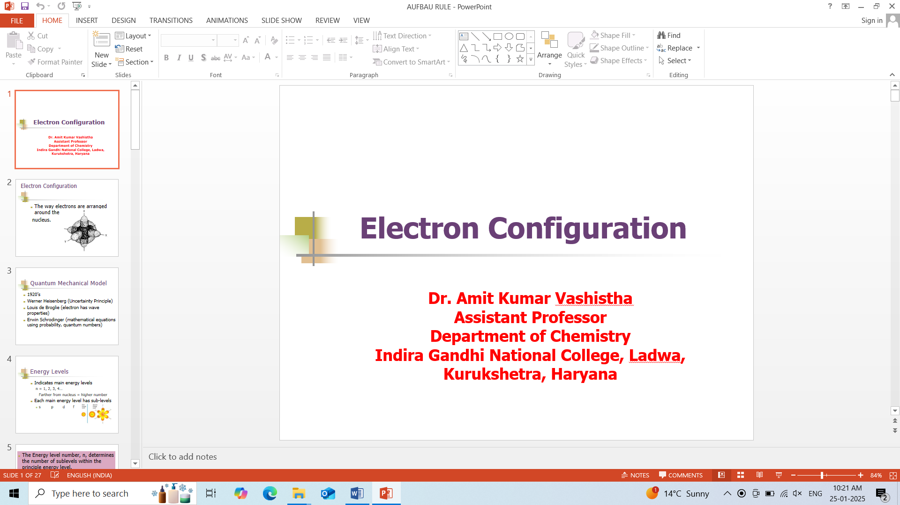

**POWER POINT PRESENTATION**

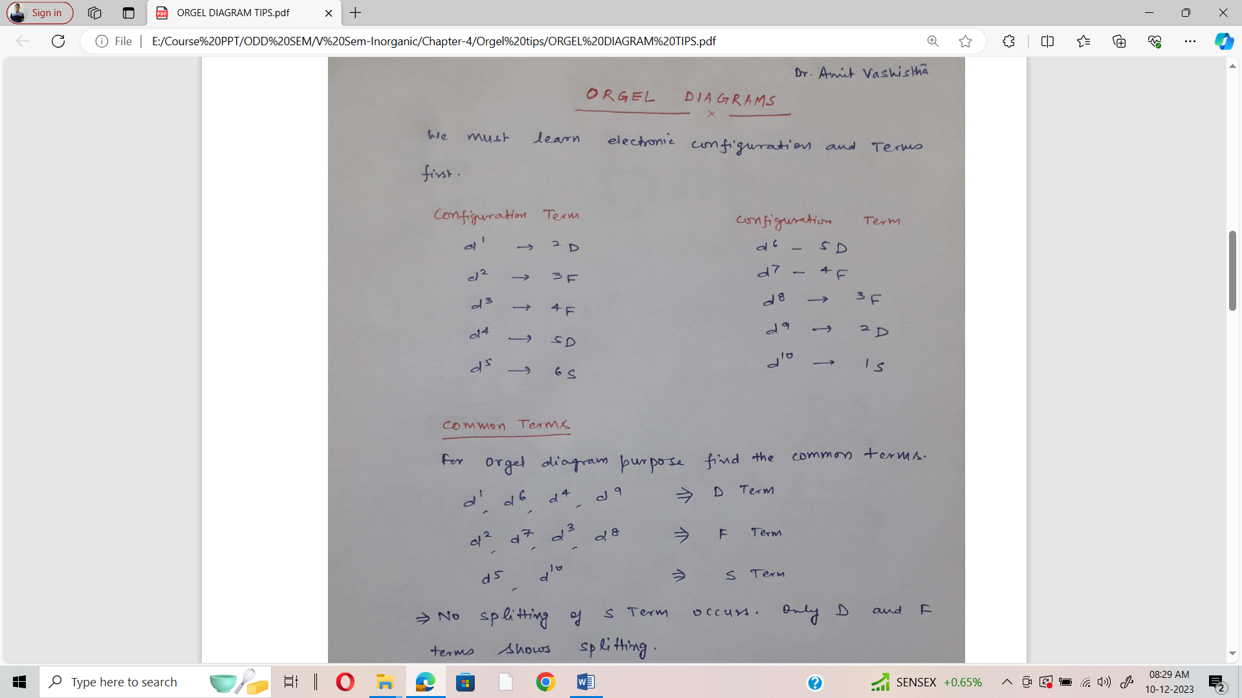

**NOTES SHARED IN GOOGLE CLASSROOM**

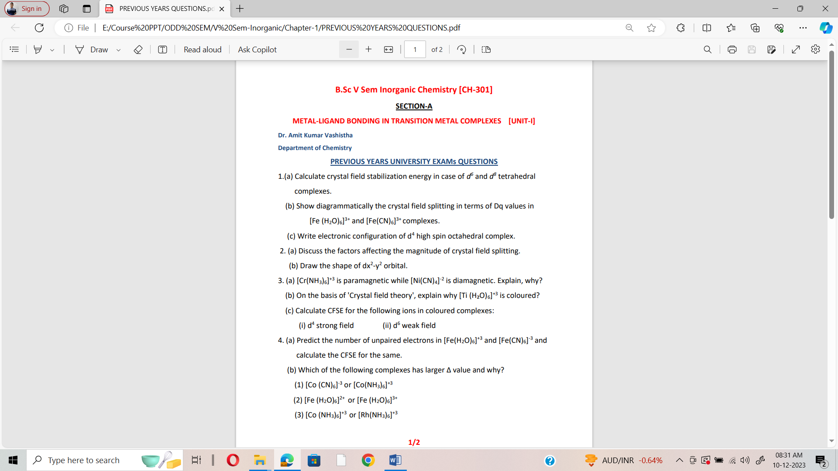

**IMPORTANT QUESTIONS SHARED IN GOOGLE CLASSROOM**