IGN COLLEGE, LADWA
CAREER GUIDANCE CELL
ONLINE AWARENESS PROGRAMME ON ENTREPRENEURSHIP

UNDER

National Level Awareness Programme (NLAP) on Entrepreneurship: ‘Sambhav-2021’.

Dated: 23.11.2021

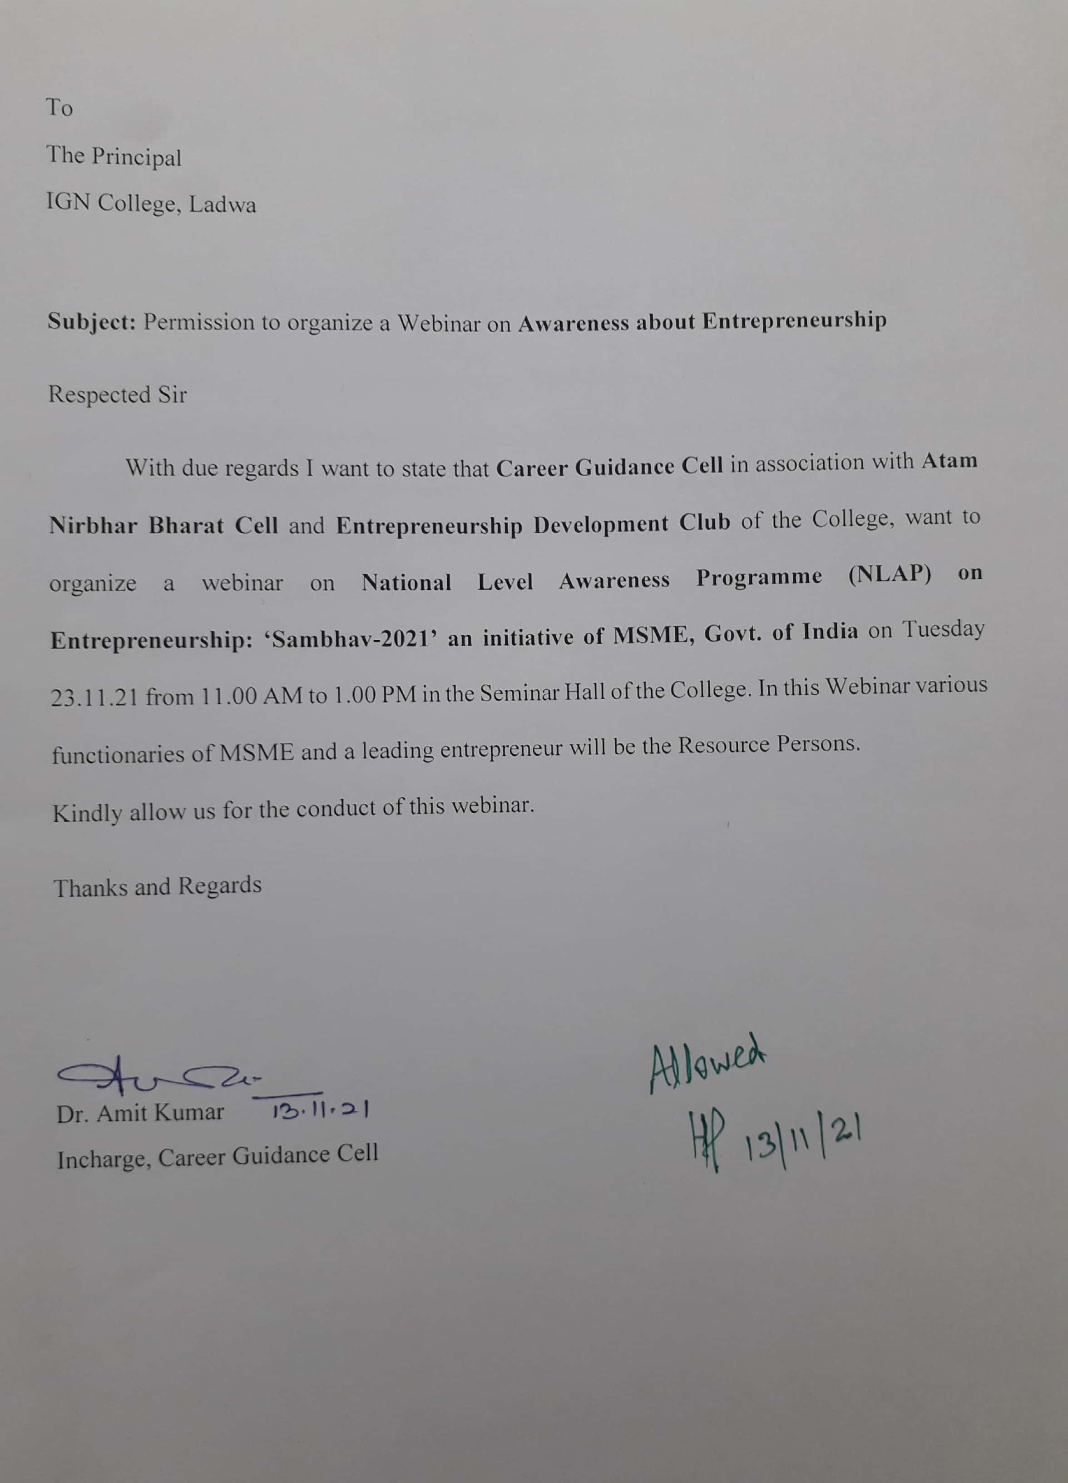
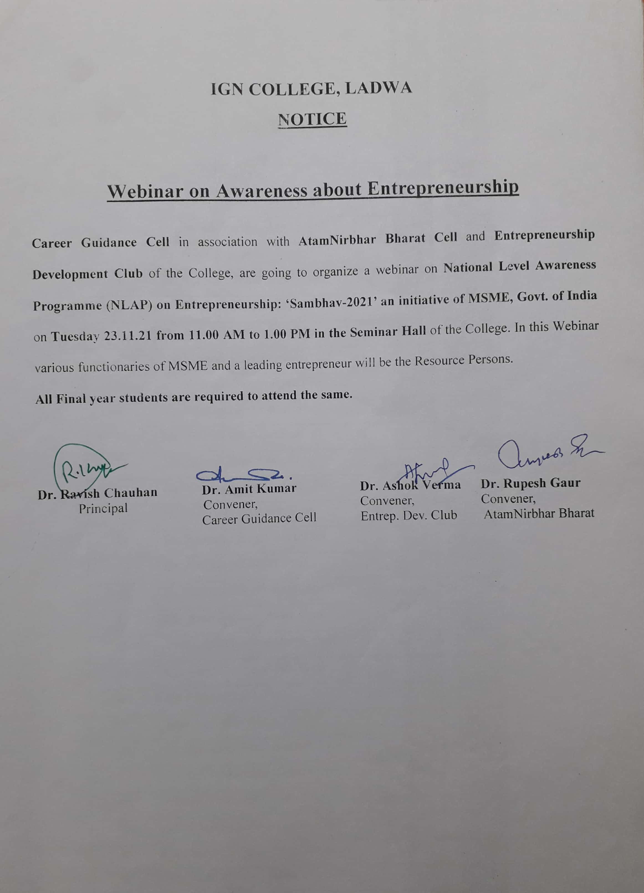

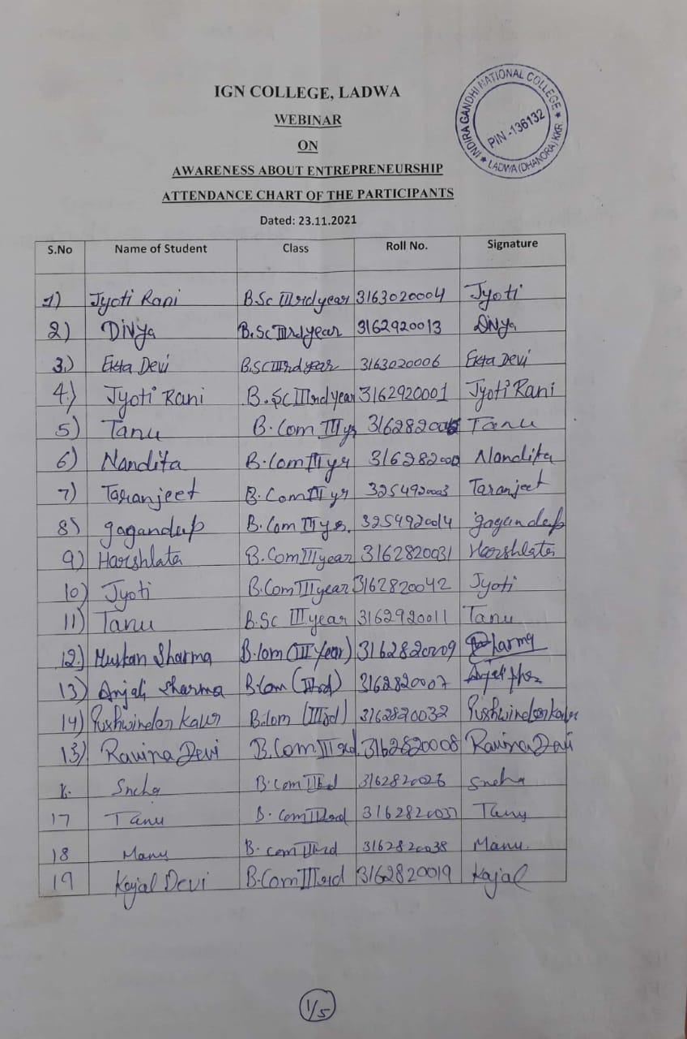
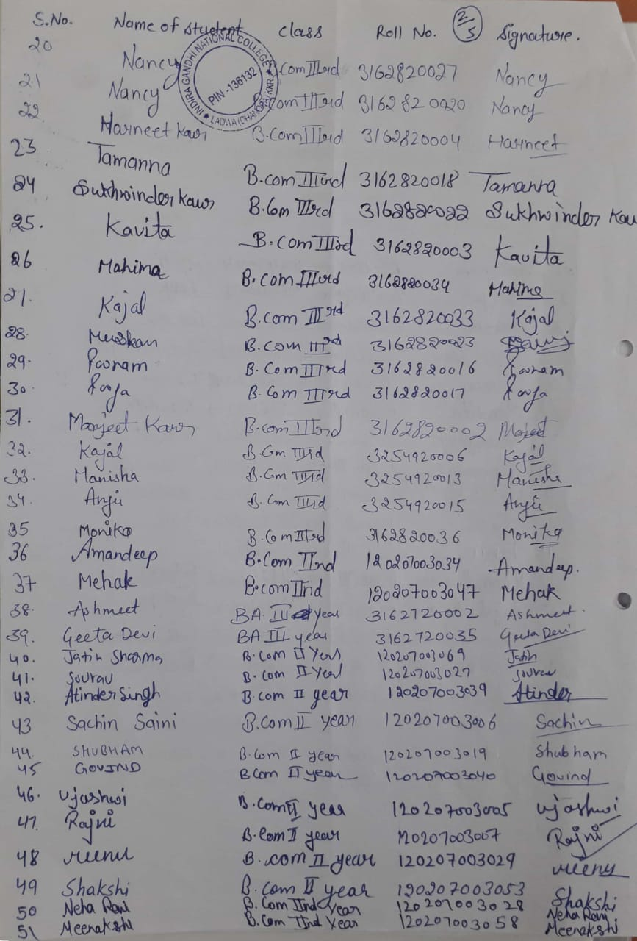

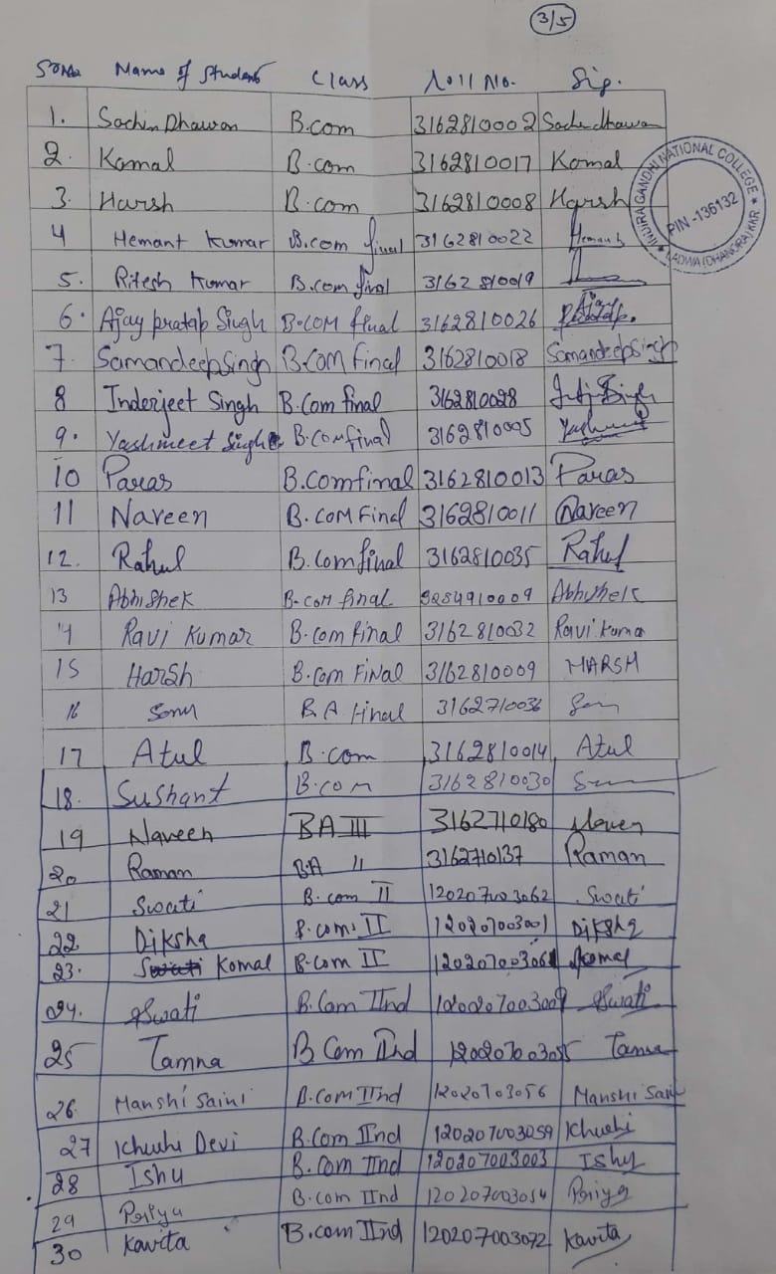
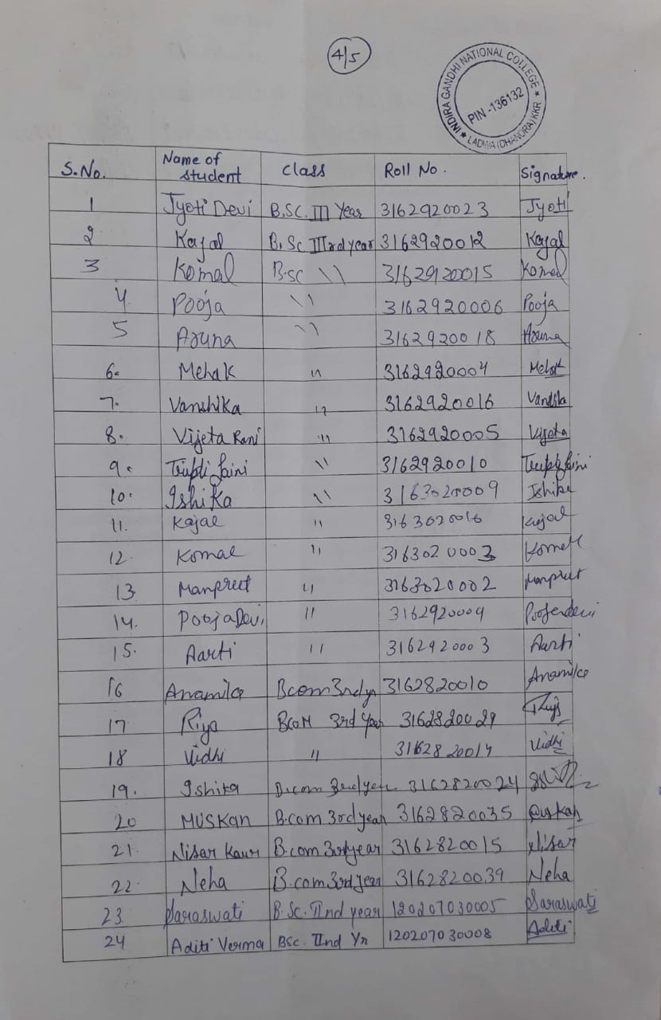
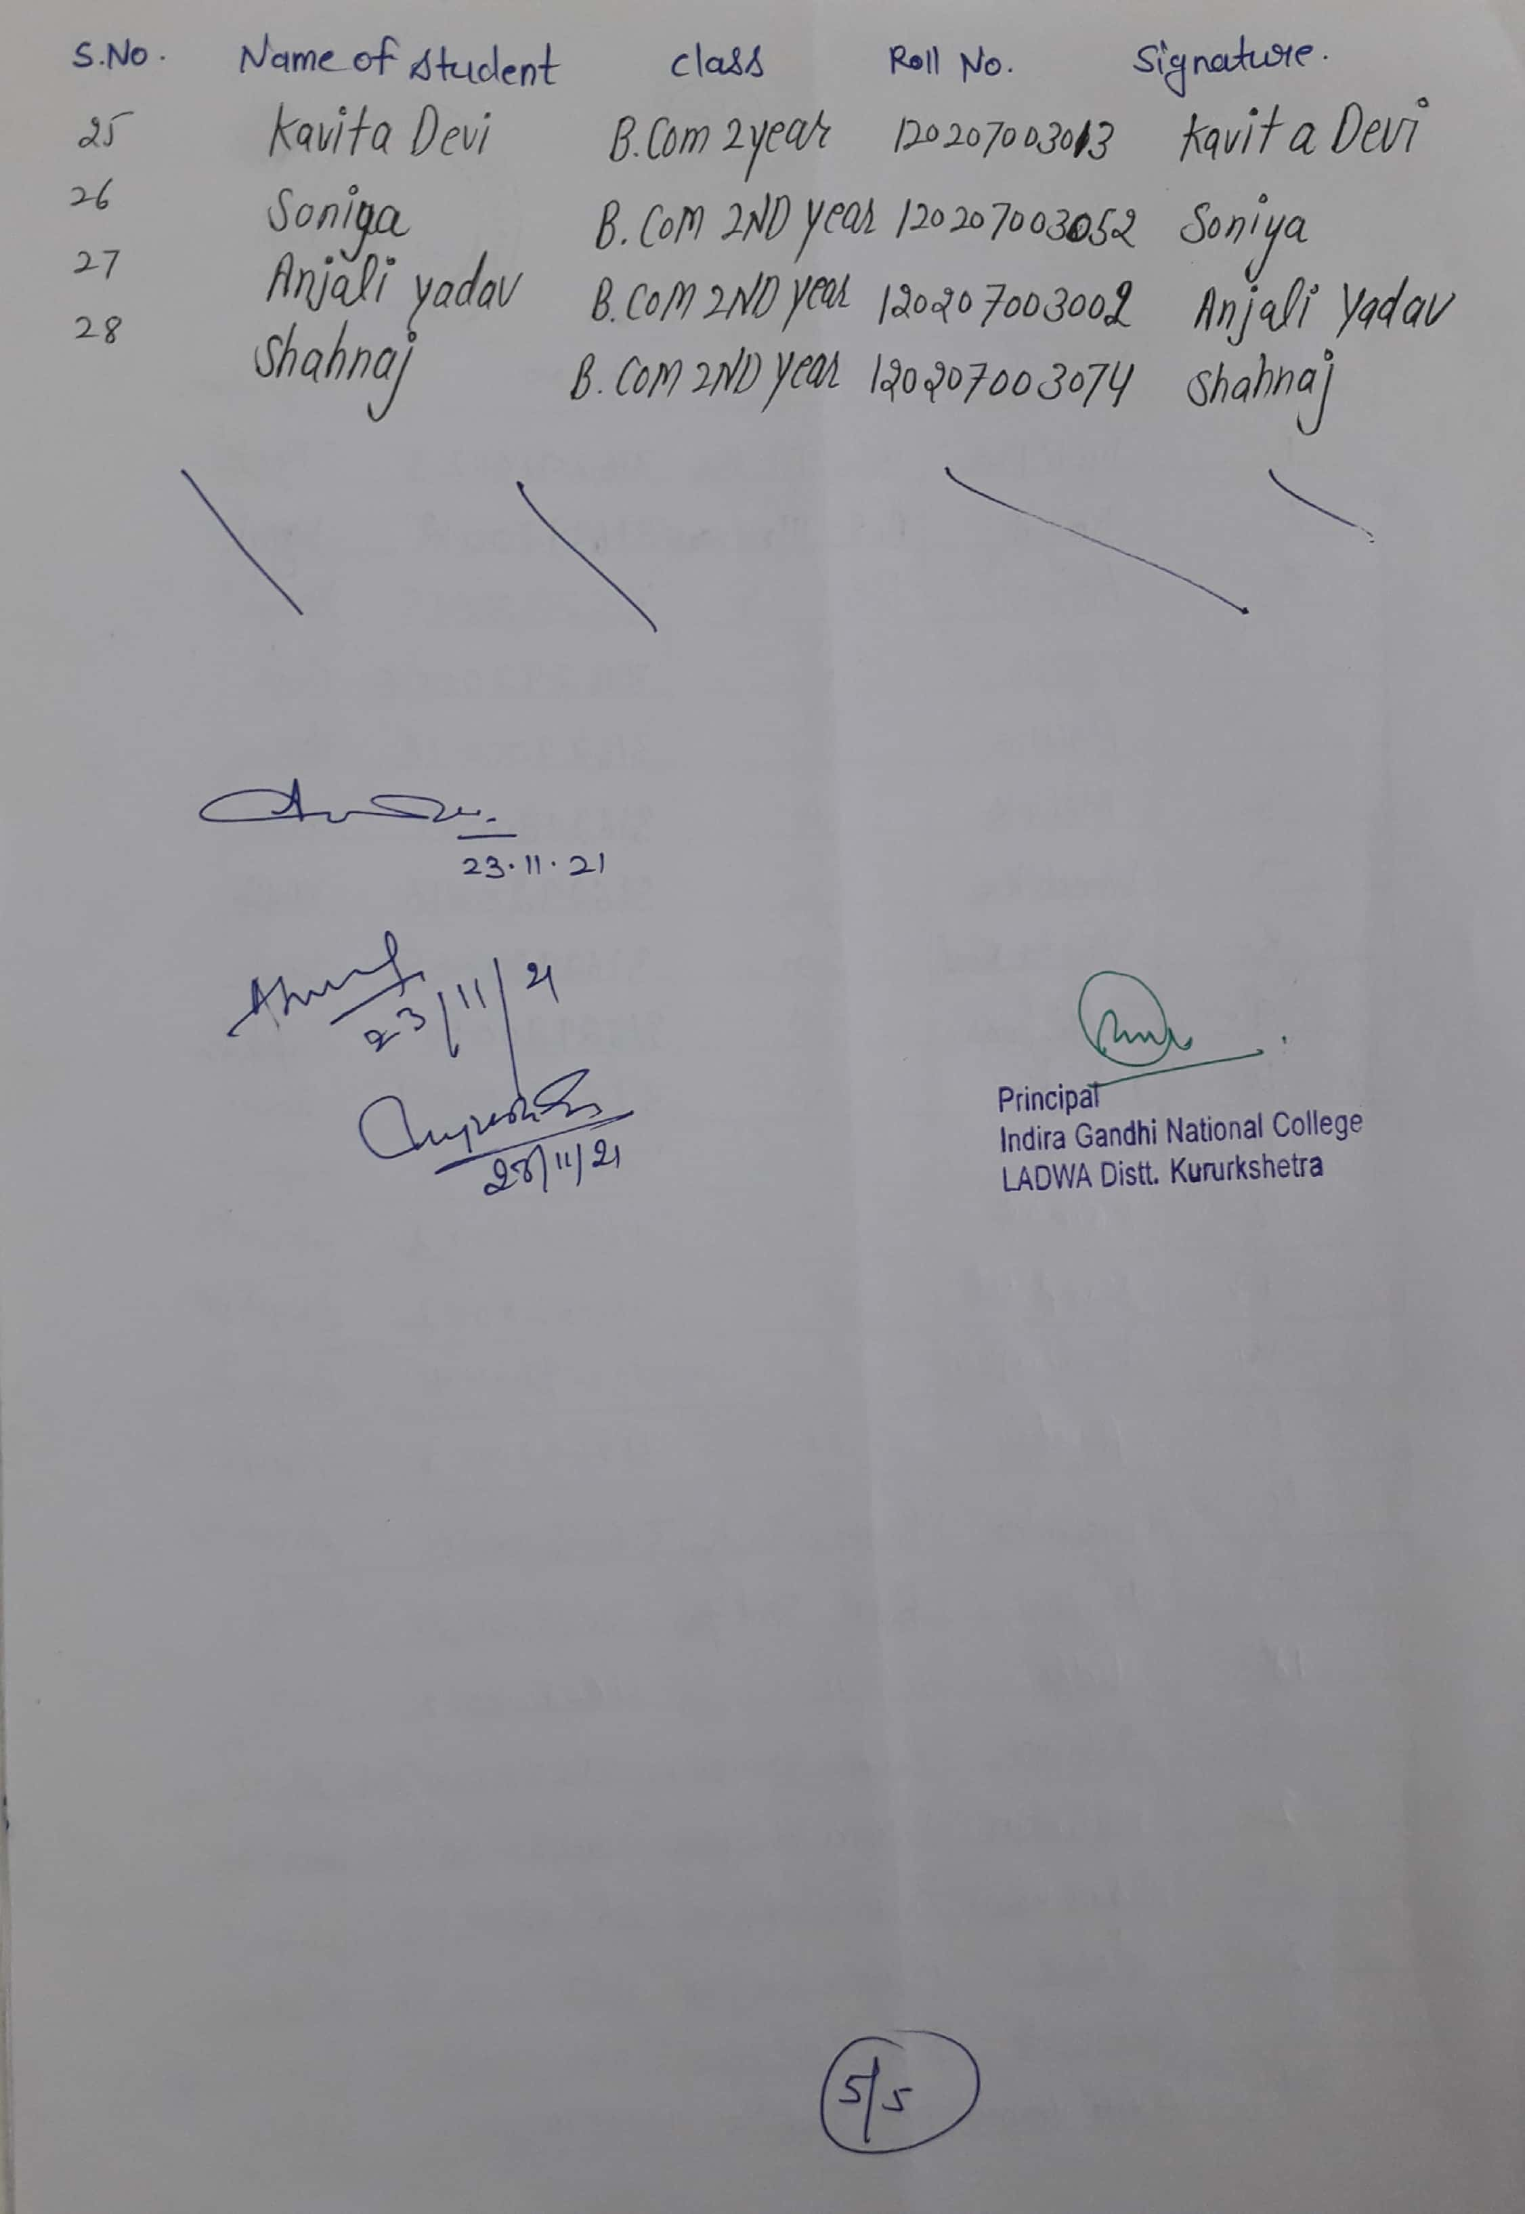

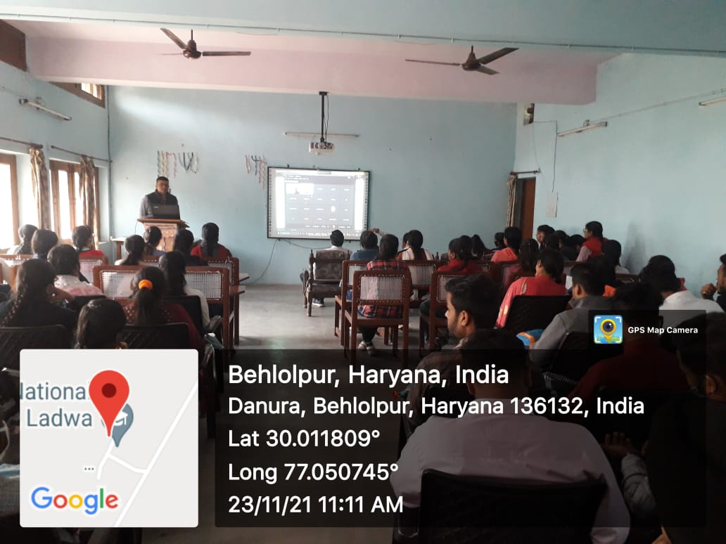
Dr. Amit Kumar, Convener, Career Guidance Cell welcome all the guests and participants of this webinar.

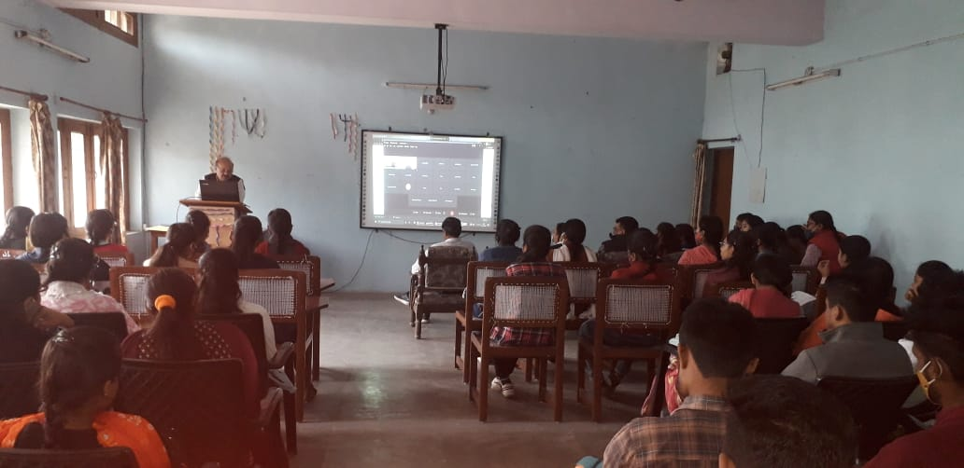
Dr. Ravish Kumar Chauhan, Principal of the College welcome the guests and participants

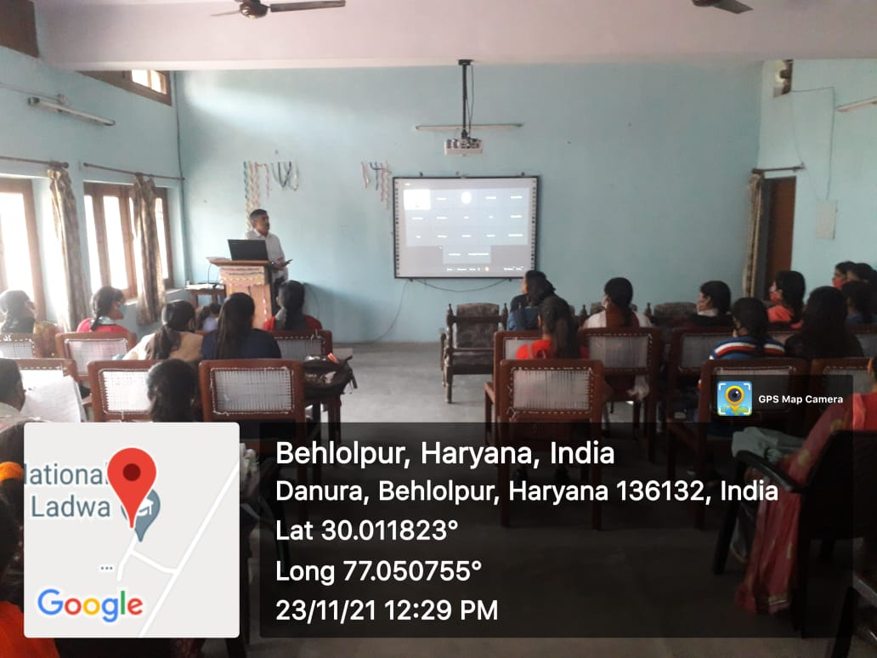

Dr. Rupesh Gaur, Convener, Atam Nirbhar Bharat Cell during his speech
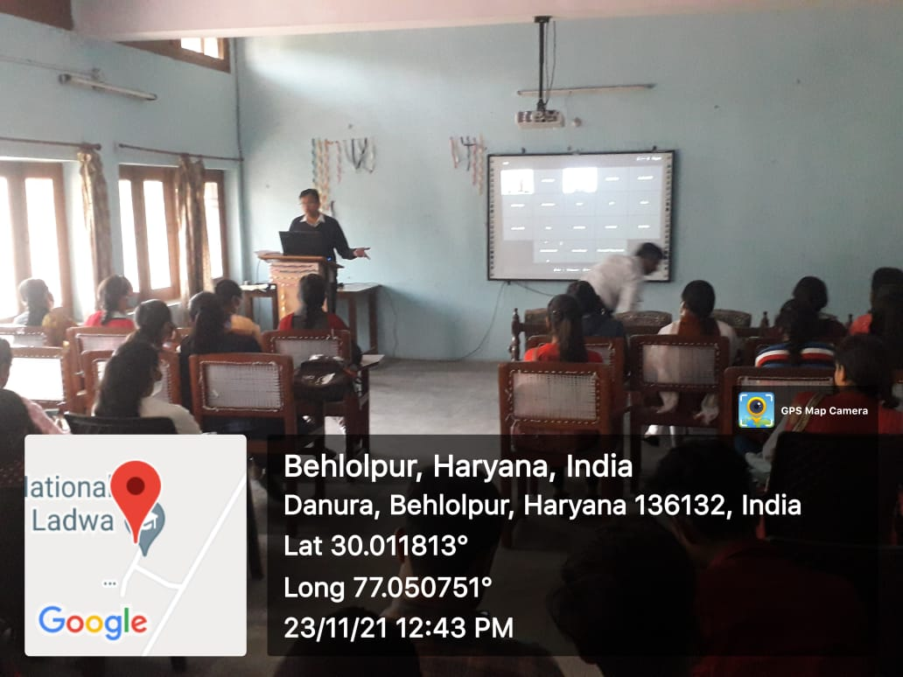
Dr. Ashok Verma, Convener, Entrepreneurship Development Club thanks all the Resource persons and participants.

