IGN COLLEGE, LADWA
CAREER GUIDANCE CELL
WEBINAR
on
‘ROLE OF ENTREPRENEURSHIP IN RURAL DEVELOPMENT’

Dated: 10.09.2021

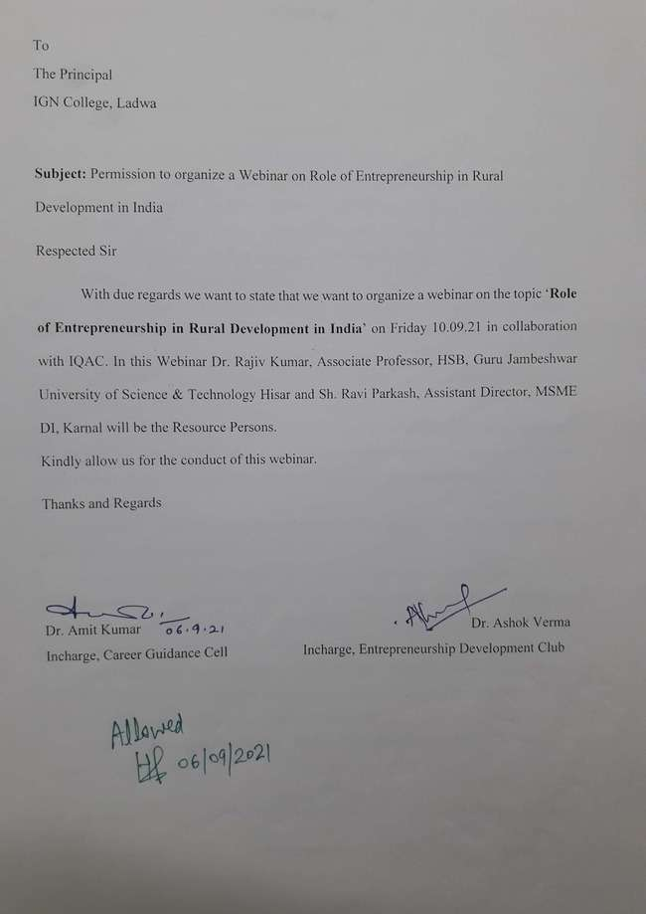

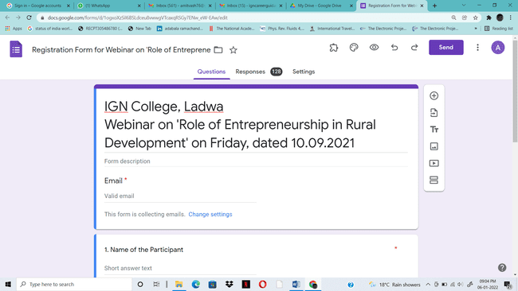

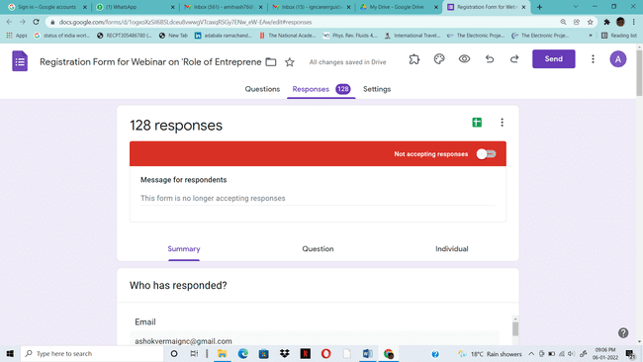

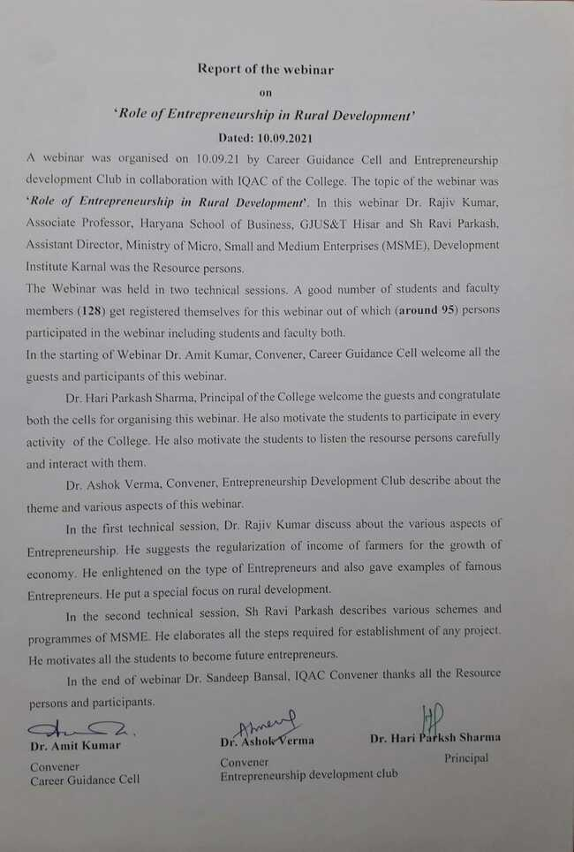
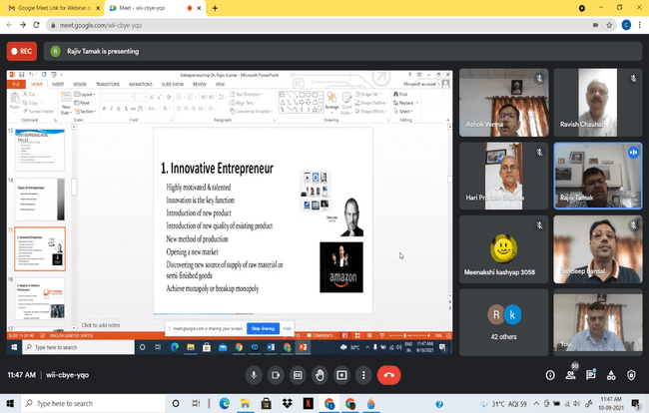
RESOURCE PERSON DR. RAJIV KUMAR, ASSOCIATE PROFESSOR, HARYANA SCHOOL OF BUSINESS, GJUS&T HISAR DURING HIS LECTURE

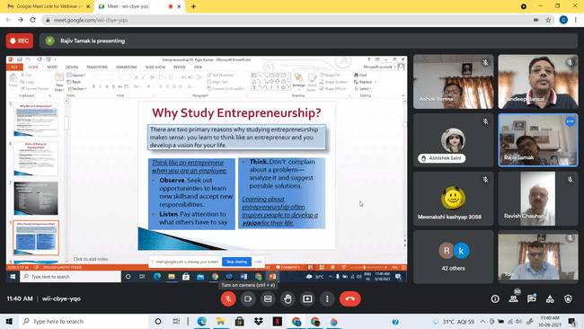
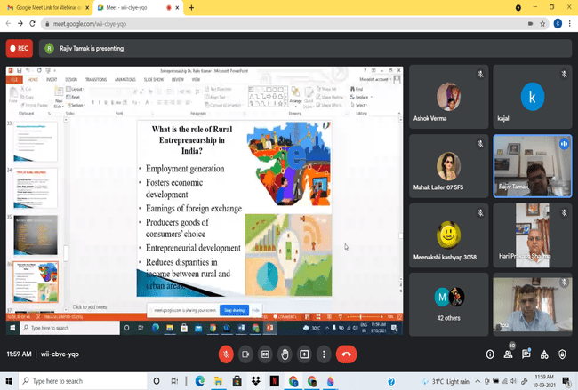

RESOURCE PERSON DR. RAJIV KUMAR, ASSOCIATE PROFESSOR, HARYANA SCHOOL OF BUSINESS, GJUS&T HISAR DURING HIS LECTURE

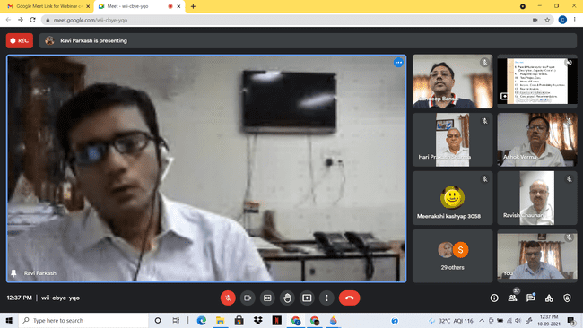
RESOURCE PERSON SH RAVI PARKASH, ASSISTANT DIRECTOR, MSME, D.I. KARNAL DURING HIS LECTURE

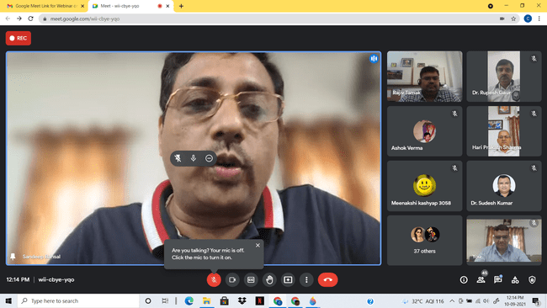
DR. SANDEEP BANSAL, IQAC CONVENER THANKS ALL THE RESOURCE PERSONS AND PARTICIPANTS.

