INDIRA GANDHI NATIONAL COLLEGE LADWA
CAREER GUIDANCE CELL
ORGANIZED
AN
ONLINE EXPERT LECTURE
ON
Career Opportunities in the field of Management after Graduation
ON
3rd JULY, 2021
BY
Ms Anuja Goel
Head, Department of Management
JMIT, Radaur, Yamunanagar, (Haryana) India

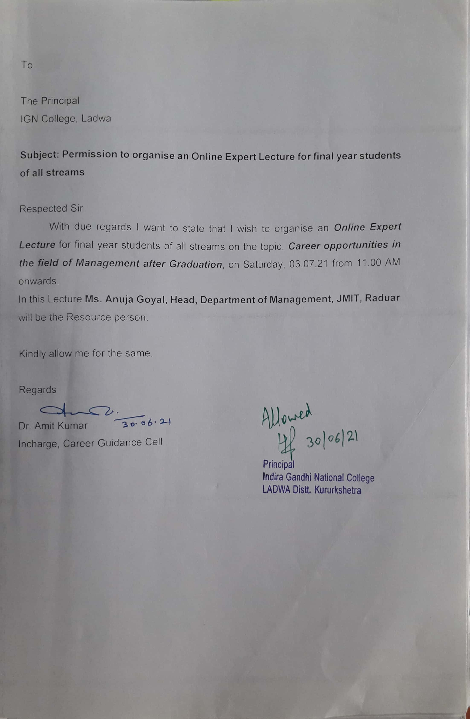
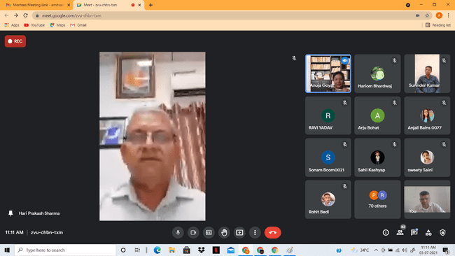
Dr. Hari Parkash Sharma, Principal, welcomes the Guest
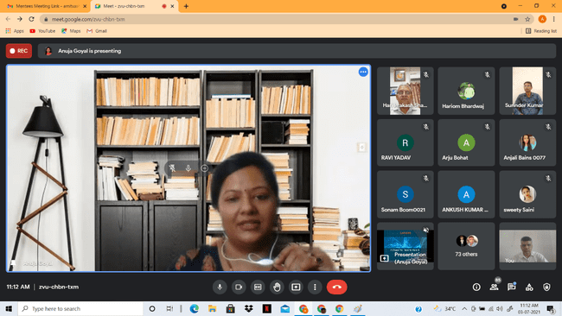
RESOURCE PERSON MS. ANUJA GOEL DURING HER LECTURE

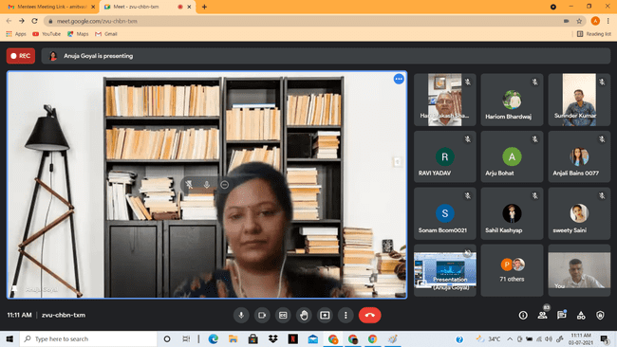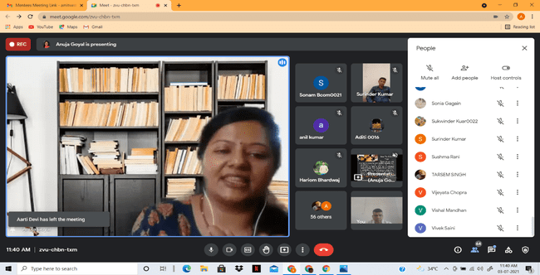

RESOURCE PERSON MS. ANUJA GOEL INTERACTING WITH STUDENTS DURING HER LECTURE

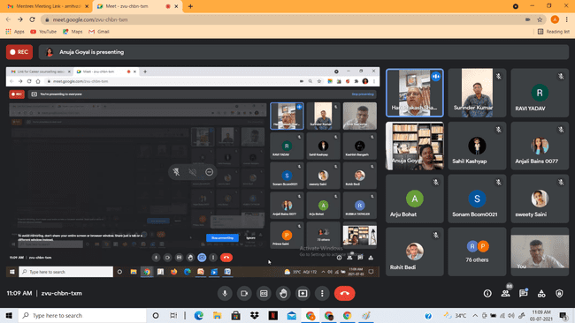

RESOURCE PERSON MS. ANUJA GOEL, SHOWING HER PRESENTATION

