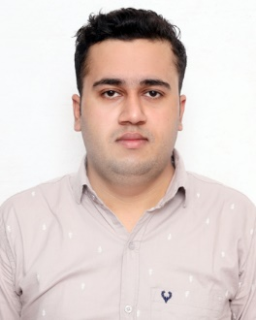 | Himanshu  Sr analyst in fertilizer section  Sahib fertilizer pvt ltd, Gharonda, karnal
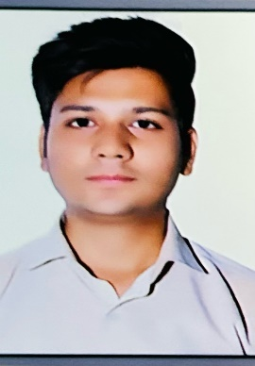 | Rajat Mittal  Senior Territory Executive  Mankind Pharma Ltd, Kurukshetra
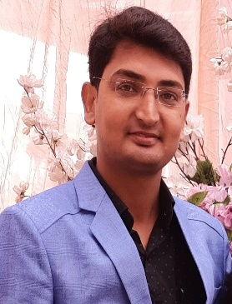 | Pardeep  PRT(PRIMARY TEACHER) in KVS  KV Damoh (MP)
Department of Mathematics (Alumni)

