Alumni of Physical Education Deptt.
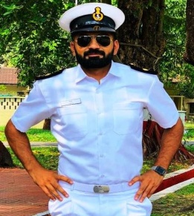 |  | 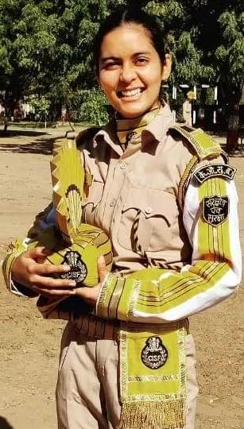
Indian Navy Rank CPOCON (EW) Cief Petty Officer Unit-Venduruthy INSCC (Kochi) | TC (Ticket Collector) in Indian Railway against sports quota.29-12-21 | Head Constable in CISF Central Industrial Security Force against Sports Quota (Shooting) 14-10-2021
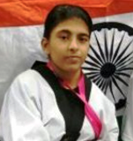
Bhim Awardee Sonali
(Para taekwondo Player)
Haryana Govt. Honoured her with
Bhim Award 2020-21. Now steeled in USA

