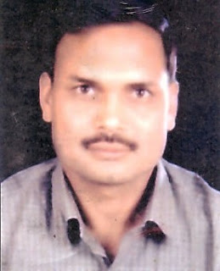
Dr. Kuldeep Singh
Joint Director (Field)
Information, Public Relations and Languages Department Haryana
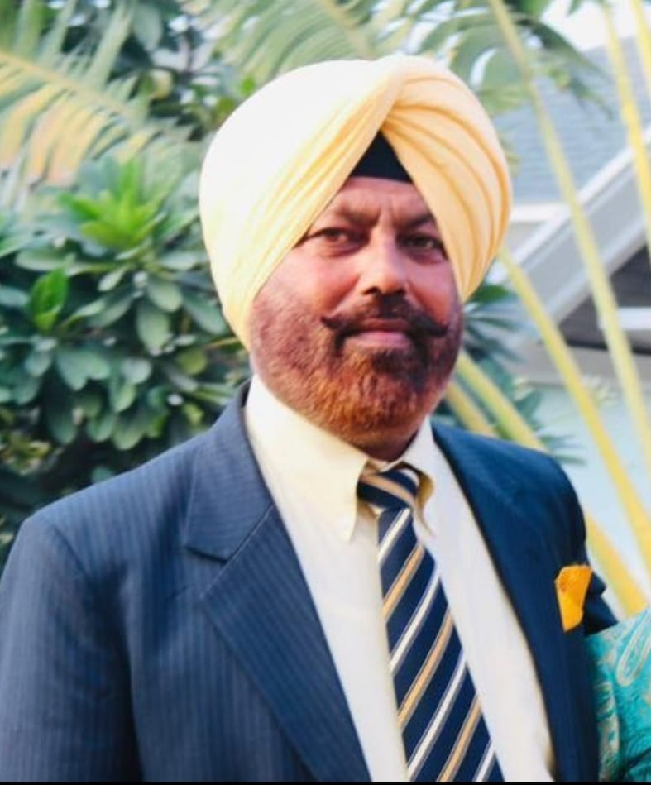
S. Jitender S. Gill, Director
Seed Development Corporation. Haryana

Sh. B.S. Malik
District Education Officer
Kurukshetra

Sh. Brahm Dutt
Haryana Sahitya Academy Prize Winning Author

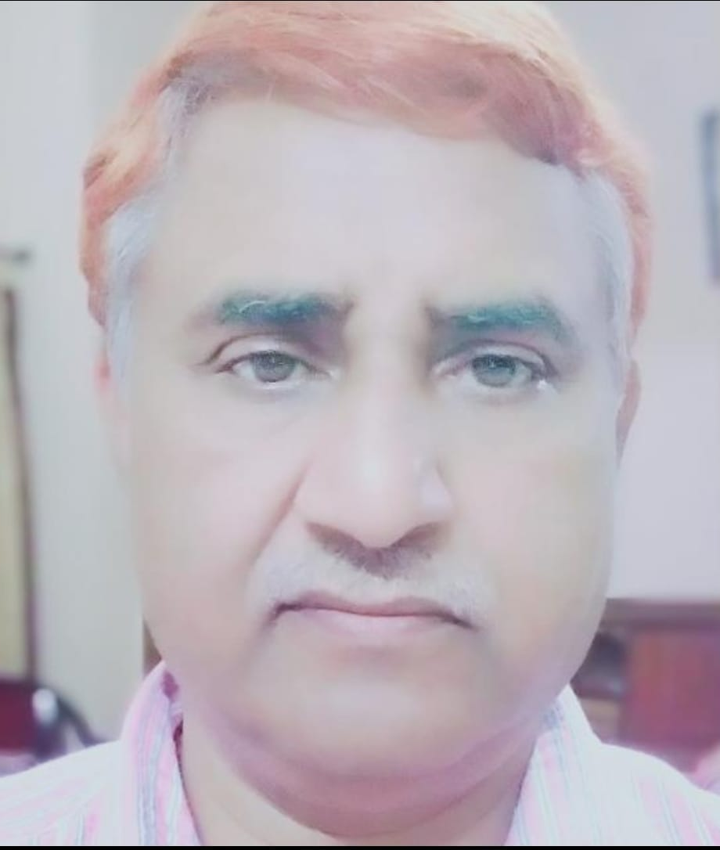
Sh. Maya Ram Saini
Income Tax Officer (Retd.)

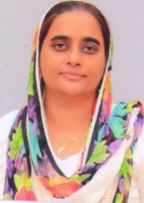

Mrs. Harneet Kaur
Assistant Professor
Department of English

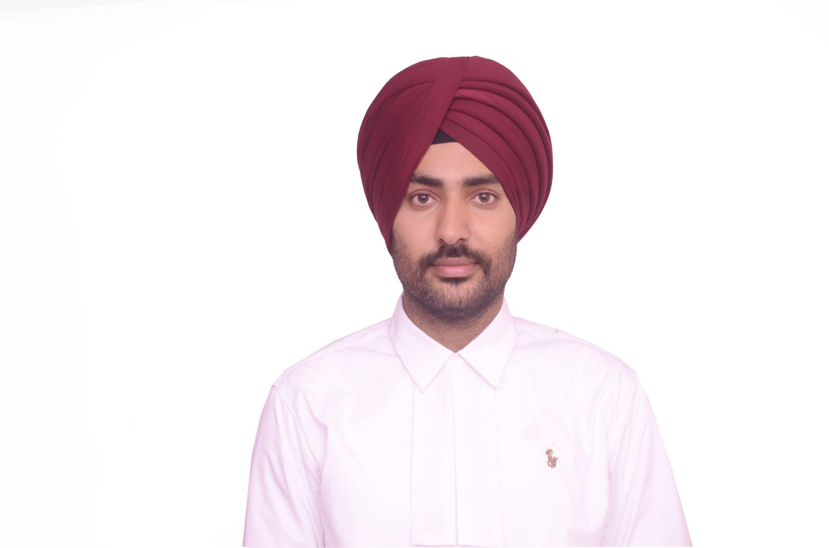

S. Satinder Singh
Advocate, Haryana & Punjab High Court Chandigarh

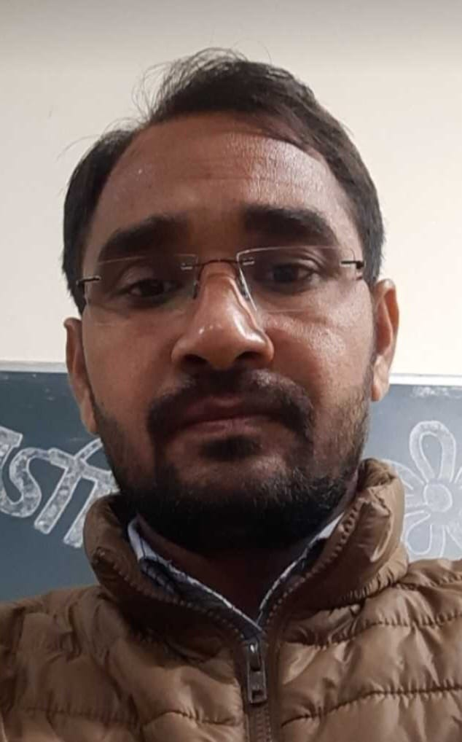
Sh. Naveen Kabir
Assistant Professor
Department of English

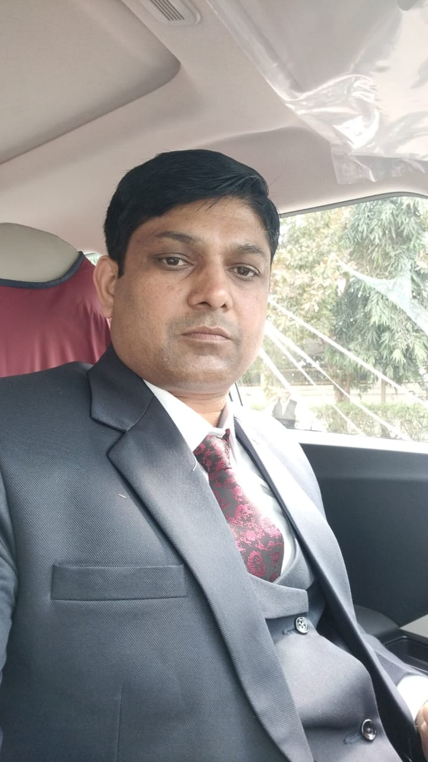
Sh. Jai Parkash Sr. Branch Manager Punjab National Bank, Kurukshetra

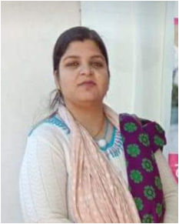
Smt. Sailja Saini
Centre Administrator
Women & Child Developement Department Kurukshetra

