Star Alumni

Commerce Department

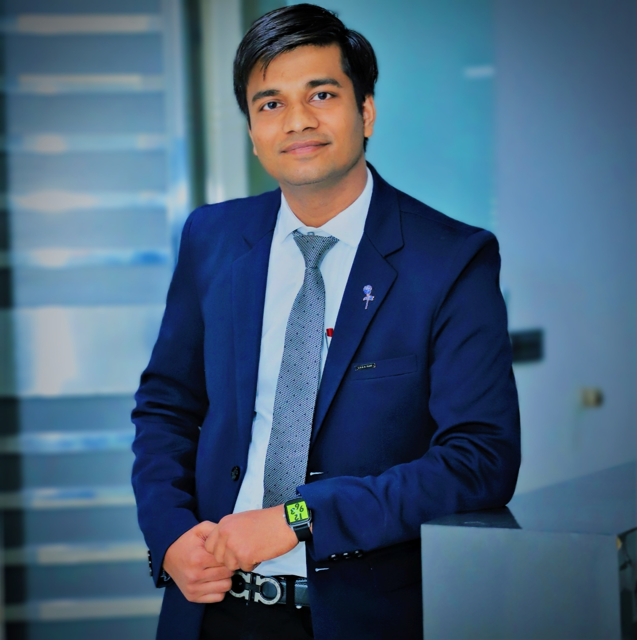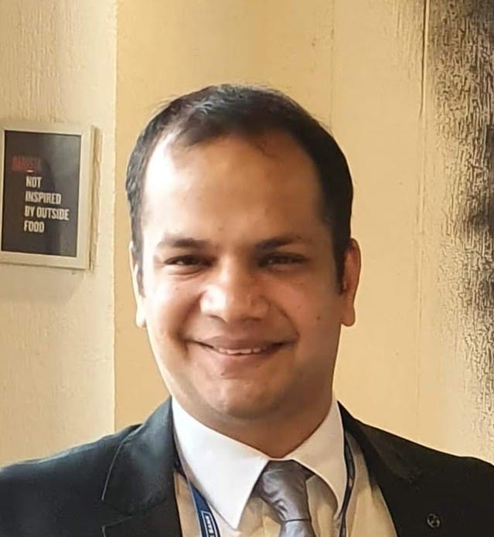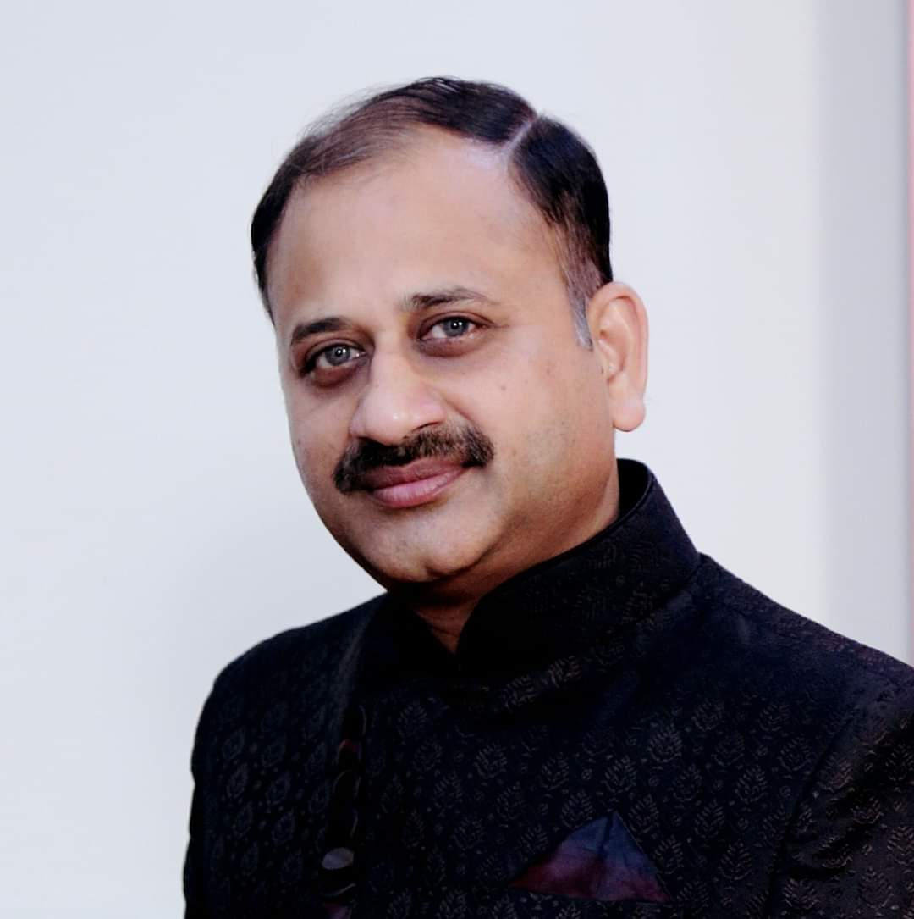
Mr. Rajat Goyal Mr. Mohit Singhal Mr. Arvind Singhal
Chartered Accountant Associate Director- HDFC Bank-wealth Advocate, Distt. Court Kurukshetra

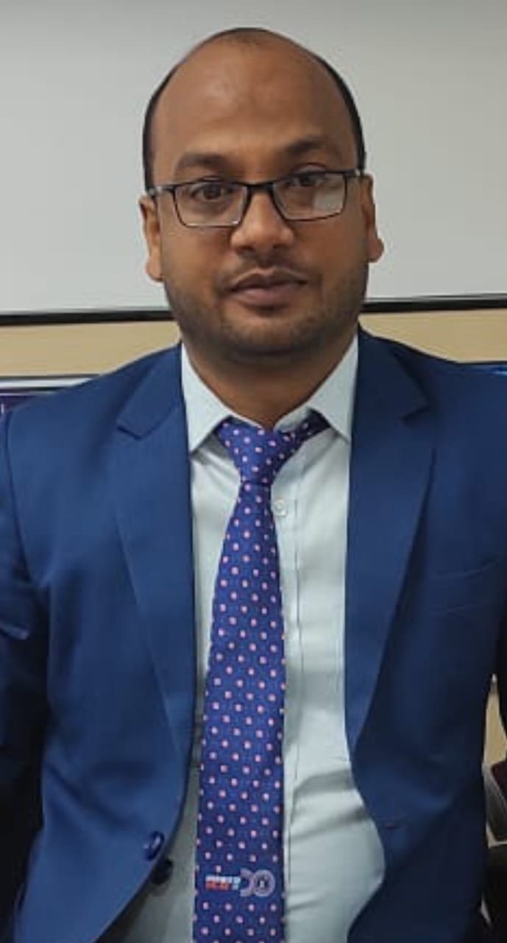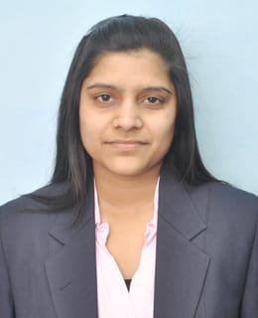
Mr. Abhishek Goel Ms. Priyanka Garg
Manager, ICICI Bank, Babain Chartered Accountant

