Star Alumni
Hindi Department

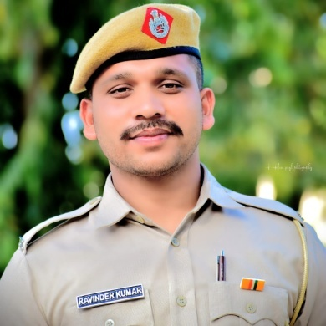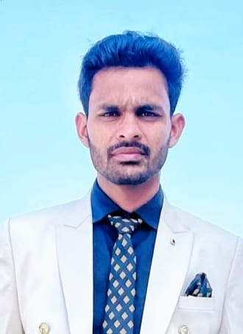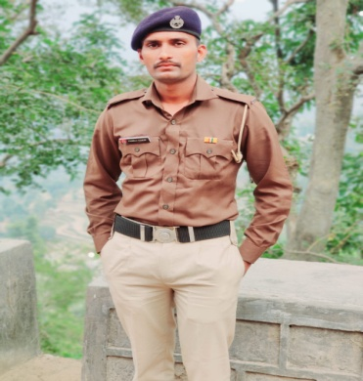
Mr. Ravinder Kumar Mr. Sahil Kumar Mr. Pankaj Kumar
Constable, Haryana Police Steno, BDPO, Ladwa Haryana Police

