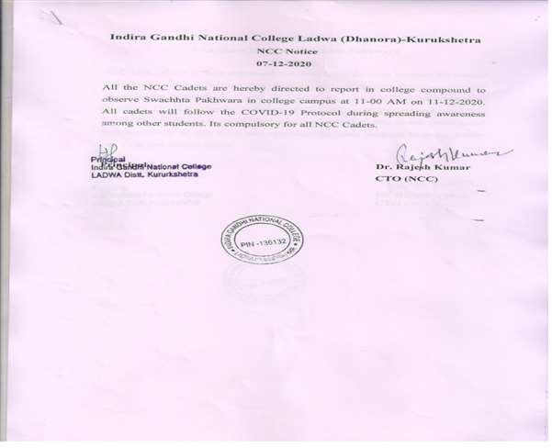
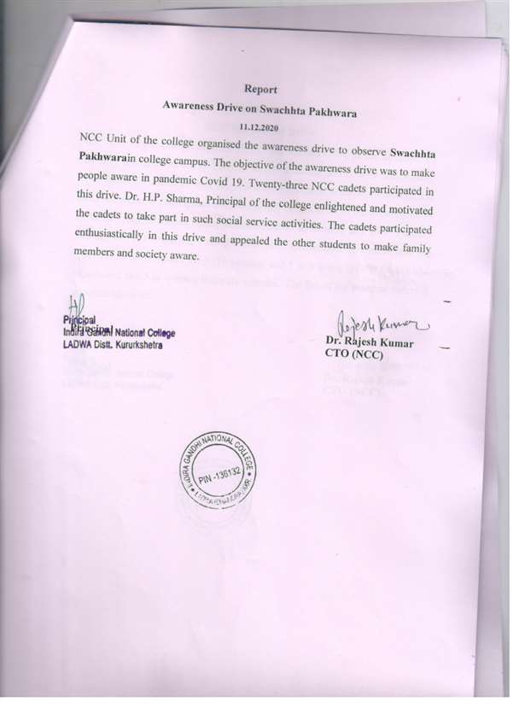
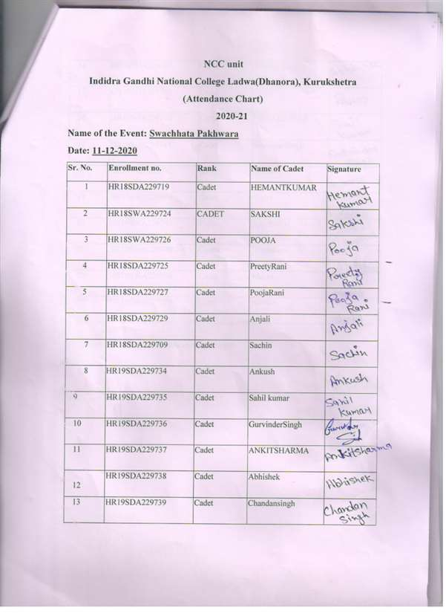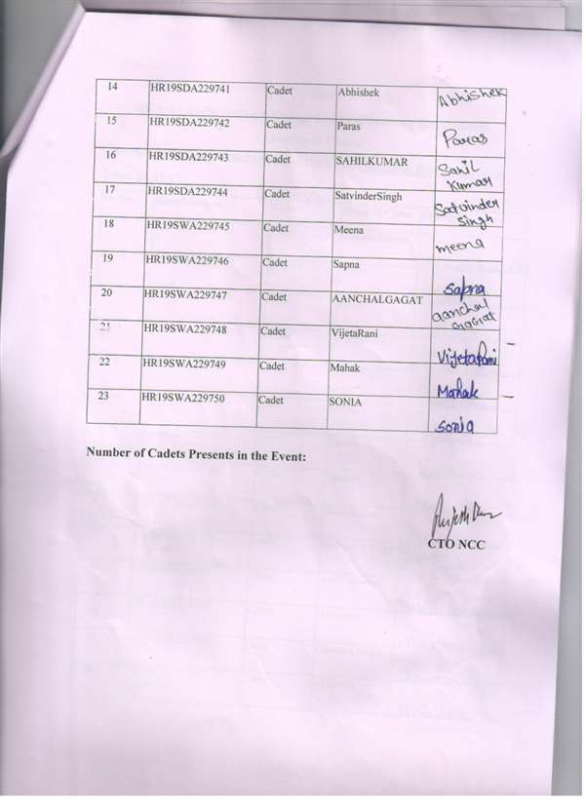
NCC Cadets Spreading Awareness about Hand Sanitisation and Use of Mask During COVID-19 on 11.01.2021.

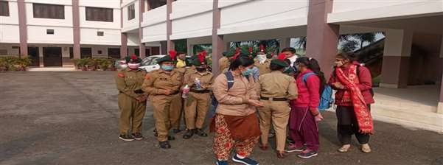
NCC Cadets Spreading Awareness about Hand Sanitisation and Use of Mask During COVID-19 on 11.12.2021
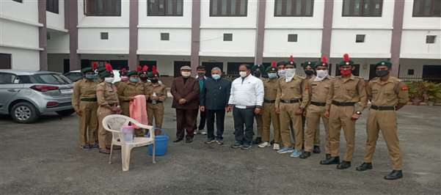NCC Cadets Spreading Awareness about Hand Sanitisation and Use of Mask During COVID-19 on 11.12.2021
