Report of National webinar
on
“Academic and research visibility”
Organized by Dayanand Mahila Mahavidyalaya, Kurukshetra in Collaboration with Indira Gandhi National College, Ladwa (Kurukshetra) On 21st September 2021 from 11:00 a.m. to 1:30 p.m. through Google meet. The webinar was started with the welcome of the guests and resource person by the convener Dr Rupesh gaur, Librarian, I.G.N College Ladwa (Kurukshetra), he introduced the Resource persons and also elaborate on the theme of the webinar. Dr Hari Parkash Sharma, Principal, I.G.N College, Ladwa (Kurukshetra) welcomed the guests and expressed his views on the importance and Usefulness of the topic of the webinar. He also expressed that during the present modern scientific era, as the teaching-learning environment has been continuously changing, there is a dire need to clarify and validate the present /current knowledge. After this Dr Vijeswari Sharma, Principal, Dayanand Mahila mahavidyalaya kurukshetra delivered the Presidential address. She expressed the importance of research in the field of education and she also told that research is inevitable for the accumulation of knowledge and it is the basis of future prospects.
At 11:30 a.m. there was a lecture by Dr.Neeraj Singh, Deputy Librarian, Panjab University, and Chandigarh. During his lecture, he expressed his views on the various aspects of academic and Research visibility. He also discussed about various technologies related to research like open Access publication, citation and Scopus database etc. At 12:30, there was a lecture by Dr Shri Ram, Librarian, Sikkim University, Gangtok. He expressed his views on the detailed Introduction of research and its structure. He also told that the demand of the recent technological world can be fulfilled only through research and one can get the answers to various unanswered questions related to teaching-learning only through research.
The webinar was concluded with the formal vote of thanks given by Dr Pooja Sharma, Librarian, Dayanand Mahila Mahavidyalaya Kurukshetra, She thanked all the guests and expressed her special thanks to Dr Vijeshwari Sharma, principal of the college for her able guidance and Motivational support.

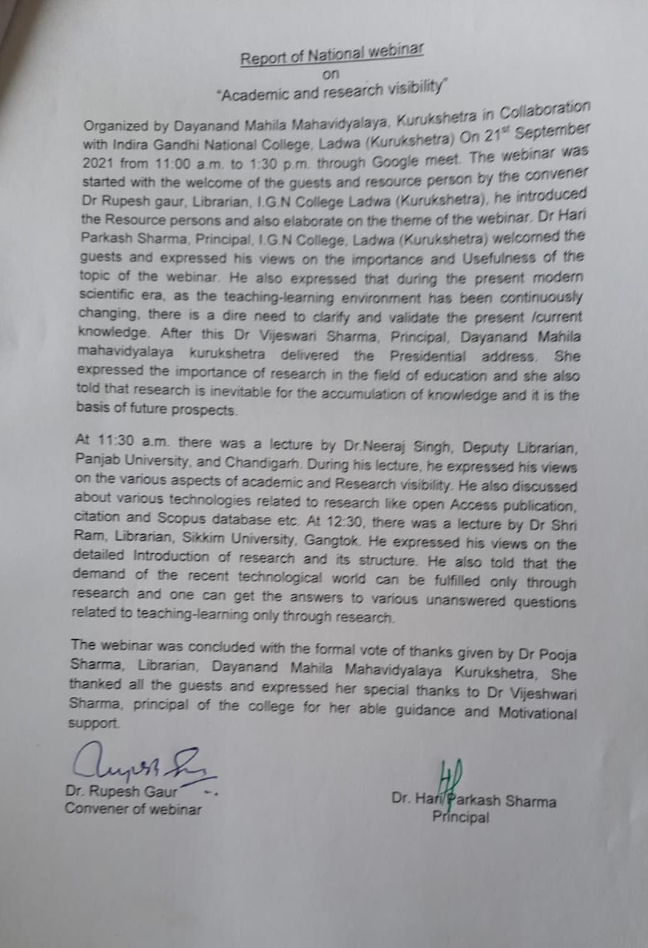

A Glimpse of the Webinar
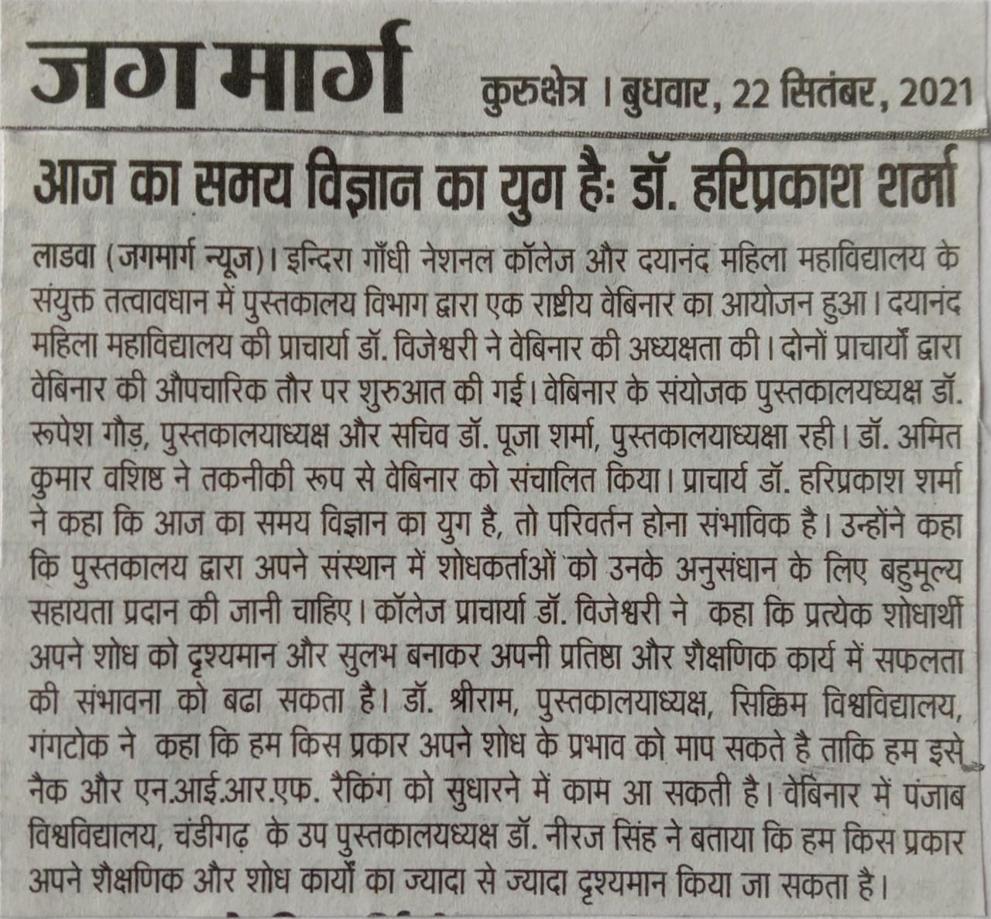
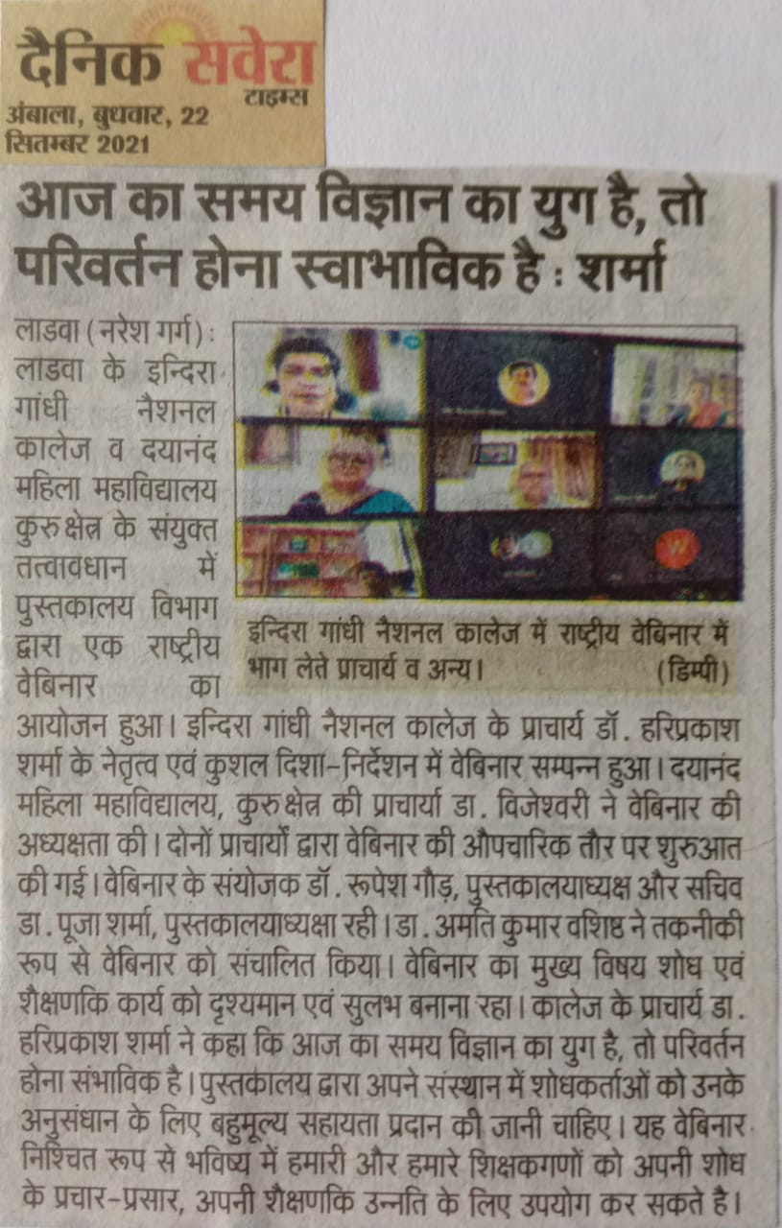

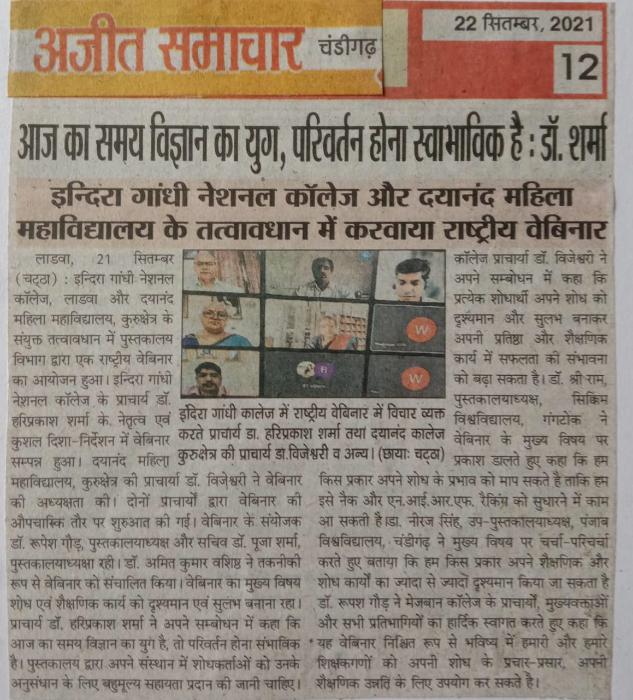

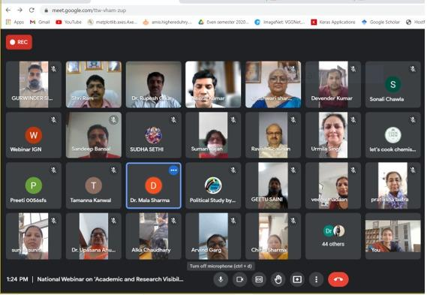

List of Participants:
Sr. No. | Name of the Participant | Designation | Affiliation (Name of Institution)
 | Dr. Vandana Gupta | Assistant Professor | IGN COLLEGE LADWA
 | Mrs. Prabhjot Kaur | Assistant Professor | Dayanand Mahila Mahavidyalaya, Kurukshetra
 | Sunita Rani | Assistant Professor | Indira Gandhi National College Ladwa
 | Rajinder Kaur | Librarian | Arya Kanya Mahavidyalya Shahabad Markanda
 | Dr. Manjeet Kaur | Assistant Professor | Dayanand mahila Mahavidyalaya kurukshetra
 | Dr. AMIT KUMAR | Assistant Professor | Indira Gandhi National College, Ladwa
 | Dr.Alka chaudhary | Assistant Professor | Dayanand Mahila Mahavidyalaya
 | Anju saini | Librarian | SNRL Jairam Girls college Lohar Majra Kurukshetra
 | Pratiksha | Assistant Professor | Dayanand Mahila Mahavidyalya
 | Bhavana | Assistant Professor | Dayanand Mahila Mahavidyalaya, Kurukshetra
 | DEEPIKA MURAL | Assistant Professor | Dayanand mahila mahavidyalya
 | Dr. Navin Kumari | Assistant Professor | Indira Gandhi National College Ladwa
 | Mahak | Assistant Professor | Dayanand mahila mahavidyalay, kurukshetra
 | Sonali chawla | Student/Research Scholar | Dayaanand mahila mahavidyla
 | Sapna Arora | Associate Professor | Dayanand Mahila Mahavidyalaya,kurukshetra
 | Veenu madan | Assistant Professor | Dayanand mahila mahavidyalaya
 | Asha Malik | Assistant Professor | Dayanand Mahila Mahavidyalaya
 | Dr.Arvind Garg | Associate Professor | I.G.N.College, Ladwa
 | Reena Nagpal | Assistant Professor | Dayanand Mahila Mahavidyalaya, Kurukshetra
 | Reena Madaan | Assistant Professor | Dayanand Mahila Mahavidyalaya kurukshetra
 | Dr.Promila Yadav | Assistant Professor | Sh.L.N.Hindu College Rohtak
 | Dr Shweta Saini | Assistant Professor | Dayanand Mahila Mahavidyalaya, Kurukshetra
 | Komal Rani | Student/Research Scholar | Dayanand Mahila Mahavidyalaya kkr
 | Heena | Student/Research Scholar | Dayanand Mahila Maha Vidyalaya
 | Dr Anu Chauhan | Associate Professor | Dayanand Mahila Mahavidyalaya, Kurukshetra
 | Dr. Seema Singh | Assistant Professor | Dayanand Mahila Mahavidyalaya, Kurukshetra
 | Dr. Neha | Assistant Professor | Dayanand Mahila Mahavidyalaya, kurukshetra
 | Sandeep Bansal | Associate Professor | Indira Gandhi National College, Ladwa
 | Preeti Devi | Student/Research Scholar | Dayananda Mahila Mahavidyalya kkr
 | Dr. Reeja | Assistant Professor | Dayanand mahila mahavidyalaya kurukshetra
 | Pooja Rani | Student/Research Scholar | Dayanand Mahila Mahavidyalay (kkr)
 | Anuja Devi | Student/Research Scholar | Dayanand mahila mahavidyalaya Kurukshetra
 | Sandeep Kaur | Student/Research Scholar | Dayanand Mahila Mahavidyalaya (Kurukshetra)
 | Tamanna | Student/Research Scholar | Dayanand Mahila Mahavidyalaya kkr
 | Dr. Himani | Assistant Professor | Dayanand Mahila Mahavidyalaya, kurukshetra
 | Mrs. Saroj Bala | Assistant Professor | Dayanand mahila mahavidyalaya, kurukshetra
 | Mrs. Kiran Ganotra | Assistant Professor | Dayanand Mahila Mahavidyalaya, Kurukshetra
 | Dr. Mala Sharma | Assistant Professor | Mukand Lal National College, Radaur; affiliated to Kurukshetra University
 | Dr.Chitra Sharma | Librarian | Sh.L.N.Hindu College, Rohtak
 | Geetu saini | Assistant Professor | Dayanand mahila maha vidyalaya kurukshetra
 | Dr.shalu rani | Assistant Professor | Dayanand mahila mahavidyalaya kurukshetra
 | Sudha Rani | Assistant Professor | DMM, Kurukshetra
 | Prachi Devi | Student/Research Scholar | Dayanand Mahila Mahavidyalaya kurukshetra
 | Dr.Geetanjali chawla | Assistant Professor | Dayanand Mahila Mahavidyalya
 | Dr.Rukmesh Chauhan | Assistant Professor | Dayanand Mahila Mahavidyalya kurukshetra
 | Mrs. Shilpa Garg | Assistant Professor | Dayanand Mahila Mahavidyalaya, Kurukshetra
 | Dr Niti Goyal | Assistant Professor | IGN COLLEGE LADWA
 | Dr. Neetu | Assistant Professor | INDIRA GANDHI NATIONAL COLLEGE,LADWA
 | Ms.Vinita | Assistant Professor | Dayanand Mahila Mahavidyalaya,kurukshetra
 | Dr.Ashok Verma | Associate Professor | I.G.N COLLEGE, LADWA
 | PRIYANKA | Assistant Professor | I.G.N COLLEGE, LADWA
 | Pawan Kumar | Student/Research Scholar | SJJT University Jhunjhunu,Rajasthan
 | Bhavya | Student/Research Scholar | DN Mahila Mahavidyalaya Kurukshetra
 | Tanu Bura | Assistant Professor | DMM Kurukshetra
 | Dr. Amit Verma | Assistant Professor | Indira Gandhi National College, Ladwa
 | Dr. pooja sharma | Librarian | Dayanand Mahila Mahavidyalaya, kurukshetra
 | Dr. Sudesh Kumar | Assistant Professor | Indira Gandhi National College Ladwa
 | Dr. Ritu | Assistant Professor | Dayanand Mahila Mahavidyalaya, kurukshetra
 | Harneet Kaur | Assistant Professor | Indira Gandhi National College, Ladwa
 | Dr. Suman Kumari Rajan | Associate Professor | Dayanand Mahila Mahavidyalay, Kurukshetra
 | Dr. Rupesh Gaur | Librarian | Indira Gandi National College, Ladwa
 | Dr.Haneef Bhatti | Others | BSEH(SRS) Bhiwani
 | Aditi | Student/Research Scholar | Dayanand mahila mahavidyalaya
 | Garima Arora | Assistant Professor | Dayanand Mahila Mahavidyalaya, Kurukshetra
 | Dr Neha | Assistant Professor | Dayanand Mahila Mahavidyalaya, kurukshetra
 | Urmila singh | Associate Professor | DN girls college kurukshetra
 | Jyoti | Assistant Professor | Dayanand mahila Mahavidyalaya kurukshetra
 | Shivani | Student/Research Scholar | Dayanand mahila Mahavidyalaya
 | Dr Renu Bala | Librarian | PIET Sanskriti sen sec school
 | Dr. R. K.Chauhan | Associate Professor | IGN College Ladwa
 | Dr.Sonia Rani | Assistant Professor | Dayanand Mahila Mahavidyalaya kurukshetra
 | Dr. Madhu Gupta | Associate Professor | I.G.N, college, Ladwa
 | Vasu | Student/Research Scholar | Dn college kurukshetra
 | Komal sharma | Student/Research Scholar | Dayanand mahila mahavidhalya kurukshetra
 | Surender Singh Kajal | Associate Professor | M N College shahbad Markanda
 | Bharti | Student/Research Scholar | Dayanand mahila mahayadalya
 | Sobiya sharma | Assistant Professor | Dayanand Mahila Mahavidyalaya,kurukshetra
 | Devender Kumar | Others | Govt.Sr.Sec.School, Khojkipur (Panipat)
 | Kajal kapoor | Student/Research Scholar | Dayanand mahila mahavidalaya
 | Dr. Urmila Panghal | Associate Professor | Dayanand Mahila Mahavidyalaya Kurukshetra
 | Ms komalpreet kaur | Assistant Professor | Dayanad mahila mahavidyalaya
 | Sunita | Others | Dayanand Mahila Mahavidyalya
 | Prachi Devi | Student/Research Scholar | Dayanand Mahila Mahavidyalaya kurukshetra
 | Dr Neeru Bala | Assistant Professor | Indira Gandhi National College Ladwa
 | Pooja Rani | Assistant Professor | Dayanand Mahila Mahavidyalaya, Kurukshetra
 | Dr.Upasana | Associate Professor | Dayanand Mahila Mahavidyalya,kurukshetra
 | Dr. Rajesh Kumar | Assistant Professor | Indira Gandhi National College Ladwa
 | Mrs.Anju Chawla | Associate Professor | Dayanand Mahila Mahavidyalya,kurukshetra
 | Manisha Garg | Student/Research Scholar | Dayanand Mahila Mahavidyalaya kkr
 | Dr.Deepti Sharma | Assistant Professor | Sh.L.N. Hindu College, Rohtak
 | Dr. Shalu Juneja | Assistant Professor | Sh. L. N. Hindu College Rohtak Haryana
 | Pushpa | Student/Research Scholar | Dayanand Mahila Mahavidyalaya
 | Riya arora | Student/Research Scholar | Dayanand mahila mahavidyalaya
 | Dr.Neelam Maggu | Associate Professor | Sh.L.N.Hindu College, Rohtak
 | Dr Rashmi Chhabra | Assistant Professor | Sh L N Hindu College Rohtak
 | RAJBIR | Assistant Professor | Indira Gandhi National College Ladwa
 | Priya | Student/Research Scholar | Dayanand Mahila Mahavidyalaya Kurukshetra
 | Priya | Student/Research Scholar | Dayanand Mahila Mahavidyalaya Kurukshetra
 | VIKAS JUNEJA | Others | PANIPAT THERMAL POWER STATION, PANIPAT
 | Himank Juneja | Research Scholar | IMSAR (MDU Rohtak)
 | VIKAS JUNEJA | Others | PANIPAT THERMAL POWER STATION, PANIPAT
 | Dr. Neetu | Assistant Professor | INDIRA GANDHI NATIONAL COLLEGE, LADWA
 | Sushil Kumar | Research Scholar | OSGU Hisar
 | Dr. Yashpal Singh | Assistant Professor | Indira Gandhi National College Ladwa
 | Dr.Suman Siwach | Assistant Professor | I.G.N.College, Ladwa Kurukshetra

