Youtube Link of the Marathon Raace: https://youtu.be/S5EJFpAwtNI

Report of the 10K Marathon
On
19 September 2021
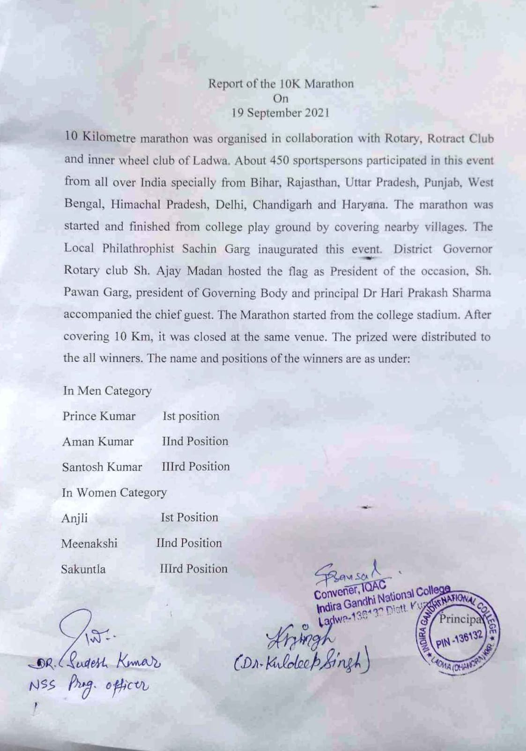
Meeting of Ladwa Rotary Club with I.G.N. College, Ladwa
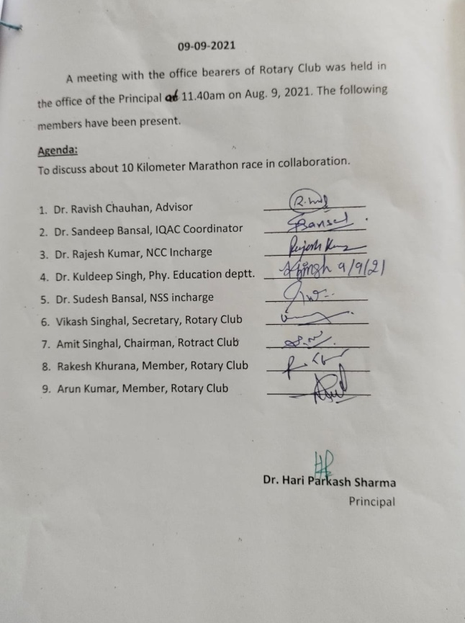
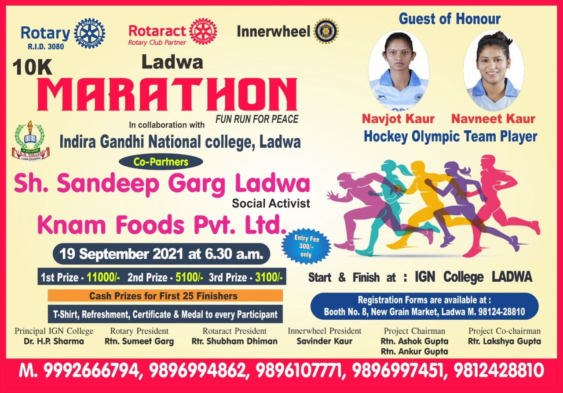

Schedule of the event
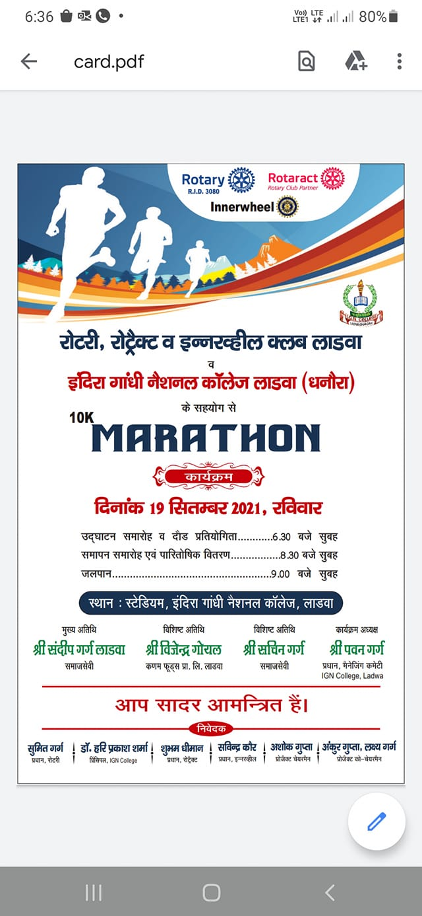
Starting Signals for the Race
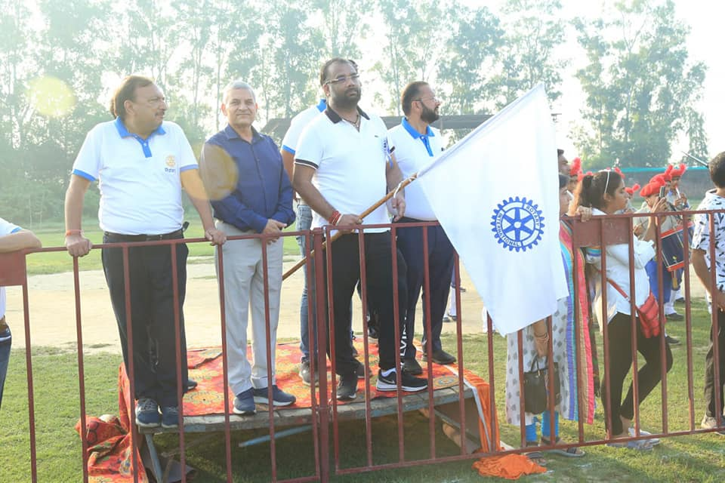
Assembly of the College Vollenteres
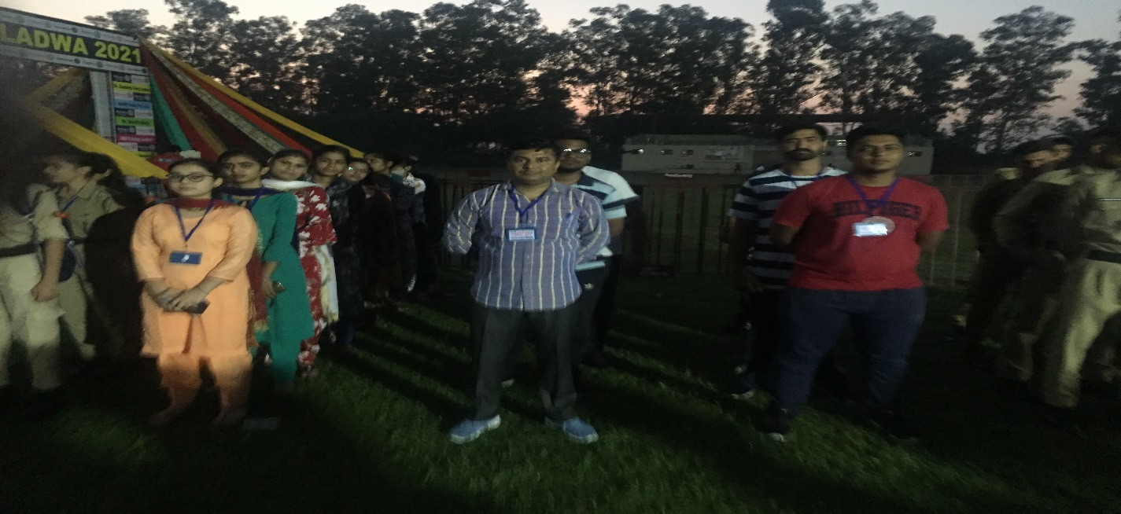

Officials with participants
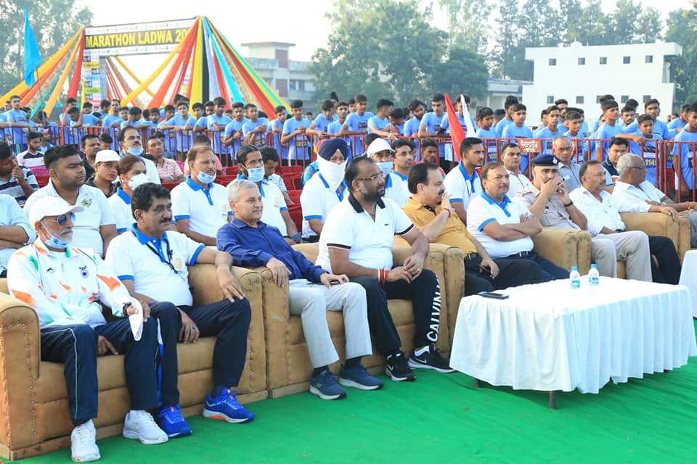
College NCC Cadets with College Staff and Rotary Club Members
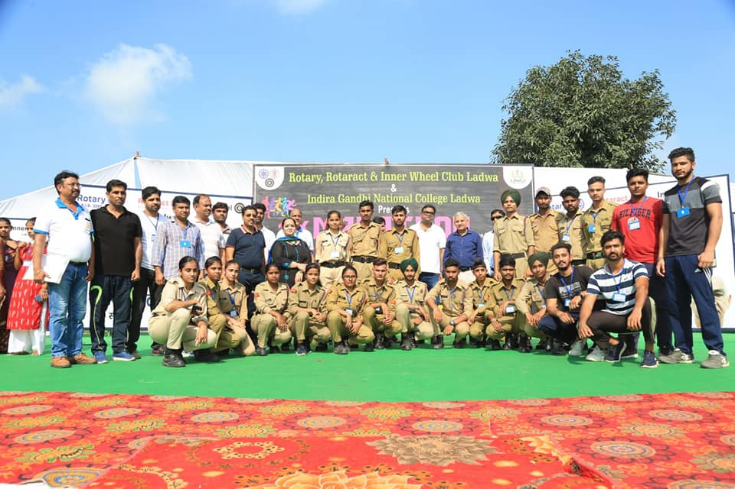

College winning Athletes
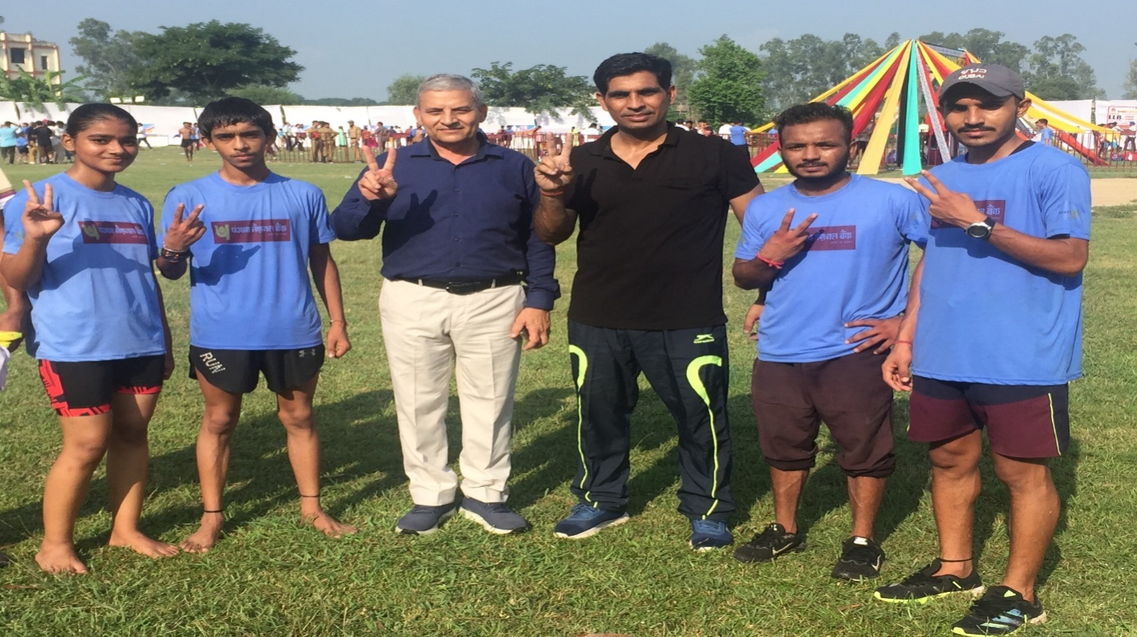
Winner Athletes with Check and medals
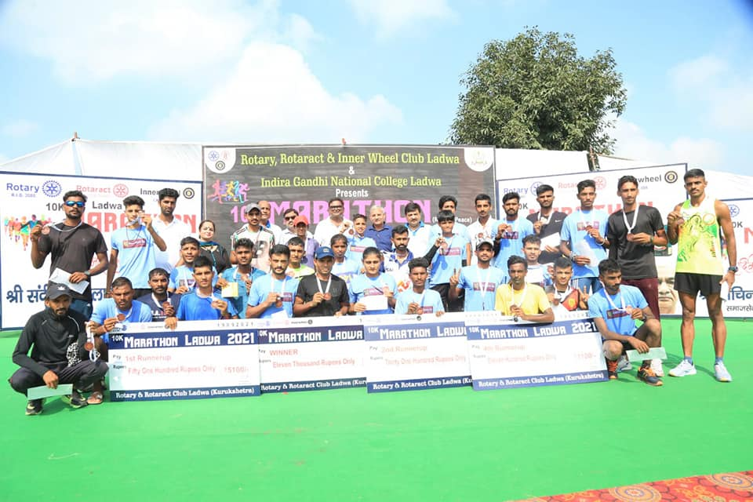

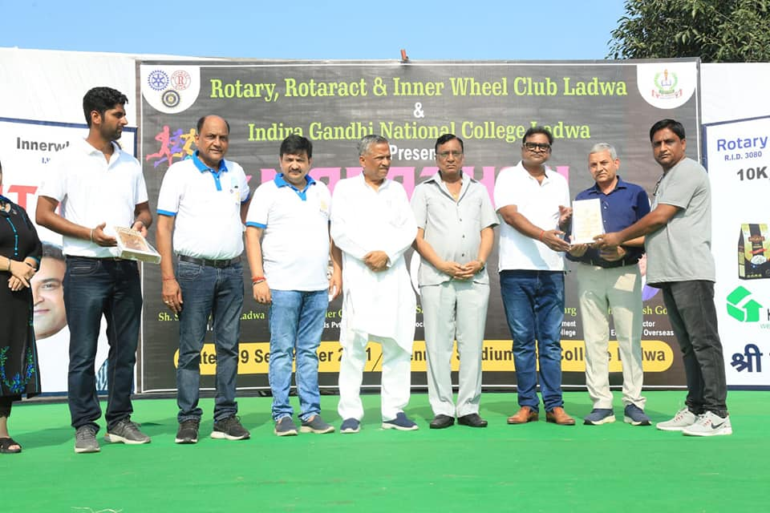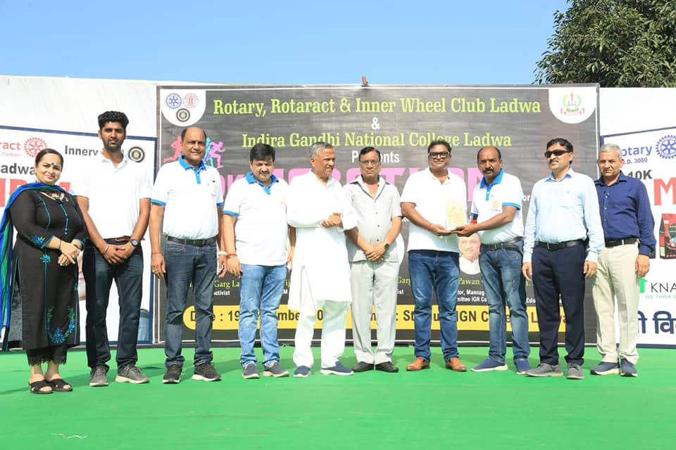
List of the College Sports students
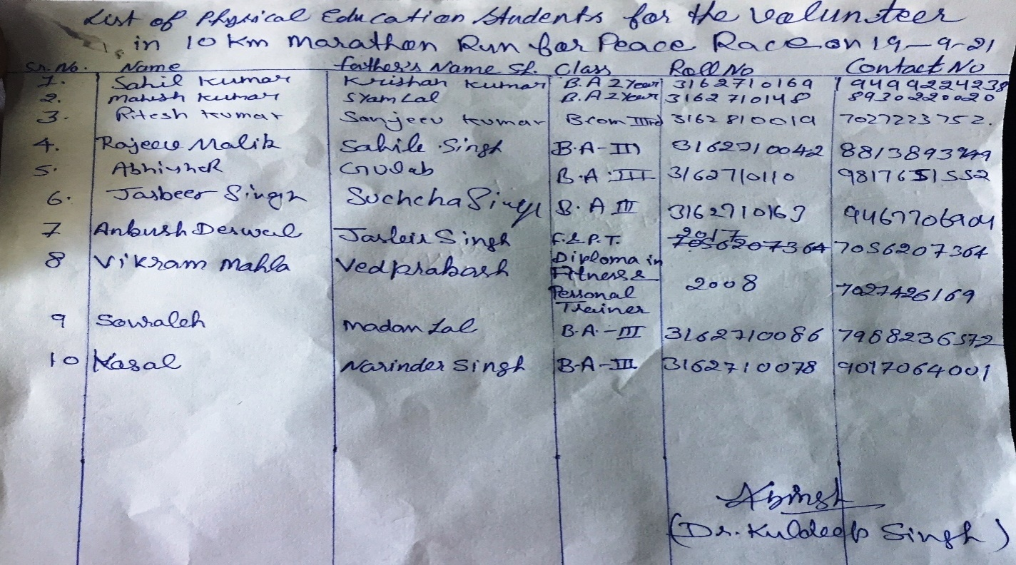
Lsit of the College teachrs who attended the event
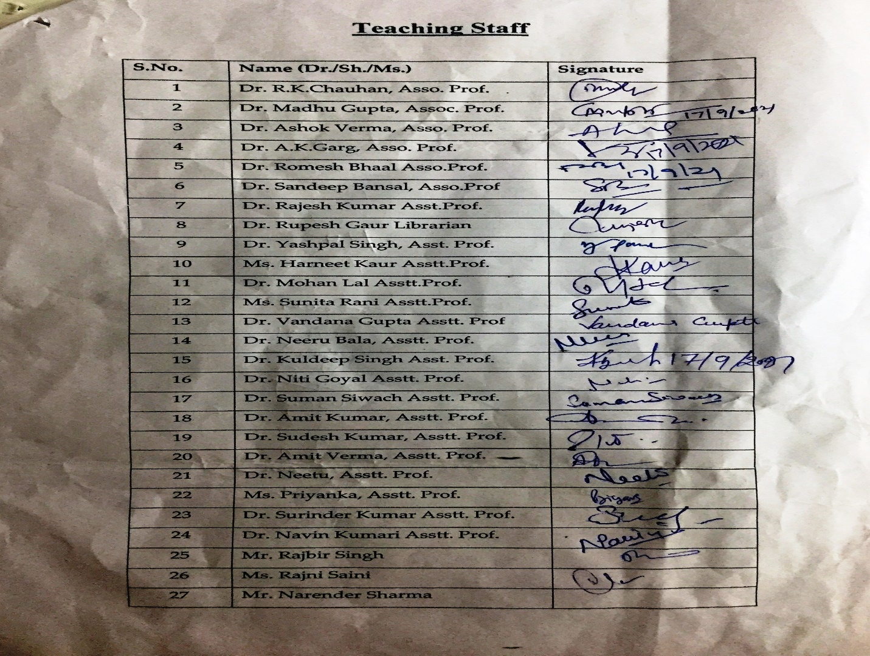
Lsit of the College Non teaching staff members who attended the event
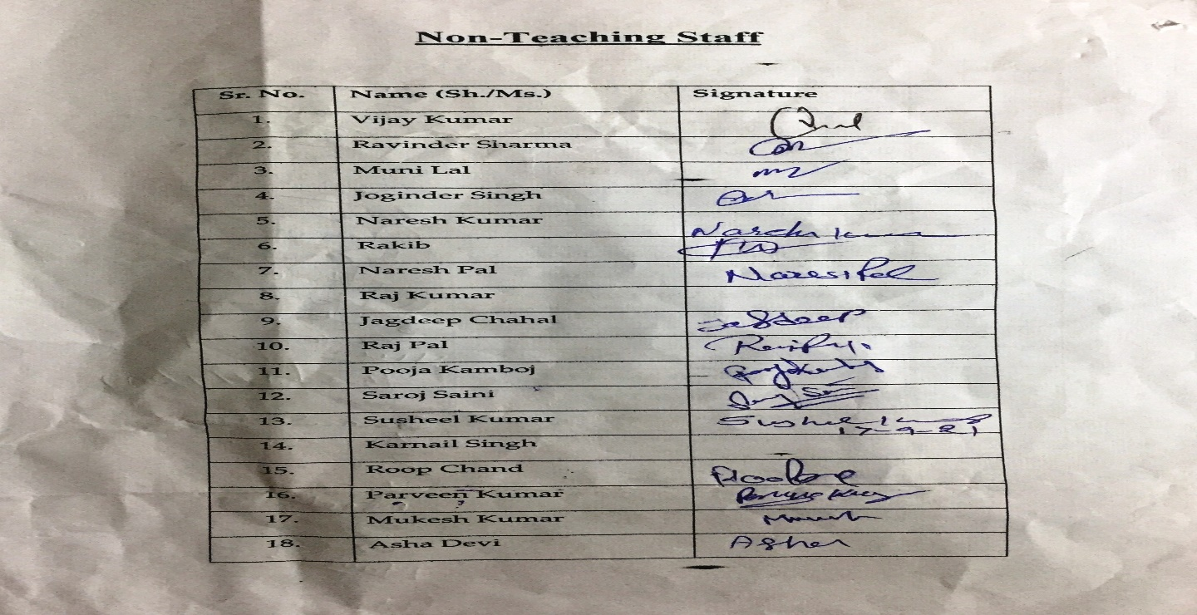

Media Coverage of the event
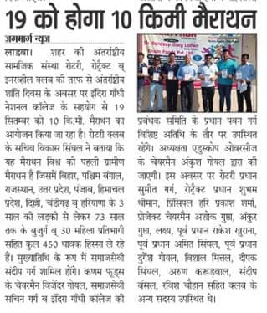
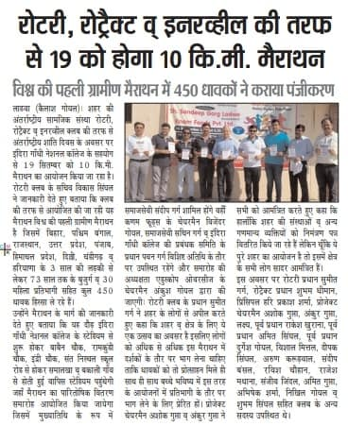
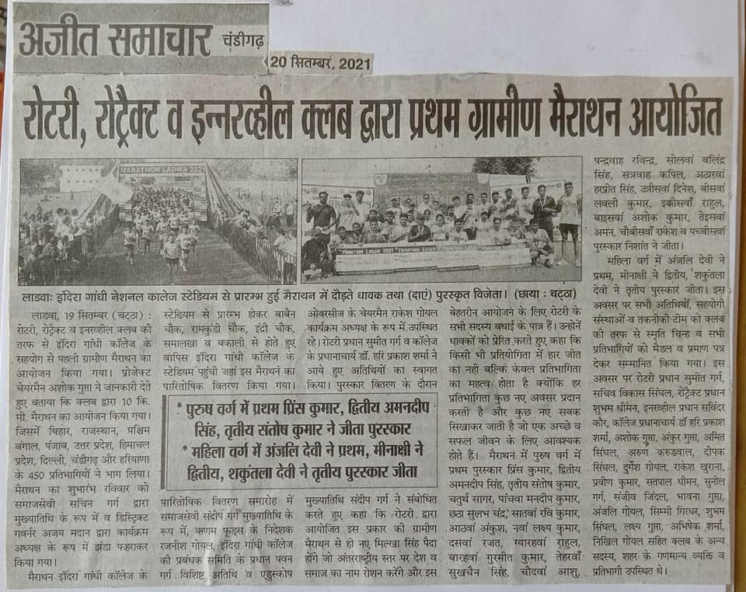
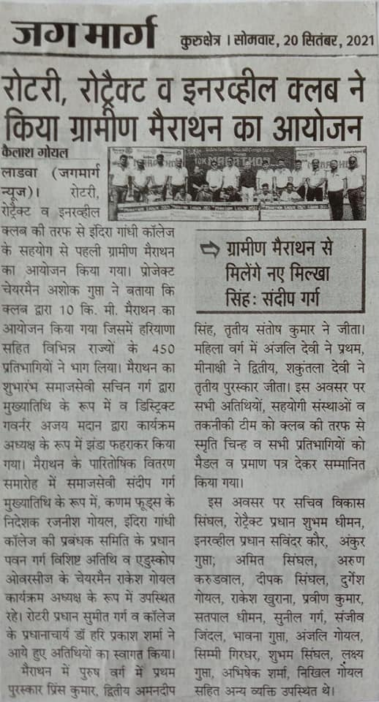
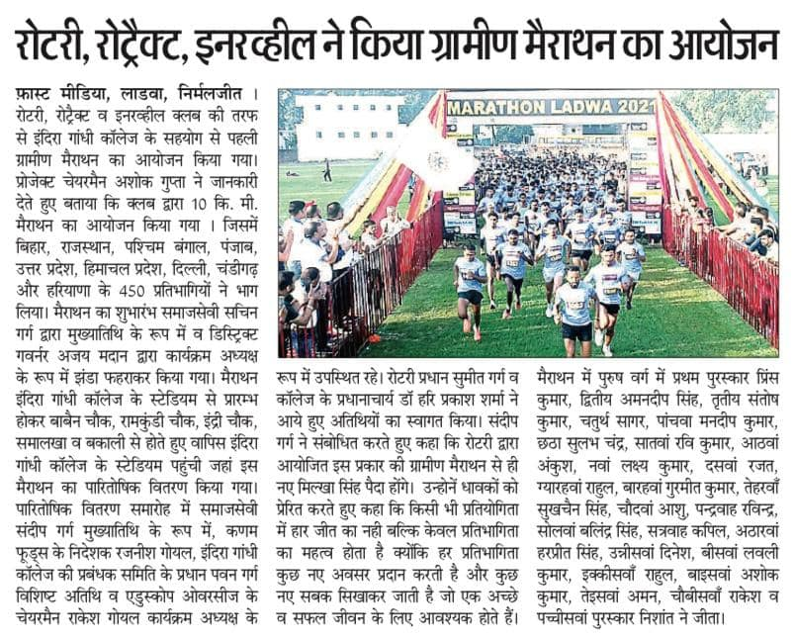
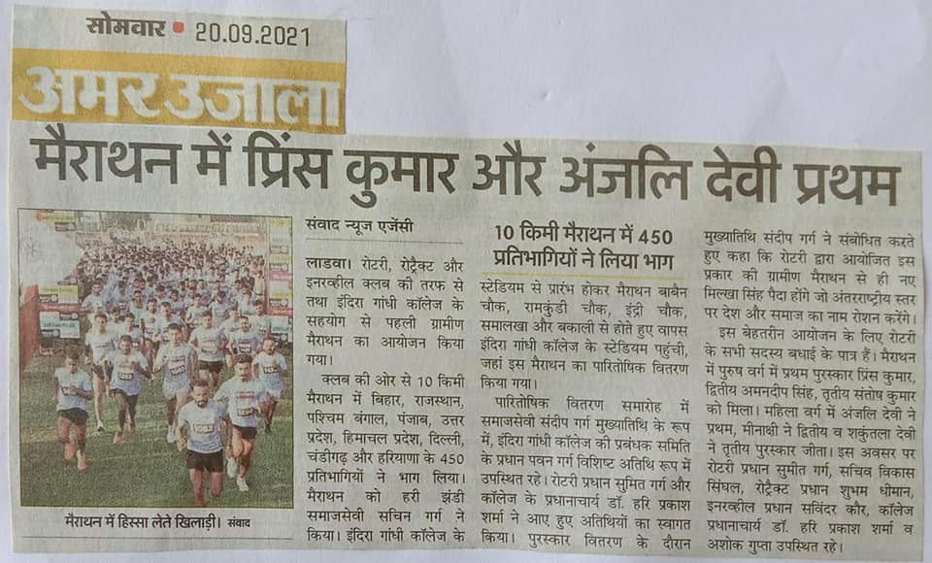
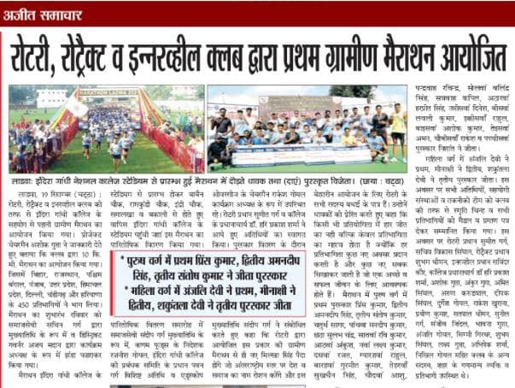
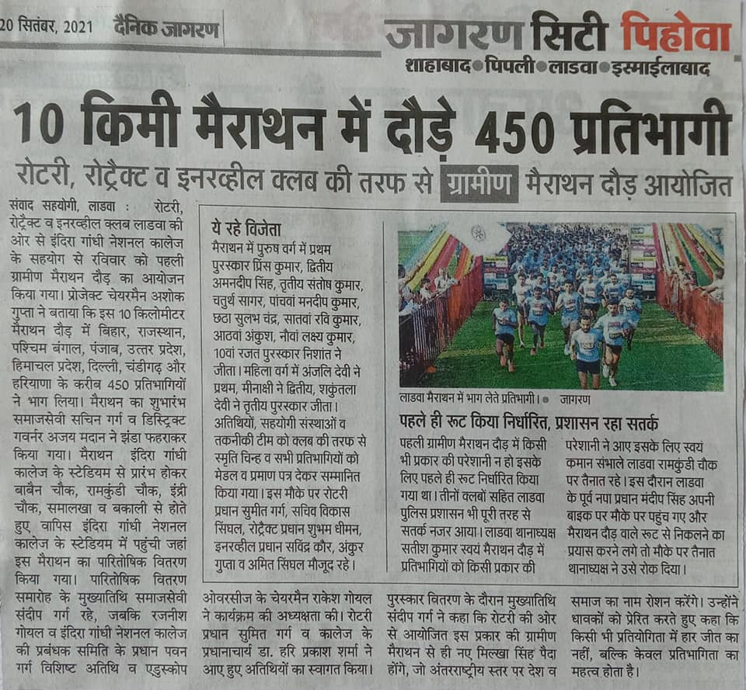
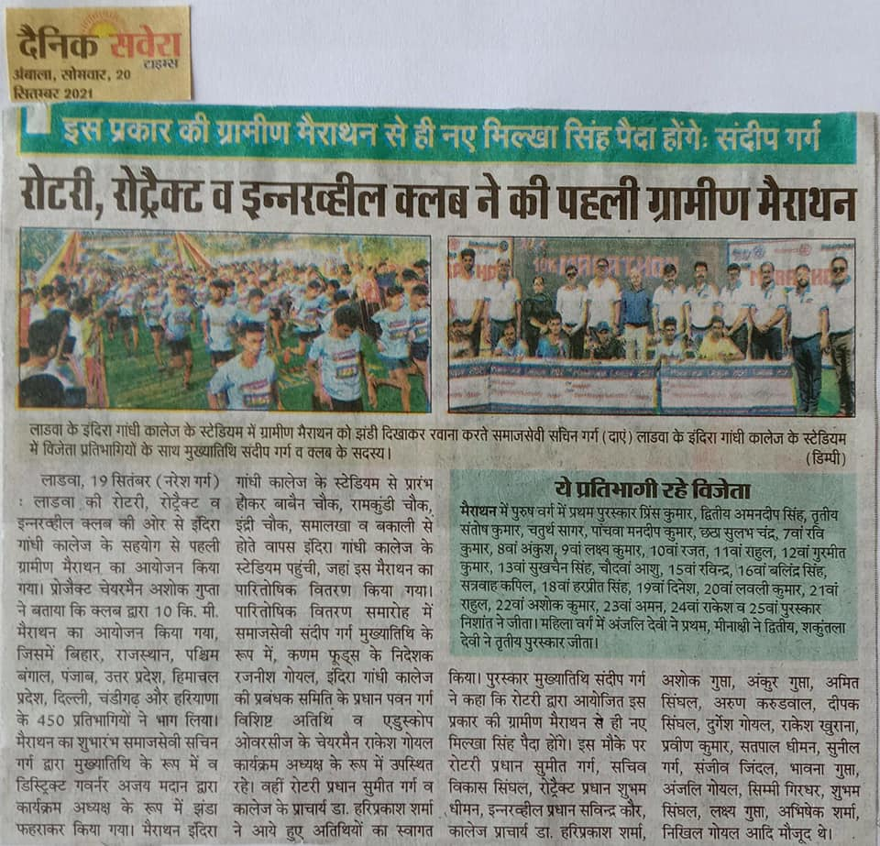
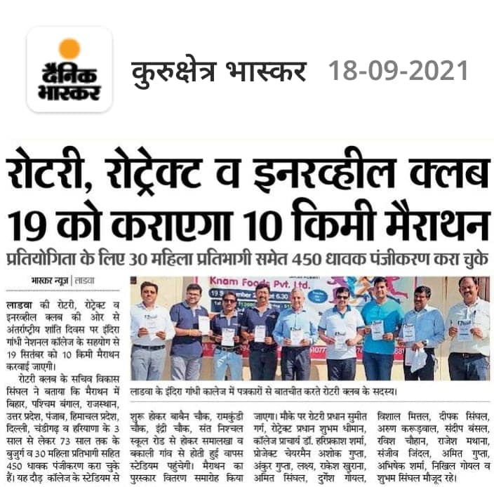

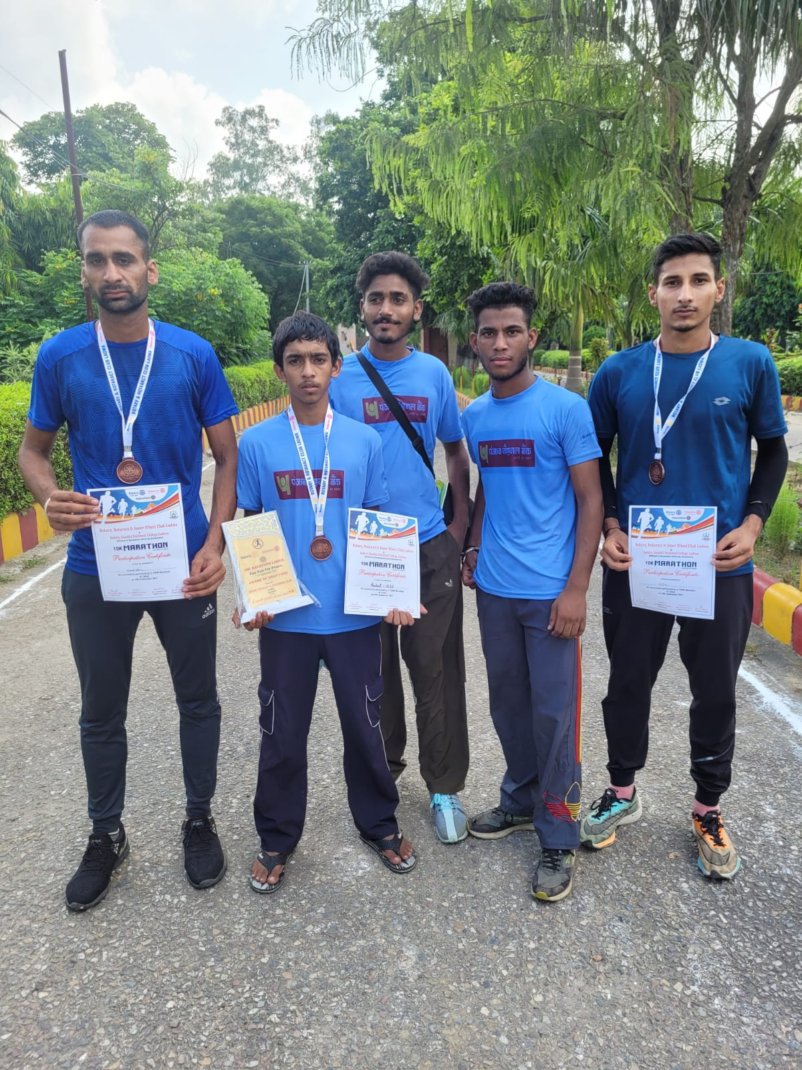
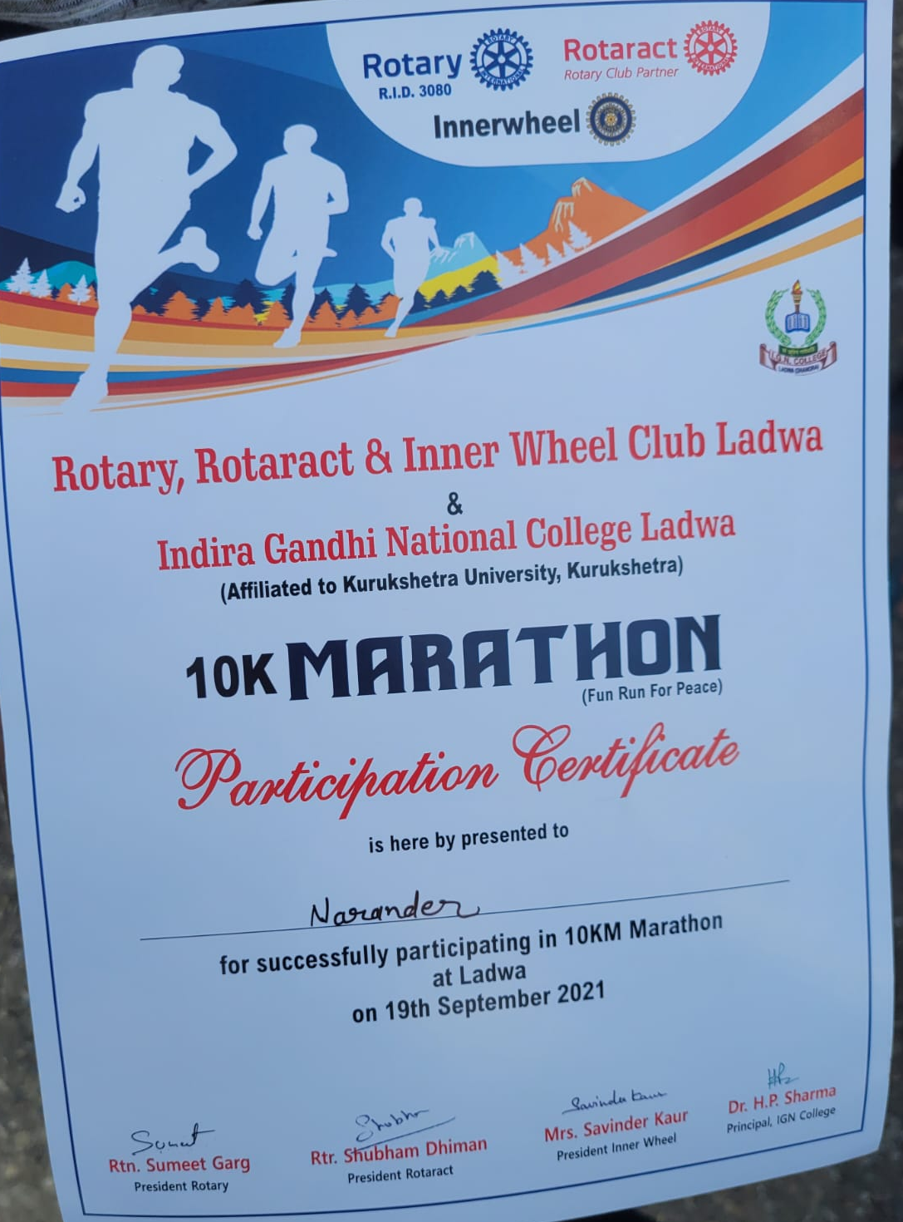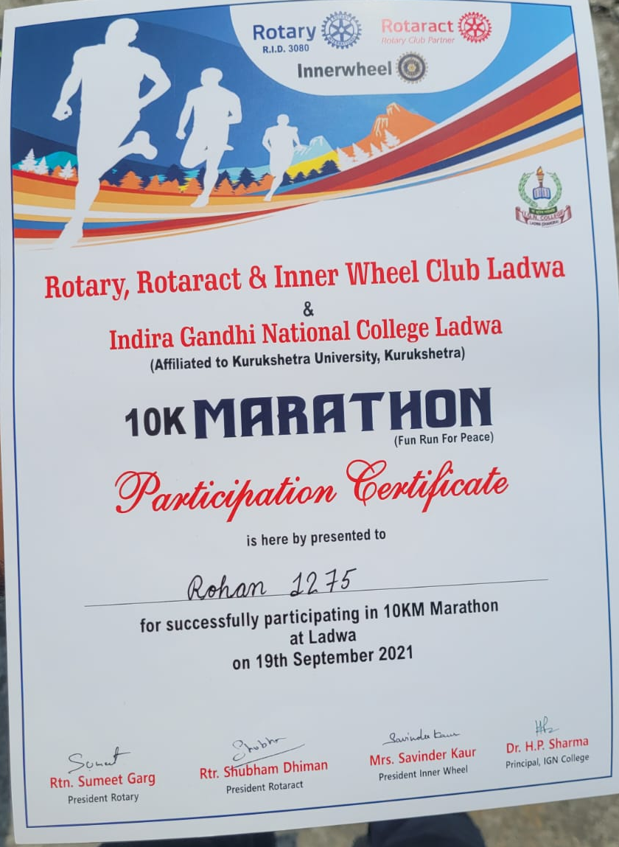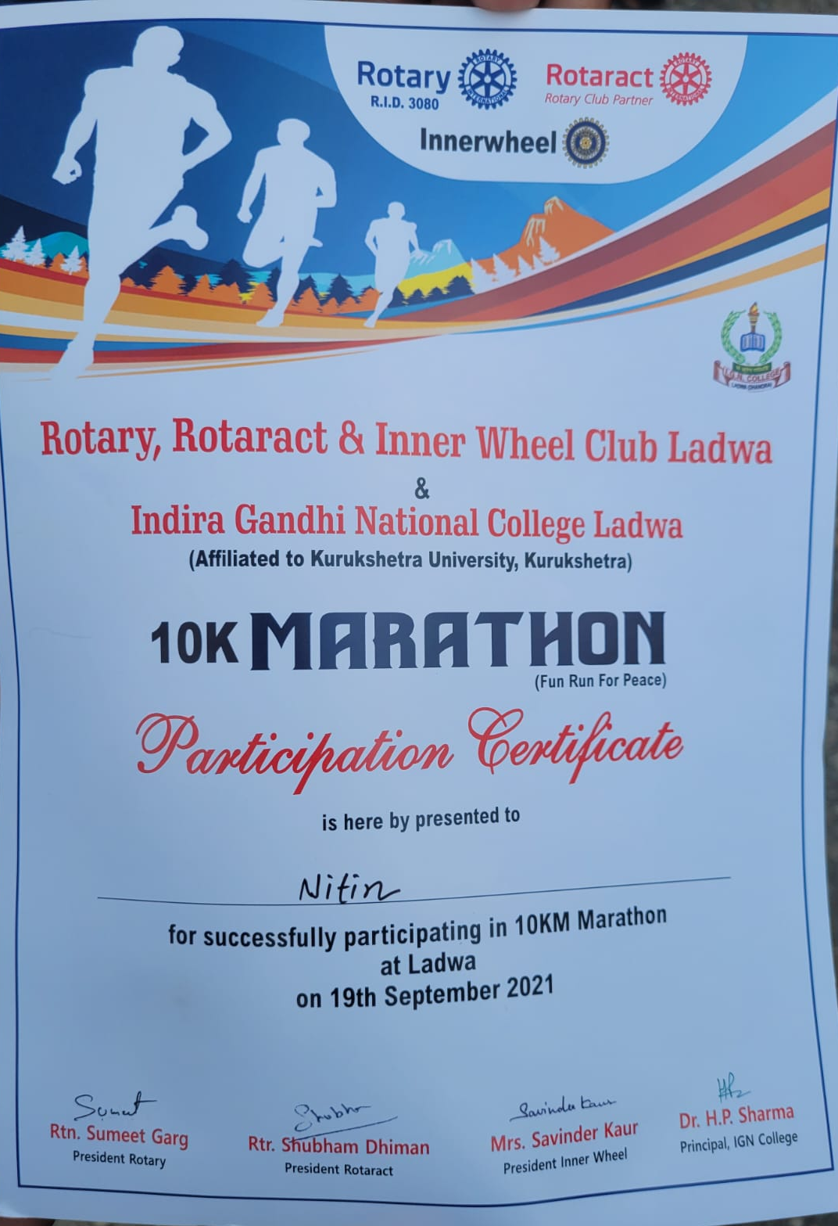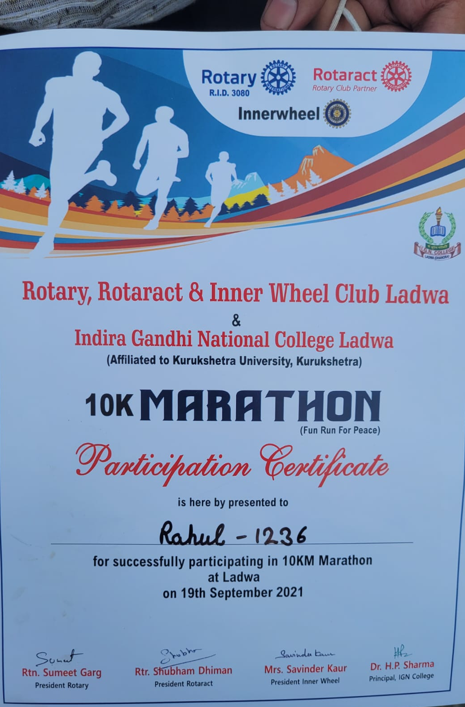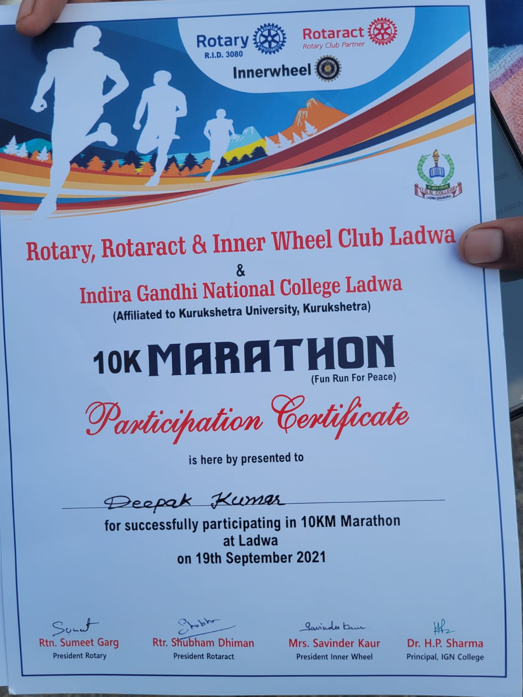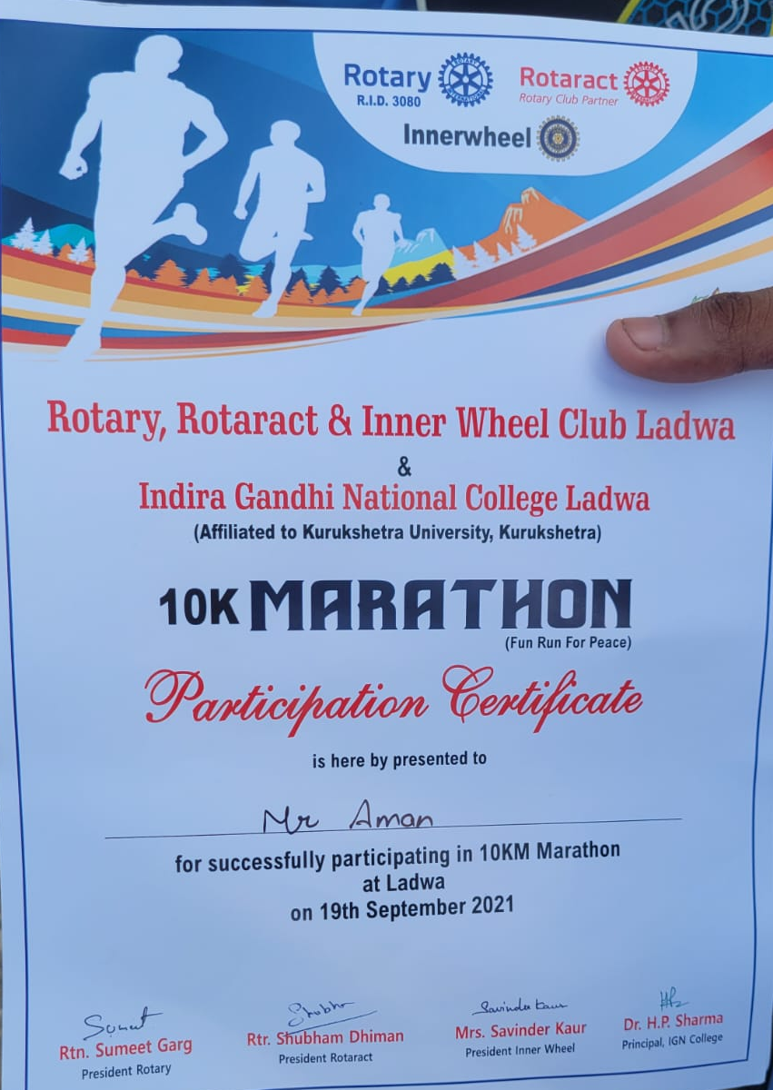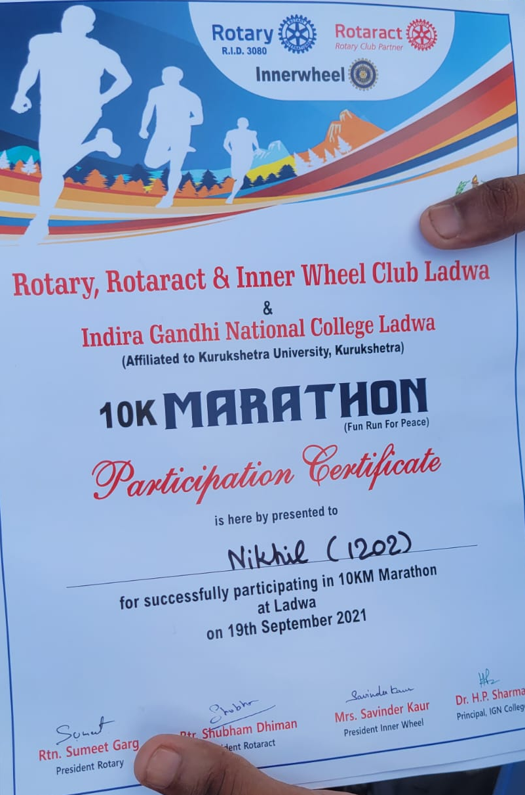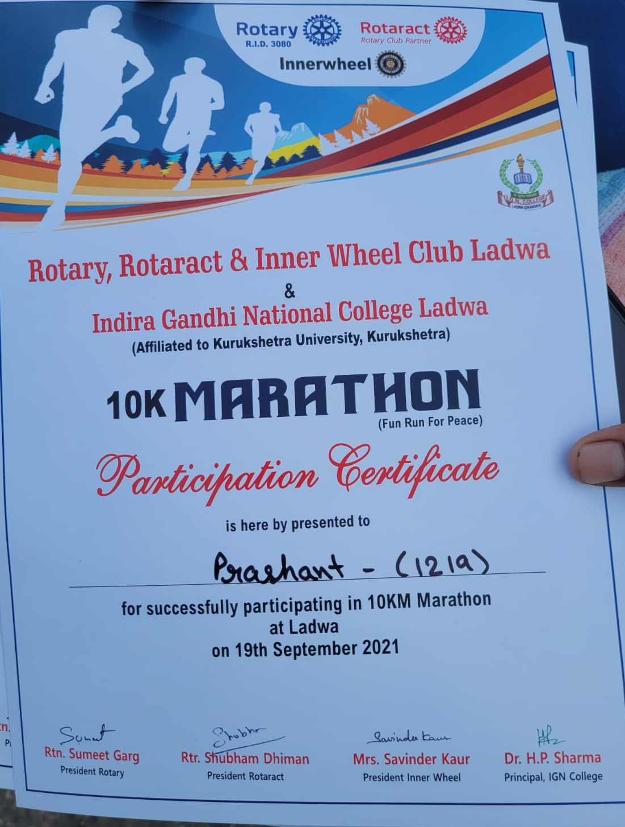

List of NSS volunteers participants in 10k Marathon
Sr. No. | Name of the Students | Class | College Roll No.
 | Harsh | B.A. 3rd | 2281410023
 | Sumit | B.A. 2nd | 3162710073
 | Sakshi | B.A. 2nd | 3162720032
 | Mahima | B.A. 3rd | 3162720052
 | Nancy | B. com. 2nd | 3162820027
 | JATIN SINGHAL | B. com. 2nd | 3162810025
 | Anju rani | B. com. 2nd | 3254920015
 | MANISHA | B. com. 2nd | 3254920013
 | SHUBHAM KUMAR | B.A. 2nd | 3162710109
 | Kulvinder | B.A. 2nd | 2281410050
 | Sachin arora | B.A. 3rd | 2281410079
 | Sonu | B.A. 2nd | 3162710036
 | Rozy | B.A. 2nd | 3162720047
 | Sahil arora | B. sc. 3rd | 2281610021
 | Kajal devi | B. com. 2nd | 3162820019
 | NISHA | B.A. 3rd | 2281420064
 | KOMAL DEVI | B.A. 3rd | 2281420005
 | Ashmeet Kaur | B.A. 2nd | 3162720002
 | Kajal Rani | B.A. 3rd | 2281420011
 | Pinki | B.A. 2nd | 3162720013
 | Manpreet kaur | B.A. 3rd | 3162720031
 | Anju Rani | B.A. 3rd | 2281420083
 | Manjeet kaur | B. com. 2nd | 3162820002
 | Kajal | B. com. 2nd | 3162820033
 | Ritu | B.A. 3rd | 2281420002
 | Rozi | B.A. 3rd | 2281420104
 | Paramjeet kaur | B.A. 3rd | 2281420046
 | Saravjeet kaur | B.A. 3rd | 2281420048
 | Neha chahal | B.A. 3rd | 2281420014
 | Mahak | B. com. 2nd | 3254920007
 | Shivani | B.A. 3rd | 2281420047
 | Mehak Rani | B.A. 2nd | 3162720010
 | GULJEET | B. sc. 3rd | 2281620002
 | Sonia | B.A. 3rd | 2281420010
 | RUBIKA DEVI | B.A. 3rd | 2281420026
 | Aanchal | B. sc. 3rd | 2281620021
 | Muskan | B. com. 2nd | 3254920002
 | Amisha | B. com. 2nd | 3154920001
 | Kirti Rani | B. com. 2nd | 3254920009
 | Monika | B.A. 3rd | 2281420116
 | Geeta devi | B.A. 2nd | 3162720035
 | Nancy | B. com. 2nd | 3162820027
 | Harpreet Singh | B.A. 3rd | 2281410008
 | ANKIT SHARMA | B.A. 2nd | 3162710080
 | Akshant babu | B.A. 3rd | 2281410005
 | Gurvinder Singh | B. sc. 2nd | 3162910003
 | Kanchan Devi | B.A. 2nd | 3162720036
 | Reenu | B.A. 3rd | 2281420044
 | Swati | B. com. 2nd | 3254920010
 | Priyanka | B.A. 2nd | 3162720048
 | Gourav sharma | B.A. 2nd | 3162710019
 | Priyanka | B.A. 2nd | 3162720111
 | Kamal Beniwal | B.A. 2nd | 3162710111
 | Sumit | B.A. 2nd | 3162710018
 | Sahil | B.A. 2nd | 3162710027
 | Kajal Rahul | B.A. 2nd | 3162720053
 | Shree Ram | B.A. 2nd | 3162710101
 | Suman Devi | B.A. 2nd | 3162720043
 | Pinki | B.A. 2nd | 3162720013
 | Shivani Sharma | B.A. 2nd | 3162720009
 | Khushi | B.A. 2nd | 3162720034
 | Simran devi | B.A. 2nd | 3162720089
 | Anju Rani | B.A. 2nd | 3162720085
 | Shilpa | B.A. 2nd | 3162720064
 | Kajal | B. com. 2nd | 3254920006
 | Anish kumar | B.A. 3rd | 2281410097
 | kamal kumar | B.A. 3rd | 2281410012

NCC unit
Indidra Gandhi National College Ladwa(Dhanora), Kurukshetra
(Attendance Chart)
2020-21

Name of the Event: 10 K Meter Marathon organised at Playground, Indira Gandhi National College ladwa(Dhanora)

Date: 19 September,2021
Sr.No. | Enrollmentno. | Rank | Name ofCadet
1 | HR19SDA229734 | Cadet | Ankush
2 | HR19SDA229735 | Cadet | Sahil Kumar
3 | HR19SDA229736 | Cadet | GurvinderSingh
4 | HR19SDA229737 | Cadet | AnkitSharma
5 | HR19SDA229738 | Cadet | Abhishek
6 | HR19SDA229739 | Cadet | ChandanSingh
7 | HR19SDA229741 | Cadet | Abhishek
8 | HR19SDA229742 | Cadet | Paras
9 | HR19SDA229743 | Cadet | SAHILKUMAR
10 | HR19SDA229744 | Cadet | SatvinderSingh
11 | HR19SWA229745 | Cadet | Meena
12 | HR19SWA229746 | Cadet | Sapna
13 | HR19SWA229747 | Cadet | AANCHALGAGAT
2214 | HR19SWA229748 | Cadet | VijetaRani
15 | HR19SWA229749 | Cadet | Mahak
16 | HR19SWA229750 | Cadet | SONIA
17 | HR20SDA229758 | Cadet | ReshamSingh
18 | HR20SDA229759 | Cadet | Karan jyot
19 | HR20SDA229760 | Cadet | KhushwantSingh
20 | HR20SDA229761 | Cadet | VikasKumar
21 | HR20SDA229727 | Cadet | Sumit Kumar  SUMITKUMAR
22 | HR20SDA229728 | Cadet | SawakSingh
23 | HR20SDA229729 | Cadet | Tusharsharma
24 | HR20SDA229730 | Cadet | Kamal
25 | HR20SDA229731 | Cadet | Raj Kumar
26 | HR20SWA229751 | Cadet | AmanpreetKaur
27 | HR20SWA229752 | Cadet | Nancy
28 | HR20SWA229753 | Cadet | Jashanpreet
29 | HR20SWA229754 | Cadet | Kritika
30 | HR20SWA229755 | Cadet | Neha Rani
31 | HR20SWA229756 | Cadet | Mansi
32 | HR20SWA229757 | Cadet | Jyoti
33 | HR20SWA229726 | Cadet | Simran Kaur
34 | HR18SWA229415 | Cadet | Balwinder Kaur
35 | HR18SDA229797 | Cadet | Parveen Kumar
36 | HR18SDA229798 | Cadet | Himanshu Kamboj

