Indira Gandhi National College Ladwa
Five Day District Level Youth Red Cross Training Camp
24-28Feb.2020
Report on District Level Youth Red Cross Training Camp
Red Cross Society Kurukshetra organised a Five-day District Level Youth Red Cross Training Camp on 24-28 Feb. 2020 at Multi Art Cultural Centre Kurukshetra. Dr. Yashpal Singh, Convenor of YRC unit and 10 students of the college participated in the training camp. The expert of different field delivered their lectures on the topics like road safety, HIV, Aids, communicable and non-communicable diseases, eye donation, First Aids, blood donation etc. The students of the college also participated in different recreational activities organised during the camp. College team stood first in quiz contest. Rahul grabbed first prize in dance competition. Ravi Kumar won second prize in declamation contest. Dr. Yashpal Singh honoured as best Male Counsellor in the training camp.

Dr. Yashpal Singh
Convener YRC
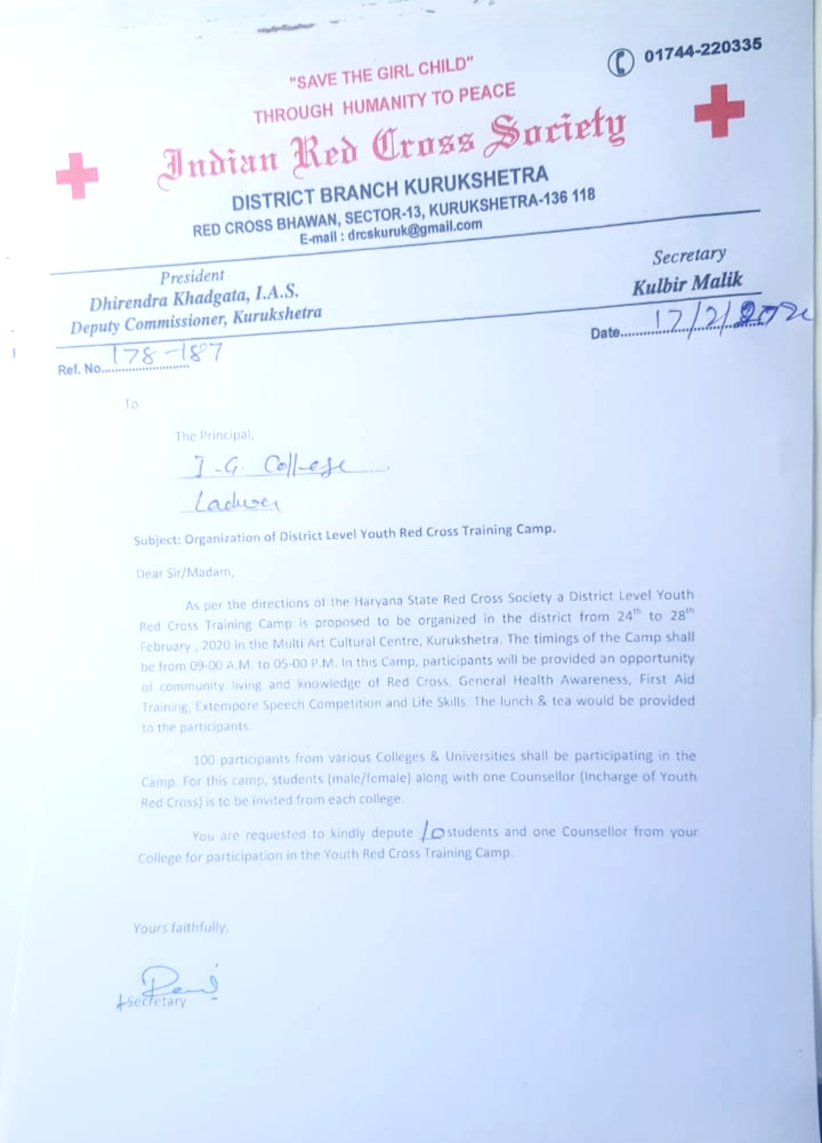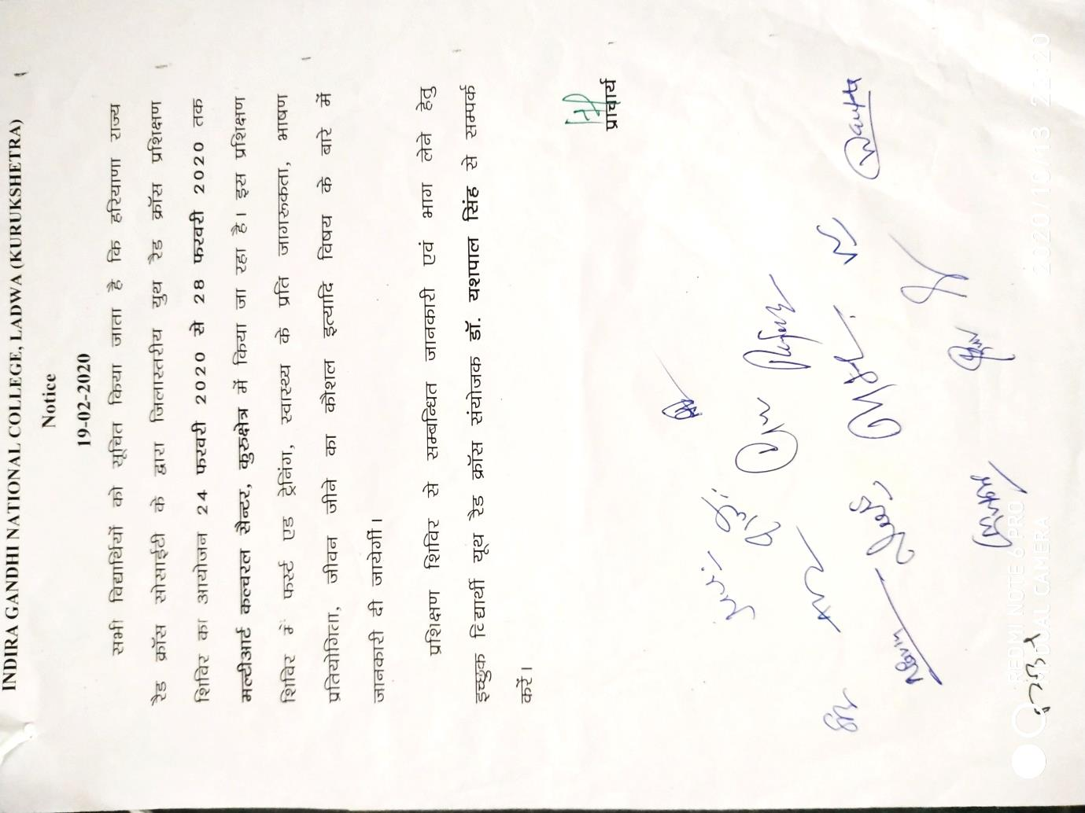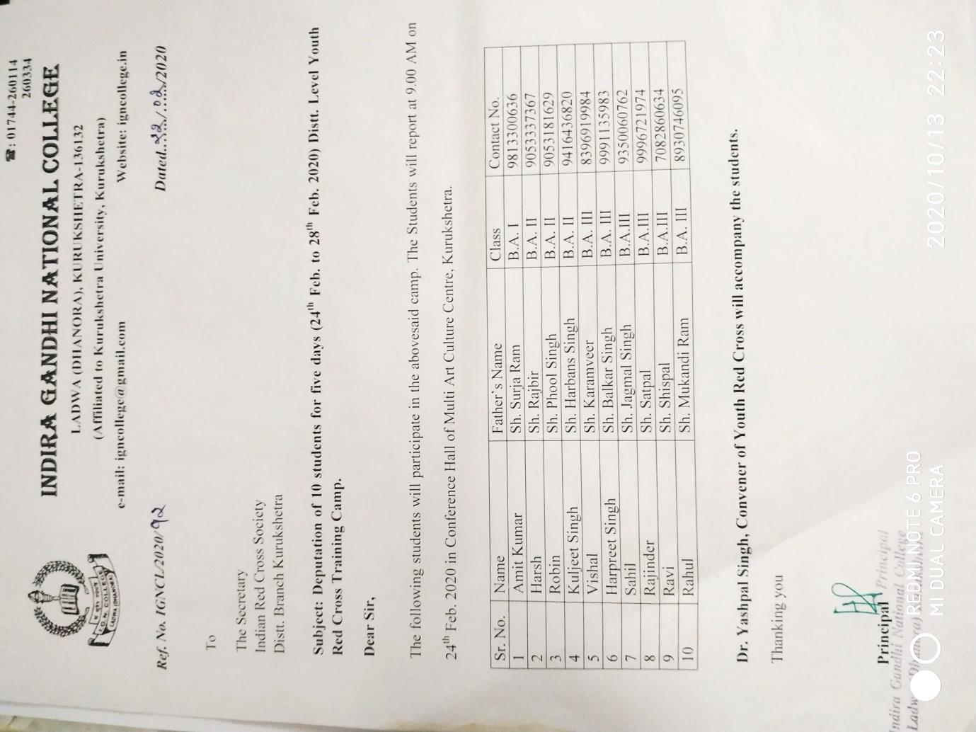

PHOTOGRAPHS OF TRAINING CAMP
