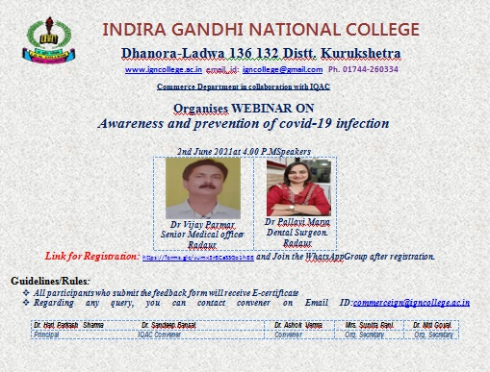

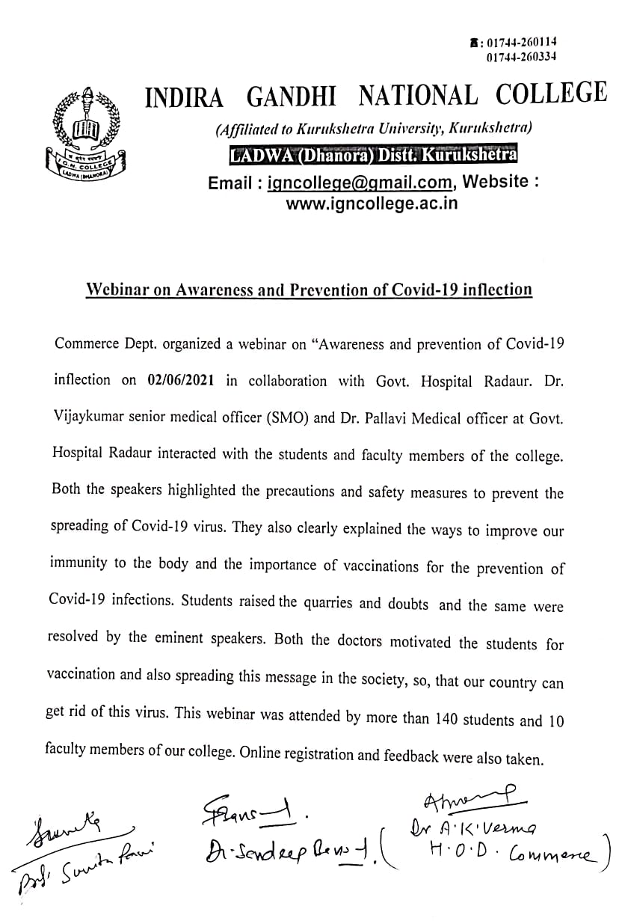
List of Students participated in the webinar

 | Name of the Participant | Class (For Student)/ Designation ( For staff) | Roll number
1 | Sandeep Bansal | Associate Professor | 123
2 | Dr. Neetu | Assistant professor | 23
3 | Sushant panchal | Bcom 2nd | 3162810030
4 | Pooja Rani | B.Com Final Year | 2281520010
5 | kamal | b.com 2nd year | 3162810017
6 | Ankit Sharma | Student | 3162710080
7 | Abhishek | B.com 2nd year | 3254910009
8 | Dr. Sudesh Kumar | Assistant Professor
9 | Vishal | Class | 3162810007
10 | Kajal | Student b.com 2nd year | 3162820033
11 | Nandita | B.com 2nd year | 3162820012
12 | Govind garg | B.com 1 year(2 sem) | 120207003040
13 | Simran | Student | 2281520019
14 | Sahil | B.COM final year | 2281510005
15 | Anjali Sharma | B. Com( 2nd) | 3162820007
16 | PRIYANKA | Assitant Professor in Mathematics
17 | Kirti bajaj | B.com 2nd year | 3254920009
18 | Harneet Kaur | Assistant Professor
19 | Yash Raheja | B.com 2nd year. 4th semester | 3254910013
20 | Harshdeep kaur | Student | 2281520028
21 | Ankush kumar | B. Com final year | 2281510002
22 | Kajal | B.sc 2nd year 4th sem | 3163020010
23 | Dr Niti Goyal | Assistant Professor
24 | Kajal devi | B.com ( 2nd year) | 3162820019
25 | DR. VANDANA GUPTA | Assistant Professor
26 | Dr.Ashok Verma | For Staff
27 | Muskan | B.com Ist year (second semester) | 120207003048
28 | Naman kansal | B.com 2nd Year | 3162810010
29 | Shilpi | B.com 2nd year | 3162820025
30 | Sachin Dhawan | B.Com 2 year | 3162810002
31 | Ravina devi | B.com (4sem ) | 3162820008
32 | Mahak | B.com 2nd year | 3254920007
33 | Priya | B.com 2nd semester | 120207003054
34 | Siya | Bcom.1st year | 120207003064
35 | Vikas | B.com 3rd year | 2281510019
36 | Mangesh Goel | B.com final | 2281510007
37 | Manjeet kaur | Student | 3162820002
38 | Sakshi | BA 2nd year | 3162720032
39 | Poonam | B.com 2nd year(4th sem.) | 3162820016
40 | Dr. Arvind Garg | Associate Professor
41 | Manisha | Student | 3254920013
42 | Harneet kaur | B.COM 2ND YEAR | 3162820004
43 | Anju rani | B.com 2nd year | 3254920015sfs
44 | Sukhwinder kaur | B.com 2nd yrar | 3162820022
45 | Sahil | B.Com Final year | 2281510021
46 | Nisar kaur | B.com 2nd year | 3162820015
47 | Priyanka devi | 3rd b.com final year | 2281520030
48 | Neha | B.Com 2nd year | 3162820039
49 | Manisha Devi | B.com 1st year | 120207003024
50 | Jaspreet Singh | B. Com 1st year | 120207003037
51 | Naveen |  | 3162810011
52 | Rahul | B. Sc medical final year | 181516
53 | Ashmeet Kaur | BA 2ND | 3162720002
54 | Manjeet Kaur | Bsc( non medical) first year | 120207015026
55 | Sunita Rani | Assistant Professor
56 | Aarti Rani | B. Com 6th sem | 2281520009
57 | Kavita | B.com 1st year | 120207003072
58 | Aditi | class.-b.com final year | 2281520016
59 | Prince kumar | B.com 1st year | 120207003014
60 | Aanchal | B.sc. 3rd yr | 2281620021
61 | Ravi kumar | B. Com 2year | 3162810032
62 | Alisha | Bcom3rd year | 2281520005
63 | Vikas | B.com 2nd year | 3162810034
64 | SHUBHAM | B.com | 120207003019
65 | Satvinder kumar | BA 3rd year 6 sam | 2281410064
66 | Dr. Rupesh Gaur | Librarian
67 | Rahul | Student | 3162810035
68 | Shubham | B.com 2nd year | 3162810006
69 | Vishal saini | B.com Final year | 2281510036
70 | Kamaljeet | B.com ist year | 120207003049
71 | Pooja | Bsc 4th sem | 3162920006
72 | Aatishsharma | B.com 3rd year | 2281510010
73 | Ishu | b.com(1st year) | 120207003003
74 | Pooja | Student | 3162820017
75 | Sneha | B.com 2nd year | 3162820026
76 | Kirti | B.com 2nd | 3162820013
77 | Nikita | B.com 1st year | 120207003004
78 | Aruna saini | Bsc 2nd year | 316290018
79 | Aarti Devi | Bcom | 2281520015
80 | Beena | B.com-3rd ( for student) | 2281520041
81 | Ramandeep Kaur | B.com 3rd year | 2281520012
82 | Sonia | B.a final year | 2281420010
83 | swati | for student | 120207003009
84 | Monika | b.com ll | 3162820036
85 | Sanchit | B.Com (3rd year) | 2281510004
86 | Neha rani | B.com first year | 120207003028
87 | Harshlata | B.com 2nd year | 3162820031
88 | Srishti | B.a 3rd year | 2281420063
89 | INDERJEET SINGH | B com 2 nd year | 3162810028
90 | Muskan | Student b.com 2 | 3162820035
91 | Tanu rani | B.com 4th semester | 3162820037
92 | Meenakshi | B.com first year | 120207003058
93 | Satyampanchal | B.com 2nd | 3162810031
94 | Vijay Kumar | Dy. Supdt.
95 | Sonam | B.com final | 2281520021
96 | Tamna | Student | 120203055
97 | khushi | b.com 1st year | 120207003059
98 | Mahak | B.Com 3rd year | 2281520007
99 | Gursevak Singh | B.com 2nd year | 3162810001
100 | Riya | Bcom | 3162820029
101 | Samriti devi | B.sc(6th semester) | 2281620019
102 | Harsh | B.com 2nd | 3162810008
103 | Kavita Devi | B com 1st year | 120207003013
104 | Diksha | Bcom 1 year | 120207003001
105 | HARSH | B. COM 4th. Sem | 3162810009
106 | Swati devi | B. Sc. -final | 2281620005
107 | Nancy | B. Com 2nd year | 3162820020
108 | Mahima | B.com 2nd year | 3162820034
109 | Sumanpreet kaur | B.com 1st | 120207003078
110 | Muskan Sharma | B.com (2nd) | 3162820009
111 | Jatin singhal | Bcom | 3162810025
112 | Neeru | B. Com 1st year | 120207003026
113 | Kajal | Student | 3254920006
114 | Pushwinder kaur | Student | 3162820032
115 | Tripti saini | Bsc 2nd year N.M | 3162920010
116 | Thakur Singh | B.com final year | 2281510014
117 | Dikshit | Student | 3254920008(sfs)
118 | Dr.Neeru Bala | Assistant professor
119 | Bharti devi | B. Com final year | 2281520032
120 | Komal | B.com 1st year (2nd sem.) | 120207003061
121 | Shivani | Bacon third year sixth semester | 2281520035
122 | Hemant kumar | B.com 2nd year | 3162810022
123 | Dr. Amit Kumar | Assistant professor of Chemistry
124 | Tanu | B.sc 2nd year | 3162920011
125 | Aarti | B.com 3rd year | 2281520008
126 | Anju | Bsc-3rd year | 2281620018
127 | Aarti | B.SC(3rd year) | 2281620008
128 | VIDHI KANSAL | Bcom 2nd year | 3162820014
129 | Sahil Arora | B.sc final year | 2281610021
130 | Sivani devi | B.com final year | 2281520004
131 | Nancy | Bcom 2nd | 3162820027
132 | Bharti Devi | B. Com final year | 2281520032
133 | Kalpana | B com final | 2281520022
134 | Neelam rani | B.com 3rd 6th semester | 2281520027
135 | Aman | class - B.com (2nd semster) | 120207003076
136 | Tamanna | B.com | 3162820018
137 | Muskan | Student | 3162820023
138 | Prince kumar | BA | 2281410035
139 | Jyoti devi | B.com 2 year | 3162820042
140 | Anju | Bsc-3rd year | 2281620018
141 | Amisha | For student | 3254920001
142 | Kajal | B.Com 2nd year | 3254920006
143 | Monika | B.A 6th sam | 2281420116
144 | Aashish | Student | 2281510020
145 | Nancy | Bcom(2nd)year | 3162820011
146 | Alka Rani | B.com 3rd year | 2281520018
147 | yashmeet Singh | B.com 2nd | 3162810005
148 | Muskan | B.com | 3254920002
149 | Swati | B. Com2nd | 3254920010sfs
150 | Kush | B.com 3rd year | 2281510011
151 | Kunal Kumar | B.com 2Nd Sem | 120207003021
152 | Kavita | B.com(2nd year) | 3162820003
153 | Sonu | B.A | 3162710036
