Orientation and save water drive: - 05-08-2019
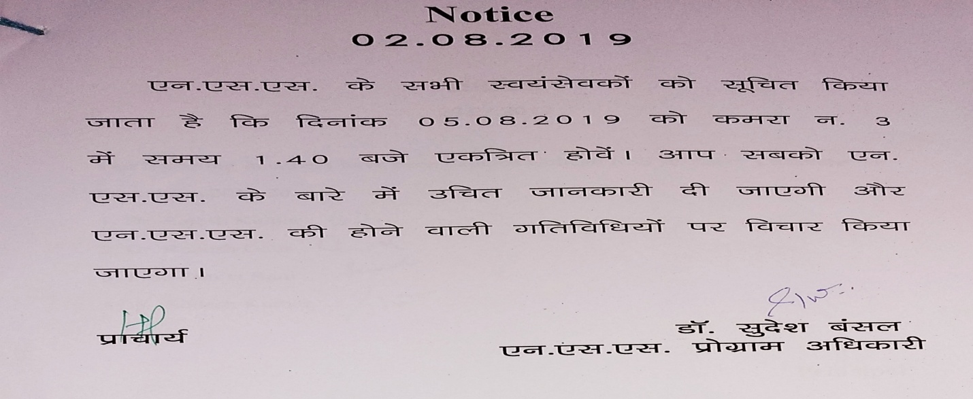

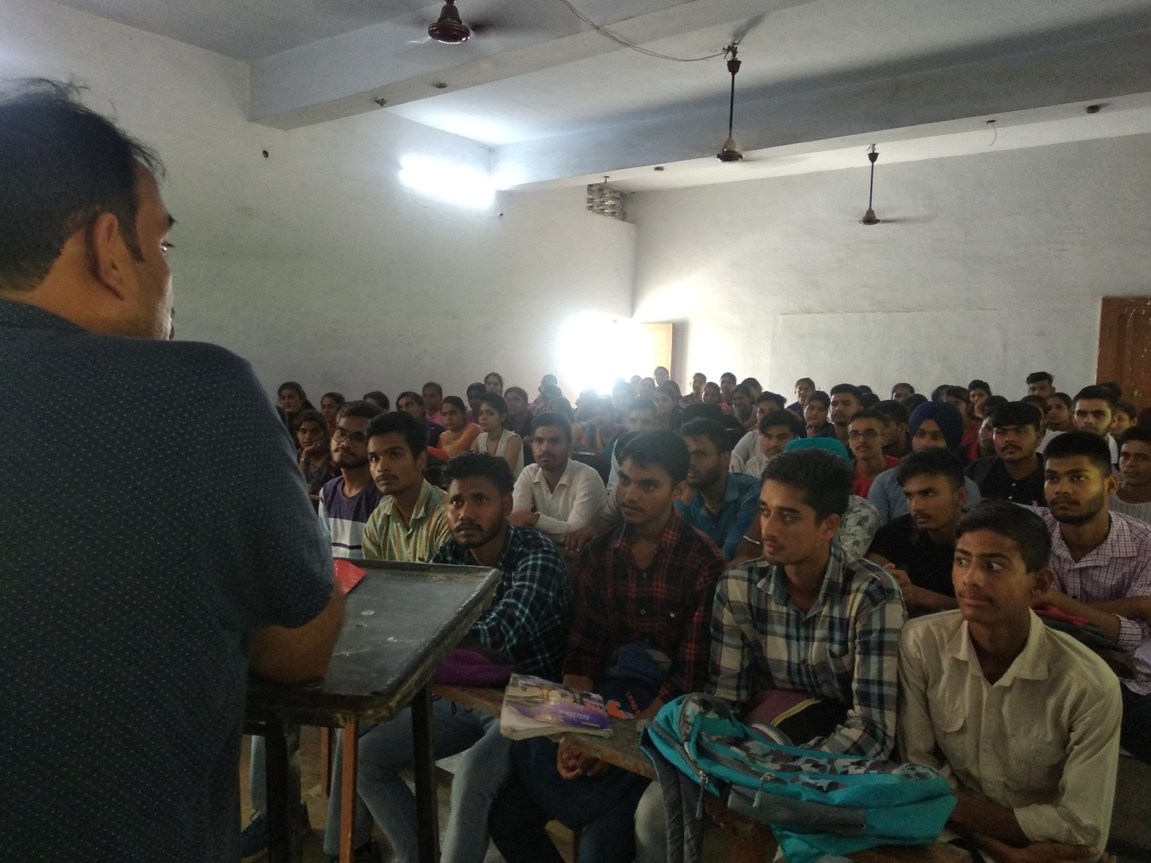
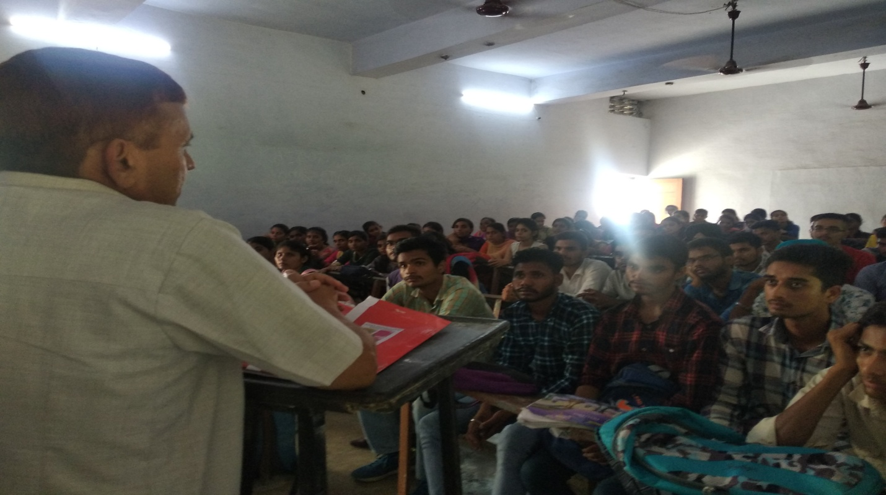
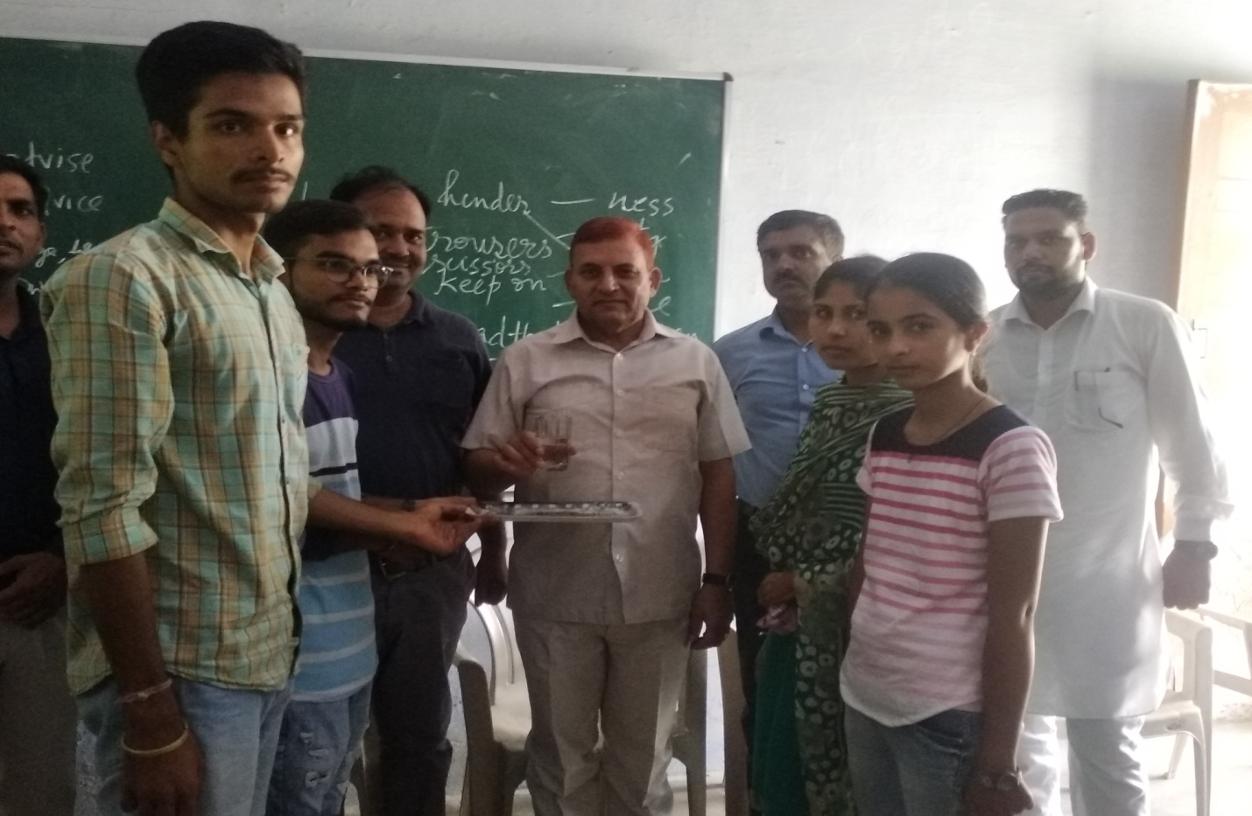
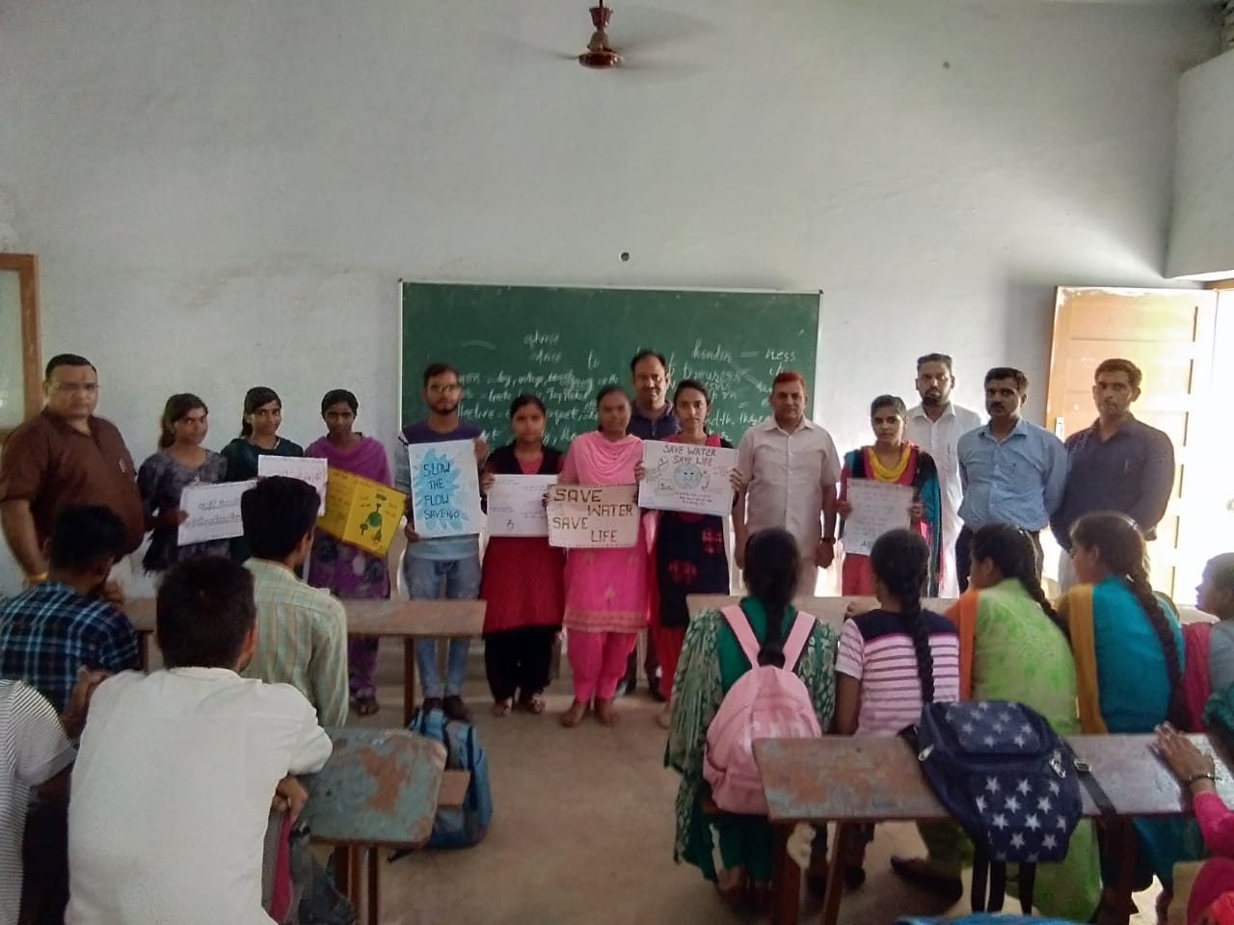
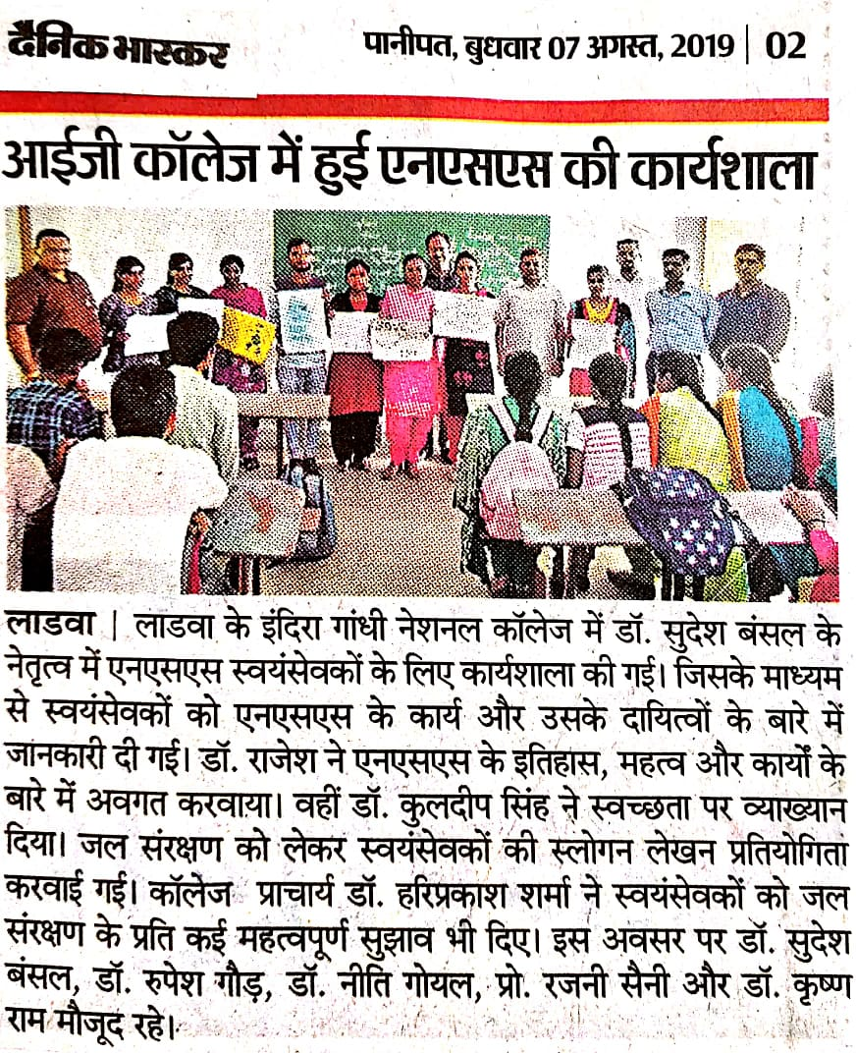
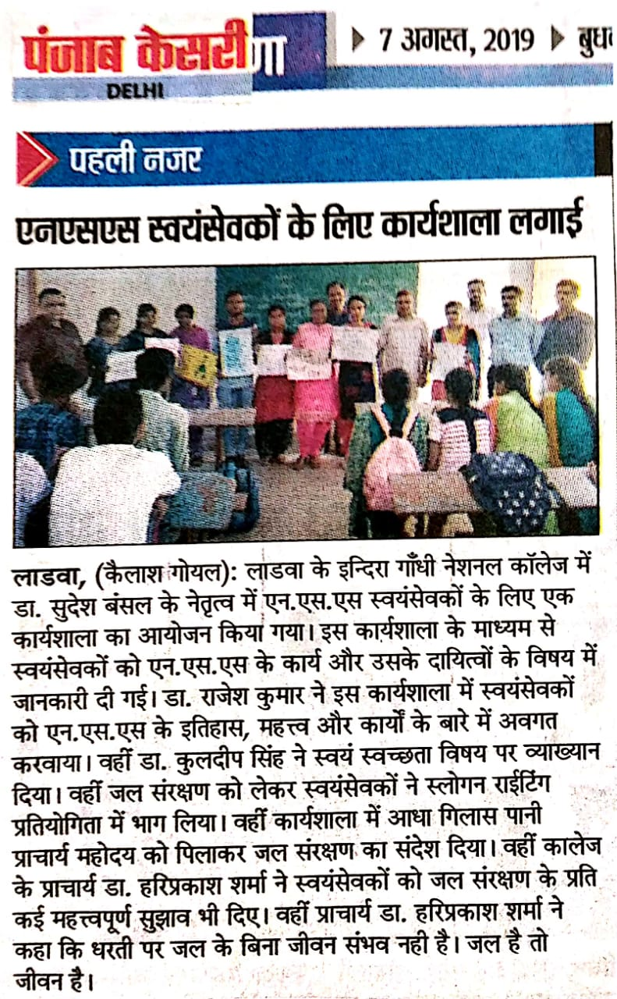
Report of Orientation Program and Save water Drive
05-08-2019

An orientation program was arranged for the NSS volunteers. In this program Dr. Rajesh Kumar delivered a talk about the benefits of NSS. Dr. Kuldeep singh talked about self cleanliness. ‘Save Water Drive’ started today with the serving of ‘Half Glass Water.’ NSS volunteers write slogans to save water. 53 volunteers took part in this program.

Principal Dr. Sudesh Kumar
NSS Programe Officer

