Poshan Abhiyan 27-09-2019
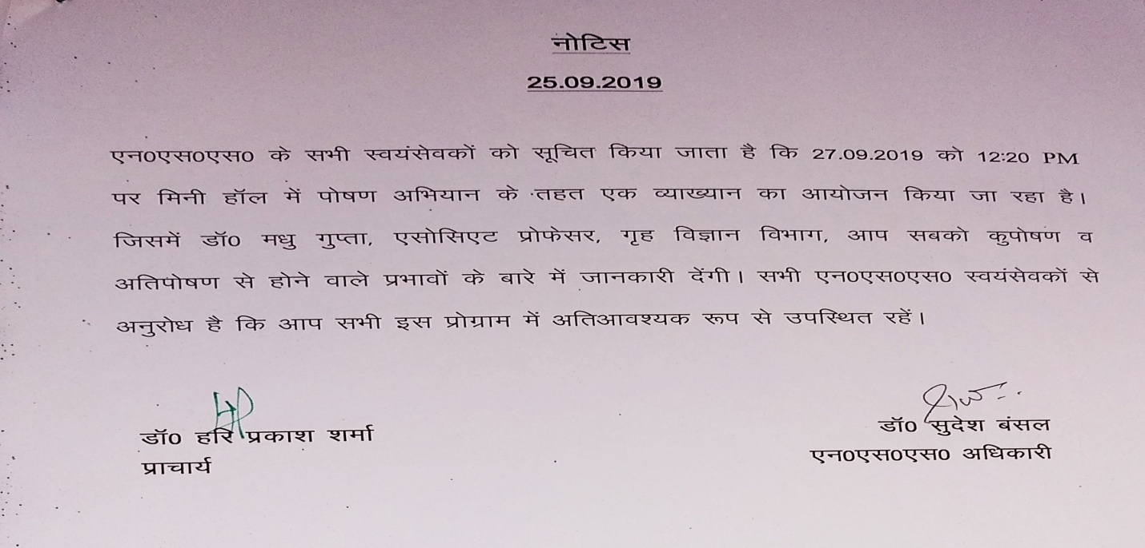
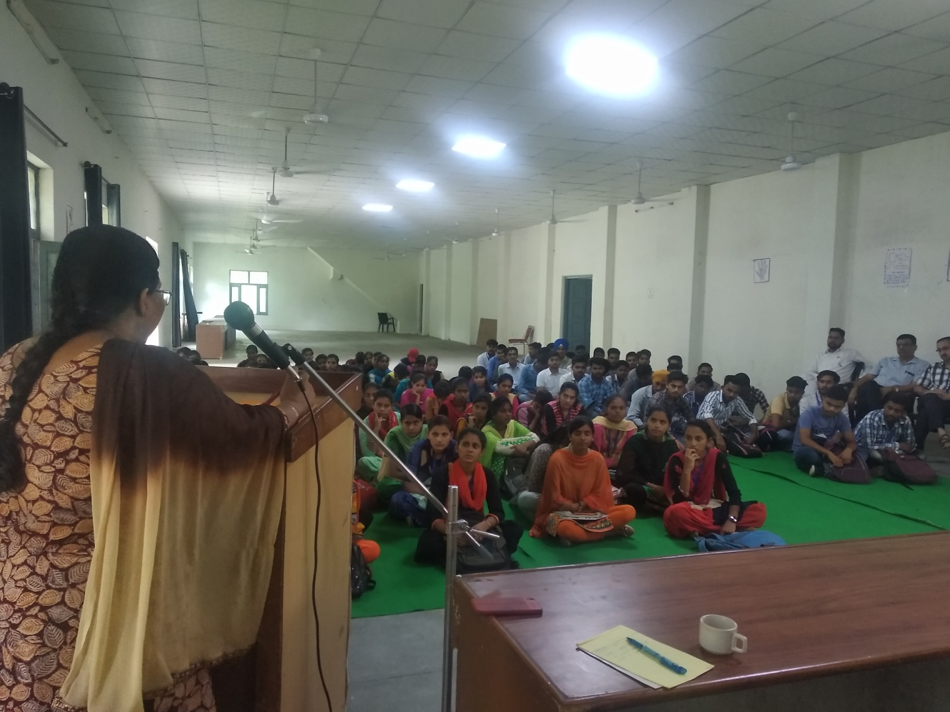
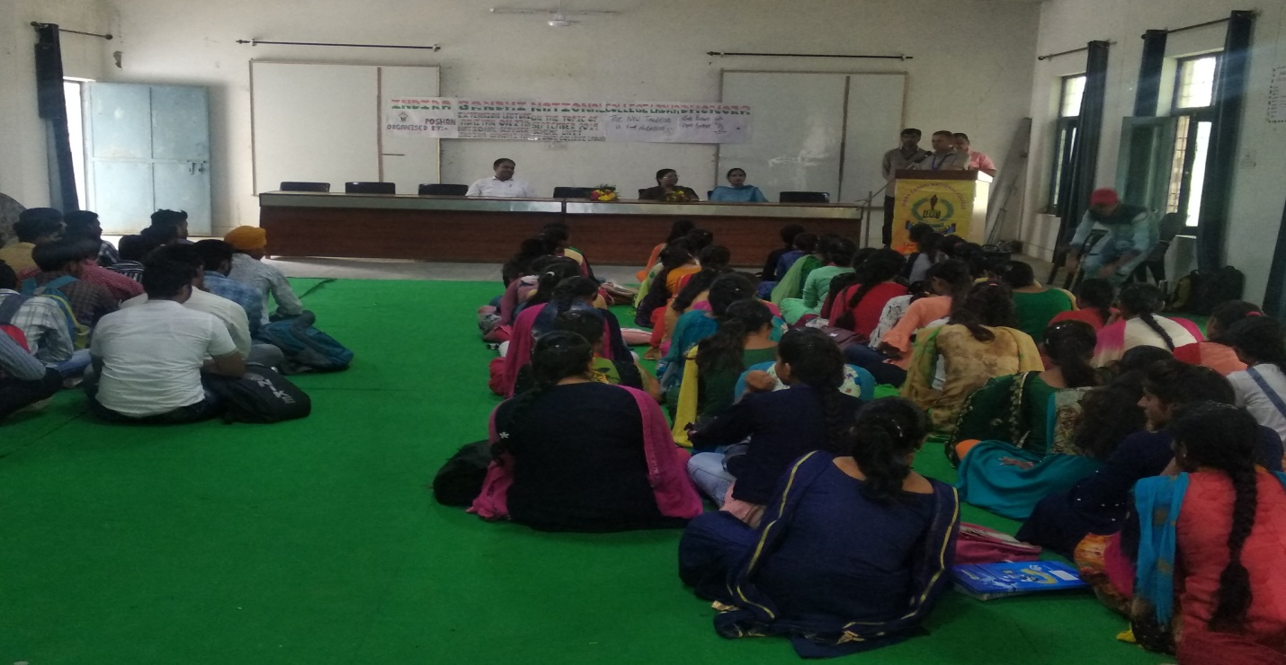
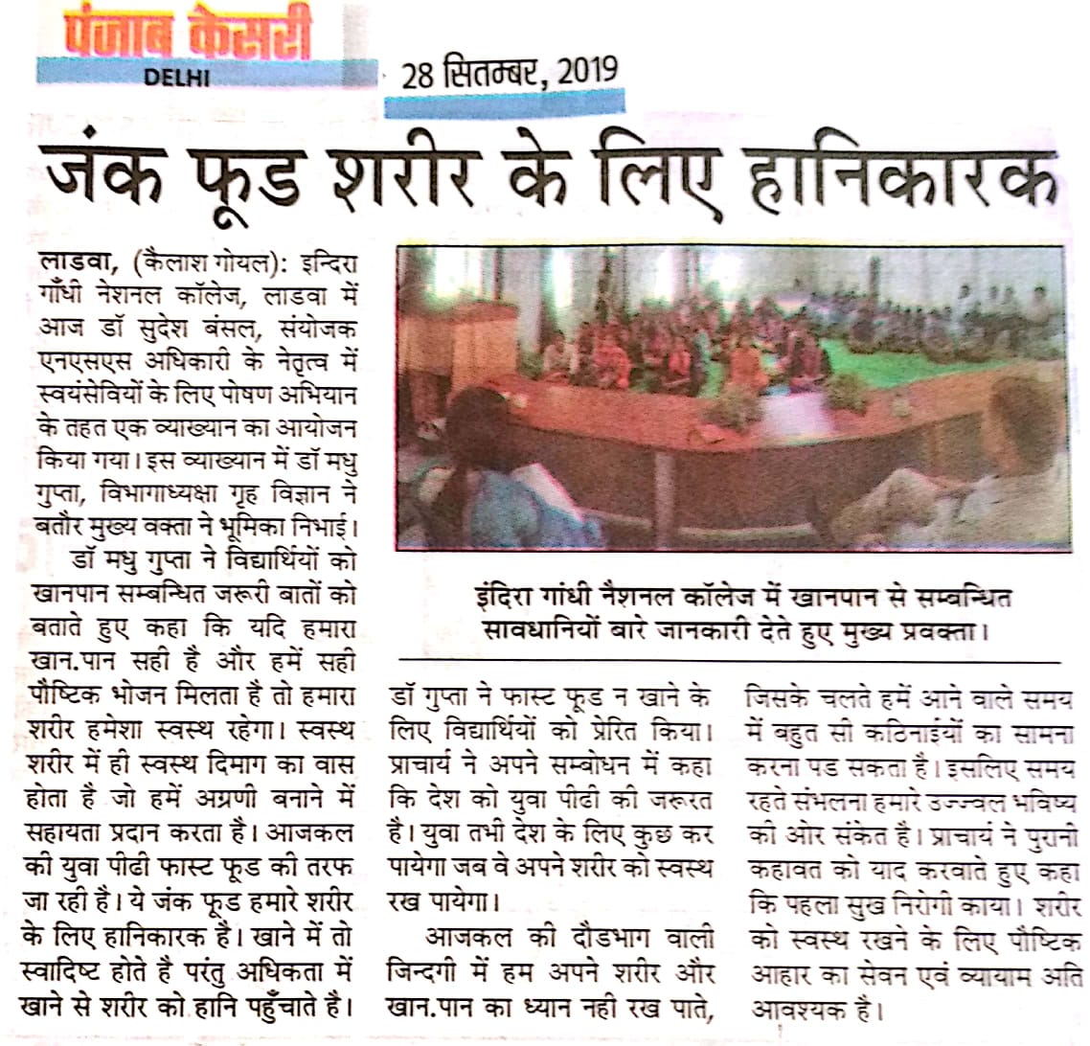
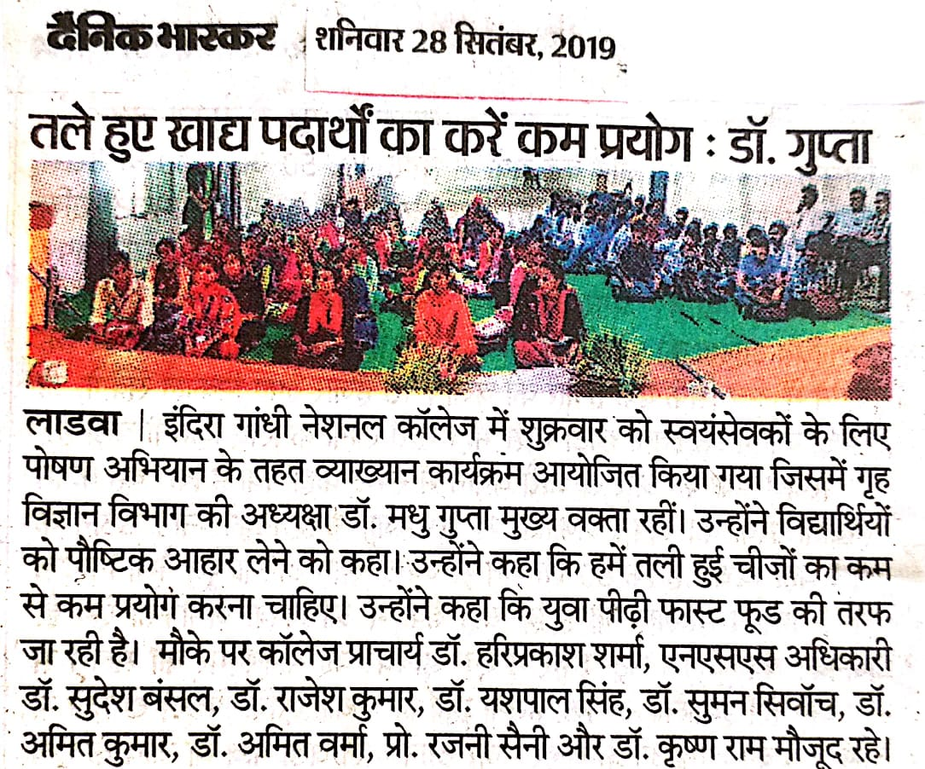

Report of Poshan Abhiyan
27-09-2019

A workshop of ‘Poshan Abhiyan’ for the NSS volunteers was organized. In this program Dr. Madhu Gupta, associate professor of Home Science delivered an awareness lecture on ‘poshan’. 56 volunteers took part in this program.

Principal Dr. Sudesh Kumar
NSS Programe Officer

