CATC 127, Kurukshetra University, Kurukshetra

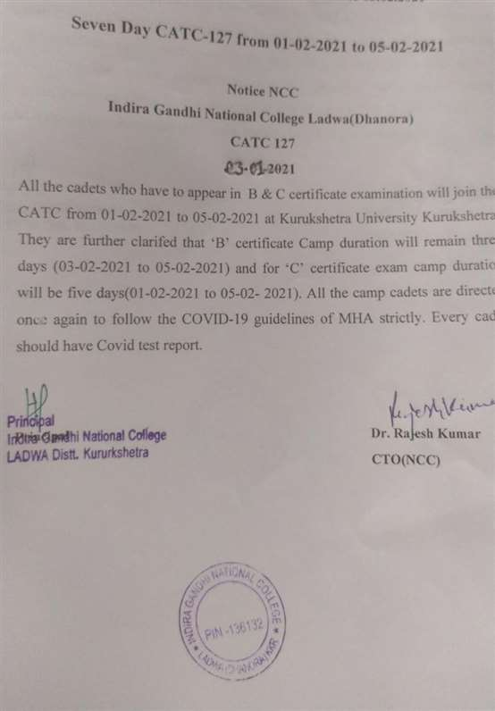

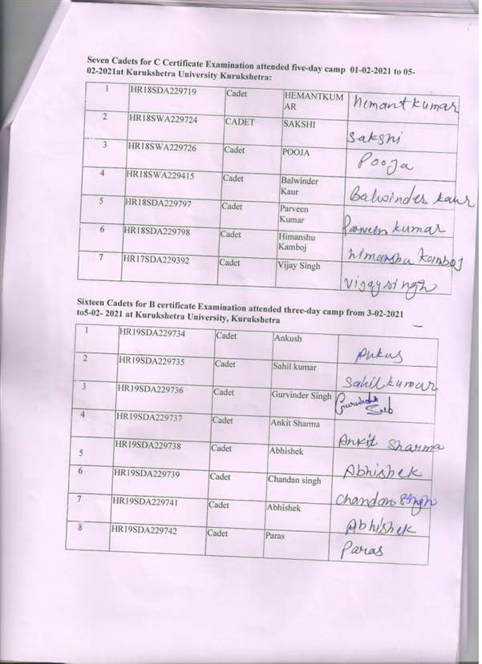
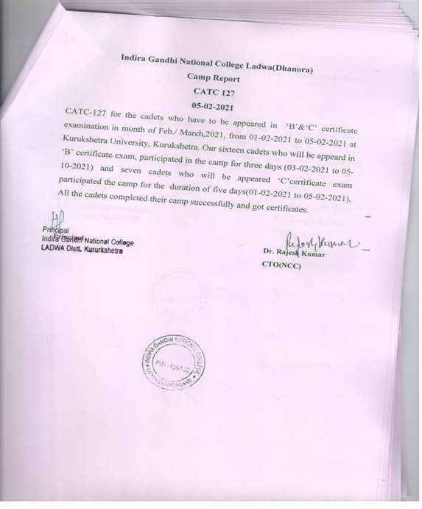
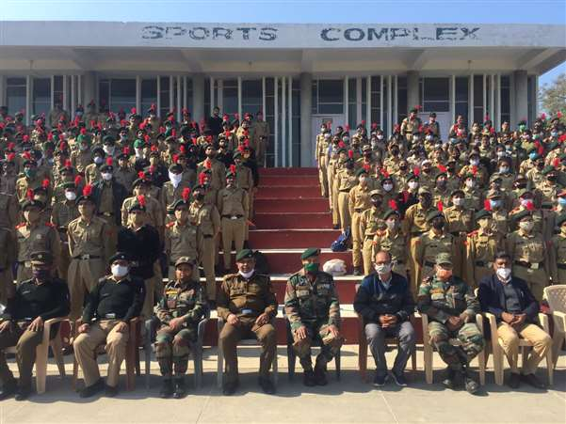

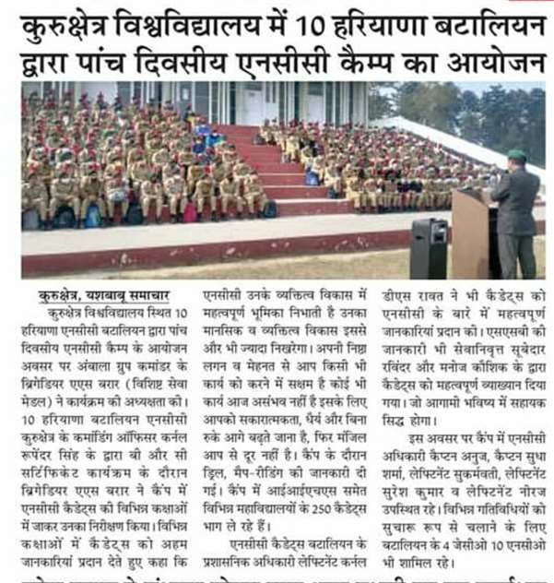

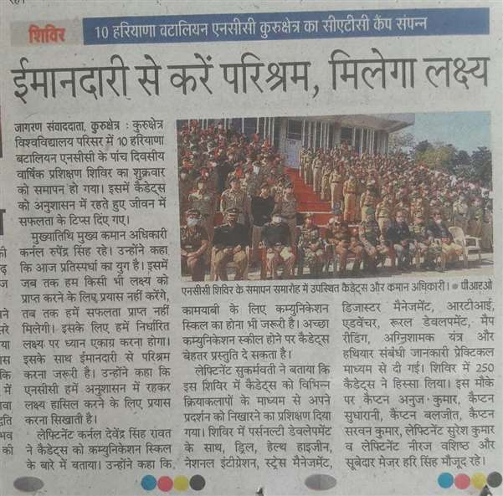

CERTIFICATE

This Is to cortlfy thai Roglmontal No.

Rank Name

Unit 10 HARYANA BN NCC KURUKSHETRA

InstitutionlUnit

PaXlcipated in Combined Ancual Training Camp No. 127 of NCC.

Place: Xurukshetra University, Xurukshetra

From : g y /«¿/ ppgj To oy" F” $ $ot /

Place:
O

Dated :

Camp Commandant

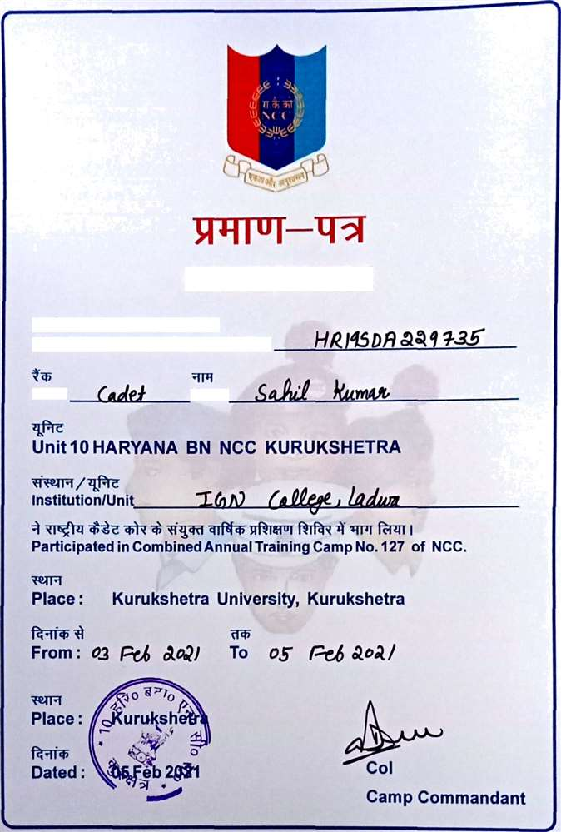

CERTIFICATE
mIPTaIrTilTalgfzs‹Tt
This is to certify that Regimental No. Rank Name

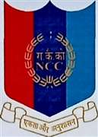

CERTIFICATE

This is to certify that Regimental No.

Rank Name

Unit 10 HARYANA BN NCC KURUKSHETRA
Institution/Unit

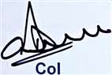
Participated in Combined Annual Training Camp No. 127 of NCC.

Place : Kurukshetra University, Kurukshetra

From: py @p§j To of was a»al

Place: uruksfie

Dated :

Camp Commandant

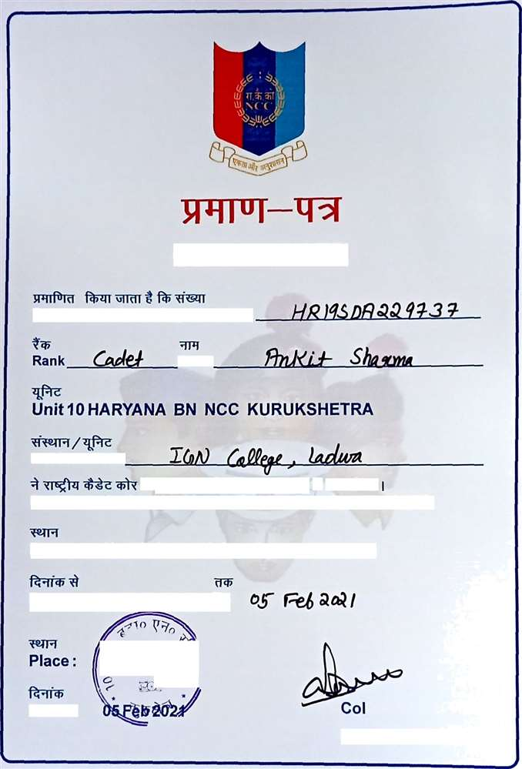

CERTIFICATE

This is to certify that Regimental No.

Name

Institution/Unit

Participated in Combined Annual Training Camp No. 127 of NCC.

Place: Kurukshetra University, Kurukshetra

From : of @| To

Dated:

Camp Commandan t

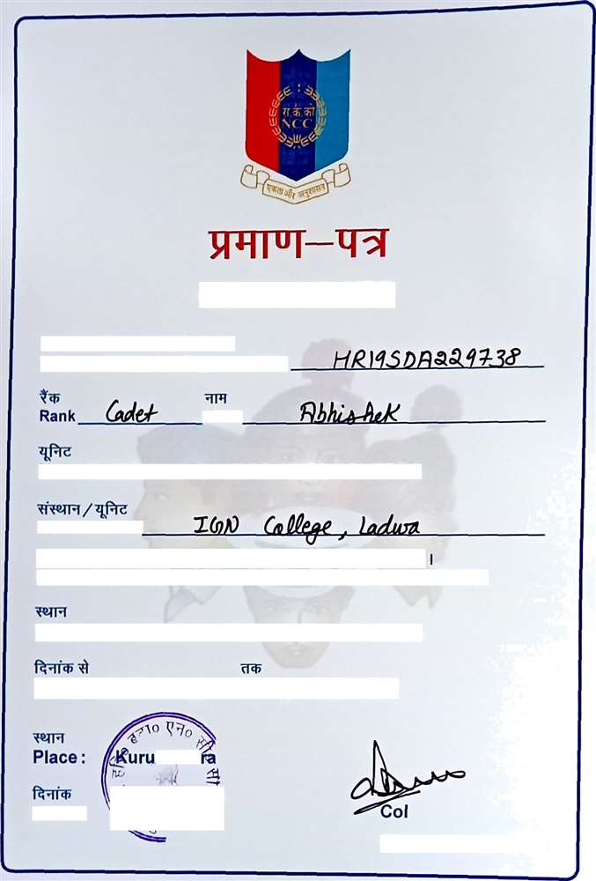

CERTIFICATE

This is to certify that Regimental No.

Name

Unit10 HARYANA BN NCC KURUKSHETRA

Institution/Unit

Participated in Combined Annual Training Camp No. 127 of NCC.

Place: Kurukshetra University, Kurukshetra

kshet

Camp Commanda nt

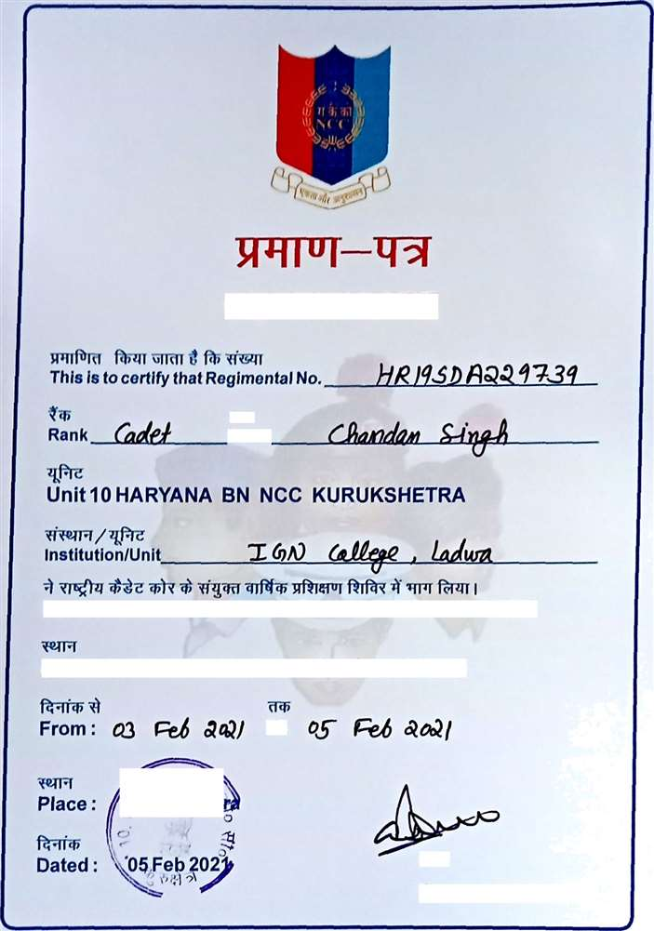

CERTIFICATE

Nama

Partlclpated In Comblned Annual Training Camp No. 127 of NCC.

Place: Xurukshetra University, Kurukshetra

<J$uruksñet

Go
Gamp Gommandant

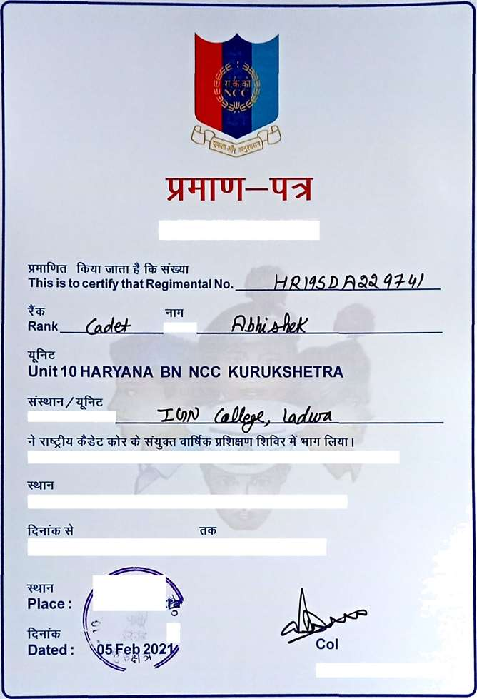

CERTIFICATE

Name

Institution/Unit

Participated in Combined Annual Training Camp No. 127 of NCC.

Place: Kurukshetra University, Kurukshetra

urukshe\

Camp Commandant

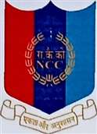

CERTIFICATE

This is to certify that Regimental No. /-/@ } J@@ @ @ Rank /jg Name Unit 10 HARYANA BN NCC KURUKSHETRA

Participated in Combined Annual Training Camp No. 127 of NCC.

Place : Kurukshetra University, Kurukshetra

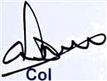
Place: uru s e

Dated :
Camp Commandant

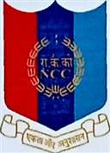

CERTIFICATE

This is to certify that Regimental No. DD

Unit10 HARYANA BN NCC KURUKSHETRA
7 &PIc Institution/Units

Participated in Combined Annual Training Camp No. 127 of NCC.

Place: Kurukshetra University, Kuruhshetra

Camp Commandant

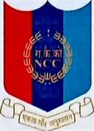

CERTIFICATE

This is to certify that Re8' = V l taI No. !g!g//)"/@@@@*/t *!/@ ’// . .. Rank /’”gjy{gz/ Nme
Ucit 10 HARYANA BN NCC KURUKSHETRA

Institution/Unit
Participated in CombinedAnnual Training Camp No. 127 of NCC.

Place: Kurukshetra University, Kurukshetra

From : #3 {@;$ Q QJ To 4f f@$ ›:3Q /

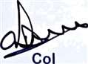
'°’** S*° *”’•

Place: i/ruk¿het/*p

Camp Commandant

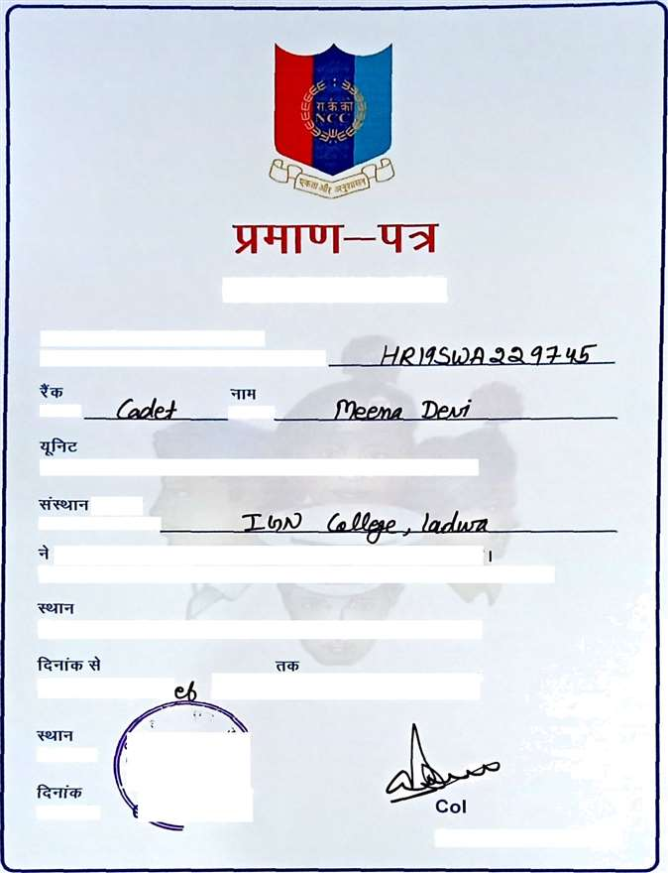

CERTIFICATE

This is to certify that Regimental No.

Name

Unit10 HARYANA BN NCC KURUKSHETRA

Institution/Unit

Participated ie Combined Annual Training Camp No. 127 of NCC.

Place: Kurukshetra University, Kurukshetra From: p/ ñ" aaJ To g/}* @o»g / Place: @urd et

Dated: i{¿Igs4é9b{t)I***

Camp Commandant

CERTIFICATE

This is to certify that Regimental No.

Rank Name

Unit J 0 HARYANA BN NCC XURUKSHETRA

InstitutionlUnit

Participated in CombinedAnnualTraining Camp No. 127 of NCC.

Place: Xurukshetra University, Kurukshetra

From: To /{$ j" @@)

Place: Kri¥y e6yy

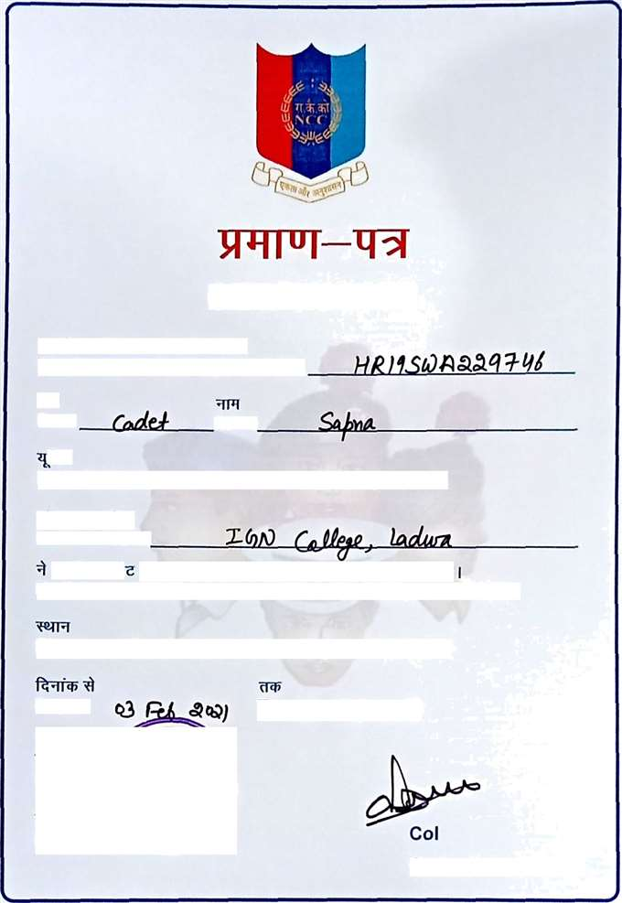
Dated :
"0¿/ 21

Camp Commandant

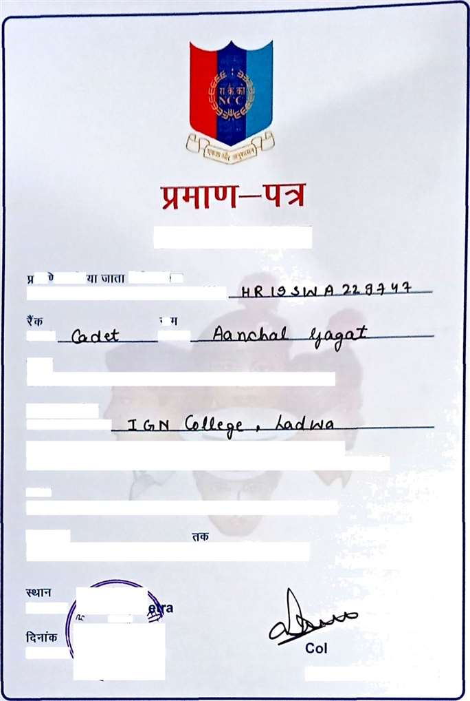

CERTIFIC ATE

Thle Is to certlfy that Ro glmontal No›

Ranh Name

"l.” “
Unit 10 HARYANA BN NCC KURUKSHETRA

institution/Unit

Participated in Combined Annual Training Gamp No. 127 of NCC.

Place : Kurukshetra University, Kurukshetra From: :sfm yoil To o5fQb'*°^l Place: luruksR

Camp Commandant

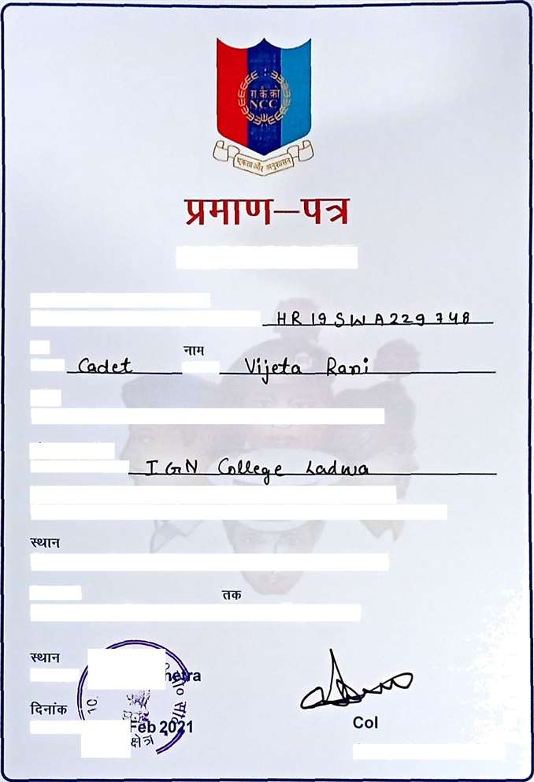

CERTIFICATE

This is to certig that Regimental No. Rank Name
Unit10 HARYANA BN NCC KURUKSHETRA

Institution/Unit

Participated in CombinedAnnual Training Camp No. 127 of NCC. Place: Xurukshetra University, Kurukshetra
From : oS feJ• ye zy To ‹ S -f"e6 k•^l

Place: Knru\sl

Dated:

Camp Commandant

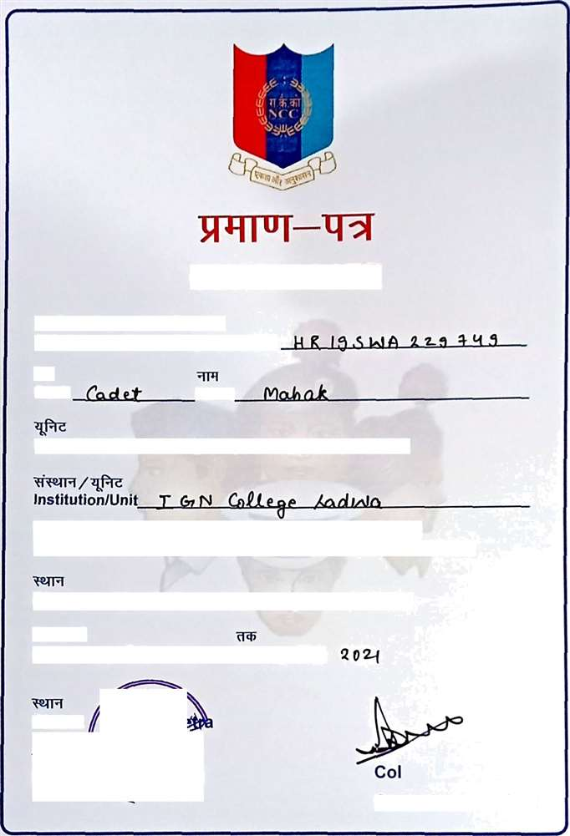

CERTIFICATE

This is to certify that Regimental No.

Rank Name

Unit10 HARYANA BN NCC KURUKSHETRA

Participated in CombinedAnnualTraining Camp No. 127 of NCC.

Ptace : Xurukshetra University, Xurukshetra

From: o3 f"4• 2 o+f To oy f"eJs
g=›o y Place: $:Xurttg¿h‹

Camp Commandant

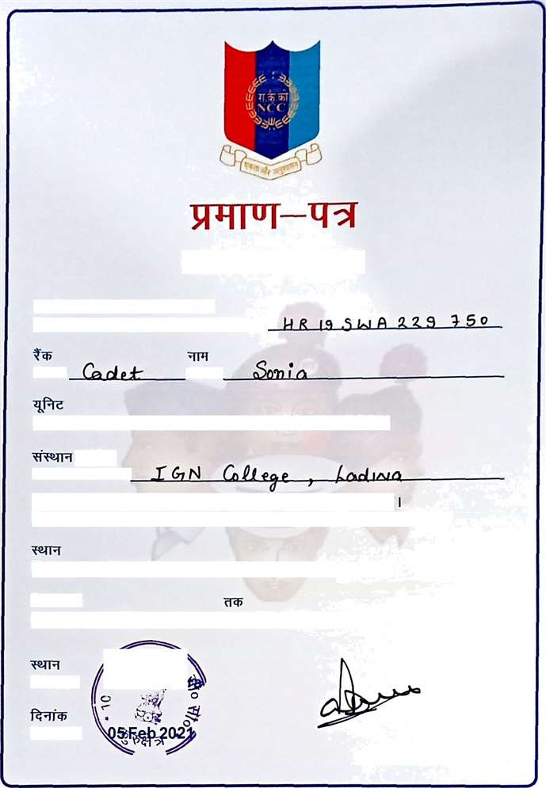

CERTIFICATE

This is to ce%ify that Regimental No.

Rank Name

Unit 10 HARYANA BN NCC KURUKSHETRA

InstitutionlUnit

Participated in CombinedAnnual Training Camp No. 127 of NCC.

Place: Kurukshetra University, Kurukshetra

From : 0z -/-@ ko x/ To oJ /c jZ.O Z{

Place : uruhsfiet

Dated : Col
Camp Commandant

