IGN COLLEGE, LADWA
ROAD SAFETY CLUB
IN ASSOCIATION WITH
NSS UNIT
A

AWARENESS PROGRAMME ON ROAD SAFETY
AT VILLAGE-DHANAURA, LADWA
ON
24th DECEMBER, 2019

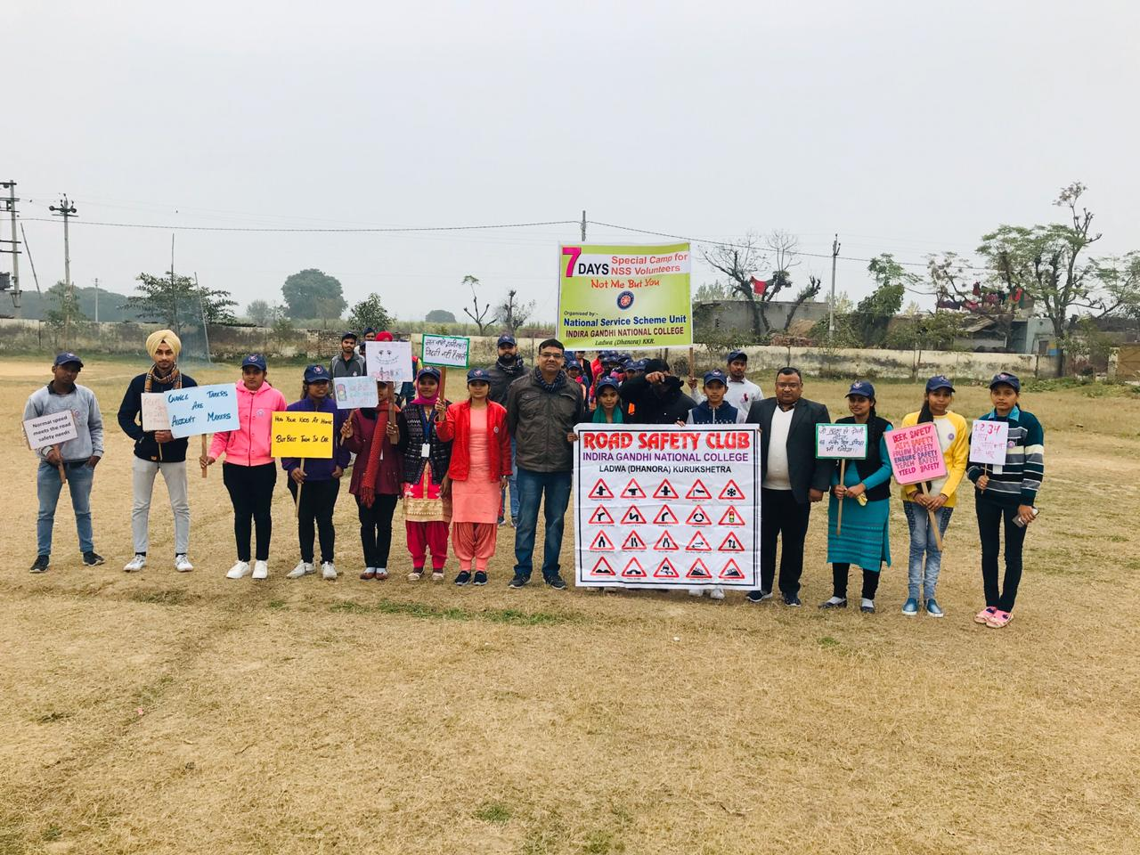

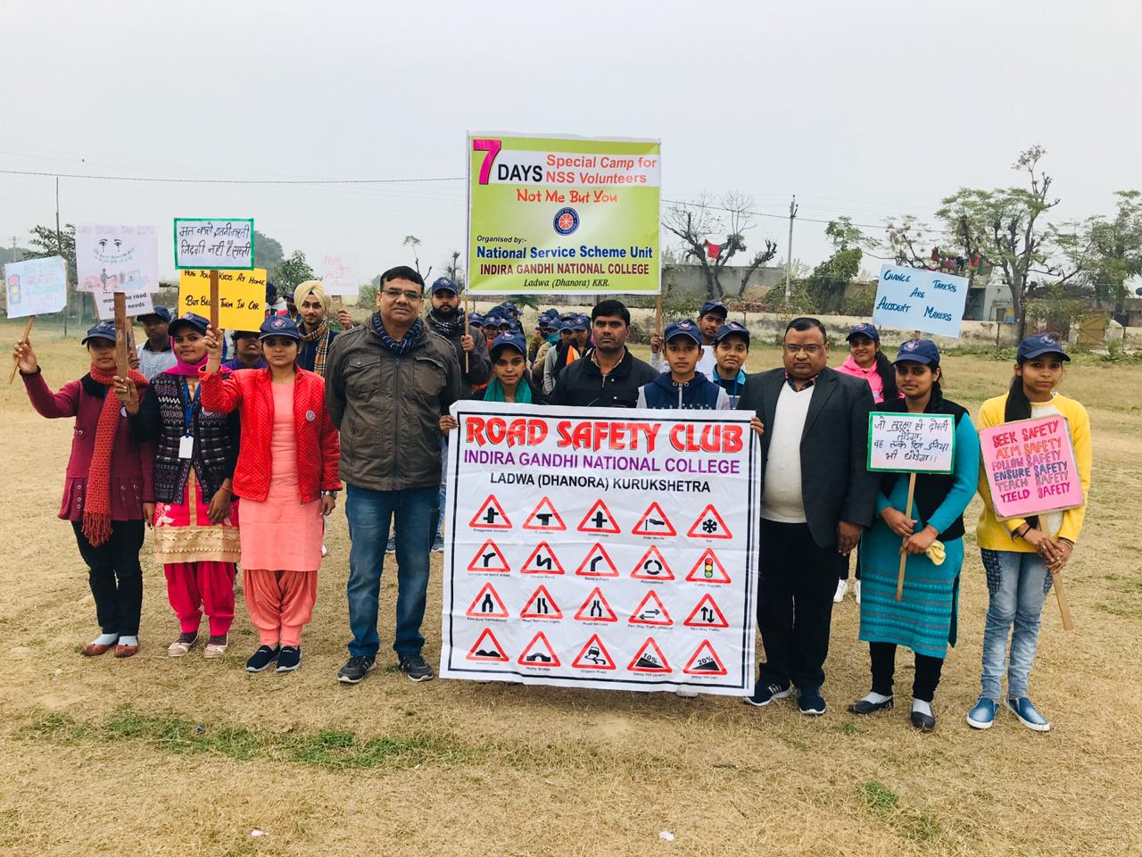

Road Safety Rally Starts from Govt. School, Dhanaura
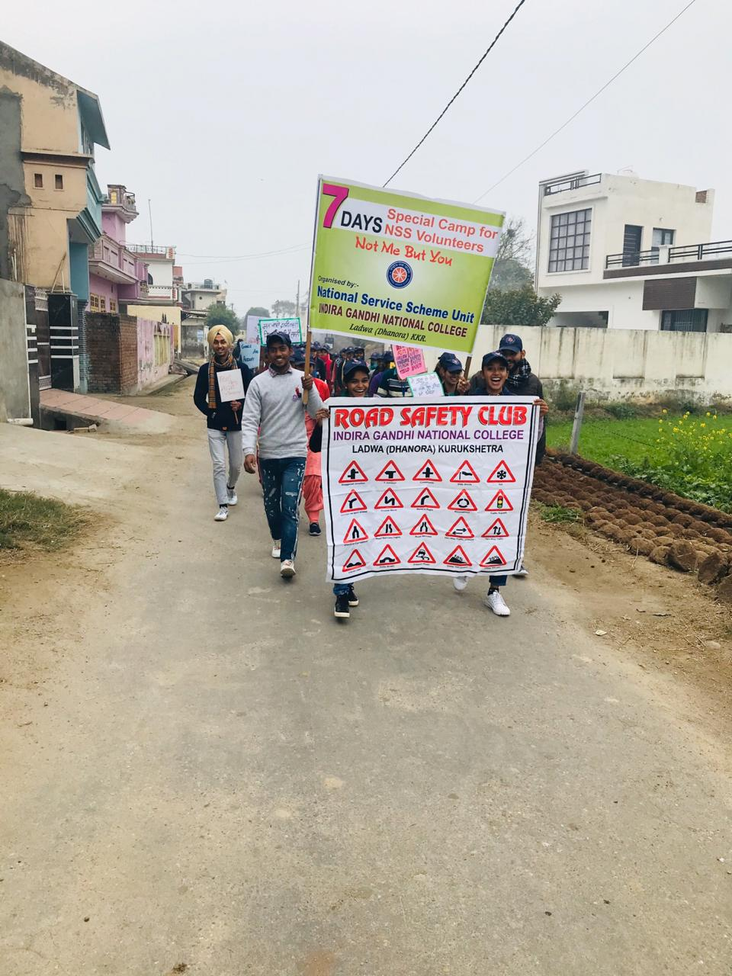
Road Safety Rally at Village Dhanaura
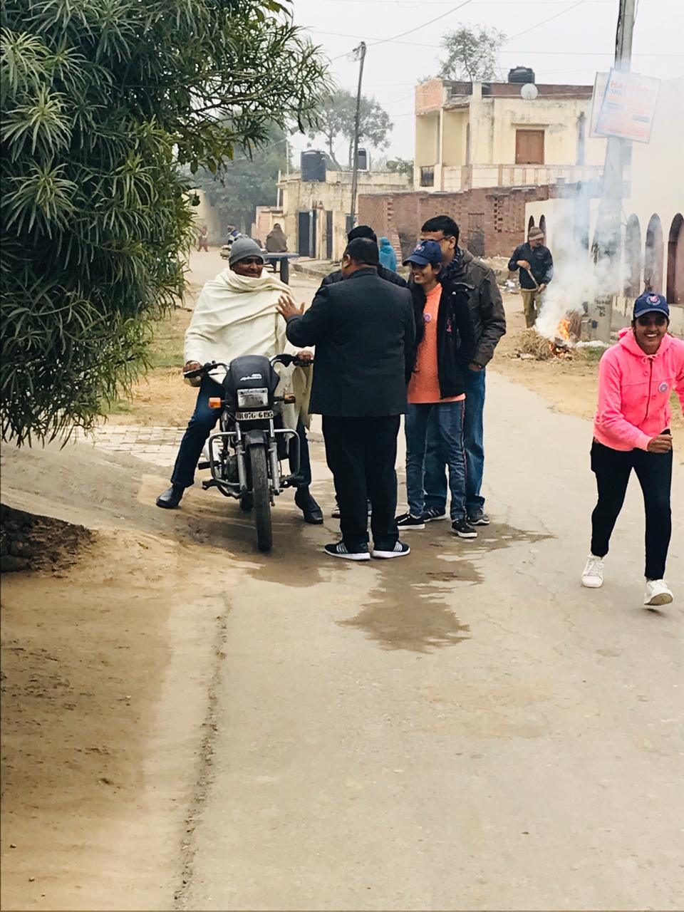
Awareing Peoples for wearing the Helmet during Road Safety Rally at Village Dhanaura

