Commerce Dept. Activity
Report: 01.02.2021

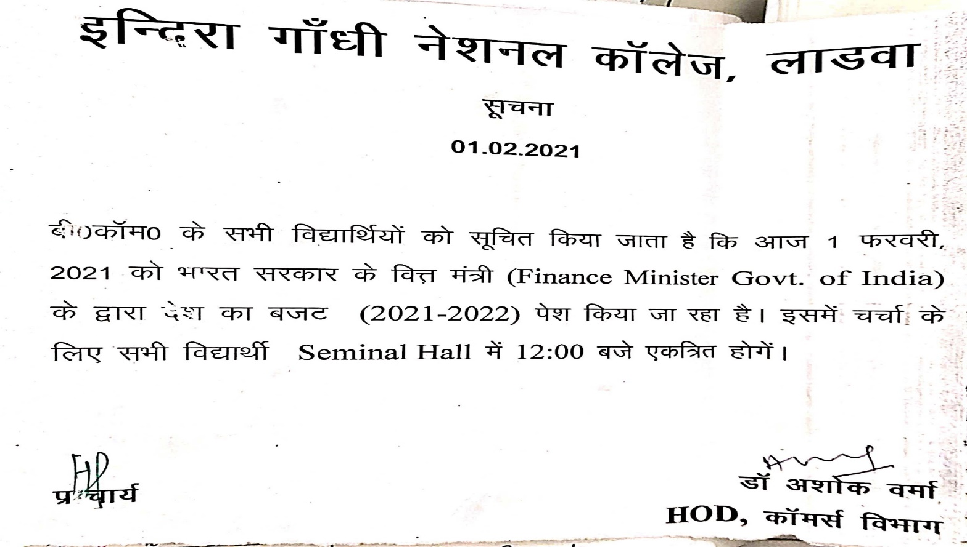

01/02/2021
A discussion on Union Budget 2021-22 (Govt. of India) was held on 01/02/2021 on the same day when it was presented by the Finance Minister Govt. of India in the Parliament. Live Presentation of the Budget was shown to the students and doubt and quarries were resolved by the faculty members of the Commerce. The faculty members highlighted the New Income Tax rates and their impact on the economy on 2021-22. This program was attended by 46 students and 6 faculty members of the College.




