INDIRA GANDHI NATIONAL COLLEGE LADWA (DHANORA)
Kurukshetra, Haryana (2016-17)
Evaluation of Feedback from Alumni (2016-17)
The Alumni Affairs Committee conducted feedback survey among alumni of the college fifty-two alumni participated in the said survey. The details of the said survey along with action taken by the college administration are mentioned below:

- How do you rate the courses that you have learnt in the college in relation to your current job / occupation?
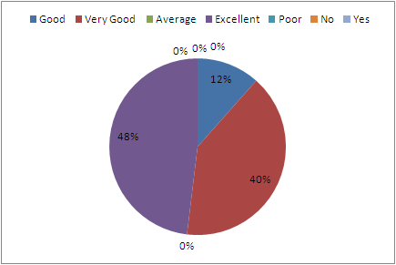
Action Taken: The majorityof respondentsrated the courses excellent, very good and good that they have learnt in the college in relation to their current job and profession. However,twelve percent respondents rated poor. The college is creating a mechanism to communicate the issues raised by the students/ alumni to the BoS of the subjects concerned of affiliated university.

2. Infrastructure and Lab facilities:
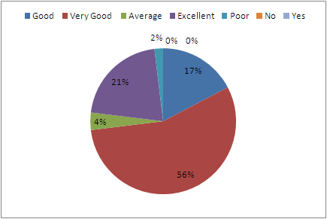

Action Taken: The majority of respondentsrated the infrastructure and lab facilities very high. However, four percent respondents rated average and four percent poor. The college is making its best efforts to improve its infrastructure and lab facility consistently.

- Faulty / Teachers:
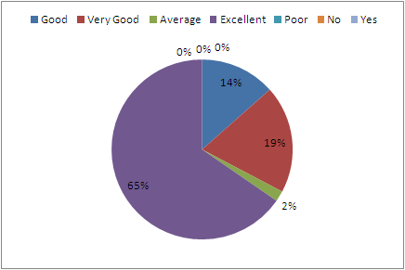

Action Taken: The majority of respondentsrated the Faulty / Teachers excellent, very good and good only two percent respondents responded average. Although, the college motivates the faculty members for in-service trainings and faculty development programmes such as orientation course/ refresher course and short-term courses. The faculty members are also encouraged to participate in international/ national seminar, conferences and workshop for their updating of knowledge.
4. Canteen Facilities:

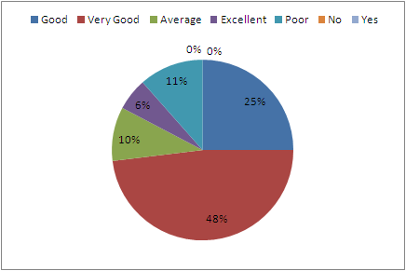

Action Taken: The majority of respondentsrated canteen facilities excellent, very good and good. However, ten percent respondents rated average and eleven percent poor. The college constitutes canteen committee for continuous quality check-up and canteen facility students’ redressal.

- Library:

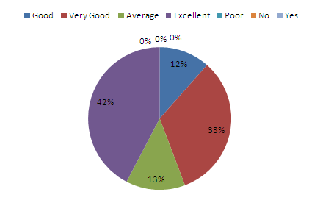

Action Taken: The majority of respondentsrated college library excellent, very good and good. However, thirteen percent respondents rated average. The college constitutes library committee for library policies and betterment of library services. In lack of UGC/ State Govt. financial support, the college purchases prescribed books, reference books and journals every year. The library provides book bank facility to all students and newspaper reading facility to all stakeholders.

6. Office Staff:

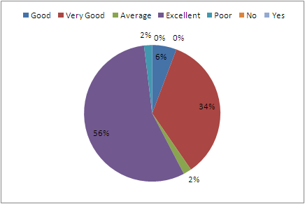

Action Taken: The majority of respondentsrated the staff excellent, very good and good. However, two percent respondents rated average and two percent poor only. Although, the college staff got very high opinion from alumni, the college motivates the staff members to do students/ alumni friendly behaviour. The staff members eagerly redress the problems of students/ alumni. The college administration is planning to organise workshop / counselling sessions for the staff members to enhance their efficiency.

7. Educational Resources:

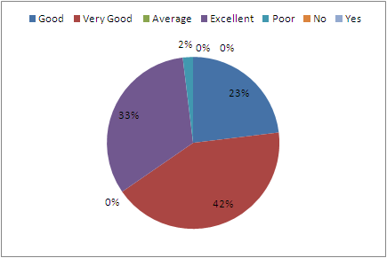

Action Taken: The majority of respondentsrated educational resources excellent, very good and good. However, two percent respondents rated average. The college is making its best efforts to improve its educational resources using ICT tools and infrastructural facility such as projectors, computer lab, seminar rooms etc.

8. Admission Procedure:

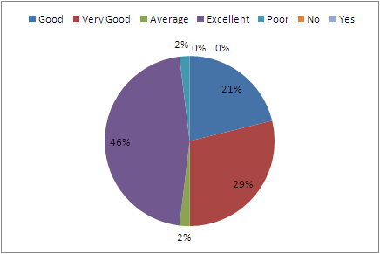

Action Taken: The majority of respondentsrated admission procedure excellent, very good and good. However, two percent respondents rated average and two percent poor only. However, the college follows the guidelines of DGHE Haryana/ Kurukshetra University, Kurukshetra, the college administration constitutes admission committee for each class separately.
9. Overall Rating of the College:

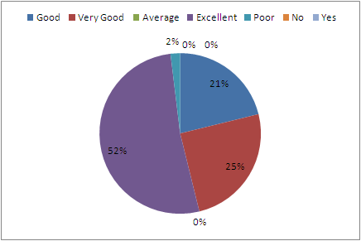

Action Taken: The majority of respondentsrated overall rating excellent, very good and good. However, two percent respondents rated average. However, the college got very positive assessment from the alumni, the college management, administration and staff are well determined to attain excellency in all fields.

10. Mention any point which make you feel proud to be associated with College as Alumni:
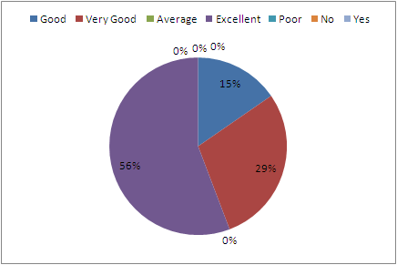

Action Taken: The majority of responded with the very high opinion which shows that they felt excellently proud to be associated with college as alumni. All the alumni feel proud to be associated with college as alumni.

11. College Campus

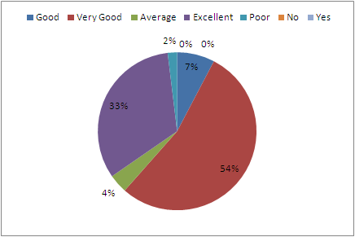

Action Taken: The majority of respondentsrated college campus excellent, very good and good. However, four percent respondents rated average and two percent poor only. Although the college got very positive assessment from the alumni, the college management, administration and staff are well determined to enhance infrastructural facility and proper maintenance of the campus.

12. (A) Do you have any grievances with the college?
As a Student* : Yes/N

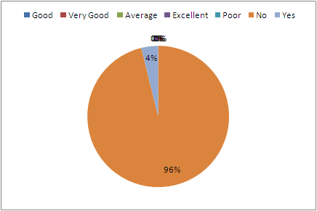

Action Taken: The majority of respondentsapproximately ninety six percent alumni responded that they have not any grievances as student with the college. However, one percent respondents responded that they have some grievances. The college administration is keenly determined to redress the grievances for the present students.
12. (B), Do you have any grievances with the college?
As aAlumni: Yes/N

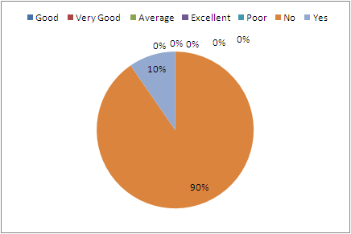
Action Taken: The majority of respondentsapproximately ninetypercent alumni responded that they have not any grievances as alumni with the college. However, ten percent respondents responded that they have some grievances with the college. The college administration is keen to redress the grievances of those alumni.

