INDIRA GANDHI NATIONAL COLLEGE
Ladwa - Kurukshetra (Haryana)
2020-21
Evaluation of Feedback from Alumni (2020-21)
The Alumni Affairs Committee conducted online feedback survey among alumni of the college fifty five alumni participated in the said survey. The details of the said survey along with action taken by the college administration are mentioned below:
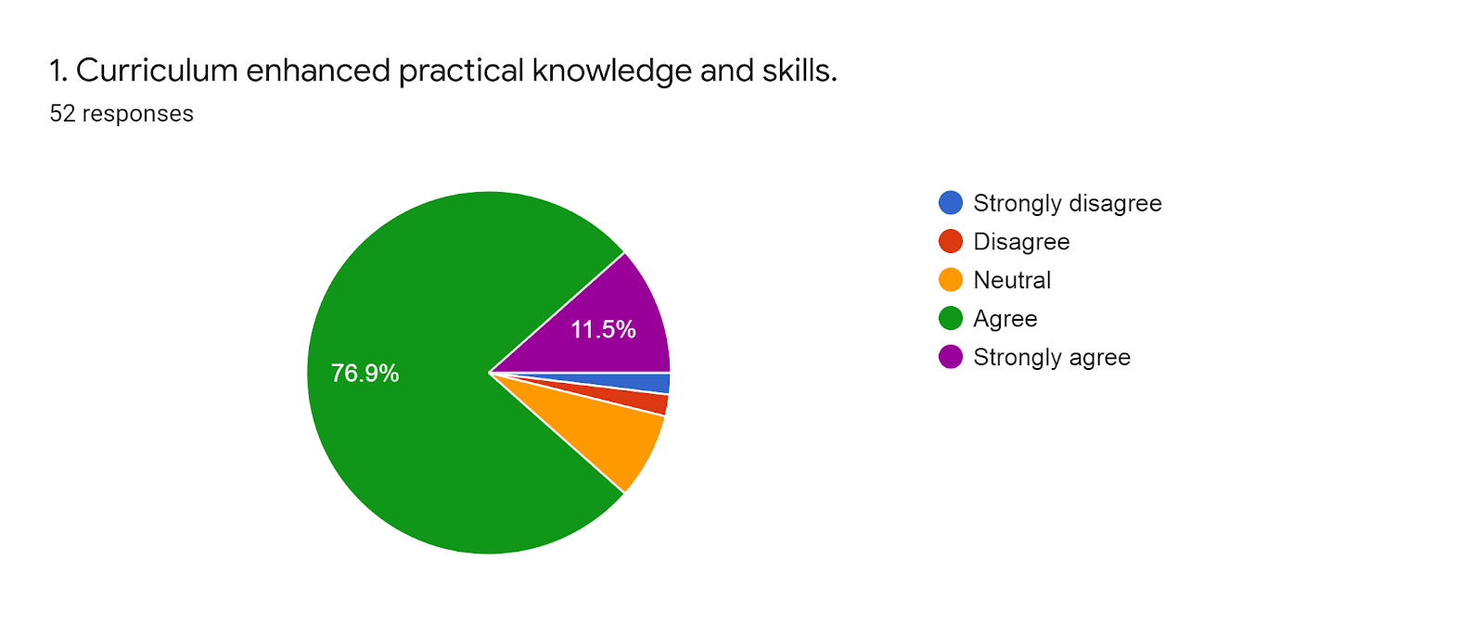

Action Taken:
The majority of the respondents responded that curriculum enhanced their knowledge and skills. The college started three skill based Diploma courses approved by UGC under NSQF scheme. The various department have been directed to start the below mentioned course under capacity building and soft skill enhancement initiatives in the academic year 2020-21.
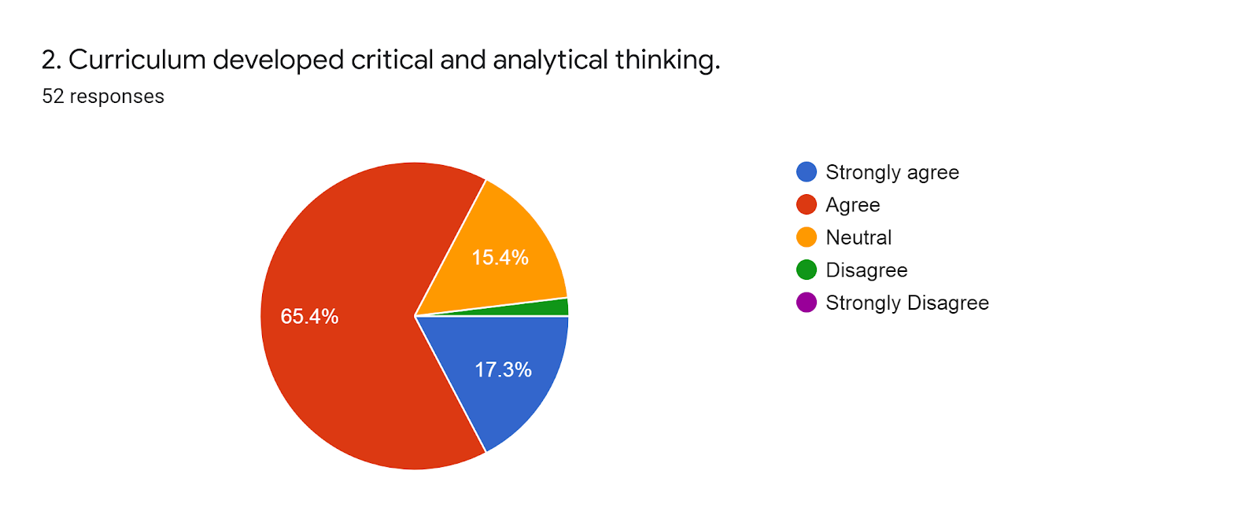
Action Taken:

The majority of the respondents responded that curriculum developed critical and analytical thinking in them. The teachers have been motivated to teach the students in such a way that critical and analytical thinking may be developed. They are motivated to relate the curriculum with the practical aspect of life.

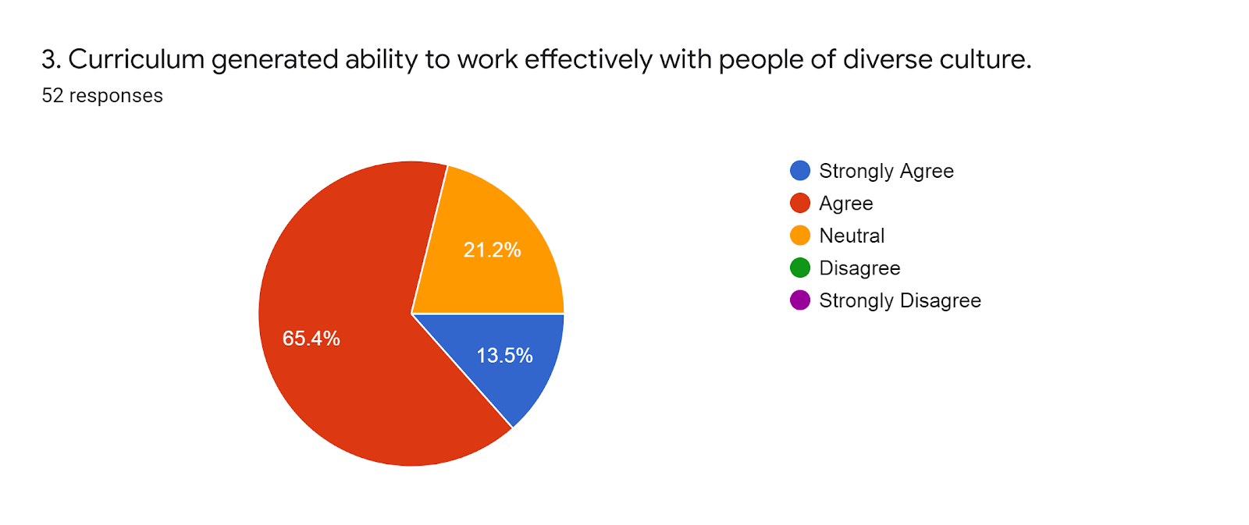
Action Taken:
The majority of the respondent responded that curriculum generated ability to work effectively with people of diverse culture. The college is pondering over to provide more opportunities of cultural exchange programme through cultural and educational trips, community out rich programme and frequent visits to various places following the SOP related to COVID-19.

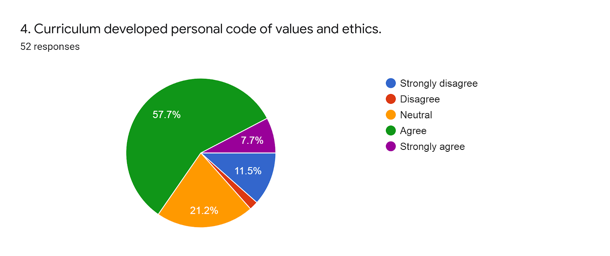
Action Taken:
The majority of the respondent responded think that curriculum developed personal code of values and ethics. The college has started four certificate courses on Universal Human Value, Leadership and Management Skills, Communication Skills and Professional Skills. The teachers have been encouraged to inculcate ethical value among the students through Mentor Mentee programme, observing the days of national importance, deathand birth anniversaries of great personalities. The college is planning to organized more seminars and extension lectures to develop personal code of value and ethics among students.

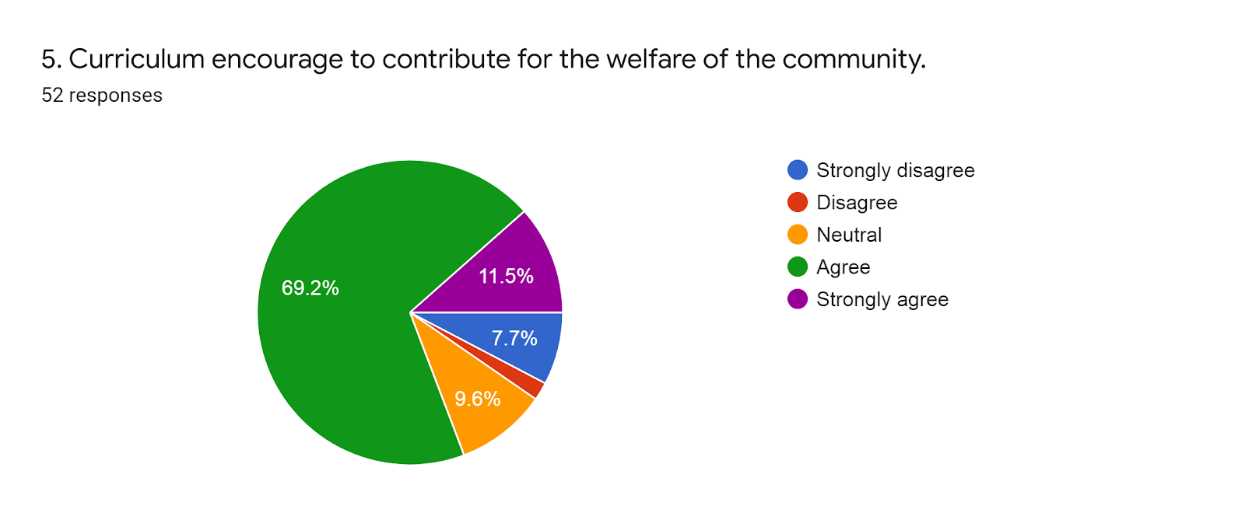
Action Taken:
The majority of the respondents responded that curriculum encouraged them to contribute in the welfare of the community as well as society. The college has started the community outreach programme through various co curricular activities.

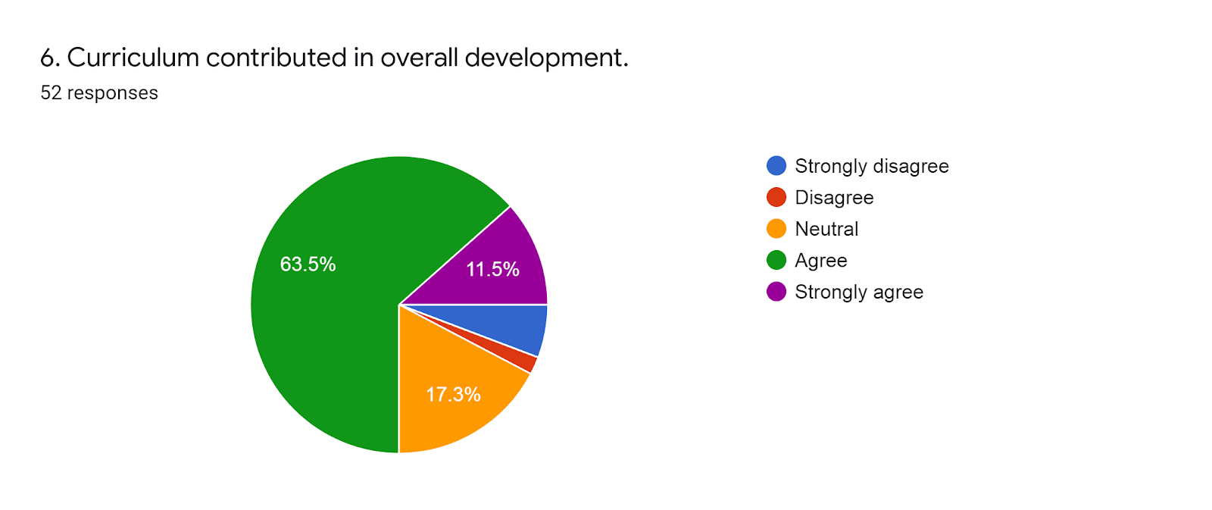
Action Taken:
The majority of the respondents responded that Curriculum contributed in overall development of the students. The college has started personality development programme through some courses such as “Communication Skills, Profession Skills, Leadership, Management Skill and Universal Human Values. All the departments and co-curricular activities in – charges have been directed to plan such progarmme that the curriculum contribution in overall development of the student may be optimized.

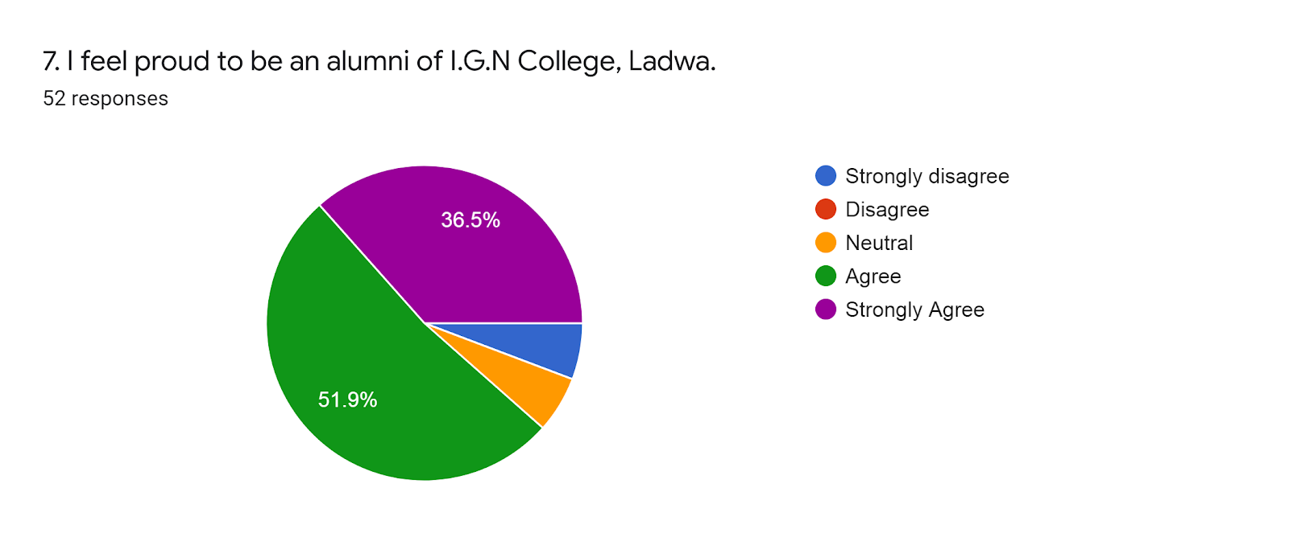
Action Taken:
The majority of the respondents enthusiastically responded that they feel proud to be alumni of Indira Gandhi National College Ladwa. The college is determined to extend more and more facilities to its alumni and present students to continue such experience.

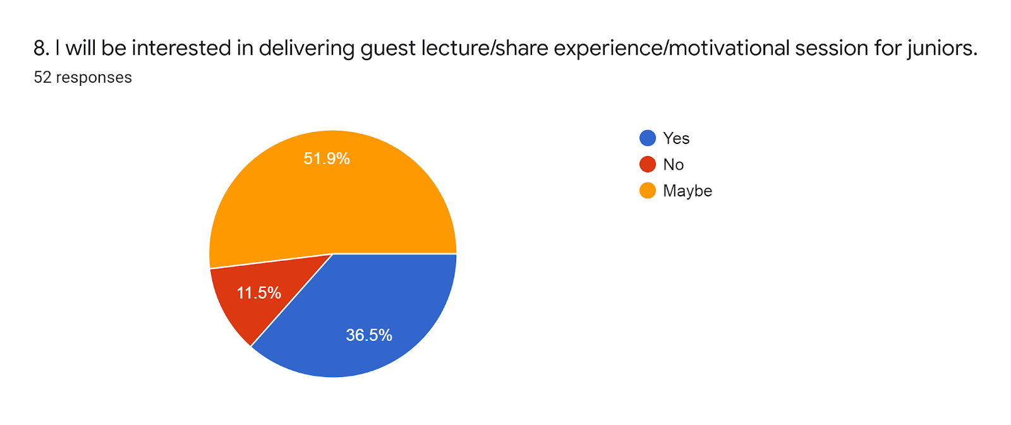

Action Taken:
The majority of the respondents responded that they are interested in delivering guest lecture / experience sharing/motivational sessions if they get such opportunities. The college is planning to organize such guest lecture/ experience sharing and motivational sessions with the co-operation of our established alumni in their respective field.

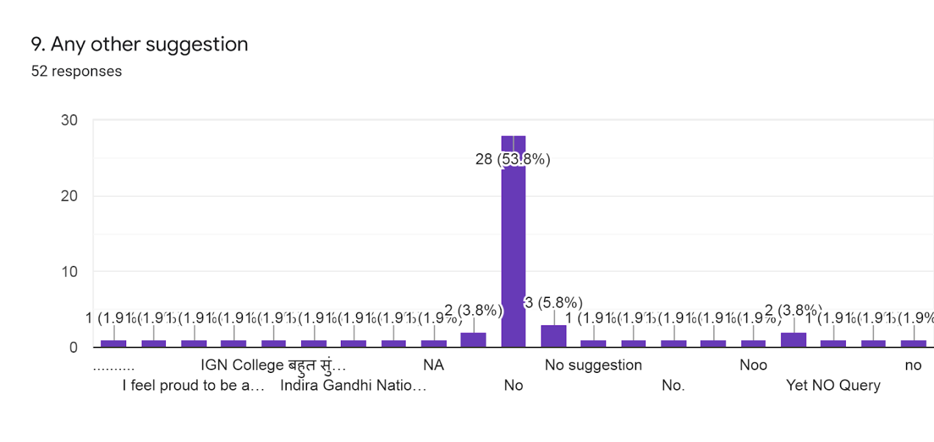

Through this alumni feedback survey, the alumni gave also some valuable suggestions and observations such as their proud feelings towards their alma mater. They also suggested organizing more guest lecture for overall development of the students. Some of the respondents suggested that more modifications are required in their curriculum.

Dr. Hari Parkash Sharma Dr. Rajesh Kumar
Principal Convener
Alumni Affairs Committee

