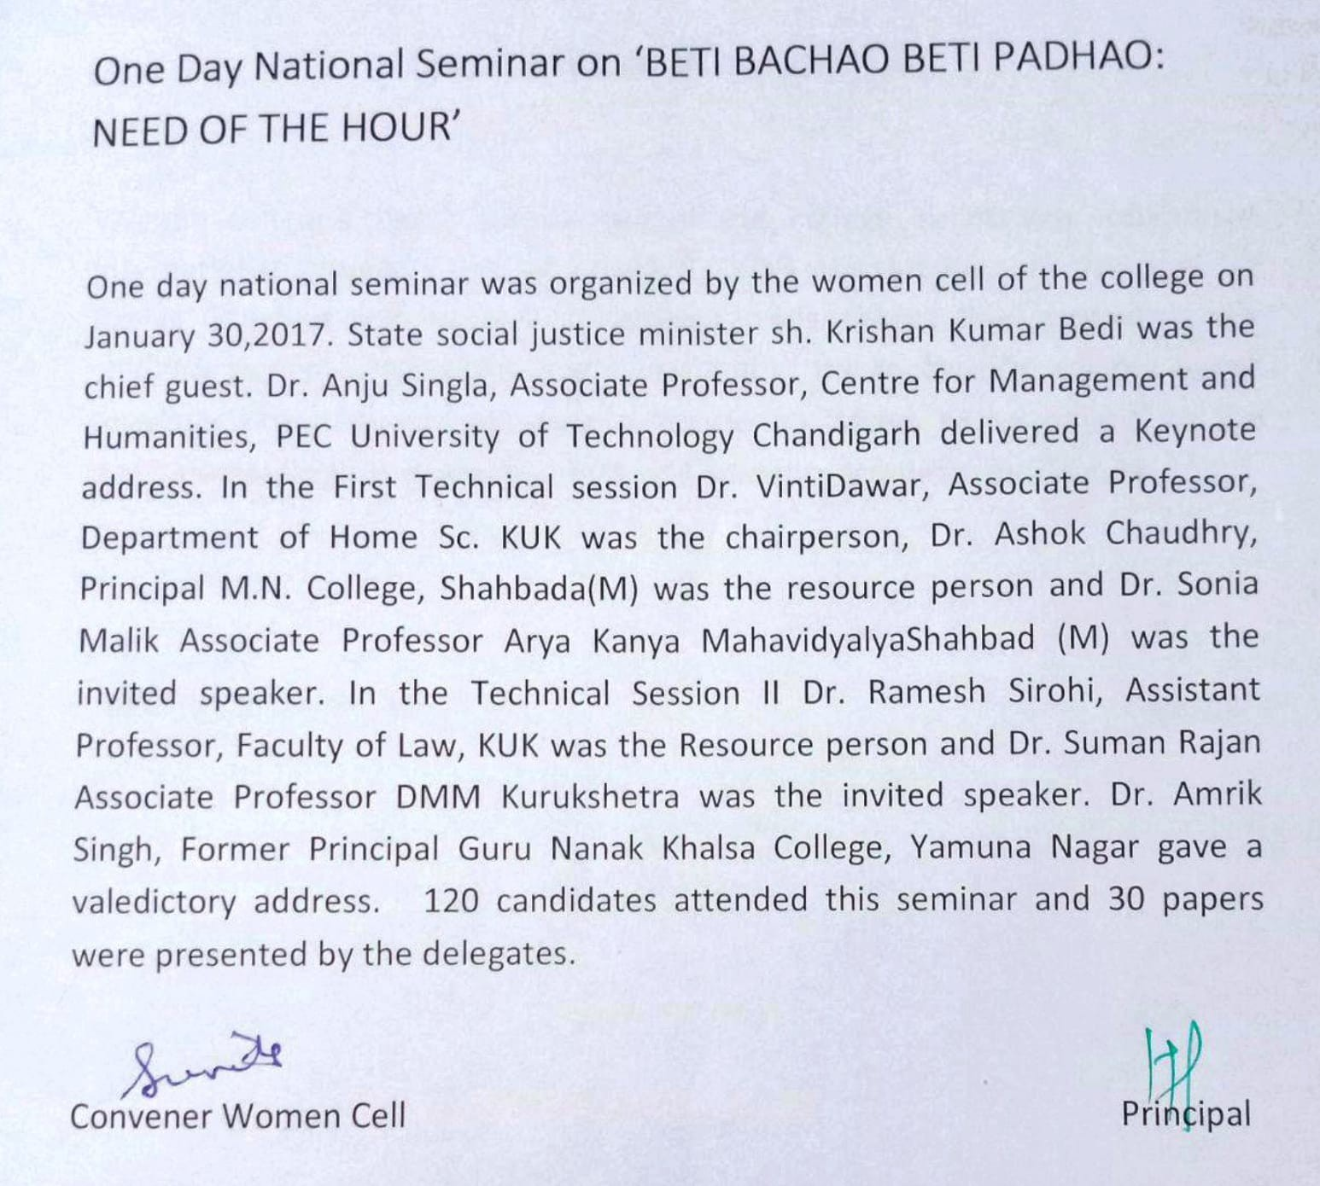
One Day National Seminar on ‘BETI BACHAO BETI PADHAO: NEED OF THE HOUR’

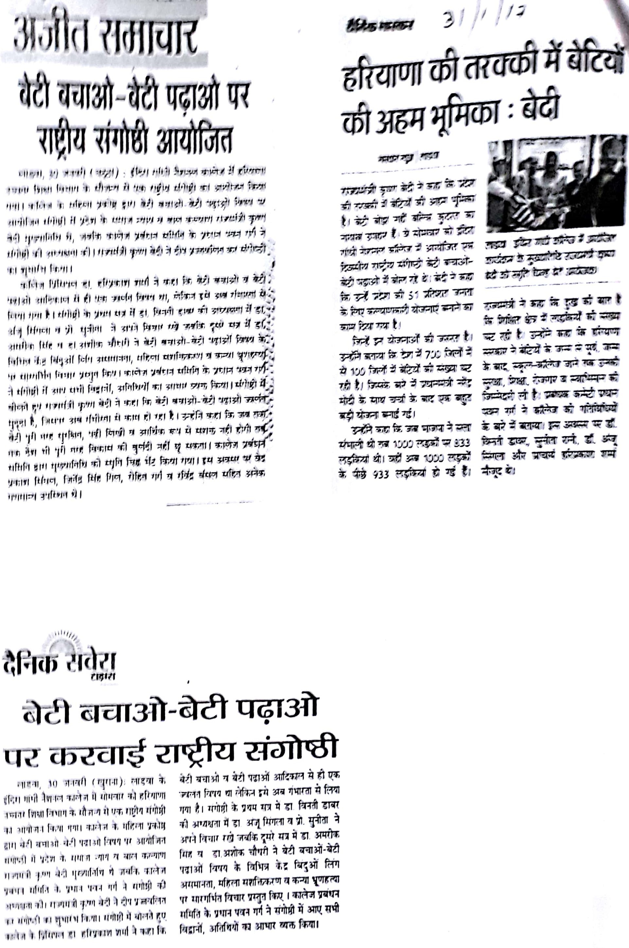

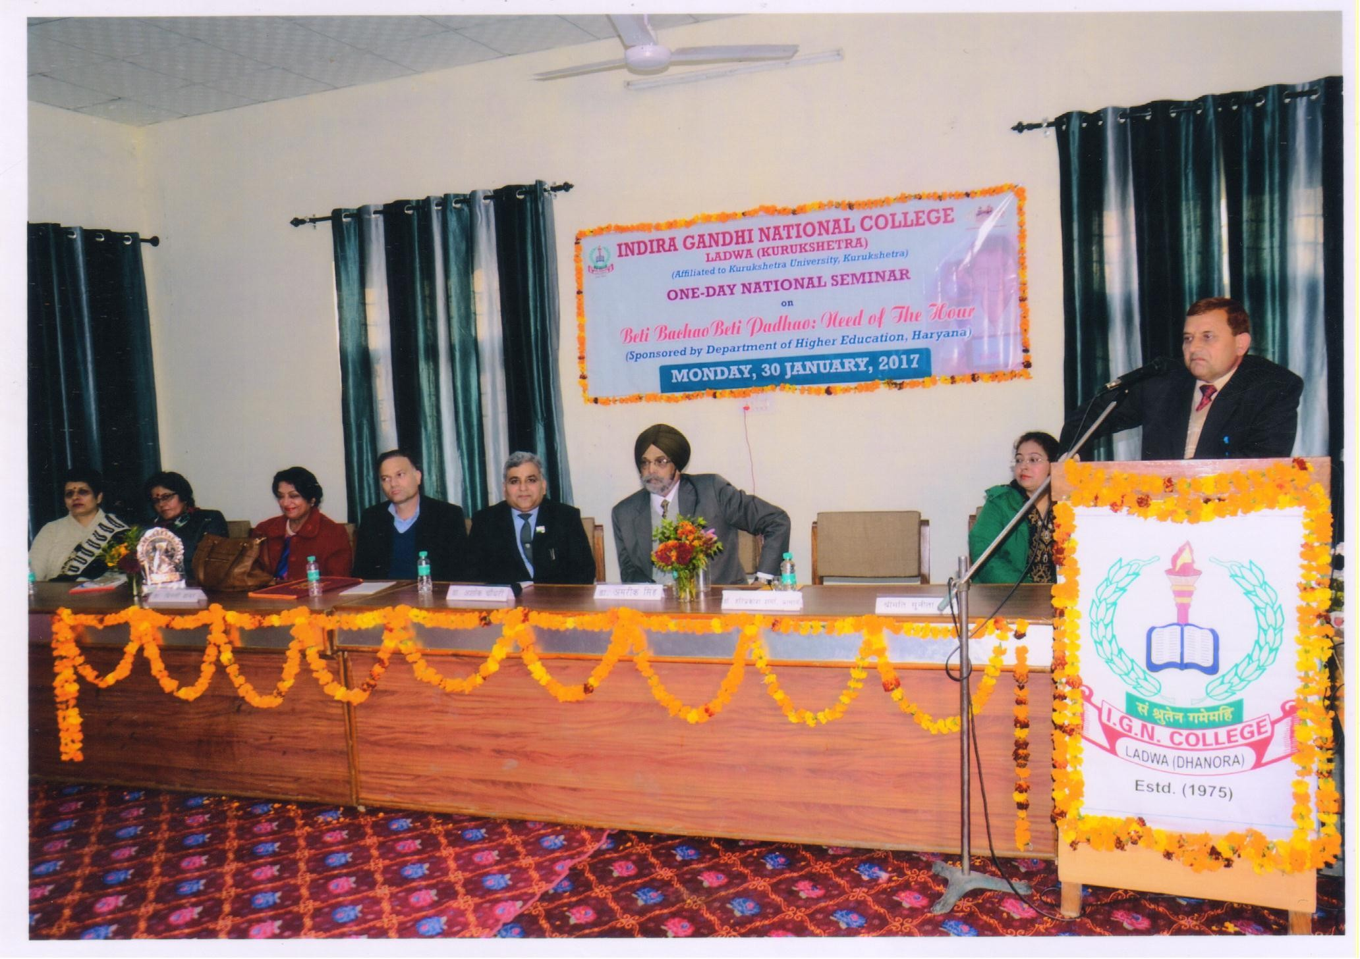

Inaugral Adress by the college Principal Dr. Hari Parkash Sharma.

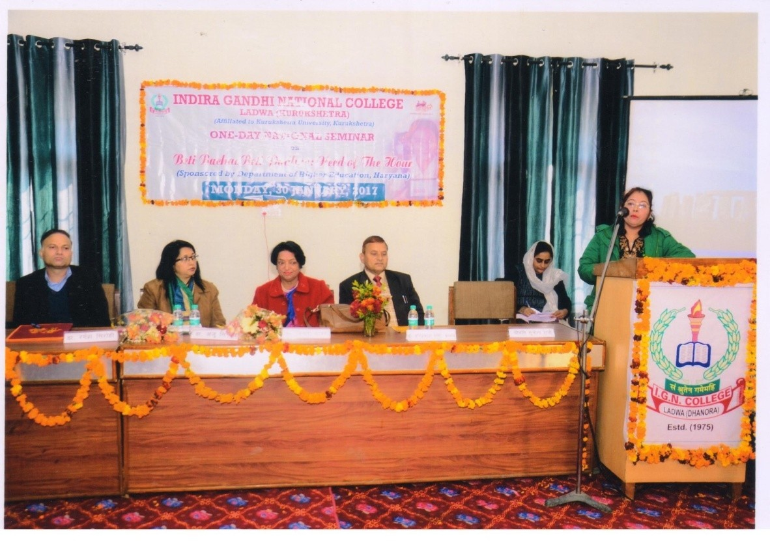
Introducing the Theme by the convener, women cell

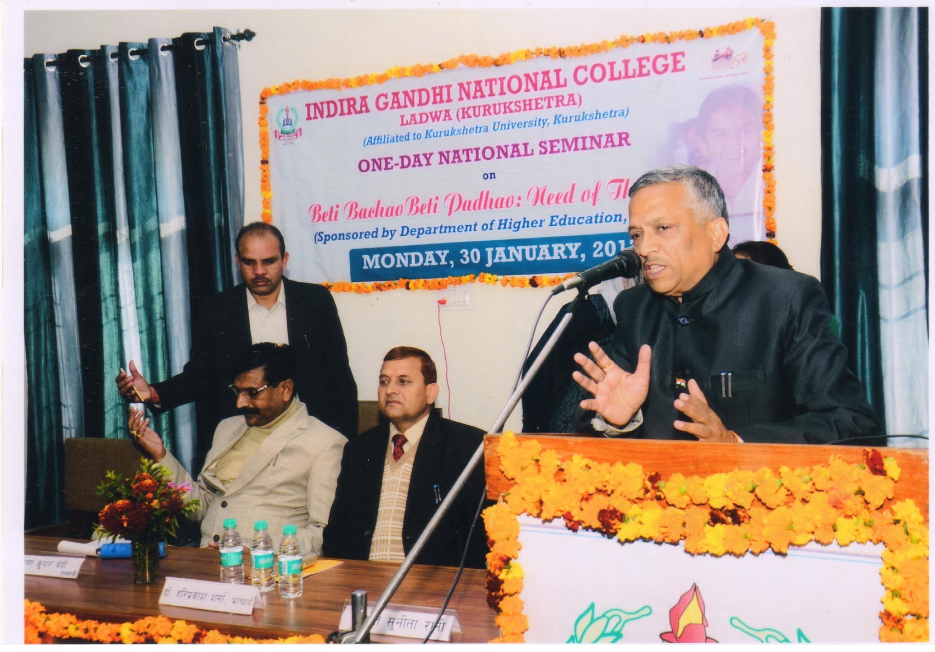

Formal welcome of the chief guest by the college president sh. Pawan
Garg.

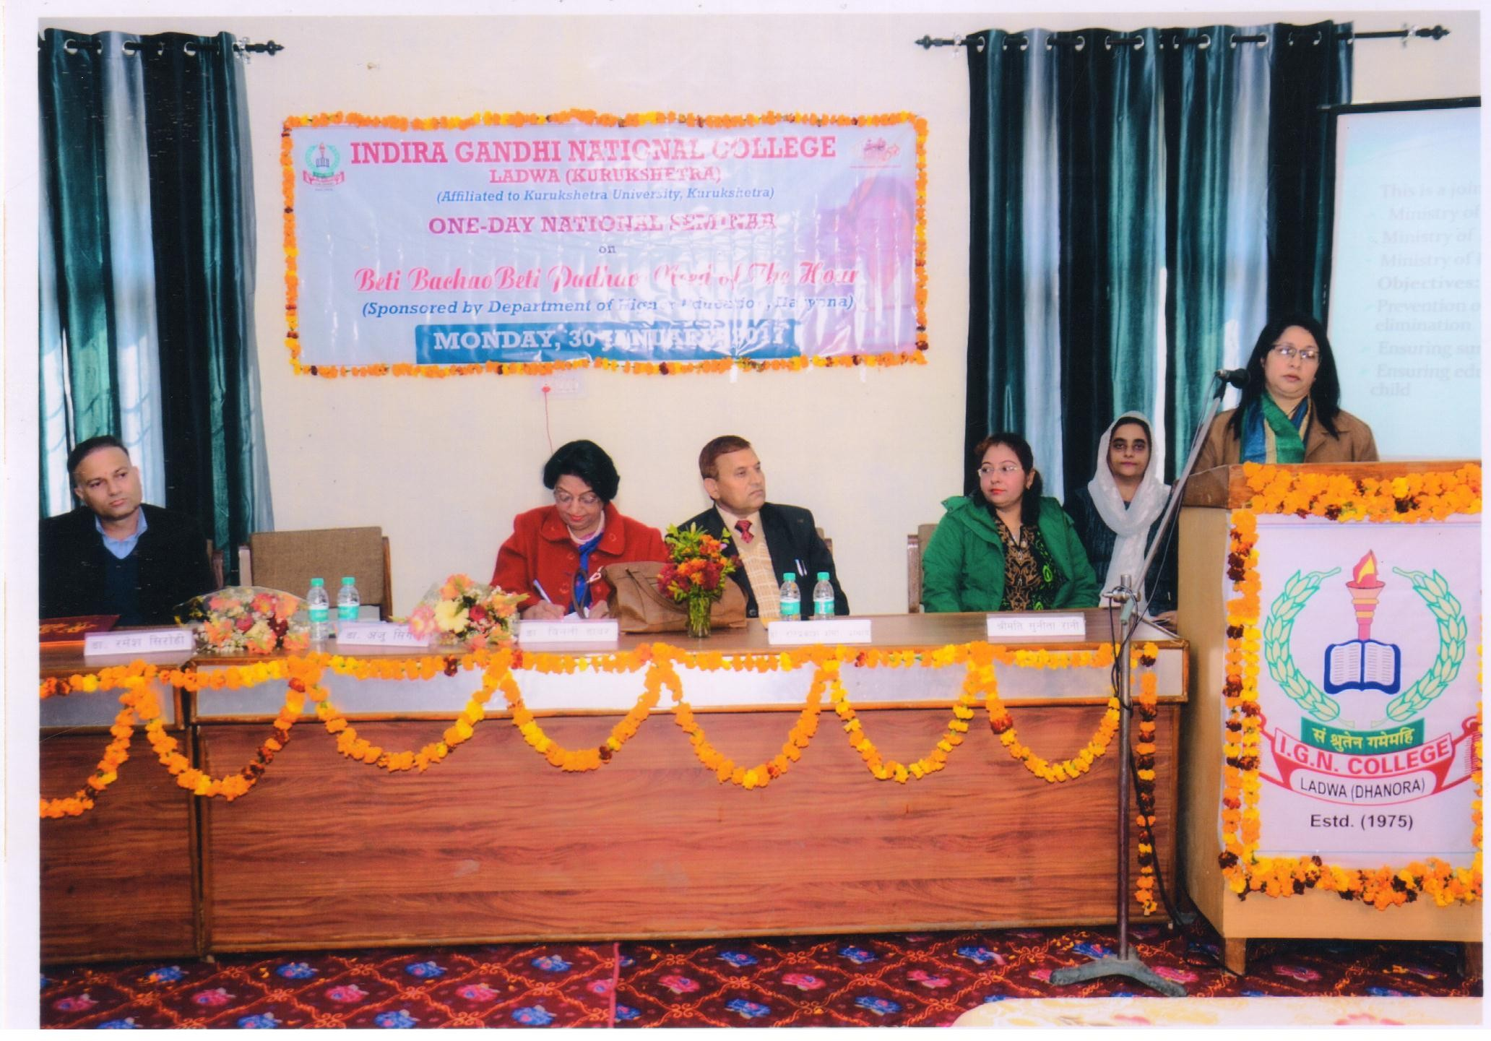

Keynote Adress by Dr. Anju Singla, Associate professor,PEC University of Technology, Chandigarh.

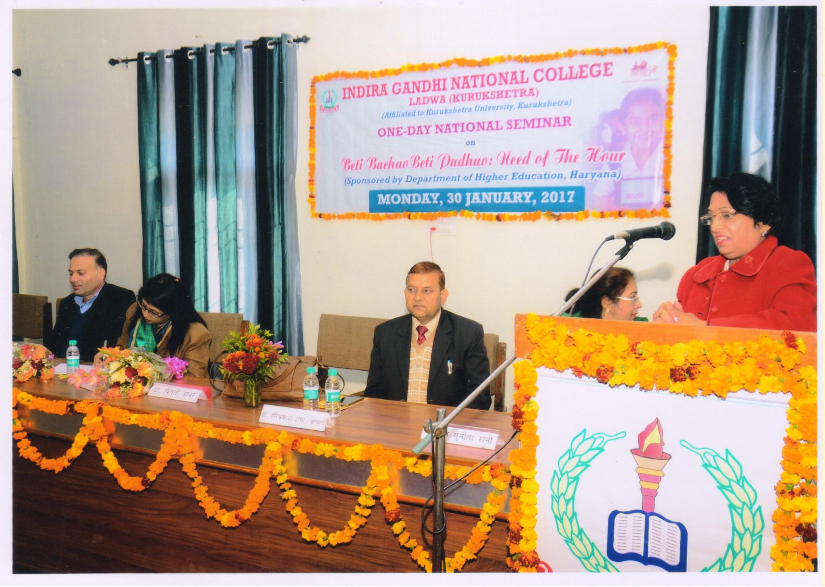

First Technical session by Dr. Vinti Dawar Ex. Chairperson, Department of Home science, KUK.

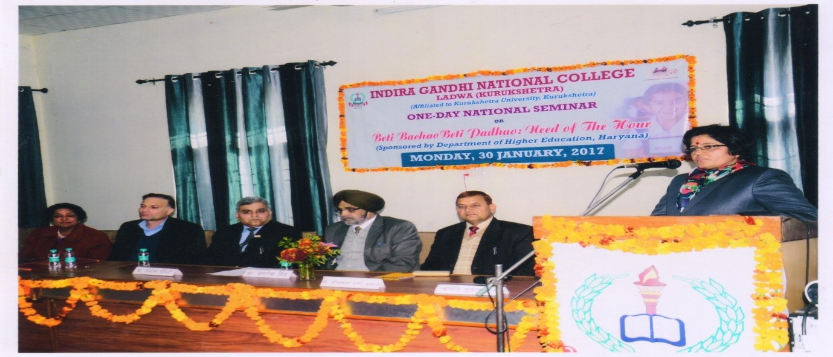

Paper presented by the delegate.

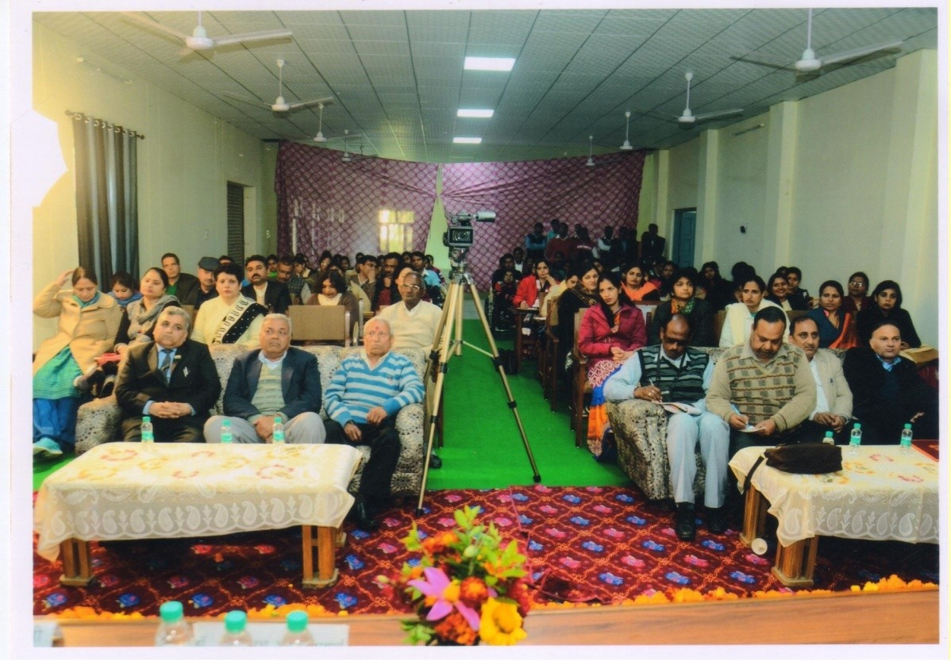

Delegates participating in One day National Seminar.

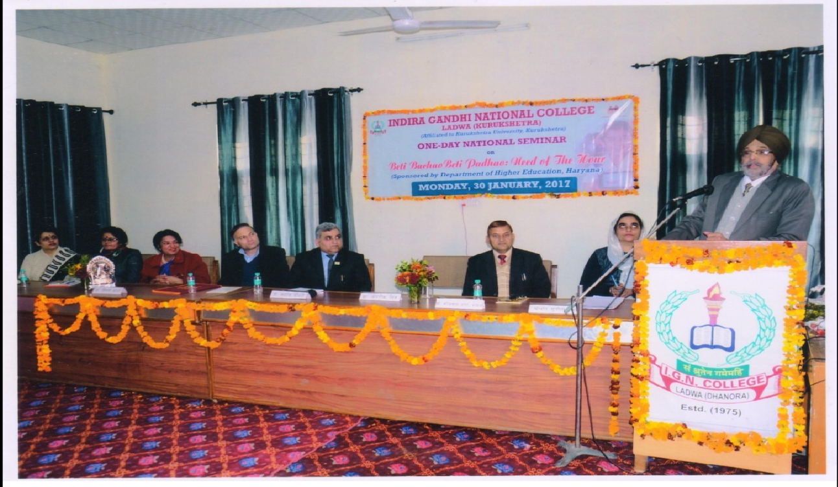

Validictory address by Dr. Amrik Singh ex. Principal, Khalsa College YNR

