Special 7 Days (Day & Night ) Camp : 03.01.2019-09.01.2019

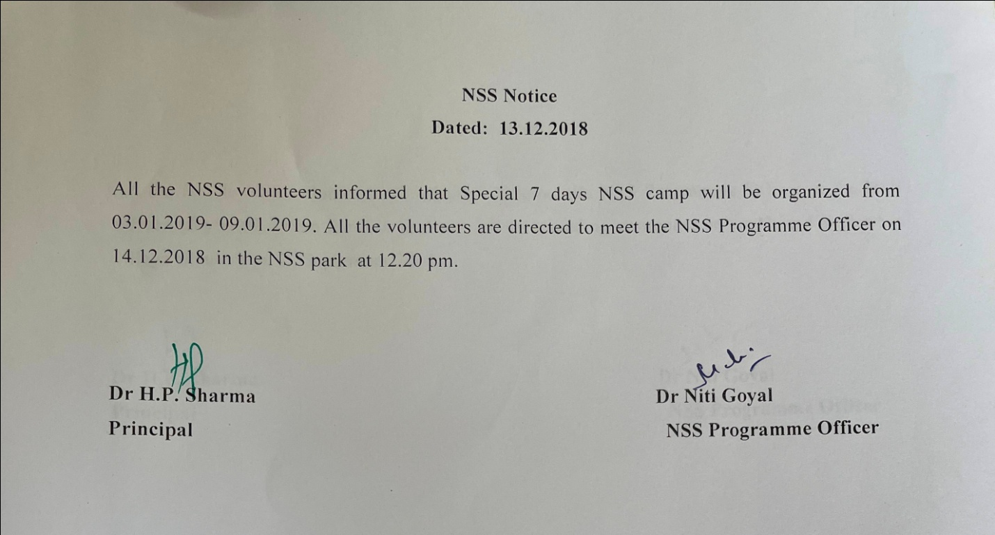

A report of 7 days Special NSS Camp
03/01/2019 | Vill. dhanora | Inauguration of camp by college principal Dr Hari Parkash Sharma. Motivational session by Dr. Rajesh Kumar.  Breaking the ice session for students
04/01/2019 | IGN COLLEGE  Vill. dhanora | Yoga, Cleaning of COLLEGE campus  Workshop on Personality Development & Creativity
05/01/2019 | Vill. dhanora | Yoga, First aid training by lecturer from red cross society, Kurukshetra  Interactive session for the students.
06/01/2019 | Vill. dhanora | Yoga, Door to door visit in village on dengue & cancer awareness & plastic utensils harmful effects ,  Team building & Recreational Games playing  Cleaning of waste land for tree plantation
07/01/2019 | Vill. dhanora | Yoga, rally against polythene use & burning  Interactive session on road safety by Dr Amit Kumar  home nursing training by lecturer from red cross society, Kurukshetra
08/01/2019 | Vill. dhanora | Yoga, tree plantation  Role playing on digital India & cultural activities
09/01/2019 | Vill. dhanora | Valedictory session and Cultural Activities

Special Seven days camp pictures
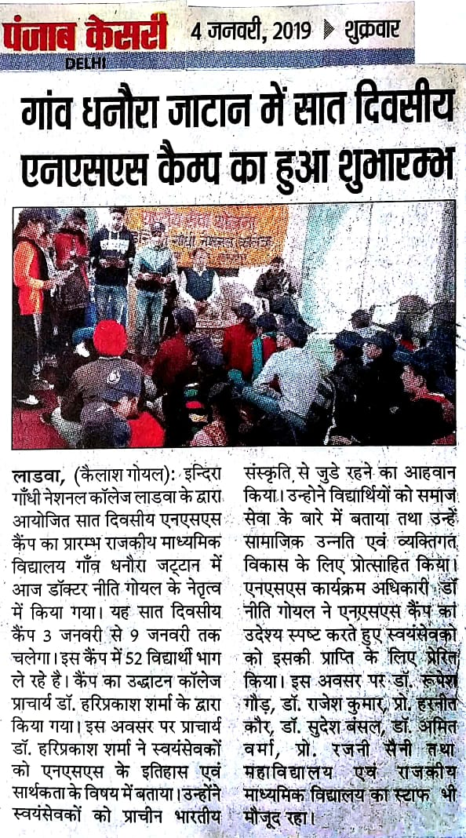
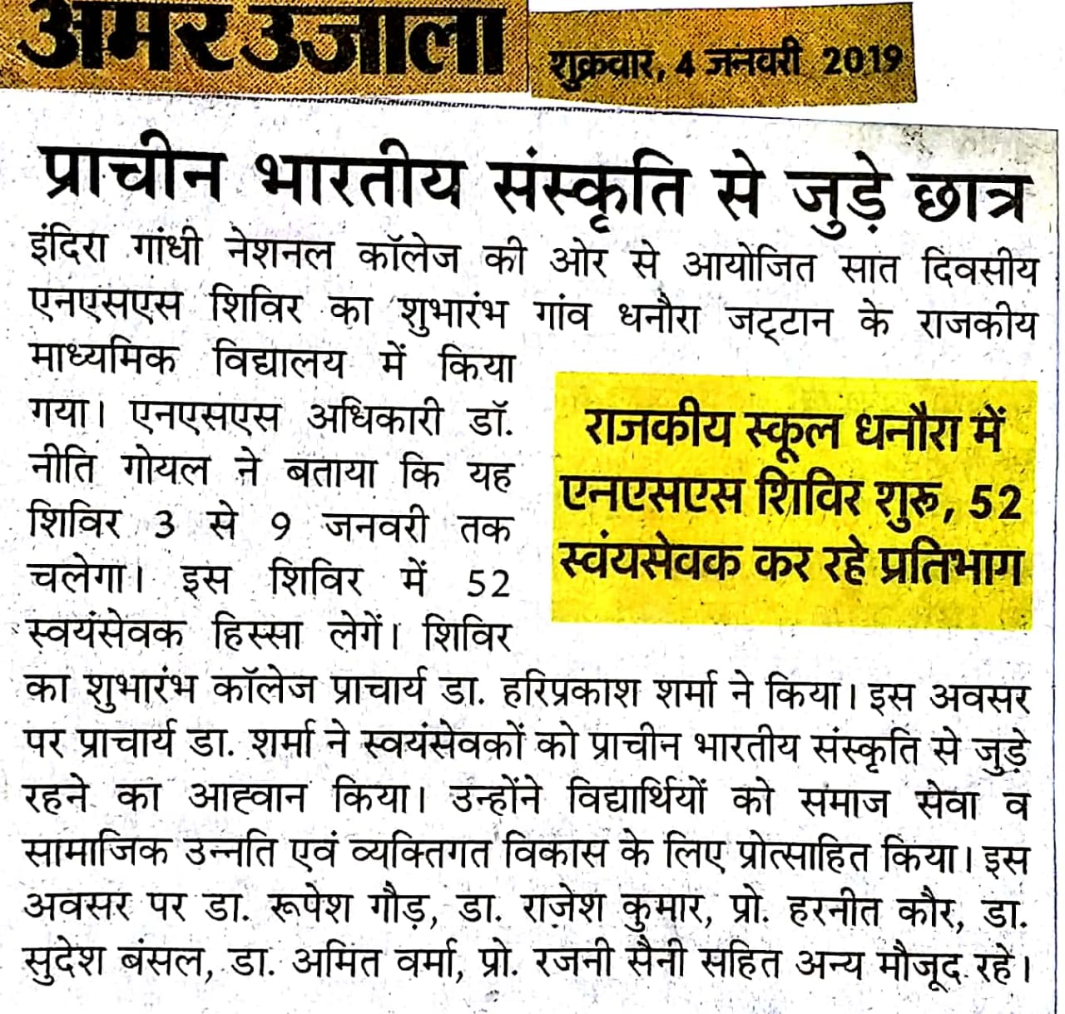
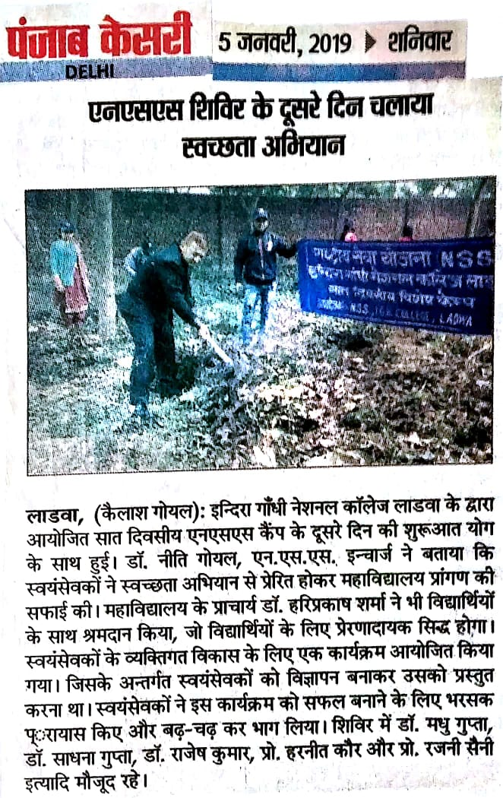
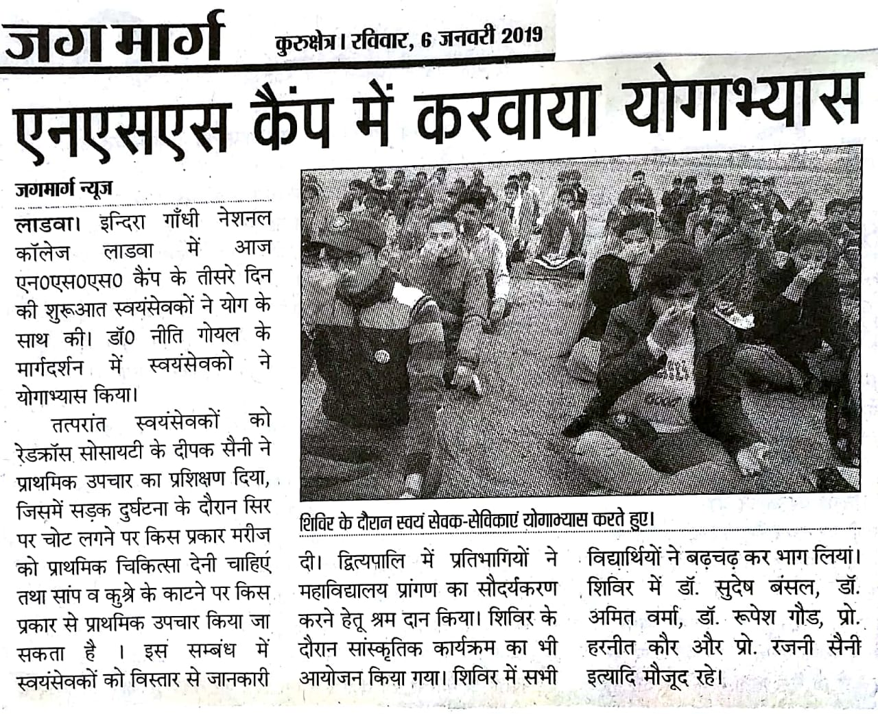
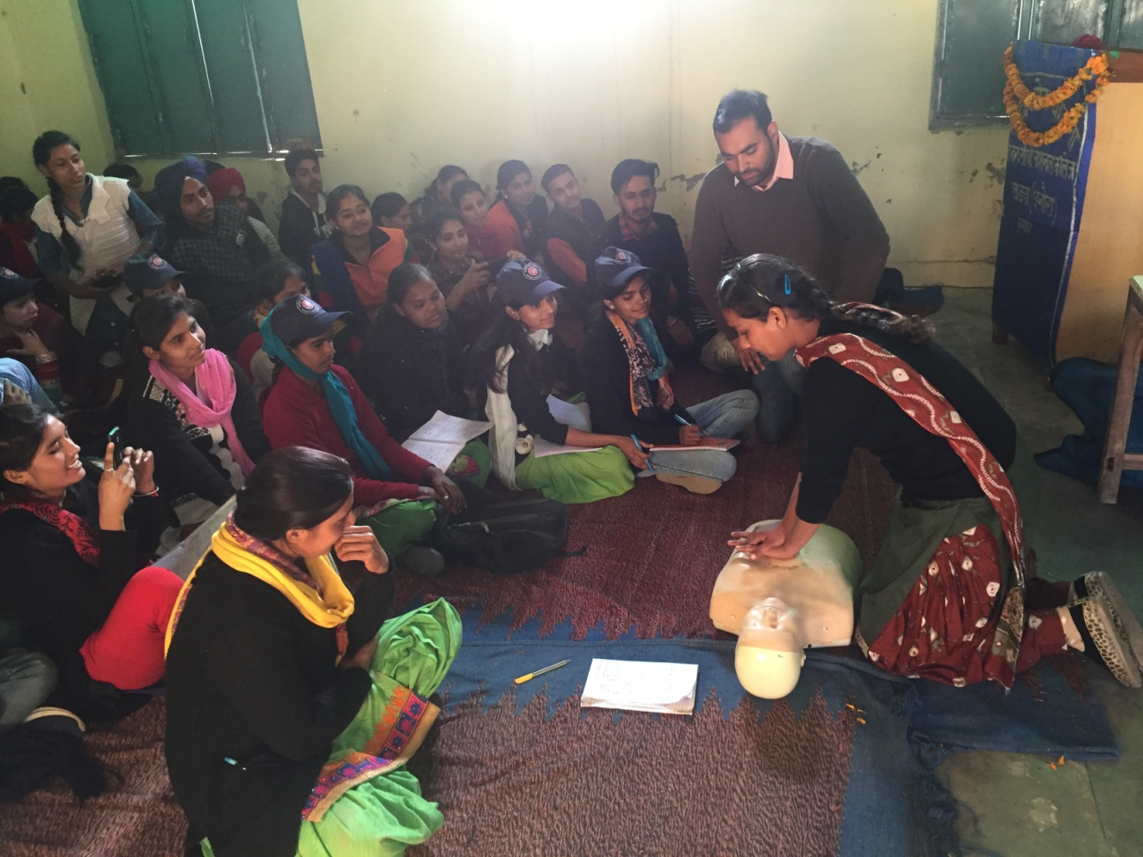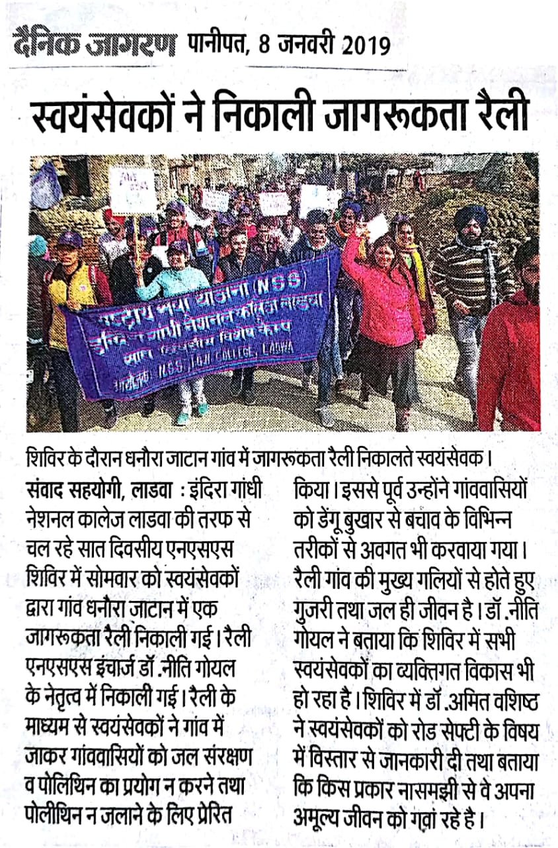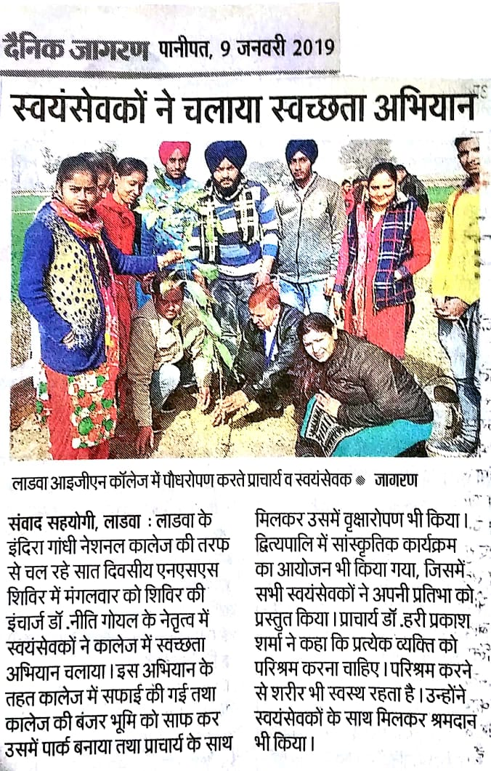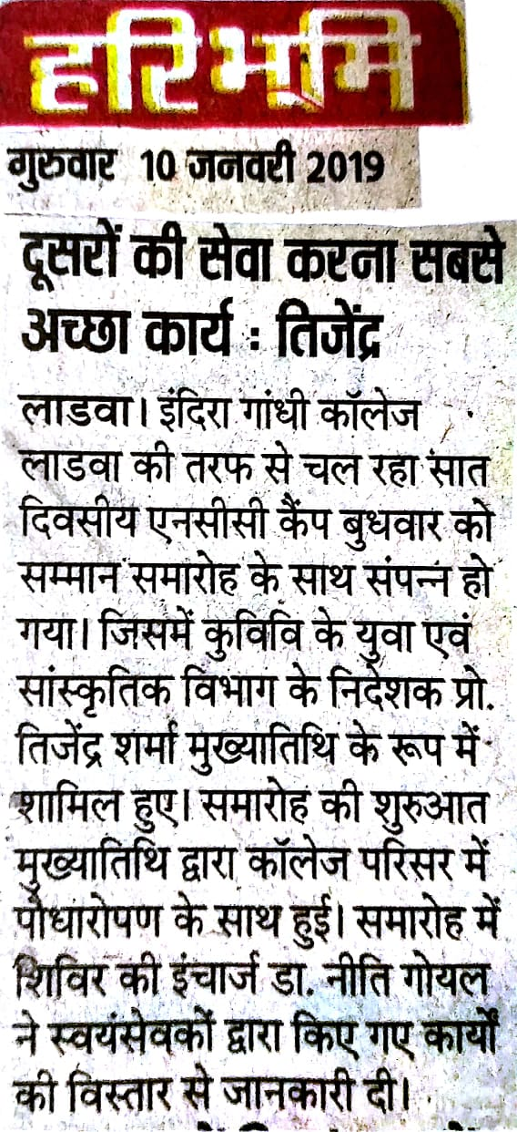

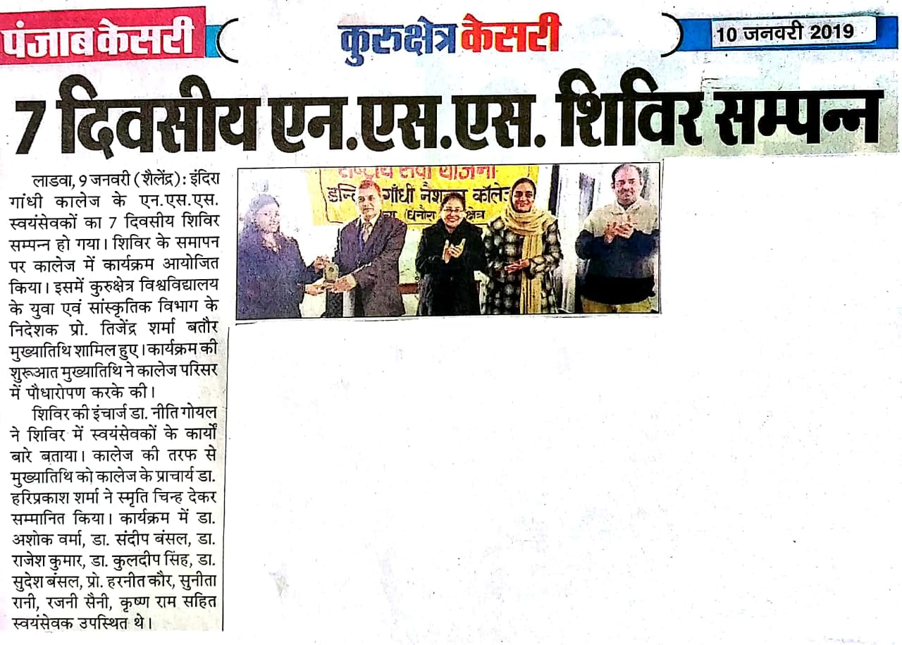

Attendance of volunteers

