One Day Camp 15-09-2019
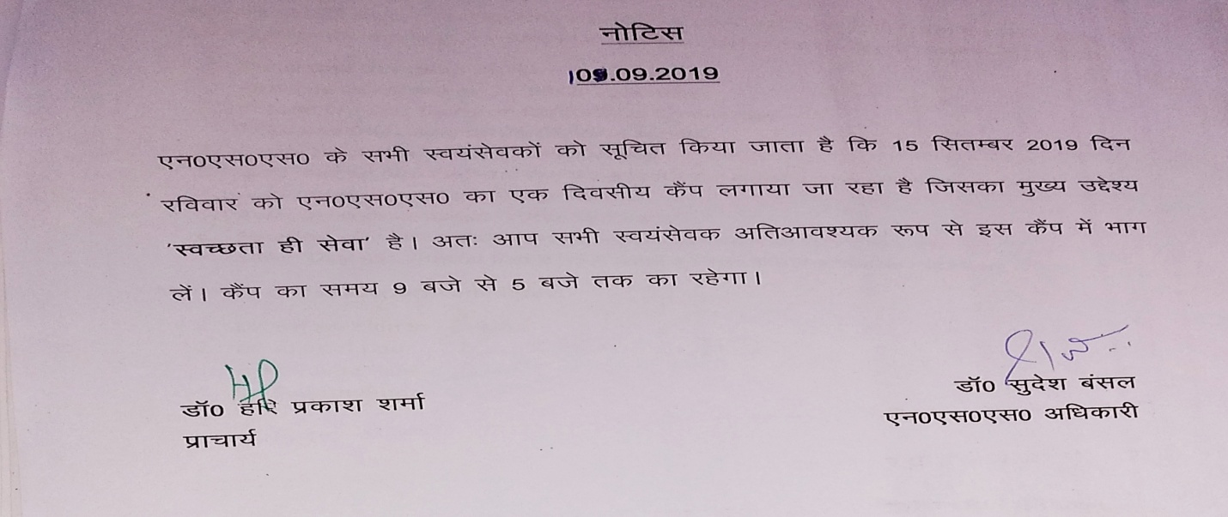
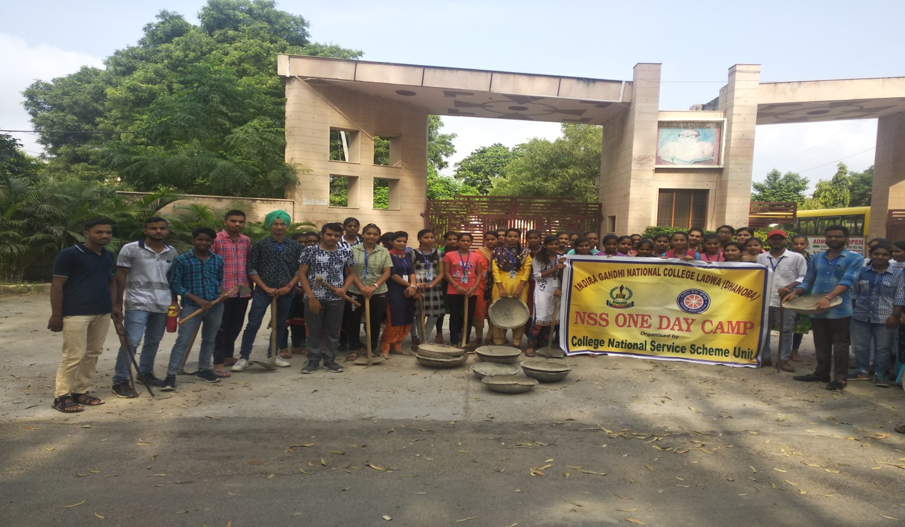
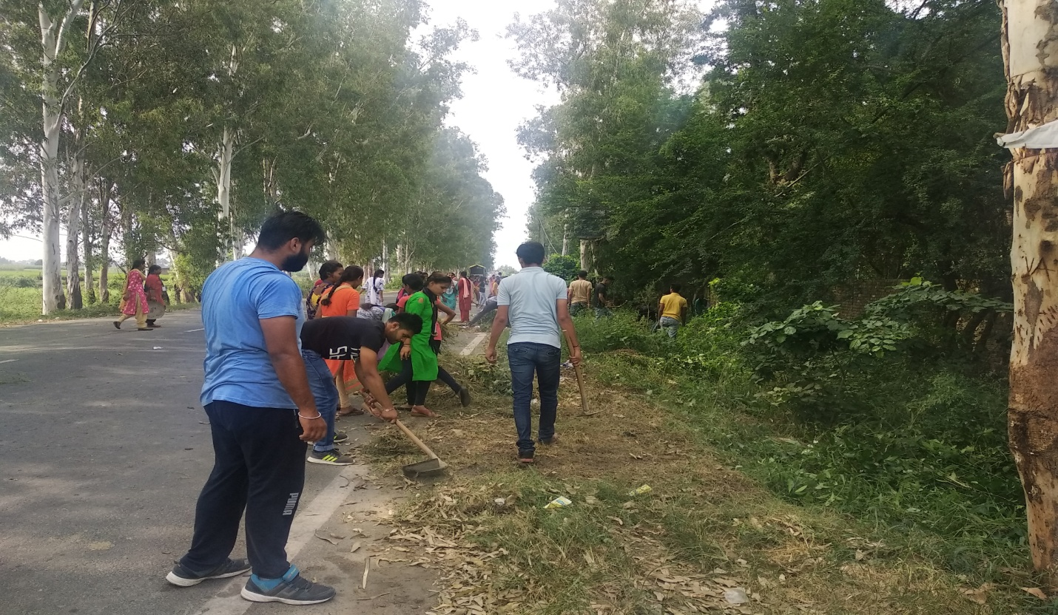
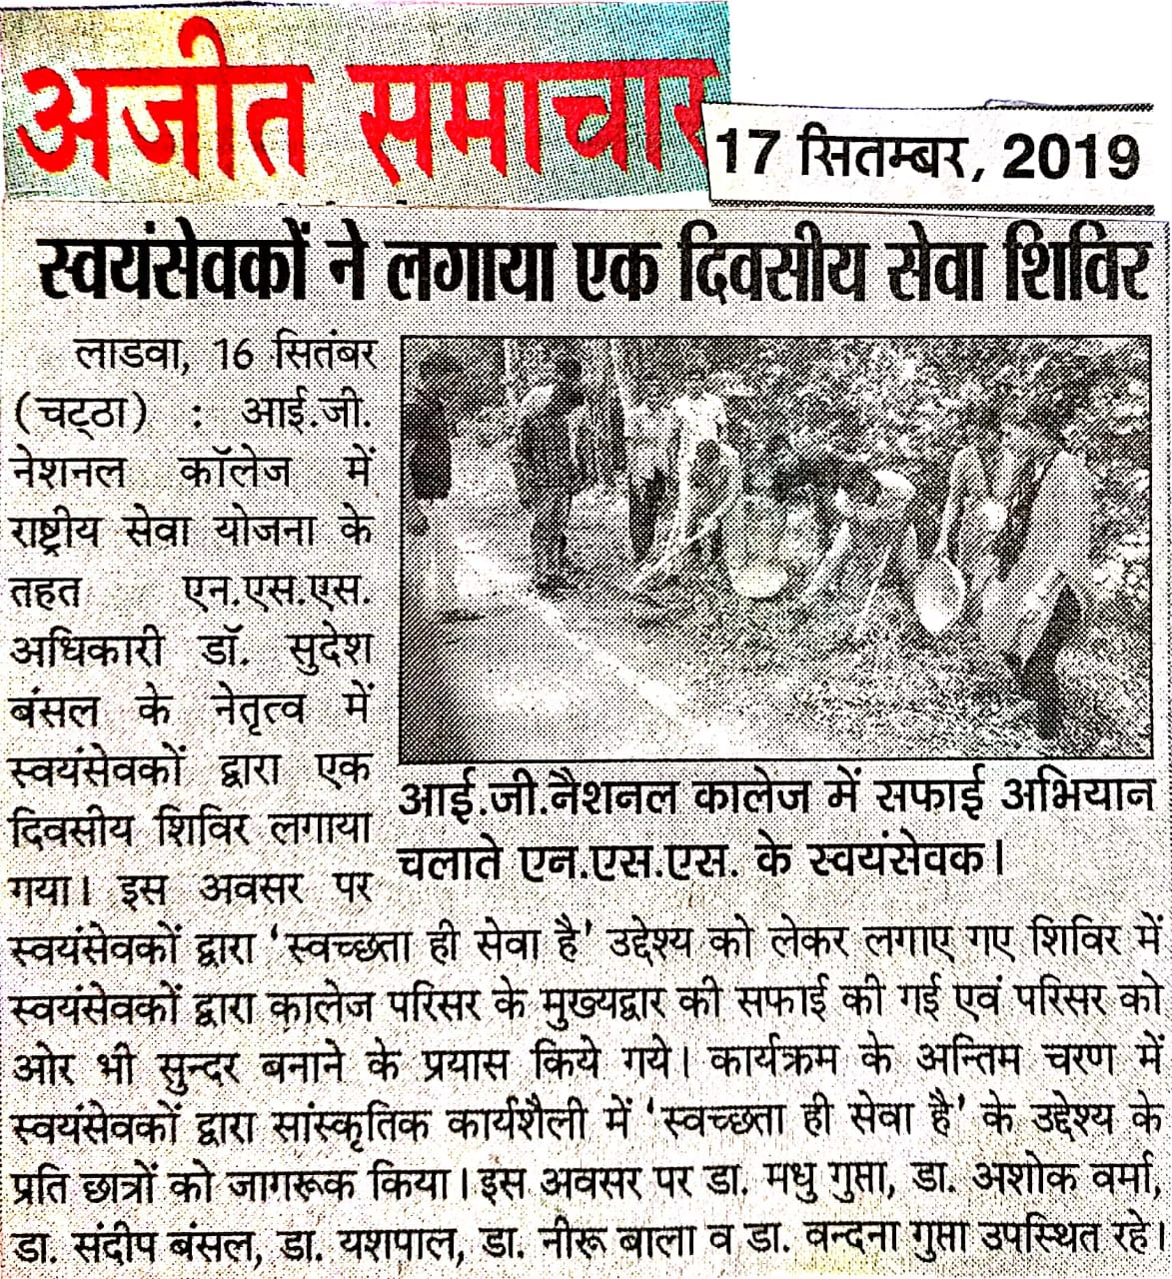
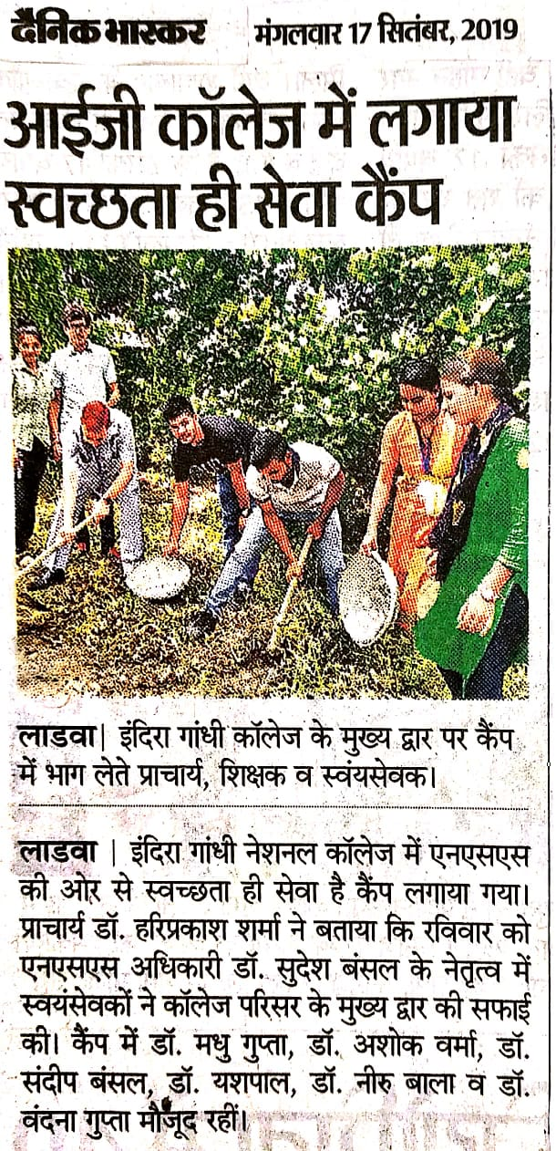
Report of One Day Camp
15-09-2019
One Day NSS camp was organized by the NSS unit of the college with the objective of ‘Swachhata Hi Sewa’ 59 Volunteers took part in this camp.

Principal Dr. Sudesh Kumar
NSS Programe Officer

