19/1/2017-ONE DAY NSS CAMP

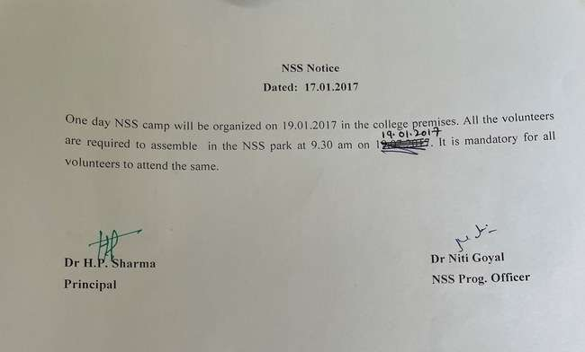

Observed Cleanliness Drive during One day NSS Camp. The volunteers were divided into several small teams under the leadership of a team leader for efficient management of work. It improves coordination, among the team and develops leadership qualities. The volunteers donated labour by undertaking the cleaning of the college premises.

