31/10/2016- PLEDGE FOR UNITY AND ‘RUN FOR UNITY’

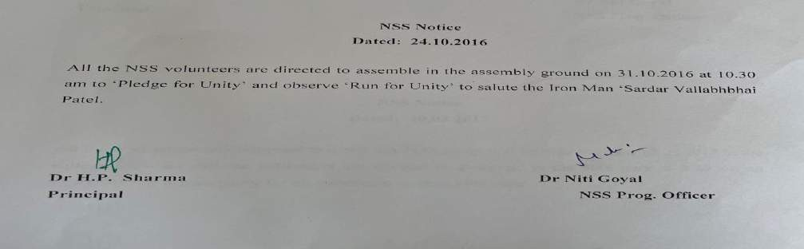

As per the orders of government, on occasion of Sardar Vallabh Bhai Patel’s birthday, National unity Day was celebrated. Principal, entire faculty members and students took a oath on unity and also observed a run for unity from IGN College spreading a message of United India.

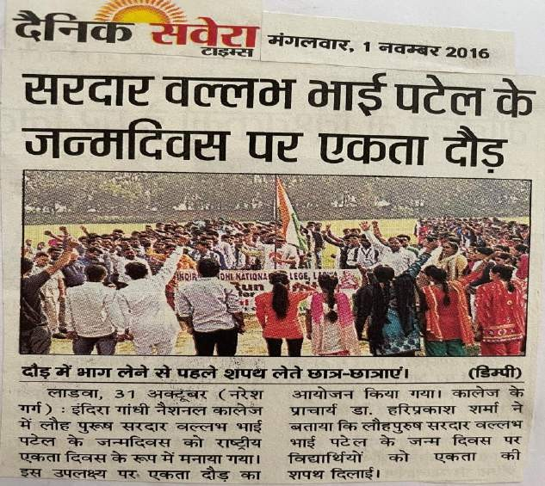

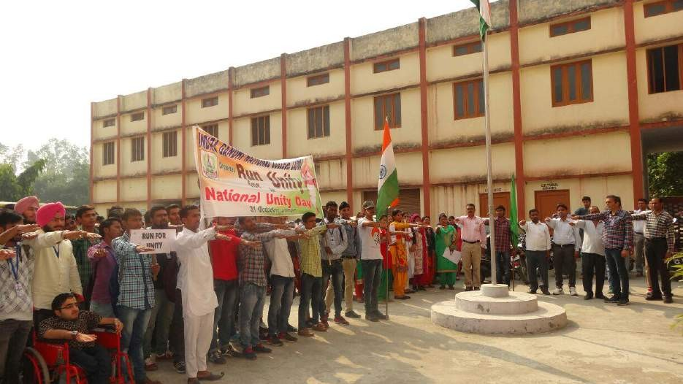

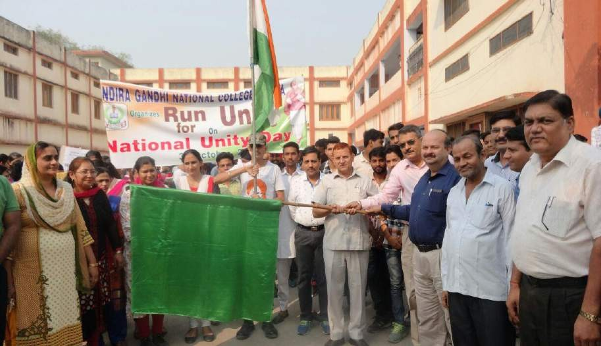
Run For unity

