Notice
05-08-2019
All the NSS volunteers are directed to assemble in the college premises on 10-08-2019 at 9:00 AM for the tree plantation drive.

Principal Dr. Sudesh Kumar
NSS Programe Officer

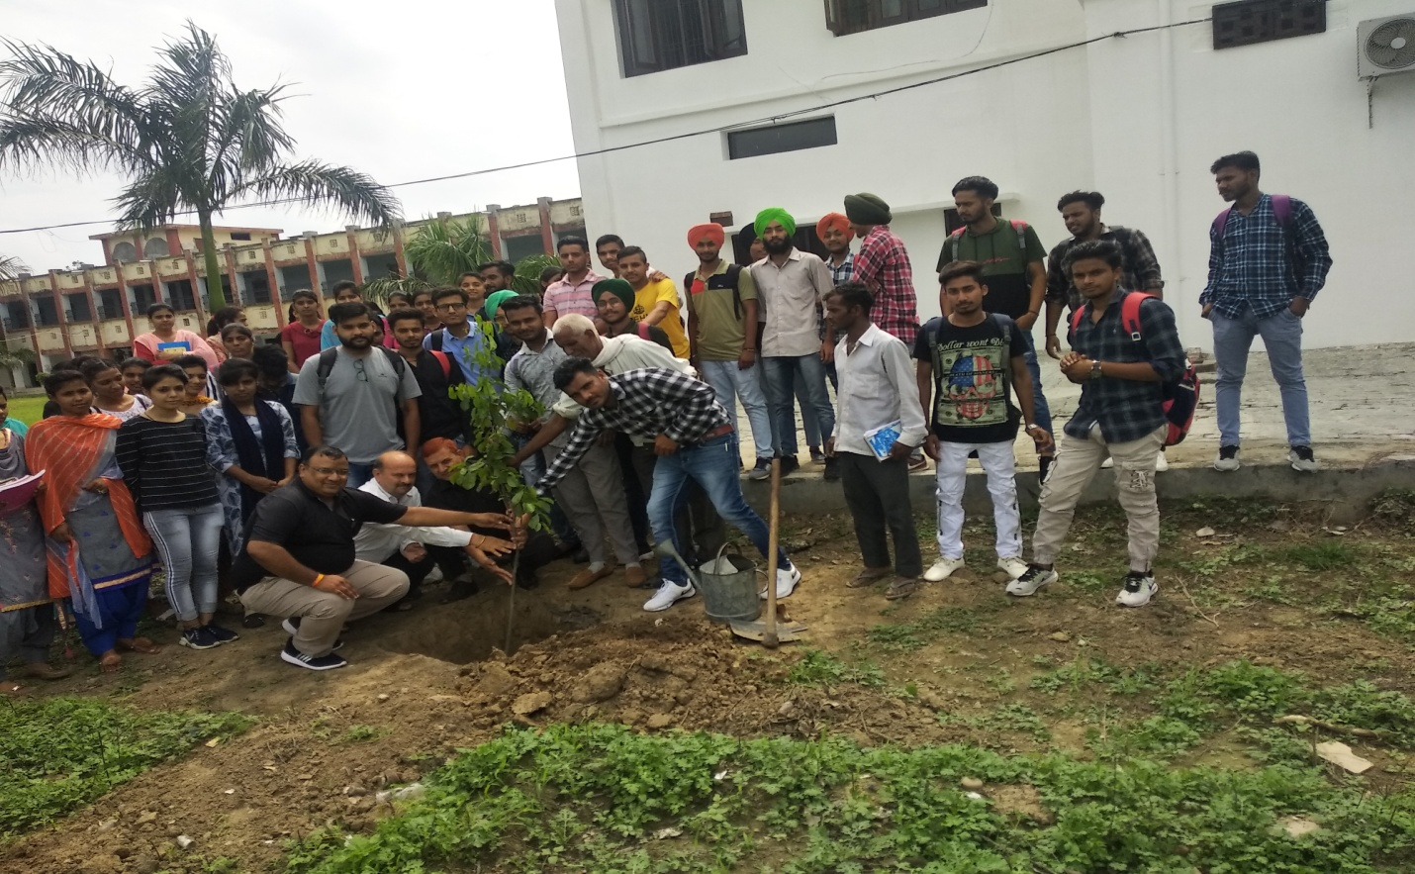
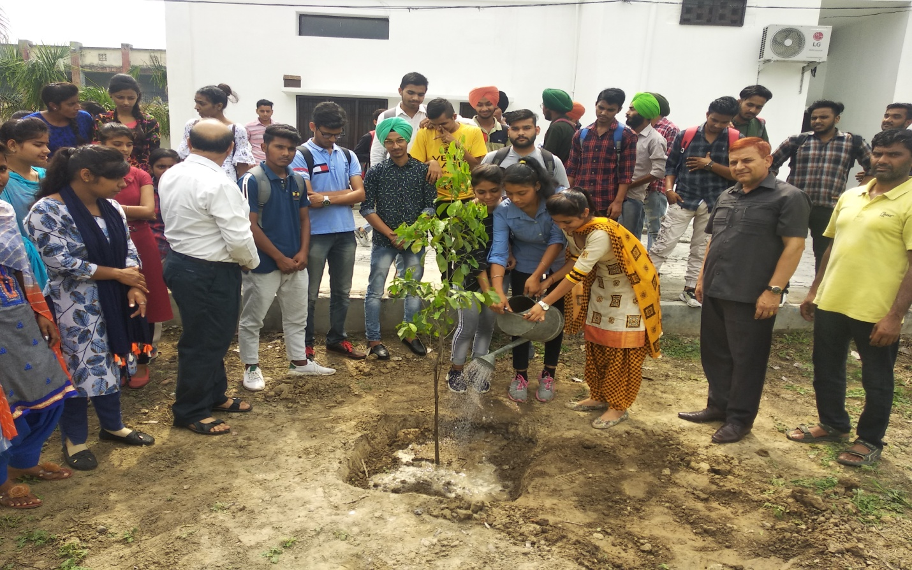
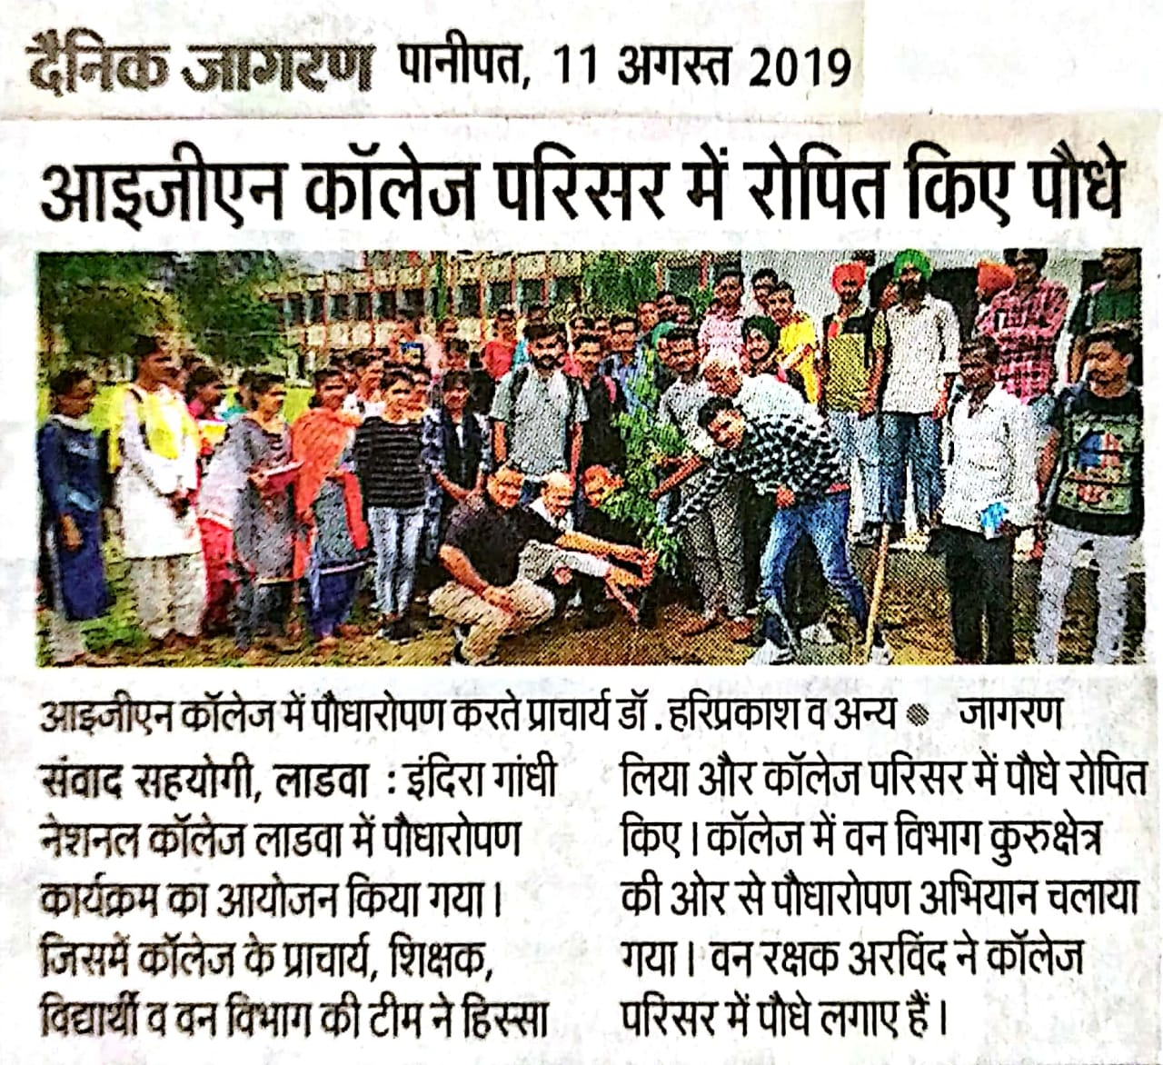
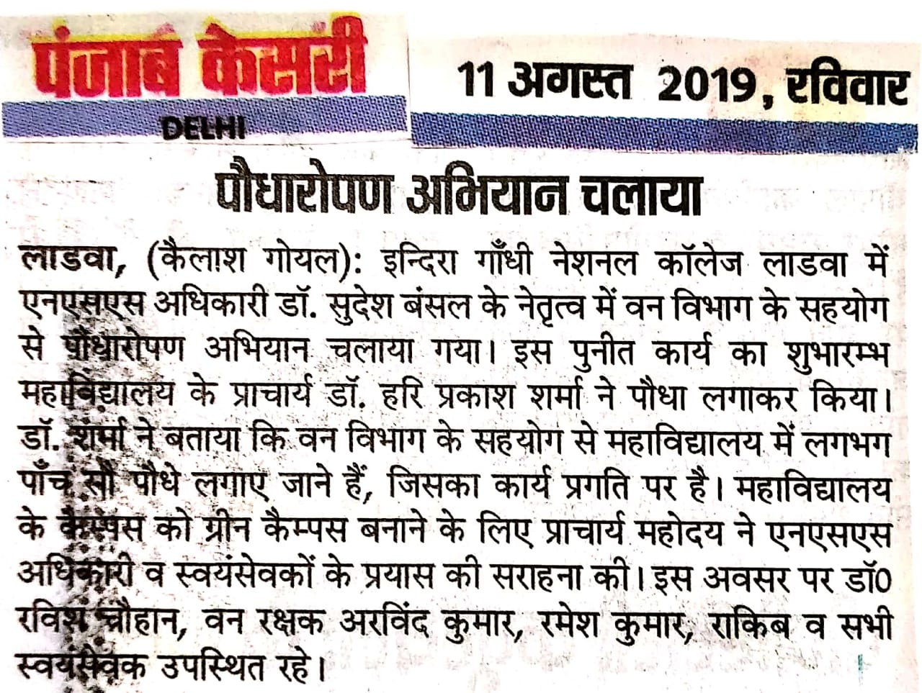

Report of Tree Plantation Drive
10-08-2019
A tree plantation program was organized on the college campus. 500 plants were planted in the college premises. 56 NSS volunteers took part in this program.

Principal Dr. Sudesh Kumar
NSS Programe Officer

