3.10.2017: One Day NSS CAMP

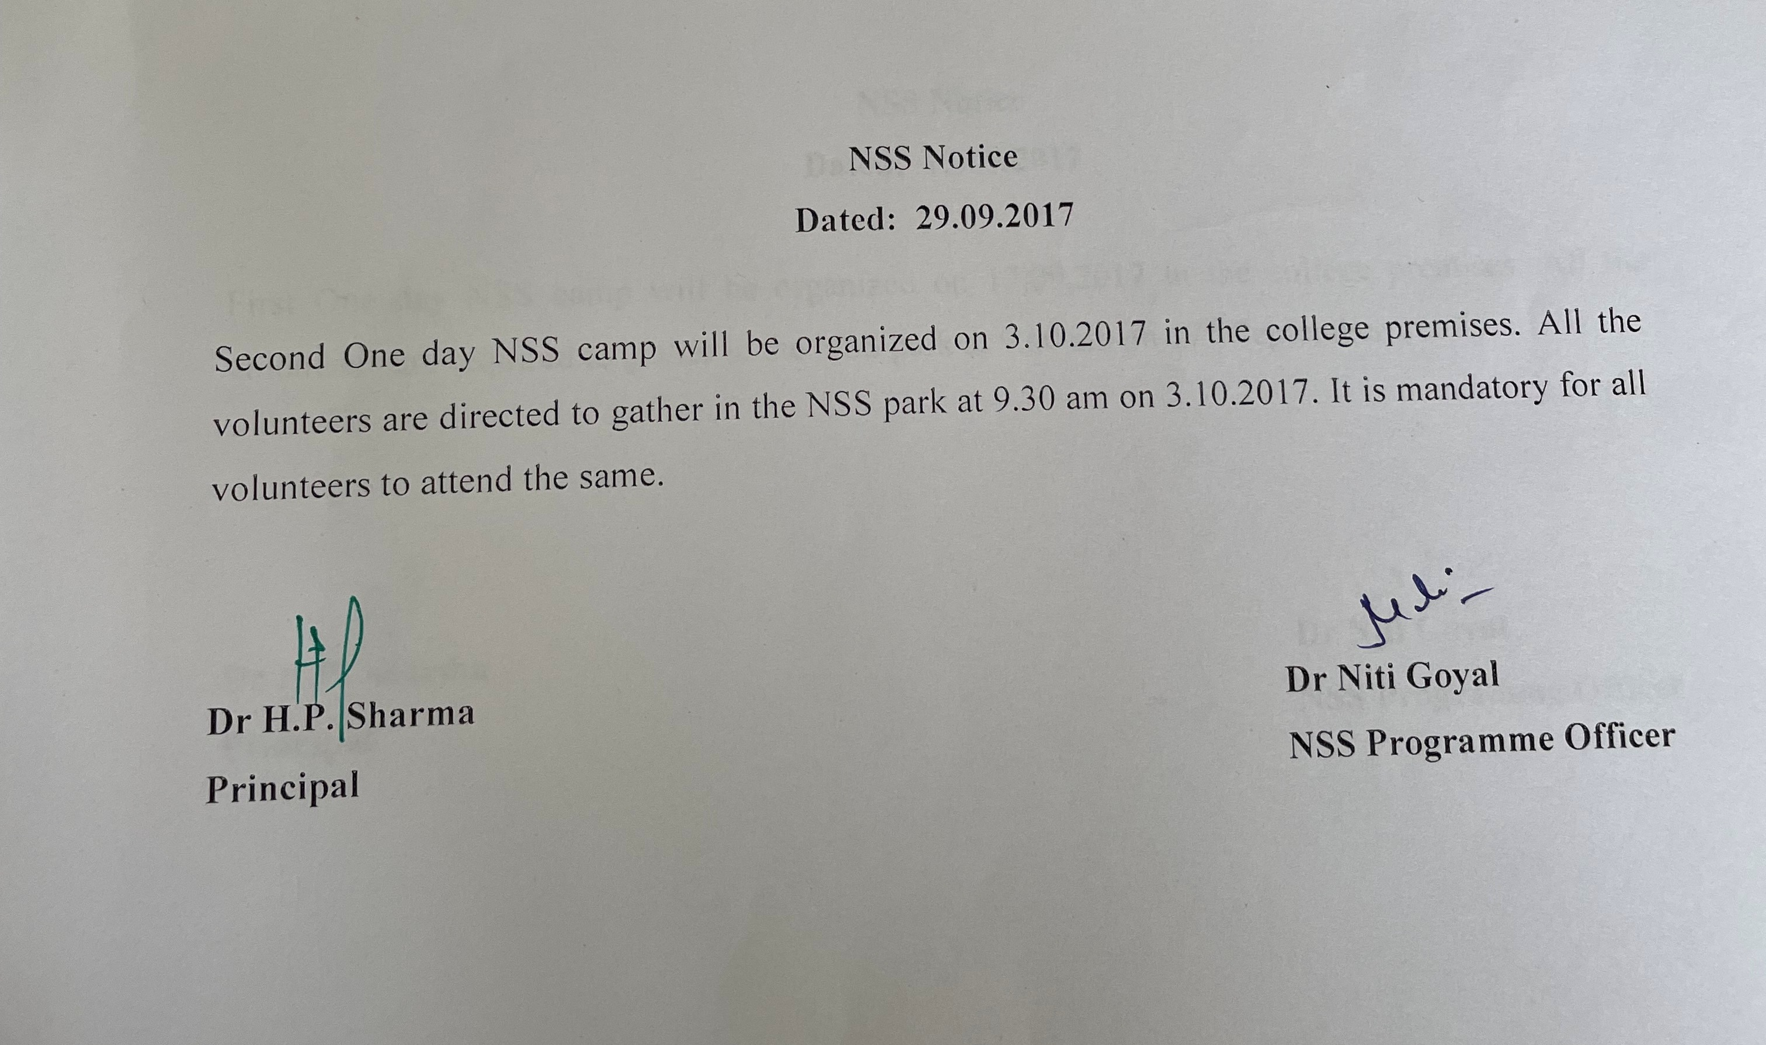
One day NSS Camp was organized on 3rd October, a day before organizing the 40th zonal youth festival from 4th to 6th October in the college premises. The volunteers were divided into groups and were assigned various duties to help in organizing the seminar. The volunteers rehearsed their duties and also helped in maintaining the college premises.
58 Volunteers participated in the camp and showed keen interest in performing the various duties allotted.

List of students who attended second one day NSS Camp. The students were also issued appreciation certificates.



List of students who contributed in organizing & managing Zonal youth festival
