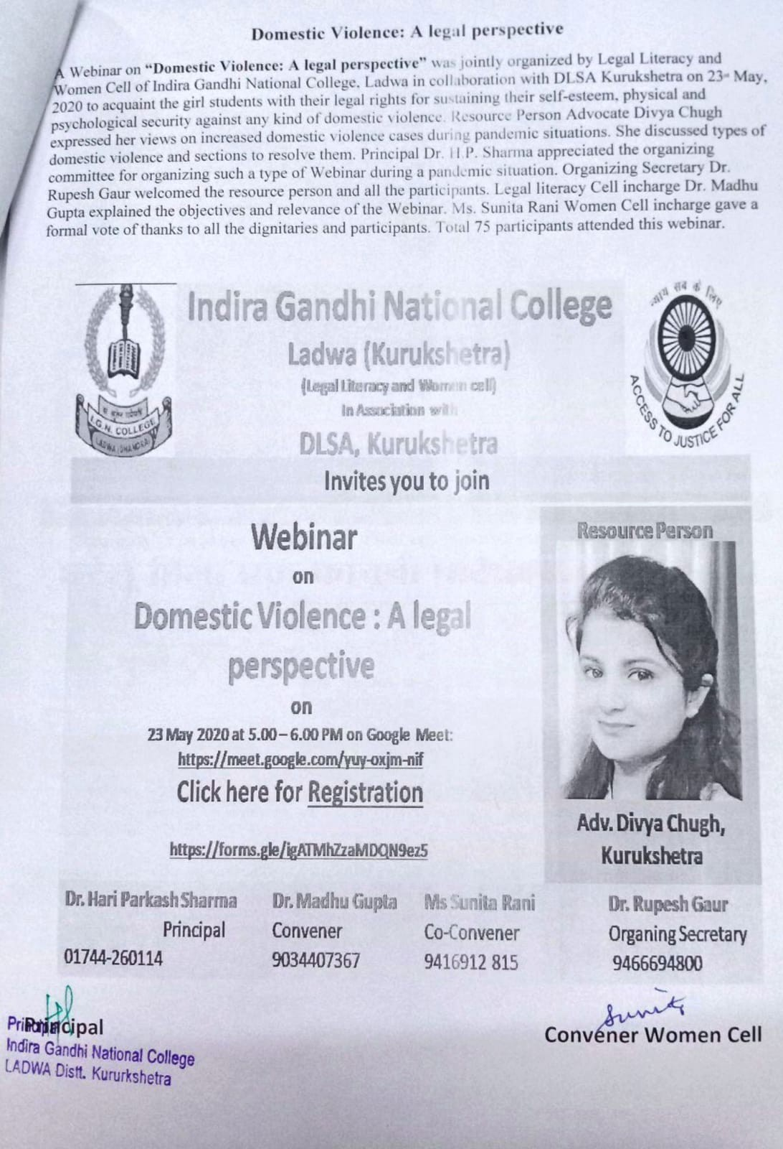Domestic Violence: A legal perspective

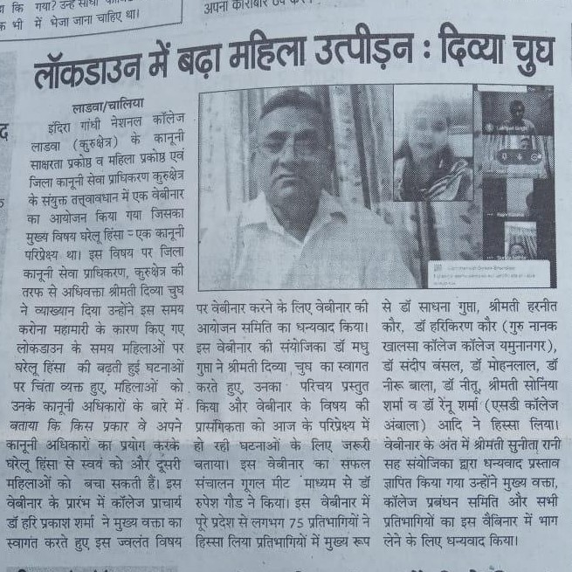

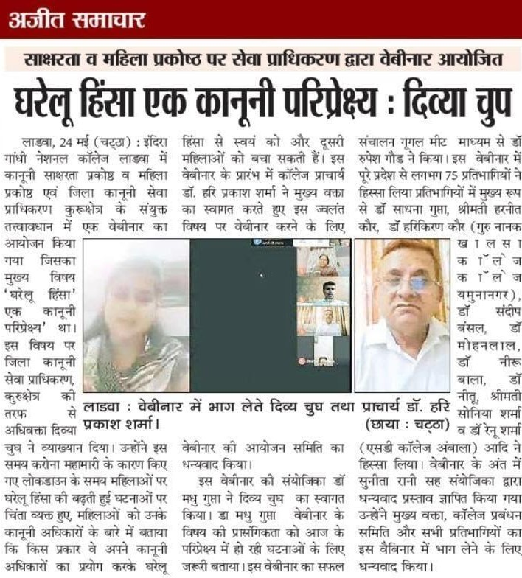

List of Participants

|  |  |  |  |  |  |
| --- | --- | --- | --- | --- | --- |
| Sr.No. | Timest amp | Email Address | Full Name | Name of College/Institute/ University | Designation / C |
|  | 5-22- | [madhugupta08@yahoo.c](mailto:madhugupta08@yahoo.c) | Dr. Madhu Gupta | Indira Gandhi National | Associate Professor |
| 1 | 2020  10:53: | om |  | College, Ladwa |  |
|  | 27 |  |  |  |  |
|  | 5-22- | [preetirana2493@gmail.co](mailto:preetirana2493@gmail.co) | Preeti | Indira Gandhi national | B.com |
| 2 | 2020  11:08: | m |  | college |  |
|  | 39 |  |  |  |  |
|  | 5-22- | [rmanu3223@gmail.com](mailto:rmanu3223@gmail.com) | Manu Rani | Indira Gandhi National | Student |
| 3 | 2020  11:23: |  |  | College Ladwa |  |
|  | 04 |  |  |  |  |
|  | 5-22- | [radhikakansaria@gmail.c](mailto:radhikakansaria@gmail.c) | Radhika | C.M.K National P.G.Girls | Lecturer in commerce |
| 4 | 2020  11:28: | om |  | College,Sirsa |  |
|  | 44 |  |  |  |  |
|  | 5-22- | [poswaldimpy55@gmail.co](mailto:poswaldimpy55@gmail.co) | Dimpy | Indira Gandhi National | B.com final |
| 5 | 2020  11:31: | m |  | College,ladwa |  |
|  | 14 |  |  |  |  |
|  | 5-22- | [mamta2017gc@gmail.co](mailto:mamta2017gc@gmail.co) | Mamta verma | Government college | Assistant professor |
| 6 | 2020  11:48: | m |  | chhachhrauli |  |
|  | 57 |  |  |  |  |
|  | 5-22- | [iamramesh1112@gmail.c](mailto:iamramesh1112@gmail.c) | Ramesh Kumar | P. I. G Govt. College for | Assistant Professor |
| 7 | 2020  11:52: | om |  | Women, Jind |  |
|  | 17 |  |  |  |  |
|  | 5-22- | sudesh.bansal1977@gma | Dr. Sudesh Kumar | Indira Gandhi National | Assistant Professor |
| 8 | 2020  12:03: | il.com |  | College ladwa |  |
|  | 39 |  |  |  |  |
|  | 5-22- | [soniarupeshgaur@gmail.c](mailto:soniarupeshgaur@gmail.c) | Sonia Sharma | GSSS, Umri, Kurukshetra | Lecturer Home Sc. |
| 9 | 2020  12:14: | om |  |  |  |
|  | 51 |  |  |  |  |
|  | 5-22- | amarjeetkaur624@yahoo. | Amarjeet Kaur | SNRL Jai Ram Girls | Assistant Professor |
| 10 | 2020  12:20: | in |  | College , Lohar Majra , Kurukshetra |  |
|  | 01 |  |  |  |  |
|  | 5-22- | poonammadan1976@gm | Dr. Poonam Madan | I.B.(PG) College, Panipat | Associate professor |
| 11 | 2020  12:33: | ail.com |  |  |  |
|  | 05 |  |  |  |  |
|  | 5-22- | [vidhikansal04@gmail.com](mailto:vidhikansal04@gmail.com) | Vidhi kansal | Indira Gandhi national | Bcom1st year |
| 12 | 2020  12:34: |  |  | college ladwa |  |
|  | 16 |  |  |  |  |
|  | 5-22- | anjalisharma43913@gmai | Anjali Sharma | IGN College Ladwa | B.A 2nd |
| 13 | 2020  12:37: | l.com |  |  |  |
|  | 23 |  |  |  |  |
|  | 5-22- | [sony.spanchal@gmail.co](mailto:sony.spanchal@gmail.co) | Nandita panchal | Indira Gandhi national | B. Com1st |
| 14 | 2020  12:38: | m |  | college ladwa(kkr) |  |

|  |  |  |  |  |  |
| --- | --- | --- | --- | --- | --- |
|  | 36 |  |  |  |  |
|  | 5-22- | [Preetyrani0123@gami.co](mailto:Preetyrani0123@gami.co) | Preety rani | Indria Gandhi national | Bachelor of art |
| 15 | 2020  12:39: | m |  | college ladwa kurukhsetra |  |
|  | 57 |  |  |  |  |
|  | 5-22- | [kashyap01kajal@gmail.co](mailto:kashyap01kajal@gmail.co) | Kajal | Indira Gandhi National | Bsc 1st year (2nd sem |
| 16 | 2020  12:43: | m |  | College Ladwa |  |
|  | 49 |  |  |  |  |
|  | 5-22- | [dhallanju@gmail.com](mailto:dhallanju@gmail.com) | Anju Dhall | GGDSD college Palwal | Assistant professor |
| 17 | 2020  12:45: |  |  | Haryana |  |
|  | 56 |  |  |  |  |
|  | 5-22- | sunitasharma52109@gm | Dr.Sunita Rani | SNRL Jai Ram Girls | Assistant Professor |
| 18 | 2020  12:46: | ail.co |  | College, Lohar Majra , kurukshetra |  |
|  | 28 |  |  |  |  |
|  | 5-22- | [radharadha3348@gmail.c](mailto:radharadha3348@gmail.c) | Radha sharma | Indira Gandhi national | B.A I year |
| 19 | 2020  13:02: | om |  | college |  |
|  | 48 |  |  |  |  |
|  | 5-22- | [prgupta613@gmail.com](mailto:prgupta613@gmail.com) | Priyanka | I.G.N college ladwa | assistant professor |
| 20 | 2020  13:09: |  |  |  |  |
|  | 49 |  |  |  |  |
|  | 5-22- | [jassigill2496@gmail.com](mailto:jassigill2496@gmail.com) | jaggar singh | indira gandhi national | B.A 4TH SEM |
| 21 | 2020  13:30: |  |  | college,ladwa |  |
|  | 58 |  |  |  |  |
|  | 5-22- | [riti2156@gmail.com](mailto:riti2156@gmail.com) | Ritika | Indira gandhi national | B.A 2nd |
| 22 | 2020  14:13: |  |  | college |  |
|  | 44 |  |  |  |  |
|  | 5-22- | [Payal7lamba@gmai.com](mailto:Payal7lamba@gmai.com) | Dr.Payal Lamba | G.n kh. College (yamuna | Asst. Prof. |
| 23 | 2020  15:03: |  |  | nagar) |  |
|  | 43 |  |  |  |  |
|  | 5-22- | [sachshaweta16@Gmail.c](mailto:sachshaweta16@Gmail.c) | Shaweta sachdeva | Guru Nanak Khalsa | Assistant professor |
| 24 | 2020  15:14: | om |  | College,Yamuna Nagar |  |
|  | 57 |  |  |  |  |
|  | 5-22- | [rahuldonkal009@gmail.co](mailto:rahuldonkal009@gmail.co) | Rahul | Indira Gandhi National | B com |
| 25 | 2020  15:37: | m |  | College Ladwa |  |
|  | 08 |  |  |  |  |
|  | 5-22- | [palak110992@gmail.com](mailto:palak110992@gmail.com) | Palak Dhall | Tilak Raj Chadha Institute | Assistant Professor |
| 26 | 2020  16:07: |  |  | of Management and  Technology |  |
|  | 09 |  |  |  |  |
|  | 5-22- | [kajaltathan14@gmail.com](mailto:kajaltathan14@gmail.com) | Kajal | Indira Gandhi national | B.com 1 st year |
| 27 | 2020  17:09: |  |  | college ladwa ( kurukshetra) |  |
|  | 45 |  |  |  |  |
|  | 5-22- | [aarti2596@gmail.com](mailto:aarti2596@gmail.com) | AARTI | Indira Gandhi National | Class-BA 3rd Year |
| 28 | 2020  17:53: |  |  | College Ladwa(kurukshetra) |  |
|  | 09 |  |  |  |  |

|  |  |  |  |  |  |
| --- | --- | --- | --- | --- | --- |
|  | 5-22- | www.lavishasaini2020@g | Lavisha saini | Indira Gandhi National | B.com ist year |
| 29 | 2020  18:20: | mail.com |  | College |  |
|  | 26 |  |  |  |  |
|  | 5-22- | [prabhmehra@74gmail.co](mailto:prabhmehra@74gmail.co) | Ritu Rani | Indira Gandhi National | B.A 3rd year |
| 30 | 2020  19:12: | m |  | college,Ladwa |  |
|  | 32 |  |  |  |  |
|  | 5-22- | keshavmehta2000.km@g | Keshav dev | Indira gandhi national | B.com 3rd year |
| 31 | 2020  19:25: | mail.com |  | college ladwa |  |
|  | 04 |  |  |  |  |
|  | 5-22- | vandanalaller123@gmail. | Vandana Rani | Indira Gandhi National | BA third year |
| 32 | 2020  19:36: | com |  | college Ladwa |  |
|  | 49 |  |  |  |  |
|  | 5-22- | [neelam15280@gmail.com](mailto:neelam15280@gmail.com) | Neelam Rani | C.M.K. National PG Girls | Assistant Professor |
| 33 | 2020  19:40: |  |  | Collage Sirsa |  |
|  | 28 |  |  |  |  |
|  | 5-22- | poojamadaan402@gmail. | Pooja madaan | Indira gandhi national | B com |
| 34 | 2020  20:05: | com |  | college |  |
|  | 49 |  |  |  |  |
|  | 5-22- | [mehrarenu468@gmail.co](mailto:mehrarenu468@gmail.co) | Renu | Indira Gandhi National | B.com 3rd year |
| 35 | 2020  20:16: | m |  | College ,ladwa |  |
|  | 51 |  |  |  |  |
|  | 5-22- | [malikranju26@yahoo.com](mailto:malikranju26@yahoo.com) | Ranju Malik | C.R.COLLEGE OF | Assistant Professor |
| 36 | 2020  20:22: |  |  | EDUCATION, ROHTAK |  |
|  | 11 |  |  |  |  |
|  | 5-22- | [vishalmalik.ubs@gmail.co](mailto:vishalmalik.ubs@gmail.co) | VISHAL MALIK | UNIVERSITY BUSINESS | M.COM(HONS)-1 |
| 37 | 2020  20:25: | m |  | SCHOOL, PANJAB UNIVERSITY, |  |
|  | 20 |  |  | CHANDIGARH |  |
|  | 5-22- | kanikamehta.ubs@gmail. | Kanika Mehta | University Business | Mcom (hons.) 1st year |
| 38 | 2020  20:36: | com |  | School, Panjab University |  |
|  | 20 |  |  |  |  |
|  | 5-22- | simerpreetkaur14@yahoo | Simerpreet Kaur | University Business | Mcom.(honors) 1st yea |
| 39 | 2020  20:39: | .com |  | School, Panjab University,  Chandigarh |  |
|  | 43 |  |  |  |  |
|  | 5-22- | [mehooda01@gmail.com](mailto:mehooda01@gmail.com) | Piyush Hooda | University Business | M.COM(HONS)-1 |
| 40 | 2020  21:27: |  |  | School, Panjab University, Chandigarh |  |
|  | 12 |  |  |  |  |
|  | 5-22- | [radhikamittal620@gmail.c](mailto:radhikamittal620@gmail.c) | Radhika Mittal | University Institute of | B.A.LL.B.(Hons.) |
| 41 | 2020  21:57: | om |  | Legal Studies , PU, CHD |  |
|  | 20 |  |  |  |  |
|  | 5-22- | arshpreetkaur2019.ubs@ | Arshpreet Kaur | UBS, PANJAB | M. Com ( honors) |
| 42 | 2020  22:14: | gmail.com |  | UNIVERSITY |  |
|  | 31 |  |  |  |  |
|  | 5-22- | navneetkaur2019.ubs@g | Navneet Kaur | University Business | Mcom Honors |
| 43 | 2020  22:15: | mail.com |  | School, Panjab University,  Chandigarh |  |
|  | 05 |  |  |  |  |

|  |  |  |  |  |  |
| --- | --- | --- | --- | --- | --- |
|  | 5-22- | rameshsaini8209@gmail. | Manjeet kaur | Indra ghandhi national, | B. Com 1st |
| 44 | 2020  22:33: | com |  | ladwa (kurkushetra) |  |
|  | 31 |  |  |  |  |
|  | 5-23- | simransimran0764@gmail | Simran | Indra Gandhi national | B. Com 2nd year |
| 45 | 2020  8:15:3 | .com |  | college, ladwa |  |
|  | 8 |  |  |  |  |
|  | 5-23- | anjalisabharwal74@gmail | Anjali Sabharwal | Chotu Ram College of | B.Ed |
| 46 | 2020  10:10: | .com |  | Education,Rohtak |  |
|  | 45 |  |  |  |  |
|  | 5-23- | [sadhnaign94@yahoo.co.i](mailto:sadhnaign94@yahoo.co.i) | Sadhna Gupta | Indira Gandhi National | Red. Associates Profe |
| 47 | 2020  10:22: | n |  | College , Ladwa |  |
|  | 04 |  |  |  |  |
|  | 5-23- | [sunita16475@gmail.com](mailto:sunita16475@gmail.com) | Sunita Rani | Indira Gandhi National | Asstt. Prof. |
| 48 | 2020  10:23: |  |  | College Ladw |  |
|  | 36 |  |  |  |  |
|  | 5-23- | [rmathana@gmail.com](mailto:rmathana@gmail.com) | Rajesh Kumar | Indira Gandhi National | Assistant Professor (E |
| 49 | 2020  10:58: |  |  | College Ladwa |  |
|  | 10 |  |  |  |  |
|  | 5-23- | [neetuphy@gmail.com](mailto:neetuphy@gmail.com) | Dr.Neetu | INDIRA GANDHI | ASSISTANT PROFES |
| 50 | 2020  11:04: |  |  | NATIONAL COLLEGE,LADWA |  |
|  | 24 |  |  |  |  |
|  | 5-23- | [vibhatisumit@gmail.com](mailto:vibhatisumit@gmail.com) | Samriti sharma | D.A.V. College for Girls | Asstt.professor |
| 51 | 2020  11:04: |  |  |  |  |
|  | 34 |  |  |  |  |
|  | 5-23- | [neharani51334@gmail.co](mailto:neharani51334@gmail.co) | Neha Rani | Indira Gandhi National | B.A. 1st year |
| 52 | 2020  11:35: | m |  | College, Ladwa (Kurukshetra ) |  |
|  | 39 |  |  |  |  |
|  | 5-23- | [kritigarg13@gmail.com](mailto:kritigarg13@gmail.com) | Kriit Garg | NXP Semiconductor | Senior Engineer |
| 53 | 2020  12:05: |  |  |  |  |
|  | 20 |  |  |  |  |
|  | 5-23- | [anitamoudgil22@gmail.co](mailto:anitamoudgil22@gmail.co) | DR. ANITA MOUDGIL | D. A. V. COLLEGE FOR | ASSOCIATE PROFES |
| 54 | 2020  12:14: | m |  | GIRLS YAMUNANAGAR/KUK) |  |
|  | 28 |  |  |  |  |
|  | 5-23- | samridhimoudgil13@gmai | Sanjay Moudgil | Maharishi | BA.L.L.B 4th year |
| 55 | 2020  12:18: | l.com |  | markandeshwar deemed to be university |  |
|  | 07 |  |  |  |  |
|  | 5-23- | [hpsharma@live.in](mailto:hpsharma@live.in) | Hari Parkash Sharma | IGN College , Ladwa | Principal |
| 56 | 2020  12:46: |  |  |  |  |
|  | 56 |  |  |  |  |
|  | 5-23- | [pranshiv7@gmail.com](mailto:pranshiv7@gmail.com) | Pranshi | Dav College (Lahore), | B.Sc 1 (N.M) |
| 57 | 2020  12:54: |  |  | Ambala City |  |
|  | 56 |  |  |  |  |
|  | 5-23- | [ritika8053@gmail.com](mailto:ritika8053@gmail.com) | Ritika Verma | D.A.V College (LAHORE) | B.sc-2(c.sc) |
| 58 | 2020  13:03: |  |  | ambala city |  |

|  |  |  |  |  |  |
| --- | --- | --- | --- | --- | --- |
|  | 24 |  |  |  |  |
|  | 5-23- | [khushi19nov88@gmail.co](mailto:khushi19nov88@gmail.co) | Khushboo Malhotra | D. A. V. College (Lahore | Assistant Professor |
| 59 | 2020  13:27: | m |  | ), Ambala City |  |
|  | 57 |  |  |  |  |
|  | 5-23- | [shivaniaster@gmail.com](mailto:shivaniaster@gmail.com) | Shivani Dawer | DAV College(lahore) | Assistant Professor in |
| 60 | 2020  13:36: |  |  | Ambala City |  |
|  | 50 |  |  |  |  |
|  | 5-23- | [drneerubala56@gmail.co](mailto:drneerubala56@gmail.co) | Dr Neeru bala | Indira Gandhi National | Assistant Professor |
| 61 | 2020  13:51: | m |  | College Ladwa |  |
|  | 57 |  |  |  |  |
|  | 5-23- | vishalyverma2060@gmail | Vishaly verma | D.A.V College lahore | Bsc csc final year |
| 62 | 2020  14:06: | .com |  | ambala city |  |
|  | 50 |  |  |  |  |
|  | 5-23- | profsandeepbansal@gma | Sandeep Bansal | IGN COLLEGE LADWA | ASSOCIATE PROFES |
| 63 | 2020  14:37: | il.com |  |  |  |
|  | 22 |  |  |  |  |
|  | 5-23- | [arunasaini2526@gmail.co](mailto:arunasaini2526@gmail.co) | Aruna saini | indira gandhi national | bsc 1st year |
| 64 | 2020  14:59: | m |  | collage |  |
|  | 04 |  |  |  |  |
|  | 5-23- | vishakhaverma8802@gm | vishakha verma | D.A.V college Lahore | b.com |
| 65 | 2020  15:01: | ail.com |  | ambala city |  |
|  | 21 |  |  |  |  |
|  | 5-23- | Amanpreetsarawan01@g | Amanpreet | Dav college for girls | BSc 1st computer scie |
| 66 | 2020  15:08: | mail.com |  | yamunanagar |  |
|  | 09 |  |  |  |  |
|  | 5-23- | [shanvipanjeta@gmail.co](mailto:shanvipanjeta@gmail.co) | Shanu | DAV college for girls | B.sc cs ist year |
| 67 | 2020  15:24: | m |  |  |  |
|  | 05 |  |  |  |  |
|  | 5-23- | [mathanasatish@gmail.co](mailto:mathanasatish@gmail.co) | Dr Satish kumar | Govt collage for palwal | Assistant Professor of |
| 68 | 2020  15:38: | m | mathana | kurukshetra | education |
|  | 00 |  |  |  |  |
|  | 5-23- | ajaypalibcpanipat@gmail. | Ajay Pal Singh | I.B.(PG) COLLEGE, | Assistant professor |
| 69 | 2020  15:38: | com |  | PANIPAT |  |
|  | 21 |  |  |  |  |
|  | 5-23- | poojasharmavivek@gmail | Dr Pooja Sharma | Dayanand Mahila | Librarian |
| 70 | 2020  15:39: | .com |  | Mahavidyalaya Kurukshetra |  |
|  | 55 |  |  |  |  |
|  | 5-23- | poojasharmavivek@gmail | Dr Pooja Sharma | Dayanand Mahila | Librarian |
| 71 | 2020  15:40: | .com |  | Mahavidyalaya Kurukshetra |  |
|  | 59 |  |  |  |  |
|  | 5-23- | [goyal1alisha@gmail.com](mailto:goyal1alisha@gmail.com) | Dr. Alisha Goyal | R.K.S.D. (PG) College, | Assistant Professor |
| 72 | 2020  15:41: |  |  | kaithal |  |
|  | 03 |  |  |  |  |

|  |  |  |  |  |  |
| --- | --- | --- | --- | --- | --- |
|  | 5-23- | gauravgoyal1462@gmail. | Gaurav | R.K.S.D. (PG) College, | Assistant Professor |
| 73 | 2020  15:43: | com |  | kaithal |  |
|  | 52 |  |  |  |  |
|  | 5-23- | [vertikatiwari75@gmail.co](mailto:vertikatiwari75@gmail.co) | Vertika | C.R. College of Education | Student/ B.Ed. Final Y |
| 74 | 2020  15:44: | m |  |  |  |
|  | 06 |  |  |  |  |
|  | 5-23- | [vikesharora24@gmail.co](mailto:vikesharora24@gmail.co) | Vikesh | Dyal Singh Public School | Librarian |
| 75 | 2020  15:48: | m |  |  |  |
|  | 47 |  |  |  |  |
|  | 5-23- | profparminder1986@gmai | Mrs. Parminder Kaur | DAV College, Pundri | Assistant professor in |
| 76 | 2020  15:49: | l.com |  | (kaithal) |  |
|  | 10 |  |  |  |  |
|  | 5-23- | [vishalgoel12487@gmail.c](mailto:vishalgoel12487@gmail.c) | Vishal Goyal | MM Deemed to be | Library Incharge |
| 77 | 2020  15:49: | om |  | University, Mullana |  |
|  | 33 |  |  |  |  |
|  | 5-23- | [ramesh70022@yahoo.co](mailto:ramesh70022@yahoo.co) | Ramesh Kumar | Arya P.G. College, | Assistant Professor |
| 78 | 2020  15:52: | m |  | Panipat |  |
|  | 13 |  |  |  |  |
|  | 5-23- | [addy.gupta84@gmail.com](mailto:addy.gupta84@gmail.com) | Dr. Aditya Kumar | Dayanand College, Hisar | Assistant Professor |
| 79 | 2020  15:52: |  |  |  |  |
|  | 37 |  |  |  |  |
|  | 5-23- | [lambamanvee@gmail.co](mailto:lambamanvee@gmail.co) | Manvi | Mukand pyblic school | Librarian |
| 80 | 2020  15:57: | m |  |  |  |
|  | 37 |  |  |  |  |
|  | 5-23- | [kaursurjeet2011@gmail.c](mailto:kaursurjeet2011@gmail.c) | SURJEET KAUR | D.N.College Hisar | Astt.Prof. |
| 81 | 2020  15:58: | om |  |  |  |
|  | 52 |  |  |  |  |
|  | 5-23- | [dineshkarnal1@gmail.co](mailto:dineshkarnal1@gmail.co) | Dinesh Kumar | Dyal Singh College,Karnal | Assistant Professor |
| 82 | 2020  15:59: | m |  | (K.UK.) |  |
|  | 02 |  |  |  |  |
|  | 5-23- | [khushjeetkaur77@gmail.c](mailto:khushjeetkaur77@gmail.c) | Khushjeet kaur | Indira gandhi national | B.a |
| 83 | 2020  15:59: | om |  | collage, Dhanora |  |
|  | 24 |  |  |  |  |
|  | 5-23- | anuchauhan9090@gmail. | Dr Anu Chauhan | DMM,Kurukshetra | Assistant professor |
| 84 | 2020  16:00: | com |  |  |  |
|  | 58 |  |  |  |  |
|  | 5-23- | [Mahimagarg@226gamil.c](mailto:Mahimagarg@226gamil.c) | Mahima | Indira Gandhi National | B. A first year |
| 85 | 2020  16:02: | om |  | College Ladwa |  |
|  | 14 |  |  |  |  |
|  | 5-23- | [harneetpahul@gmail.com](mailto:harneetpahul@gmail.com) | Harneet Kaur | Indira Gandhi National | Assistant Professor |
| 86 | 2020  16:02: |  |  | College Ladwa (Dhanora) |  |
|  | 26 |  |  |  |  |
|  | 5-23- | [pooja.mphil@gmail.com](mailto:pooja.mphil@gmail.com) | Pooja Rani | S.D.College Ambala Cantt | assistant Professor |
| 87 | 2020  16:04: |  |  |  |  |
|  | 52 |  |  |  |  |

|  |  |  |  |  |  |
| --- | --- | --- | --- | --- | --- |
|  | 5-23- | [kb1293855@gmail.com](mailto:kb1293855@gmail.com) | KOMAL | Indira Gandhi National | BA 1st year |
| 88 | 2020  16:05: |  |  | College ladwa (kurukshetra) |  |
|  | 22 |  |  |  |  |
|  | 5-23- | muskansangal219@gmail | Muskan sangal | Indira Gandhi national | B.com 3rd year |
| 89 | 2020  16:07: | .com |  | college ladwa (dhanora) |  |
|  | 26 |  |  |  |  |
|  | 5-23- | [b.sareen86@gmail.com](mailto:b.sareen86@gmail.com) | Dr. Bhawana Sareen | SD College, Ambala Cantt | Assistant professor |
| 90 | 2020  16:07: |  |  |  |  |
|  | 59 |  |  |  |  |
|  | 5-23- | [shakti0471@gmail.com](mailto:shakti0471@gmail.com) | Dr. Shakti | Guru Nanak Girls college | Assitant prof Hindi |
| 91 | 2020  16:11: |  |  | YamunaNagar |  |
|  | 48 |  |  |  |  |
|  | 5-23- | ambikasharma137@gmail | Ambika Rani | Dyal Singh College , | Assistant Professor |
| 92 | 2020  16:11: | .com |  | Karnal |  |
|  | 54 |  |  |  |  |
|  | 5-23- | [kourharikiran@gmail.com](mailto:kourharikiran@gmail.com) | Dr.Hari kiran kour | GURU NANAK KHALSA | Associate prof |
| 93 | 2020  16:12: |  |  | COLLEGE YAMUNA NAGAR |  |
|  | 05 |  |  |  |  |
|  | 5-23- | [pooja.mphil@gmail.com](mailto:pooja.mphil@gmail.com) | Pooja Rani | S.D.College Ambala Cantt | Assistant Professor |
| 94 | 2020  16:13: |  |  |  |  |
|  | 19 |  |  |  |  |
|  | 5-23- | [zoyaips@gmail.com](mailto:zoyaips@gmail.com) | Zoya | Dav college | Bsc.comp.science |
| 95 | 2020  16:13: |  |  |  |  |
|  | 28 |  |  |  |  |
|  | 5-23- | [zoyaips@gmail.com](mailto:zoyaips@gmail.com) | Zoya | Dav college | Bsc.comp.science |
| 96 | 2020  16:13: |  |  |  |  |
|  | 43 |  |  |  |  |
|  | 5-23- | [singhchem2020@gmail.c](mailto:singhchem2020@gmail.c) | Shalini Singh | Dyal Singh College Karnal | Asst. Prof. |
| 97 | 2020  16:14: | om |  |  |  |
|  | 25 |  |  |  |  |
|  | 5-23- | sangalmuskan219@gmail | Muskan sangal | Indira Gandhi national | B. Com 3rd year |
| 98 | 2020  16:14: | .com |  | college ladwa (dhanora) |  |
|  | 58 |  |  |  |  |
|  | 5-23- | [ravivatskuk@gmail.com](mailto:ravivatskuk@gmail.com) | Ravi Kumar | Government College | Assistant professor |
| 99 | 2020  16:15: |  |  | Chammu Kalan |  |
|  | 58 |  |  |  |  |
|  | 5-23- | harvindernarang52@gmai | Harvinder Singh | SD College, Ambala | Assistant prof. |
| 100 | 2020  16:16: | l.com |  | Cantt. |  |
|  | 51 |  |  |  |  |
|  | 5-23- | [drrenugaur@gmail.com](mailto:drrenugaur@gmail.com) | Dr. Renu Sharma | Sanatan Dharma College | Assistant Professor |
| 101 | 2020  16:17: |  |  | Ambala Cantt/ Kurukshetra university |  |
|  | 19 |  |  | Kurukshetra |  |
|  | 5-23- | [bharti86sujan@gmail.com](mailto:bharti86sujan@gmail.com) | Bharti Sujan | SD College Ambala Cantt | Assistant Professor |
| 102 | 2020  16:17: |  |  |  |  |
|  | 55 |  |  |  |  |

|  |  |  |  |  |  |
| --- | --- | --- | --- | --- | --- |
|  | 5-23- | [priya280684@gmail.com](mailto:priya280684@gmail.com) | Priya Gupta | Arya PG College panipat | Assistance Professor |
| 103 | 2020  16:18: |  |  |  |  |
|  | 05 |  |  |  |  |
|  | 5-23- | [mlal.ign.@gmail.com](mailto:mlal.ign.@gmail.com) | Dr. Mohan Lal | Indira Gandhi National | Assistant Professor in |
| 104 | 2020  16:22: |  |  | College,Ladwa |  |
|  | 00 |  |  |  |  |
|  | 5-23- | [nsingh0001@gmail.com](mailto:nsingh0001@gmail.com) | Niti goyal | IGN COLLEGE | Assistant professor |
| 105 | 2020  16:23: |  |  |  |  |
|  | 07 |  |  |  |  |
|  | 5-23- | [mehla29dec@gmail.com](mailto:mehla29dec@gmail.com) | Naveen Mehla | Kurukshetra university | Research scholar |
| 106 | 2020  16:26: |  |  | kurukshetra |  |
|  | 57 |  |  |  |  |
|  | 5-23- | [nancychoprasdc@gmail.c](mailto:nancychoprasdc@gmail.c) | Nancy Chopra | S. D. College, Ambala | Assistant Professor |
| 107 | 2020  16:27: | om |  | Cantt |  |
|  | 08 |  |  |  |  |
|  | 5-23- | [smritibhagat6@gmail.com](mailto:smritibhagat6@gmail.com) | Smriti | ASBASJSM college | Librarian |
| 108 | 2020  16:27: |  |  |  |  |
|  | 22 |  |  |  |  |
|  | 5-23- | [aarti.sharma@timt.ac.in](mailto:aarti.sharma@timt.ac.in) | Aarti Sharma | Tilak Raj Chadha Institute | Librarian |
| 109 | 2020  16:28: |  |  | of Management & Technology |  |
|  | 33 |  |  |  |  |
|  | 5-23- | [verma.indu90@gmail.com](mailto:verma.indu90@gmail.com) | Indu bala | Sd college | Assistant professor |
| 110 | 2020  16:28: |  |  |  |  |
|  | 56 |  |  |  |  |
|  | 5-23- | [surinderk7901@gmail.co](mailto:surinderk7901@gmail.co) | Dr.surinder kumar | Indira Gandhi National | Assistant professor |
| 111 | 2020  16:31: | m |  | College Ladwa kkr |  |
|  | 01 |  |  |  |  |
|  | 5-23- | [anunagia@rediffmail.com](mailto:anunagia@rediffmail.com) | Dr. Anuradha Nagia | KVA DAV College for | Assistant Professor |
| 112 | 2020  16:37: |  |  | Women,Karnal |  |
|  | 45 |  |  |  |  |
|  | 5-23- | [maclibrary40@gmail.com](mailto:maclibrary40@gmail.com) | Lakhpat Singh | Maharaja Agarsen | Librarian |
| 113 | 2020  16:38: |  |  | Mahavidyalya, Jagadhri |  |
|  | 11 |  |  |  |  |
|  | 5-23- | dheerajsangwan@yahoo. | Dr. Dheeraj Sangwan | Ahir PG College Rewari ( | Asstt. Prof. |
| 114 | 2020  16:47: | com |  | Haryana ) |  |
|  | 51 |  |  |  |  |
|  | 5-23- | [manjeet.chem@gmail.co](mailto:manjeet.chem@gmail.co) | Manjeet rani | Mukand lal national | Assistant professor |
| 115 | 2020  16:47: | m |  | college |  |
|  | 58 |  |  |  |  |
|  | 5-23- | abhakhetarpal@rediffmail | Abha Khetarpal | DAV College for girls | Principal |
| 116 | 2020  16:48: | .com |  | Yamunanagar |  |
|  | 57 |  |  |  |  |
|  | 5-23- | jitenderchauhantosham@ | Jitender Kumar | Cblu bhiwani | Professional Assistant |
| 117 | 2020  16:50: | gmail.com |  |  |  |
|  | 38 |  |  |  |  |

|  |  |  |  |  |  |
| --- | --- | --- | --- | --- | --- |
|  | 5-23- | simerpreetkaur14@yahoo | Simerpreet Kaur | University Business | Mcom(honors) 1st yea |
| 118 | 2020  16:51: | .com |  | School, Panjab University, Chandigarh |  |
|  | 40 |  |  |  |  |
|  | 5-23- | [simerjit77@gmail.com](mailto:simerjit77@gmail.com) | Simerjit Kaur | D A V College Pundri | Librarian |
| 119 | 2020  16:52: |  |  | Kaithal Haryana |  |
|  | 39 |  |  |  |  |
|  | 5-23- | gauravmonika.kaushik@g | Monika Sharma | S D College Ambala Cantt | Assistant Professor |
| 120 | 2020  16:52: | mail.com |  |  |  |
|  | 45 |  |  |  |  |
|  | 5-23- | [librarianrkgaba@gmail.co](mailto:librarianrkgaba@gmail.co) | Dr. Rajeev Kumar | Babu Anant Ram Janta | Librarian |
| 121 | 2020  16:53: | m | Gaba | College, Kaul |  |
|  | 23 |  |  |  |  |
|  | 5-23- | neerajkashyap0483@gm | Mahak | Indira Gandhi National | B.A first year |
| 122 | 2020  16:54: | ail.com |  | college Ladwa |  |
|  | 09 |  |  |  |  |
|  | 5-23- | amanmaan956.am@gmai | Dr.Amandeep Kaur | Research scholar | Research scholar |
| 123 | 2020  16:59: | l.com |  |  |  |
|  | 11 |  |  |  |  |
|  | 5-23- | [poswalsurbhi@gmail.com](mailto:poswalsurbhi@gmail.com) | Surbhi | Indira Gandhi National | B.com final year |
| 124 | 2020  17:04: |  |  | College Ladwa |  |
|  | 22 |  |  |  |  |
|  | 5-23- | [bhawnaban@gmail.com](mailto:bhawnaban@gmail.com) | BHAWNA | G.S.S.S. Deeg | ABRC |
| 125 | 2020  17:09: |  |  |  |  |
|  | 22 |  |  |  |  |
|  | 5-23- | [sachingoyal015@gmail.c](mailto:sachingoyal015@gmail.c) | SACHIN GOYAL | Dyal Singh college karnal | Assistant professor |
| 126 | 2020  17:11: | om |  |  |  |
|  | 02 |  |  |  |  |
|  | 5-23- | [ay88148@gmail.com](mailto:ay88148@gmail.com) | Anup Yadav | Indira Gandhi national | Student / BA final |
| 127 | 2020  17:11: |  |  | college Ladwa |  |
|  | 29 |  |  |  |  |
|  | 5-23- | [msaini60041@gmail.com](mailto:msaini60041@gmail.com) | Kajal devi | Indira Gandhi national | B.com 1st year |
| 128 | 2020  17:15: |  |  | collage ladwa (kkr) |  |
|  | 00 |  |  |  |  |
|  | 5-23- | [vjbansal05@gmail.com](mailto:vjbansal05@gmail.com) | VIJAY KUMAR | I.G.N.College | Dy. Supdt. |
| 129 | 2020  17:15: |  |  |  |  |
|  | 13 |  |  |  |  |
|  | 5-23- | [bajrangbhatti@gmail.com](mailto:bajrangbhatti@gmail.com) | Bajrang lal s/o Jile | Bajrang lal s/o Jile Singh | Library Attendant |
| 130 | 2020  17:15: |  | Singh |  |  |
|  | 18 |  |  |  |  |
|  | 5-23- | [chhavi.mngl@gmail.com](mailto:chhavi.mngl@gmail.com) | Dr.Chhavi Mangla | Dayanand College, Hisar | Assistant Professor |
| 131 | 2020  17:17: |  |  |  |  |
|  | 43 |  |  |  |  |
|  | 5-23- | [renu.bala149@gmail.com](mailto:renu.bala149@gmail.com) | Dr Renu Bala | PIET sanskriti senior | Librarian |
| 132 | 2020  17:19: |  |  | secondary school |  |
|  | 36 |  |  |  |  |

|  |  |  |  |  |  |
| --- | --- | --- | --- | --- | --- |
|  | 5-23- | kanikamehta.km.km@gm | Bhavika Mehta | Akal Academy, Baru | 12 Class |
| 133 | 2020  17:21: | ail.com |  | Sahib |  |
|  | 17 |  |  |  |  |
|  | 5-23- | rajender.singh408@gmail | Dr. Rajender singh | Dav college cheeka | Assistant professor |
| 134 | 2020  17:23: | .com |  |  |  |
|  | 48 |  |  |  |  |
|  | 5-23- | poojamadaan402@gmail. | Pooja | Bcom | Indira gandhi national |
| 135 | 2020  17:24: | com |  |  |  |
|  | 06 |  |  |  |  |
|  | 5-23- | poojamadaan402@gmail. | Pooja | Indira gandhi national | B.com |
| 136 | 2020  17:25: | com |  | college |  |
|  | 37 |  |  |  |  |
|  | 5-23- | [dalbirsingheco@gmail.co](mailto:dalbirsingheco@gmail.co) | Dalbir Singh | Mukand Lal National | Assistant Professor |
| 137 | 2020  17:27: | m |  | College Yamuna Nagar |  |
|  | 17 |  |  |  |  |
|  | 5-23- | [chughrupali7@gmail.com](mailto:chughrupali7@gmail.com) | Rupali Chugh | Govt College Kaithal | Assistant Professor |
| 138 | 2020  17:27: |  |  |  |  |
|  | 43 |  |  |  |  |
|  | 5-23- | [doly.lamba@gmail.com](mailto:doly.lamba@gmail.com) | Dolly Lamba | Dolly Lamba | HOD Fashion Designin |
| 139 | 2020  17:28: |  |  |  |  |
|  | 03 |  |  |  |  |
|  | 5-23- | poojamadaan402@gmail. | Pooja madaan | B.com | B.com |
| 140 | 2020  17:28: | com |  |  |  |
|  | 47 |  |  |  |  |
|  | 5-23- | anjuchoudhary68@gmail. | Anju Choudhary | Guru Nanak Khalsa | Assistant Professor |
| 141 | 2020  17:28: | com |  | College, karnal |  |
|  | 56 |  |  |  |  |
|  | 5-23- | kansalpooja1991@gmail. | Ms. Pooja | K.M. Govt. College | Assistant professor |
| 142 | 2020  17:32: | com |  | Narwana |  |
|  | 14 |  |  |  |  |
|  | 5-23- | [renubala.rb11@gmail.co](mailto:renubala.rb11@gmail.co) | Dr. Renu Bala | Government college | Extension lecturer |
| 143 | 2020  17:33: | m |  | chhachhrauli |  |
|  | 50 |  |  |  |  |
|  | 5-23- | [paryas24@gmail.com](mailto:paryas24@gmail.com) | Pariyas Sharma | Central University of | Library Attandent |
| 144 | 2020  17:49: |  |  | Jammu |  |
|  | 13 |  |  |  |  |
|  | 5-23- | [poonamiitr2016@gmail.co](mailto:poonamiitr2016@gmail.co) | Poonam singh | Jawahar navodhaya | Librarian |
| 145 | 2020  19:36: | m |  | vidhalaya |  |
|  | 33 |  |  |  |  |
|  | 5-30- | [drgahlawat70@gmail.com](mailto:drgahlawat70@gmail.com) | Dr.Navin kumari | Indira Gandhi National | Assistant Professor Sa |
| 146 | 2020  10:26: |  |  | College Ladwa ( kurukshetra) |  |
|  | 53 |  |  |  |  |
|  | 5-30- | [mlal.ign@gmail.com](mailto:mlal.ign@gmail.com) | Dr. Mohan Lal | IGN college Ladwa | Assistant Prof. |
| 147 | 2020  10:45: |  |  |  |  |

|  |  |  |  |  |  |
| --- | --- | --- | --- | --- | --- |
|  | 35 |  |  |  |  |
|  | 5-30- | anjalisharma43913@gmai | Anjali Sharma | IGN College Ladwa | B.A 2nd |
| 148 | 2020  12:52: | l.com |  |  |  |
|  | 20 |  |  |  |  |
|  | 5-30- | [bhartibains86@gmail.com](mailto:bhartibains86@gmail.com) | Bharti devi | Indira Gandhi national | B.a 2nd year |
| 149 | 2020  13:01: |  |  | college, ladwa |  |
|  | 47 |  |  |  |  |
|  | 5-30- | [riti2156@gmail.com](mailto:riti2156@gmail.com) | Ritika | Indira gandhi national | B,A 2nd |
| 150 | 2020  14:09: |  |  | college |  |
|  | 09 |  |  |  |  |
|  | 5-30- | [riti2156@gmail.com](mailto:riti2156@gmail.com) | Ritika | Indira gandhi national | B,A 2nd |
| 151 | 2020  14:09: |  |  | college |  |
|  | 41 |  |  |  |  |
|  | 5-30- | ravidhanora1256@gmail. | Aarti | Indira Gandhi national | BA final year |
| 152 | 2020  14:28: | com |  | college ladwa kurukshetra |  |
|  | 43 |  |  |  |  |
|  | 5-30- | [riti2156@gmail.com](mailto:riti2156@gmail.com) | Ritika | Indira gandhi national | B,A 2nd |
| 153 | 2020  14:49: |  |  | college |  |
|  | 34 |  |  |  |  |
|  | 5-30- | [neharani51334@gmail.co](mailto:neharani51334@gmail.co) | Neha Rani | Indira Gandhi National | B.A. 1st year |
| 154 | 2020  14:49: | m |  | College Ladwa ( Kurukshetra) |  |
|  | 54 |  |  |  |  |
|  | 5-30- | [riti2156@gmail.com](mailto:riti2156@gmail.com) | Ritika | Indira Gandhi national | B.A 2nd |
| 155 | 2020  14:58: |  |  | college |  |
|  | 32 |  |  |  |  |