Red Ribbon Club
Activities done by Red Ribbon Club in the session 2019-20

Sr.No. | Date | Days | Chief Guest | Topic | Participant
1. | 19.02.2020 | One day | Dr.Anupama Saini, | HIV/AIDS & | 01 Teacher
 |  | workshop | Dy.Civil Surgeon | Drug | and 04
 |  |  | AIDS,KKR & | awareness and | volunteers
 |  |  | Dr.Neha Sobti | Mental Hygiene
 |  |  | LNJP,KKR

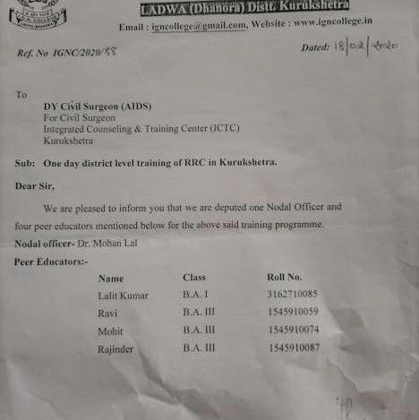

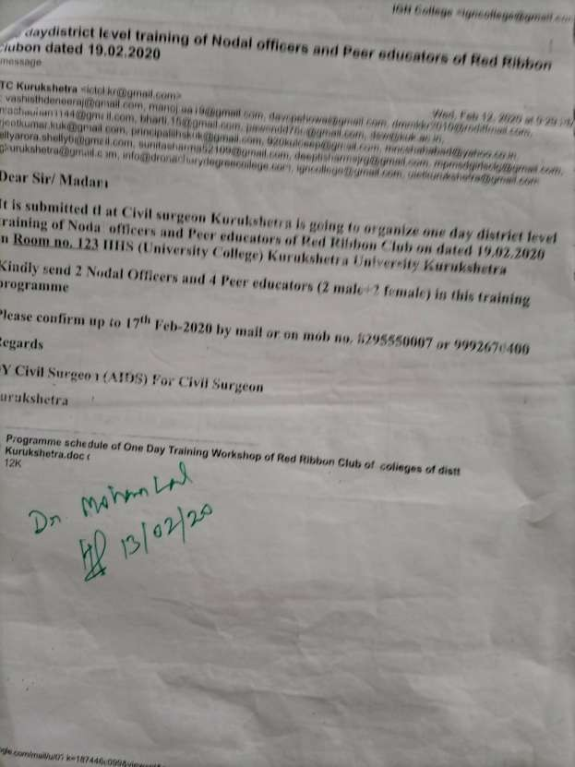

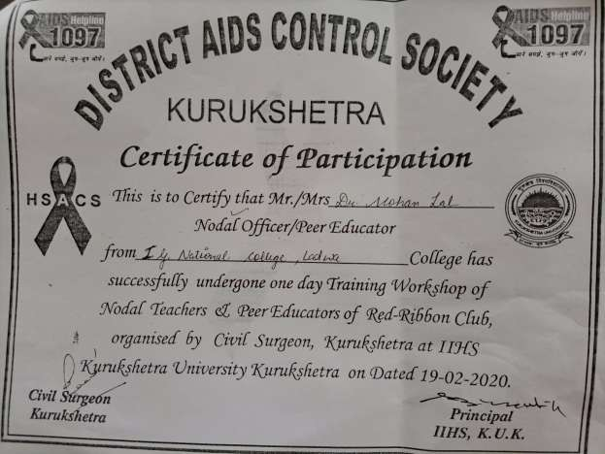

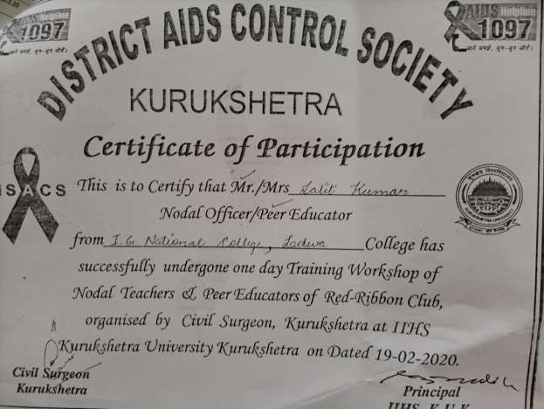

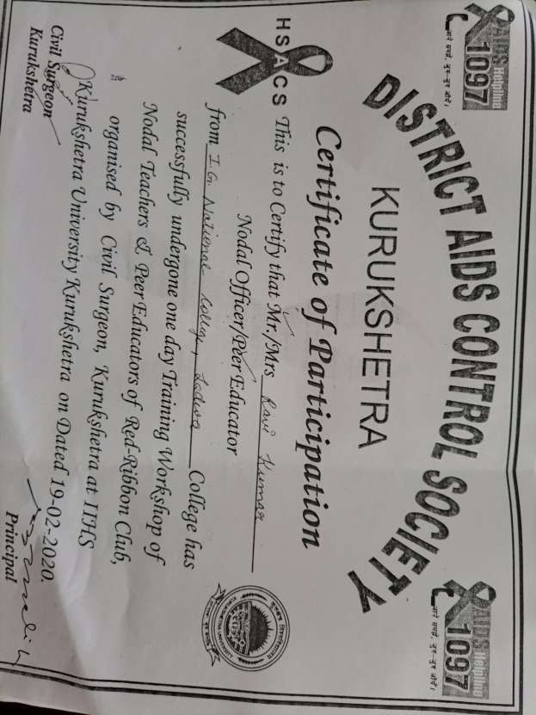

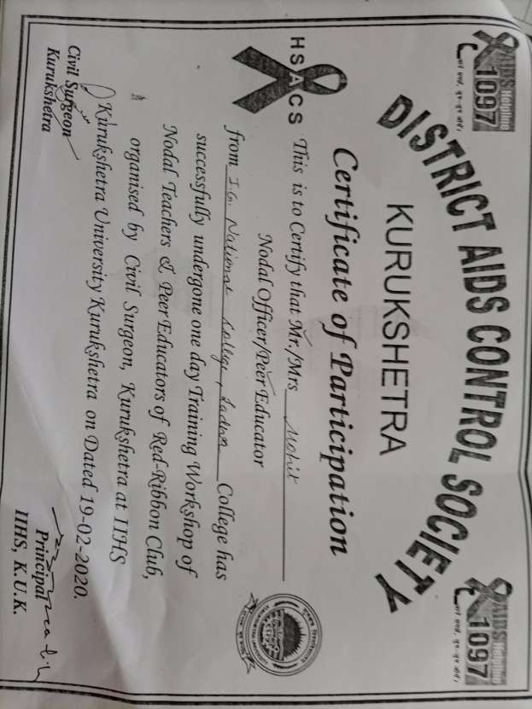

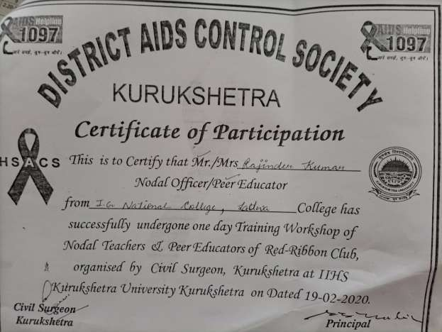

Report

Report on one day district level training of Nodal Officer and Peer Educator of Red Ribbon club dated 19.02. 2020

A workshop for nodal teachers and peer educators of Red Ribbon club was organised on behalf of district AIDS control society Kurukshetra.Dr.Anupma Saini,( Dy. Civil Surgeon,AIDS) and Dr. Neha Sobti (Medical Officer) LNJP,KKR were the resource persons in this workshop. The teachers and volunteers associated with RRC were acquainted with drug awareness and mental hygiene and other activities of RRC.In this workshop four students and one teacher participated. All the participants were also given certificates.

Dr.Mohan Lal Incharge,Red Ribbon Club

