Dr. Mohan Lal, Incharge, Red Ribbon Club

Activities done by Red Ribbon Club in the session 2019-20

Sr.No. | Date | Days | Chief Guest | Topic | Participant
1. | 12.02.2020 | One day workshop | Dr. Anjali Vaid,SMO, CHC,Ladwa | Health Problems of Youth | 7 faculty Members & 59 Students

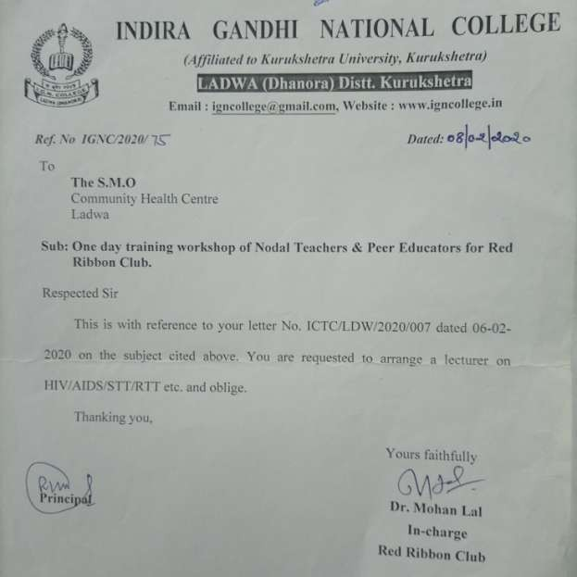

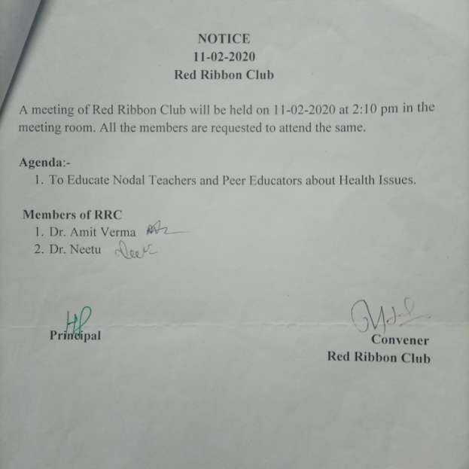

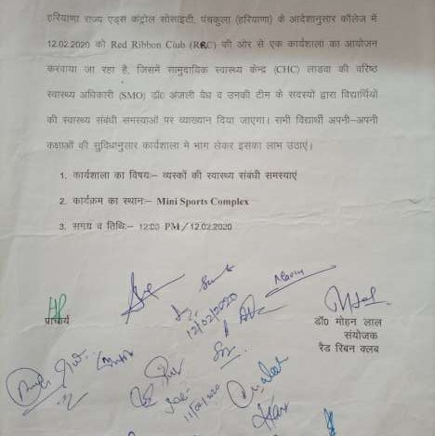

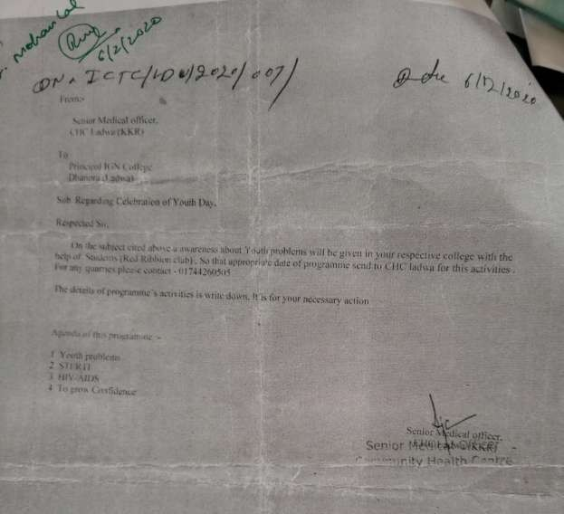

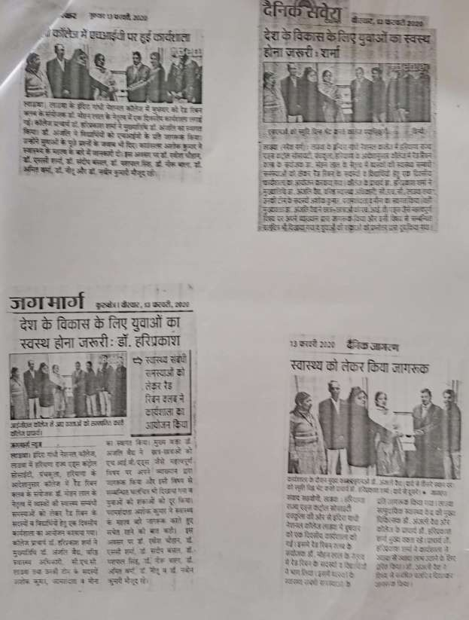

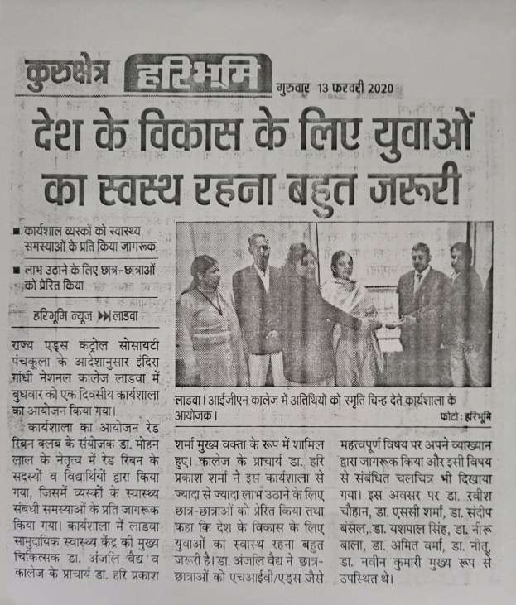

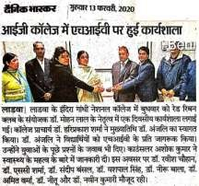

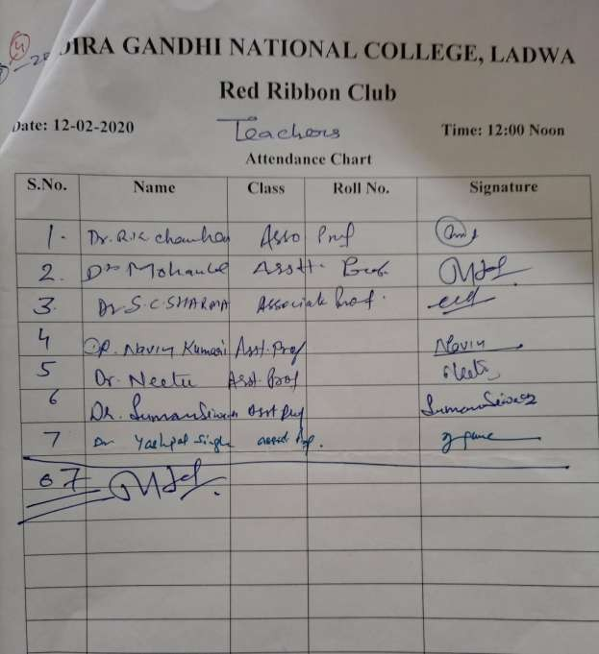

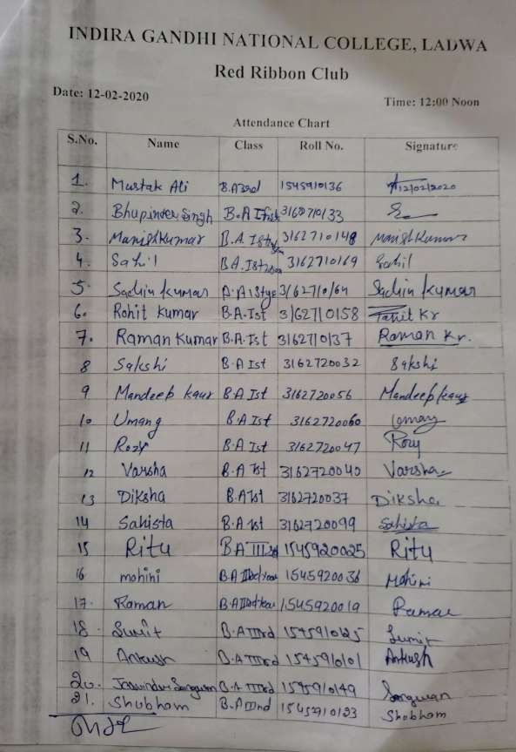

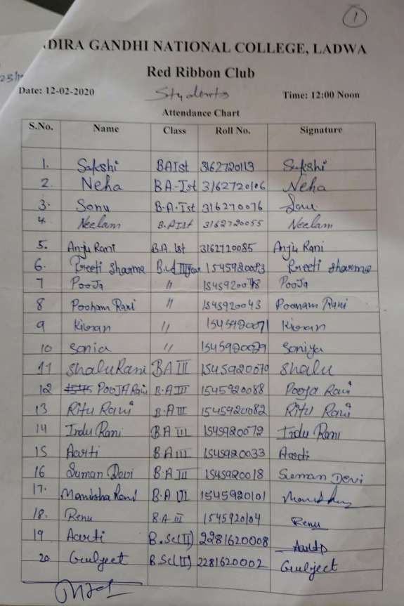

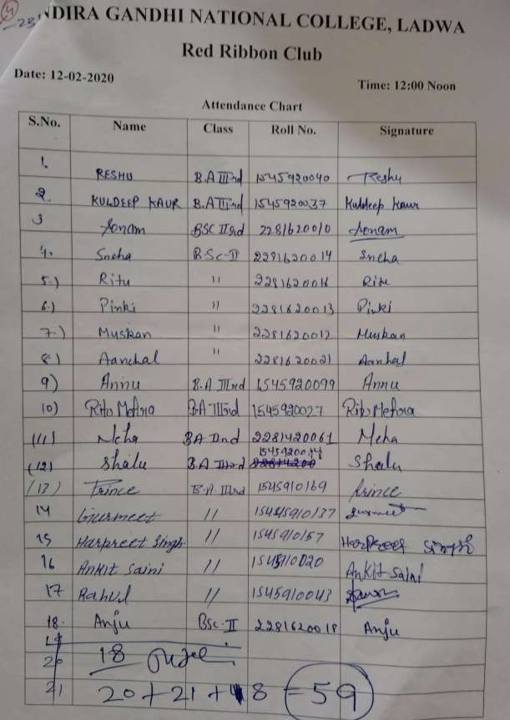

Report

Report on one day workshop conducted on 12.02.2020

One-day workshop on "Health Problem of Youth" was organised for the faculty members and students of Red Ribbon club in direction of Haryana state AIDS control society
Panchkula under the leadership of Dr.Mohan Lal , convener of Red Ribbon club.On this occasion Dr Anjali Vaid SMO,CHC,Ladwa and Mr Ashok Kumar,consultant were the chief guest
.The students were acquainted with health problems & preventive measures for diseases like AIDS and coronavirus by Dr.Anjali Vaid. 59 students and seven faculty member attended the workshop.

Dr. Mohan Lal

Incharge, Red Ribbon Club

