Awareness Programme on National Voter Day 25-01-2020
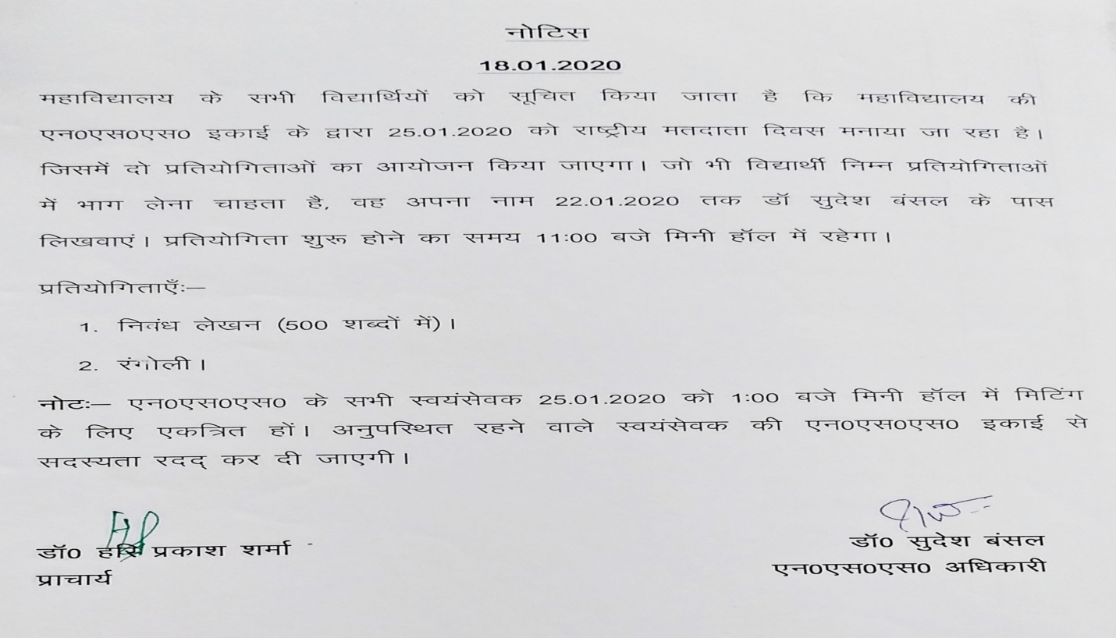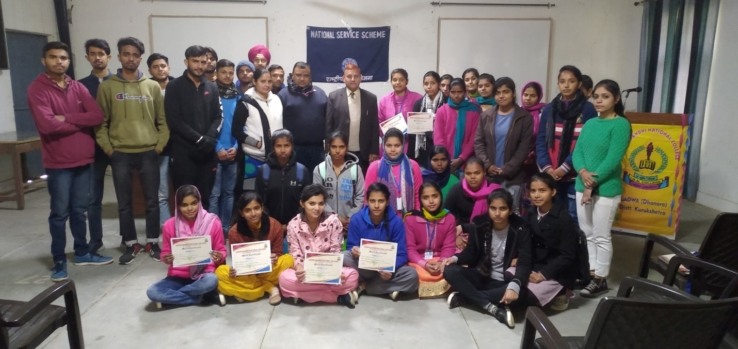
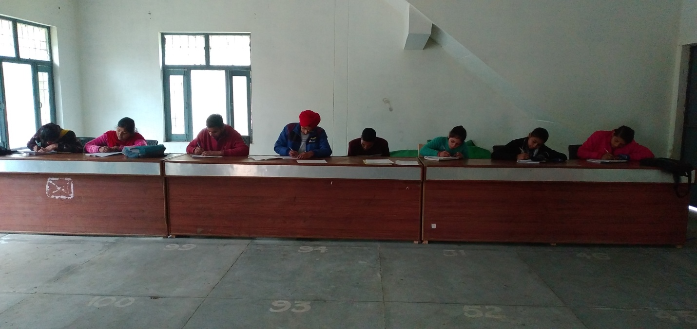
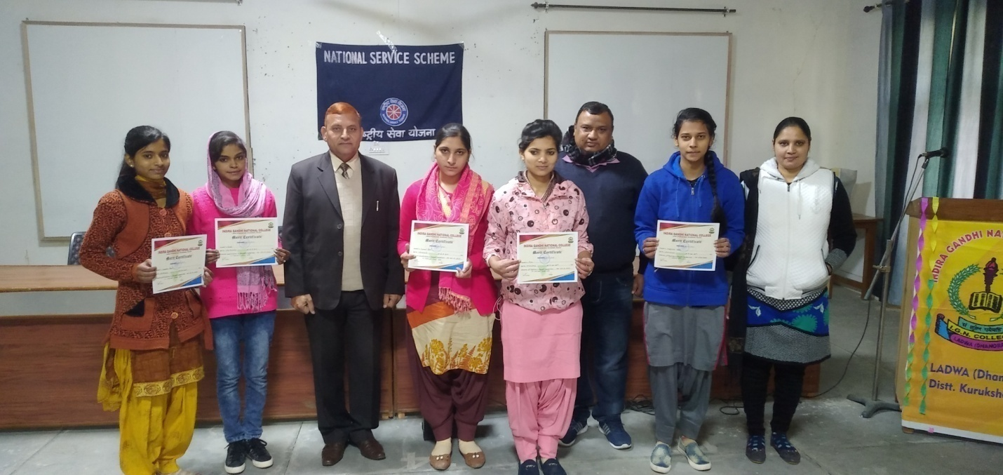
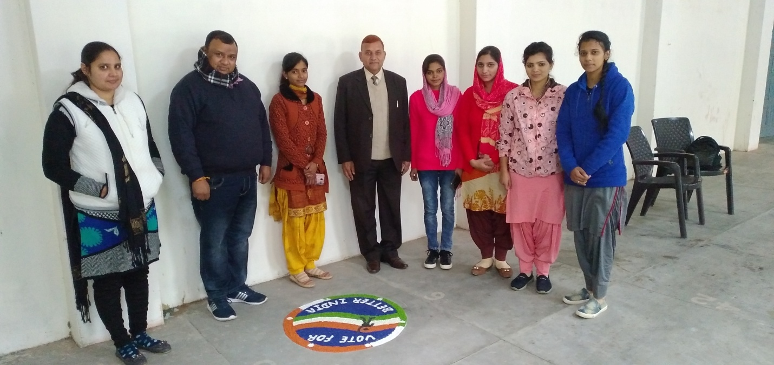
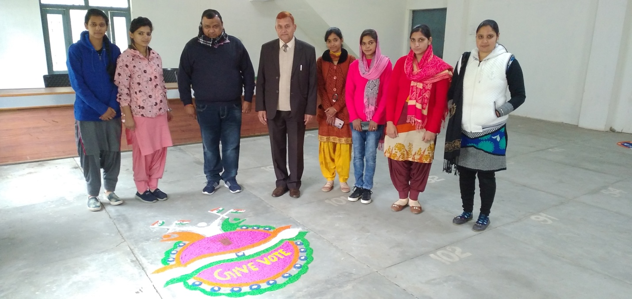
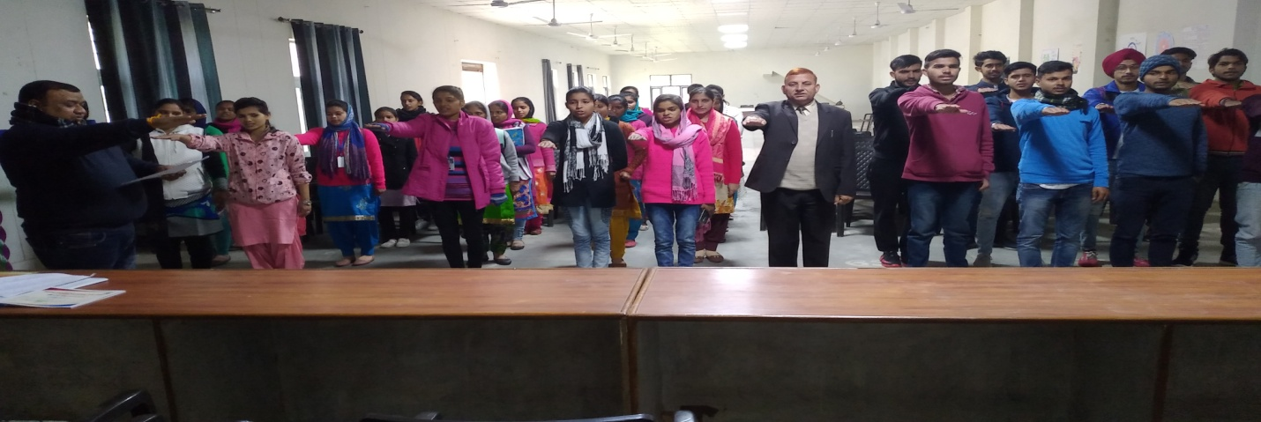Oath Taking on National Voter Day
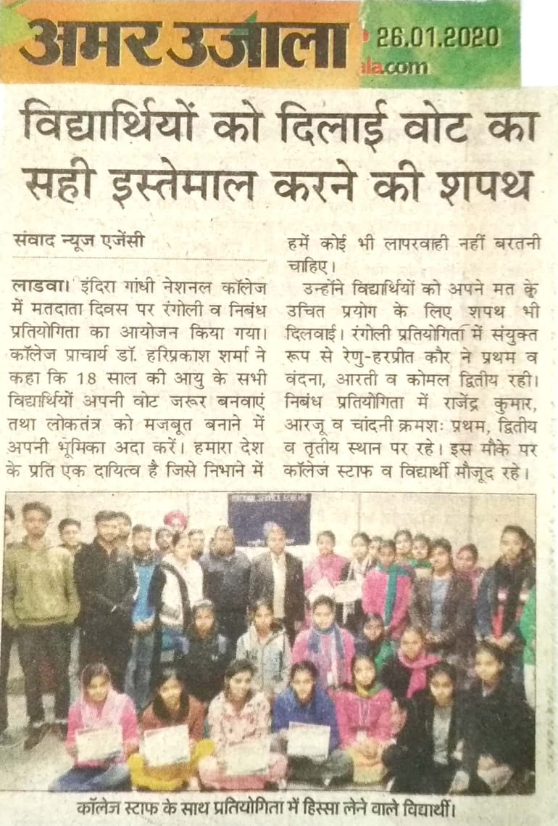
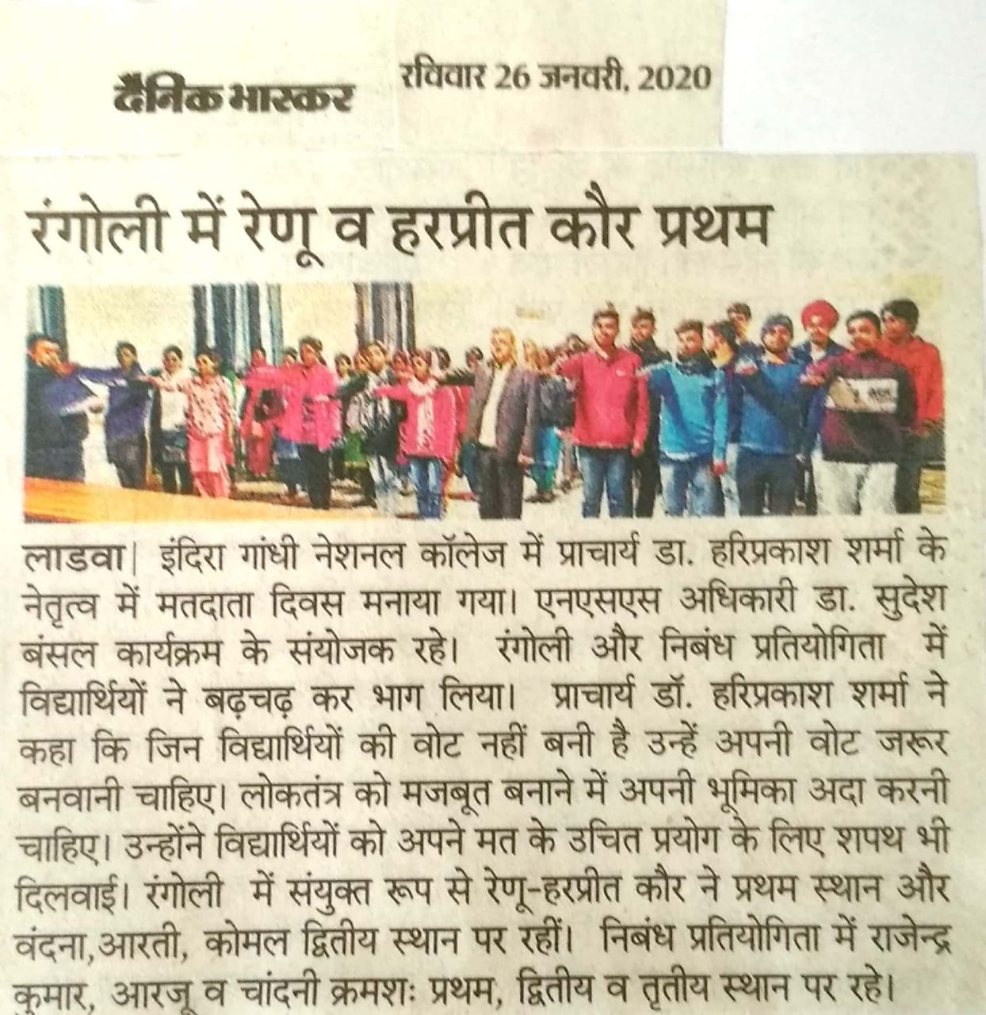

Report of National Voters’ Day
25-01-2020
National Voters’ Day was celebrated by the NSS unit of the college. On this occasion Essay writing and rangoli competition was organized. 18 volunteers took part in the both events. Function was conclude with a pledge taking ceremony.

Principal Dr. Sudesh Kumar
NSS Programe Officer

