Notice
30-10-2019
All the students of the college are informed that today, on the occasion of National Unity Day, an oath taking ceremony and Run for Unity program will be organized in the ground in front of the classroom at 11:00 am. In which all the students must participate. After this program, essay writing competition and painting competition will also be organized in the college library on the occasion of National Unity Day. The program will start at 11:30. Therefore, all the students participate in today's program and cooperate in national integration.

Principal Dr. Sudesh Kumar
NSS Programe Officer

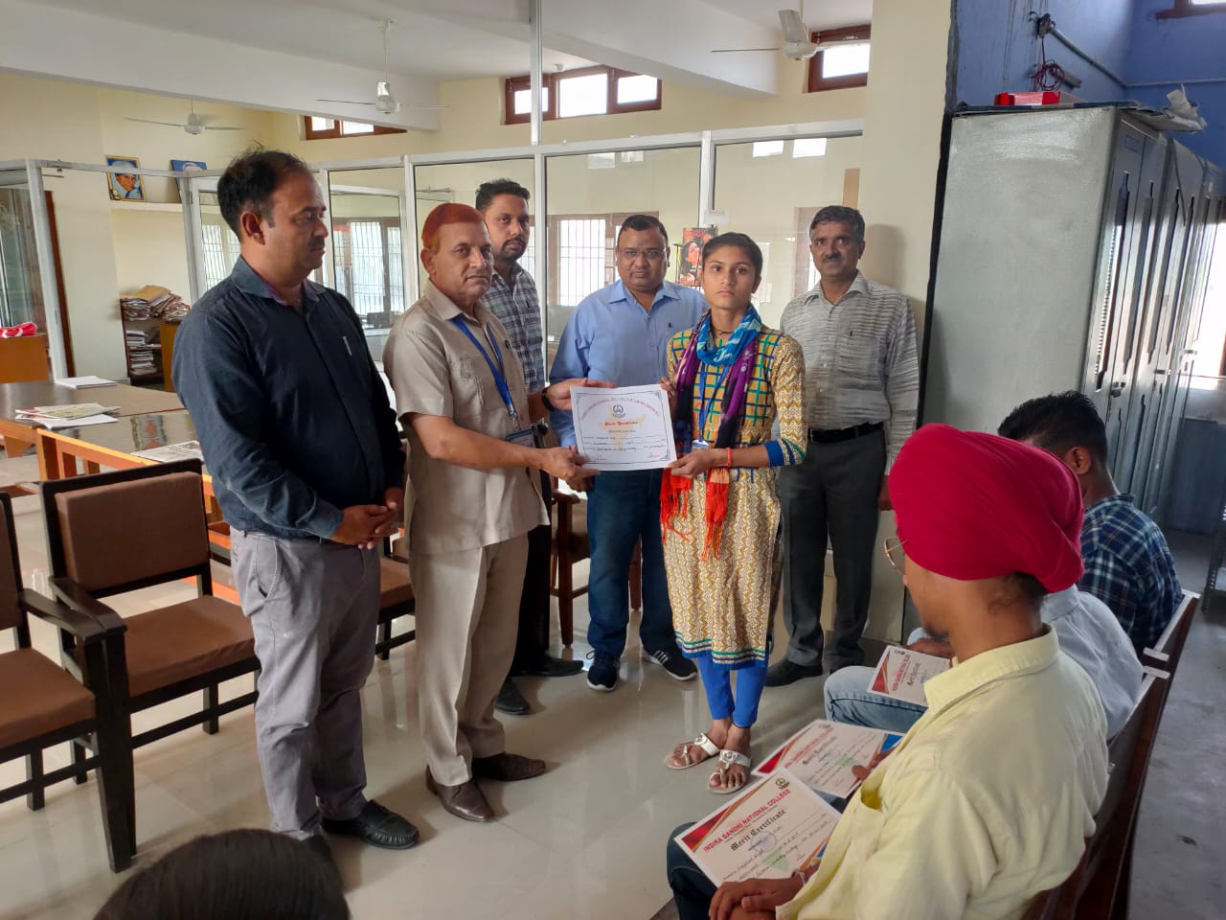
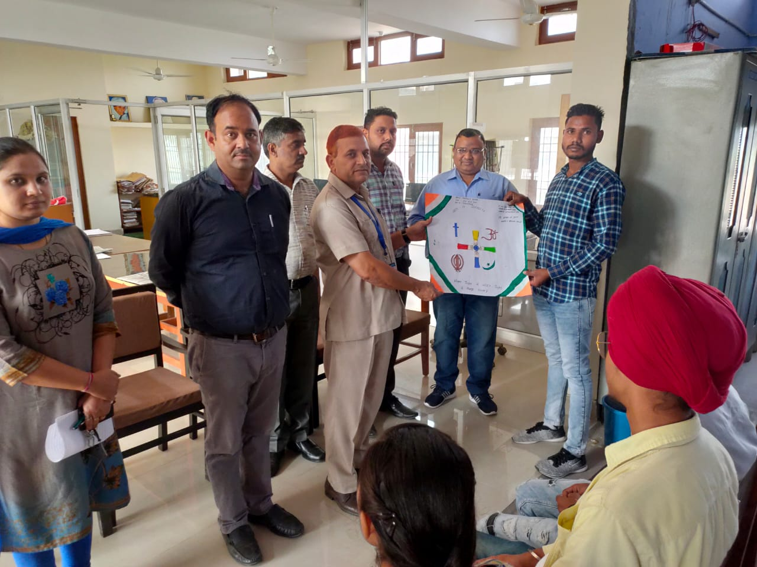Easy Writing & Poster Making Competition
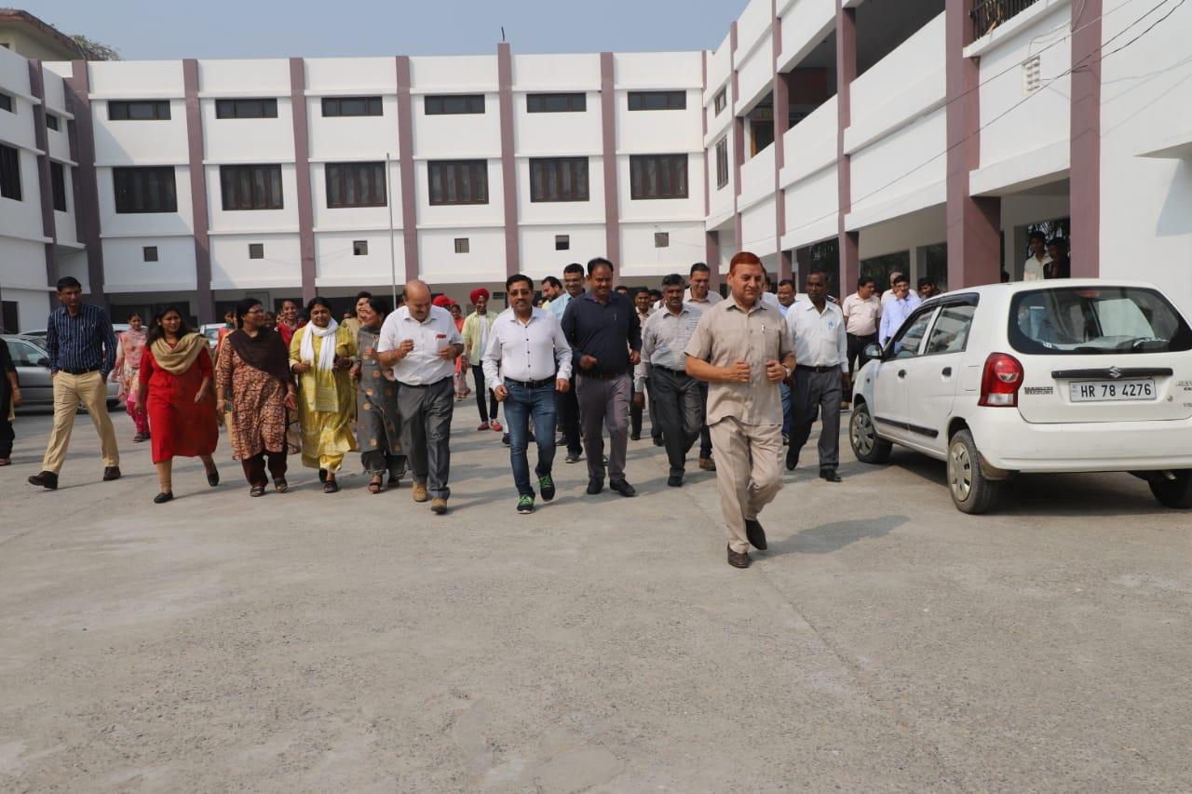Run for Unity
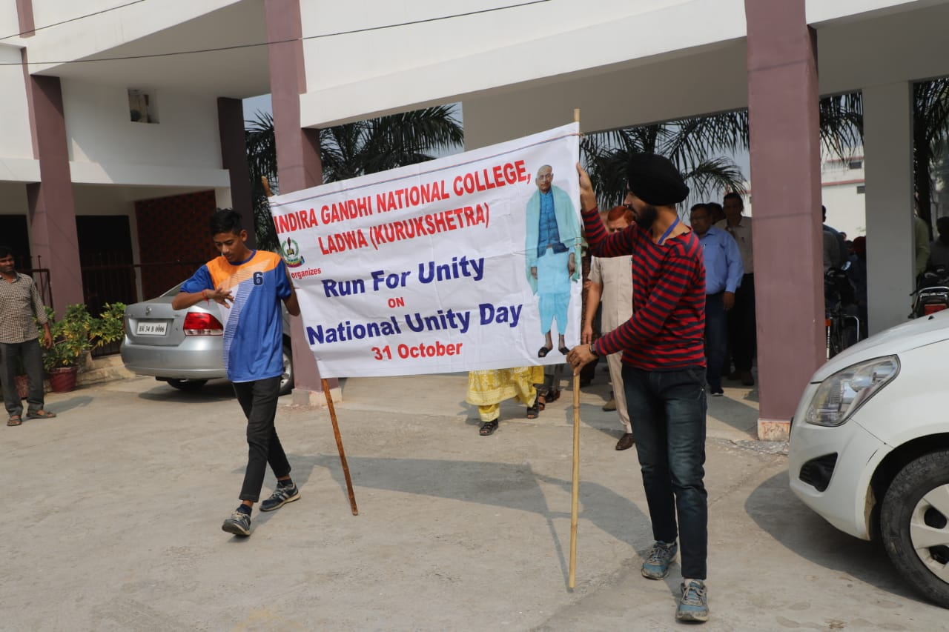
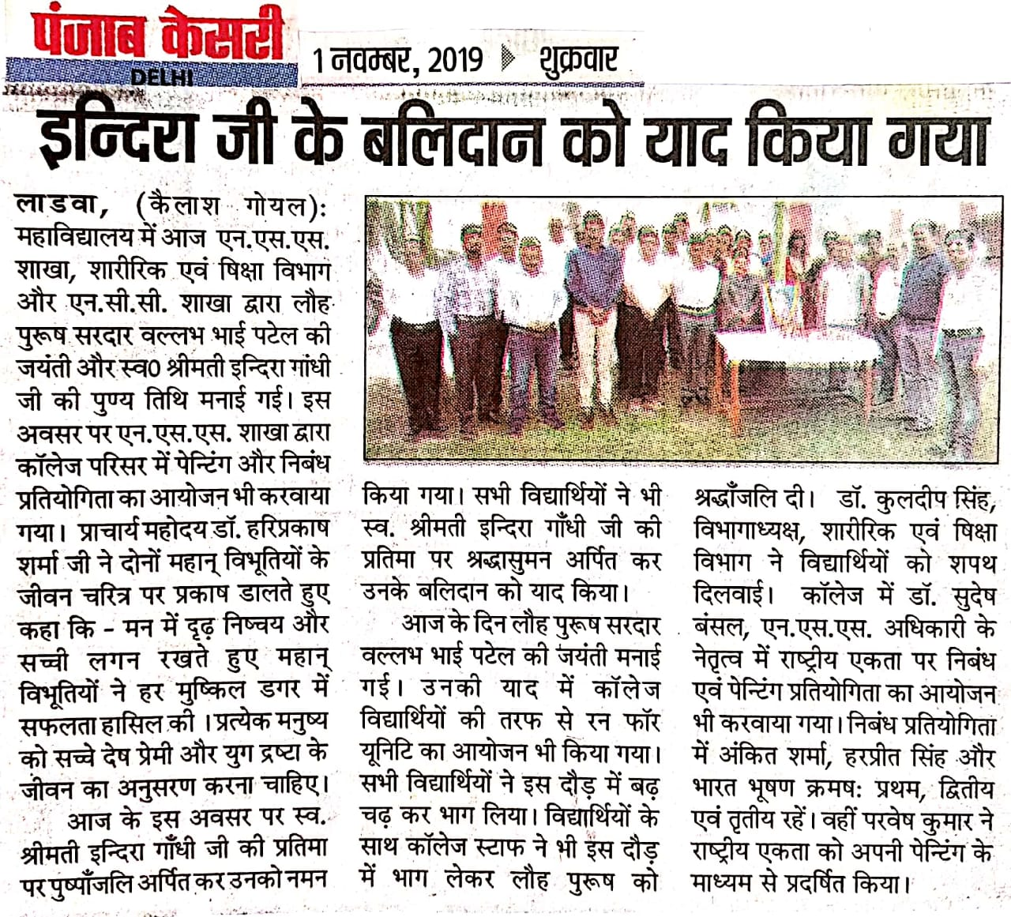

Report of National Unity Day
31-10-2019
National Unity Day was celebrated by the NSS unit of the college on 31-10-2019. Run for Unity, Essay writing and poster making competitions were organized on this occasion. 58 volunteers took part in this program.

Principal Dr. Sudesh Kumar
NSS Programe Officer

