Notice
23-10-2019
All the students of the college are informed that those who have cast their vote in the Haryana legislative assembly. An appreciation certificate will be given to all the students by the Higher Education Department on 23-10-2019 in the mini sports complex at 10:00 AM.

Principal Dr. Sudesh Kumar
NSS Programe Officer

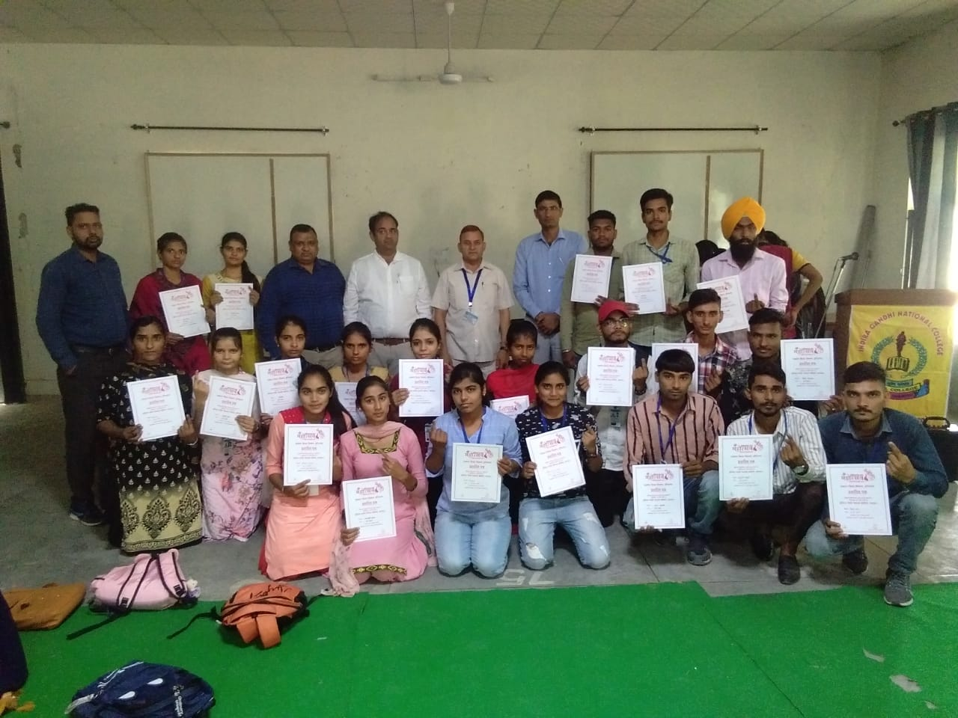
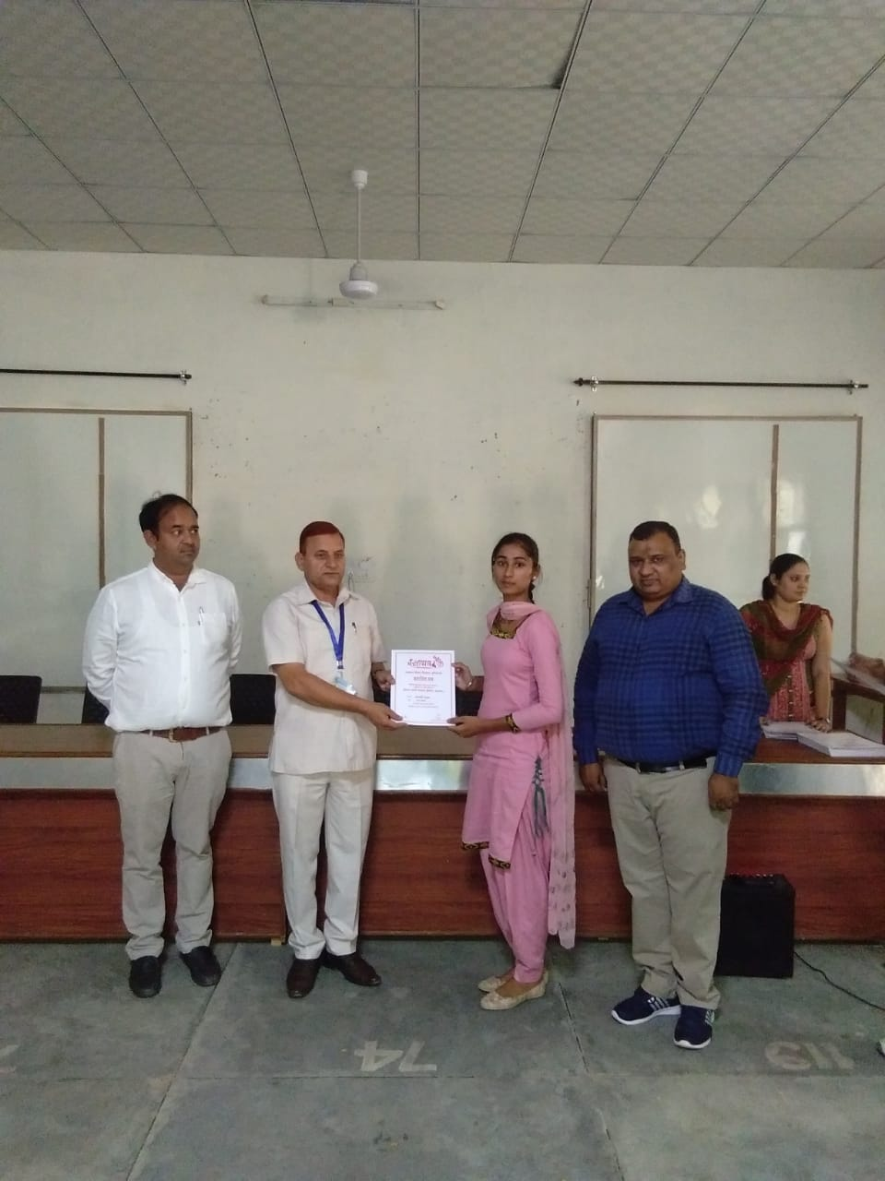
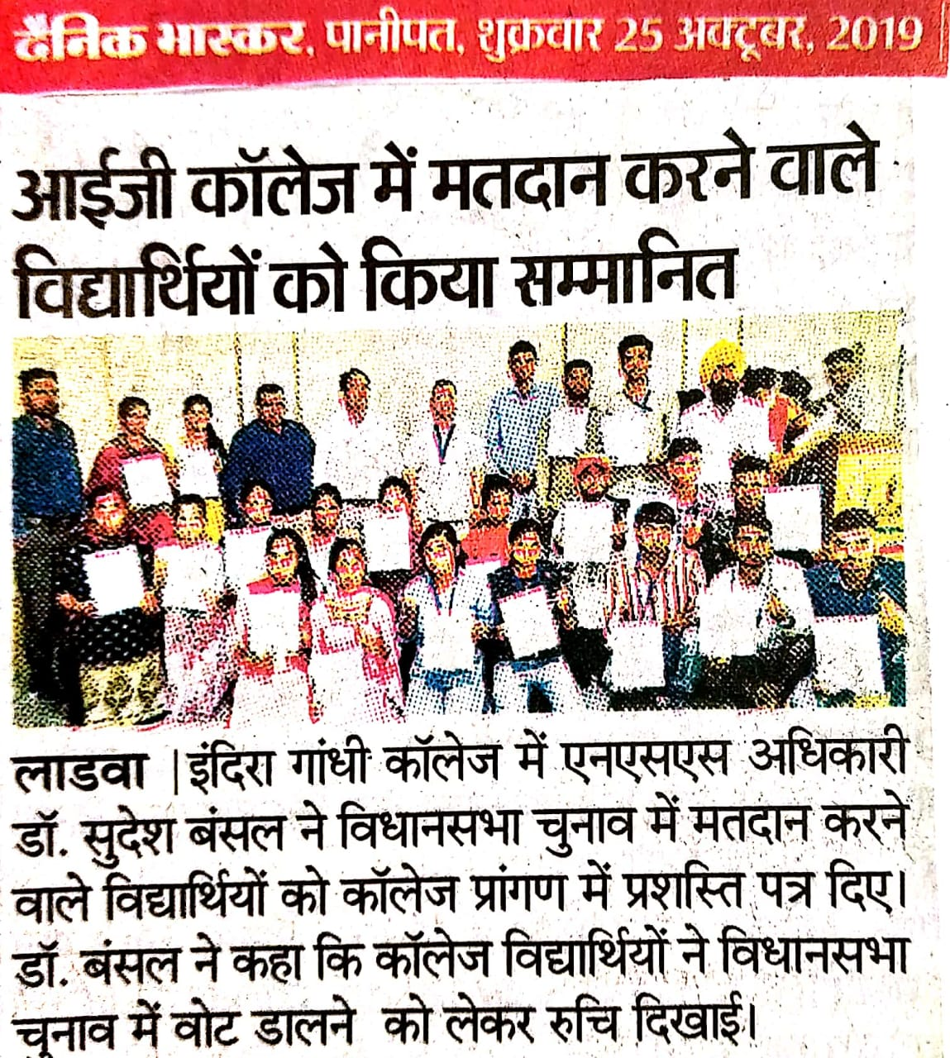
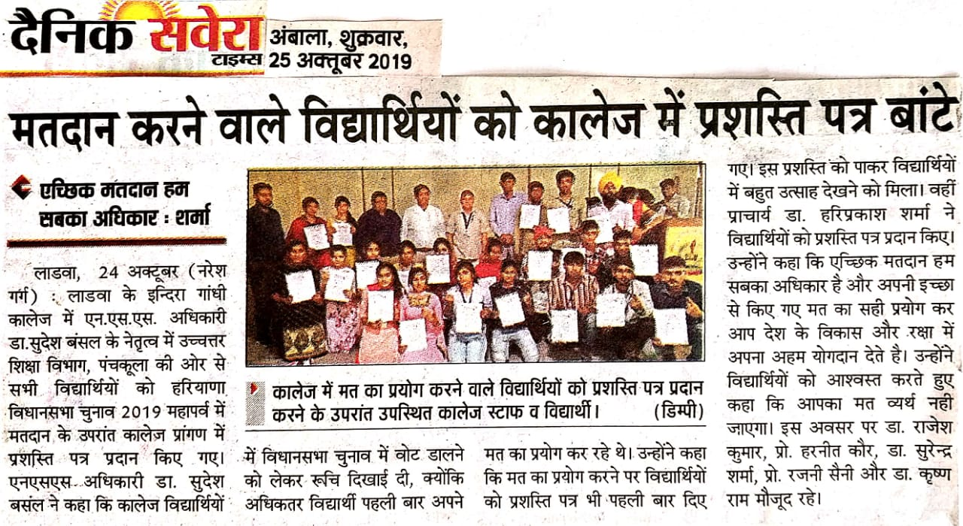
Report of Voter Appreciation
23-10-2019
An Appreciation certificate was given to all the voter students of the college for casting their vote in Haryana Legislative Assembly by the Higher Education Department. 53 Volunteers took part in this program.

Principal Dr. Sudesh Kumar
NSS Programe Officer

