Report
Ratnawali Yuva Saang Mahotsav 2018-19

“Ratnawali Yuva Saang Mahotsav, 2018-19” (Yamunanagar Zone) was organized at nearby villages – Mathana and Budha from 27 February to 2 March 2019. During this event, different colleges of Yamunanagar zone presented their performances each day. The celebration aimed at the promotion of “Saang – A folk theatre form of Haryana”
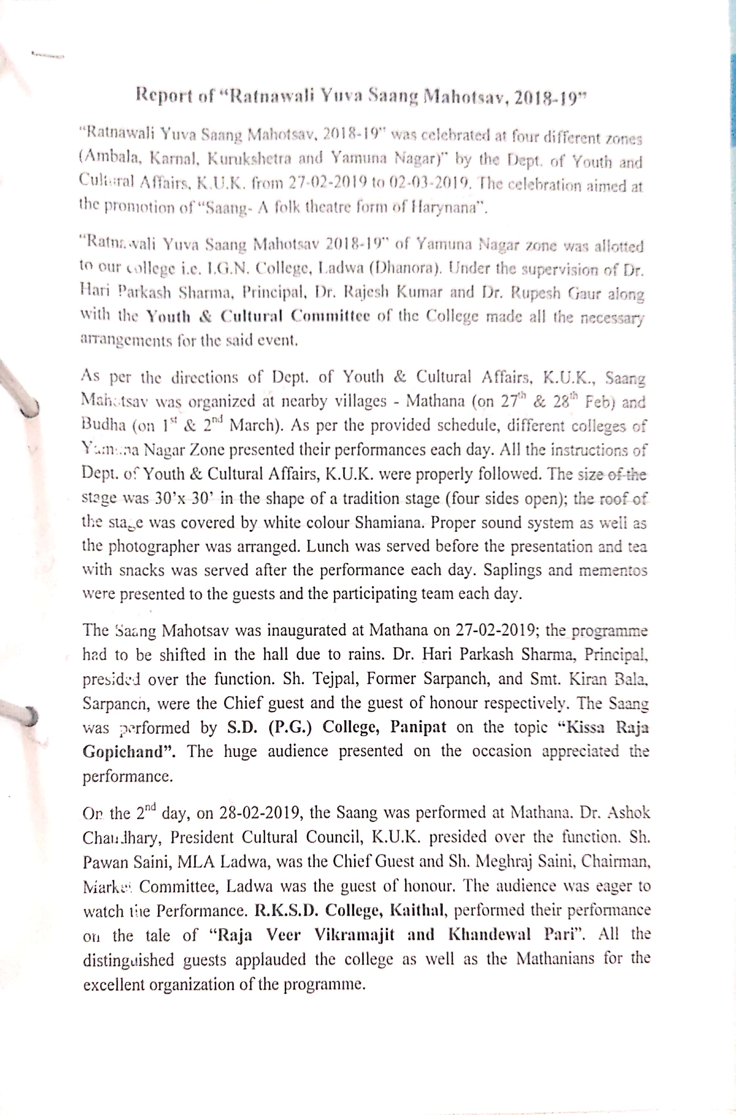
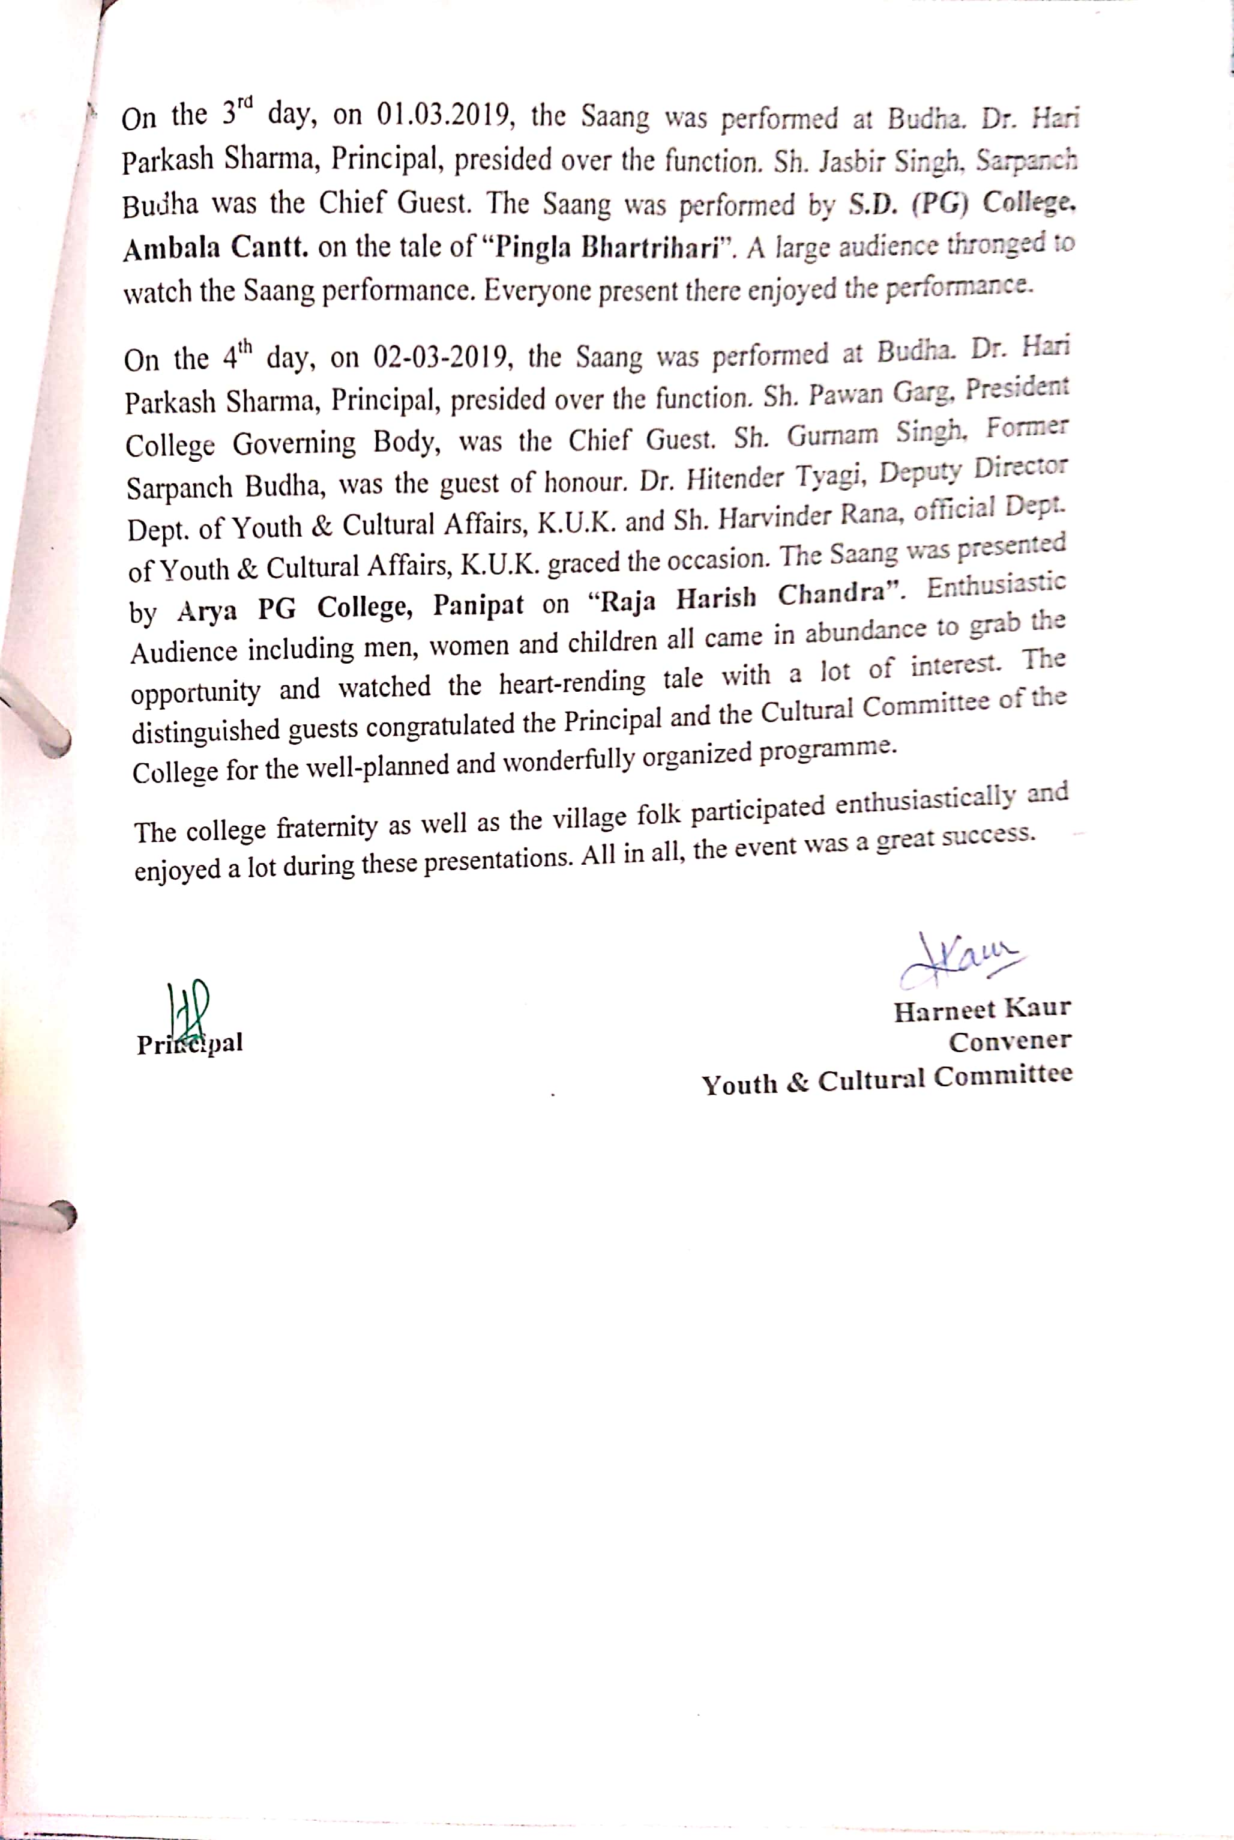
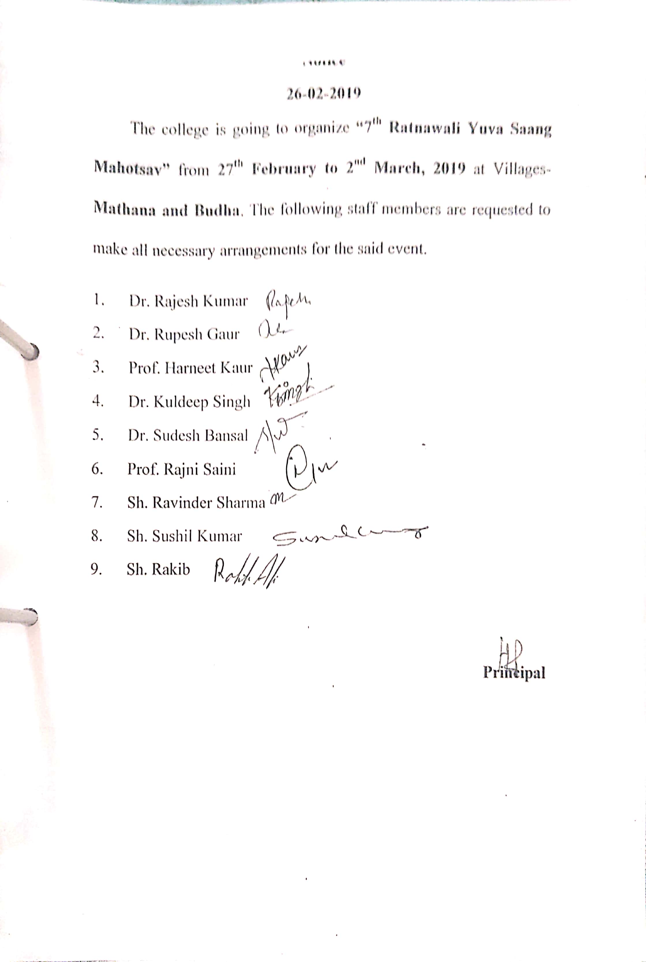

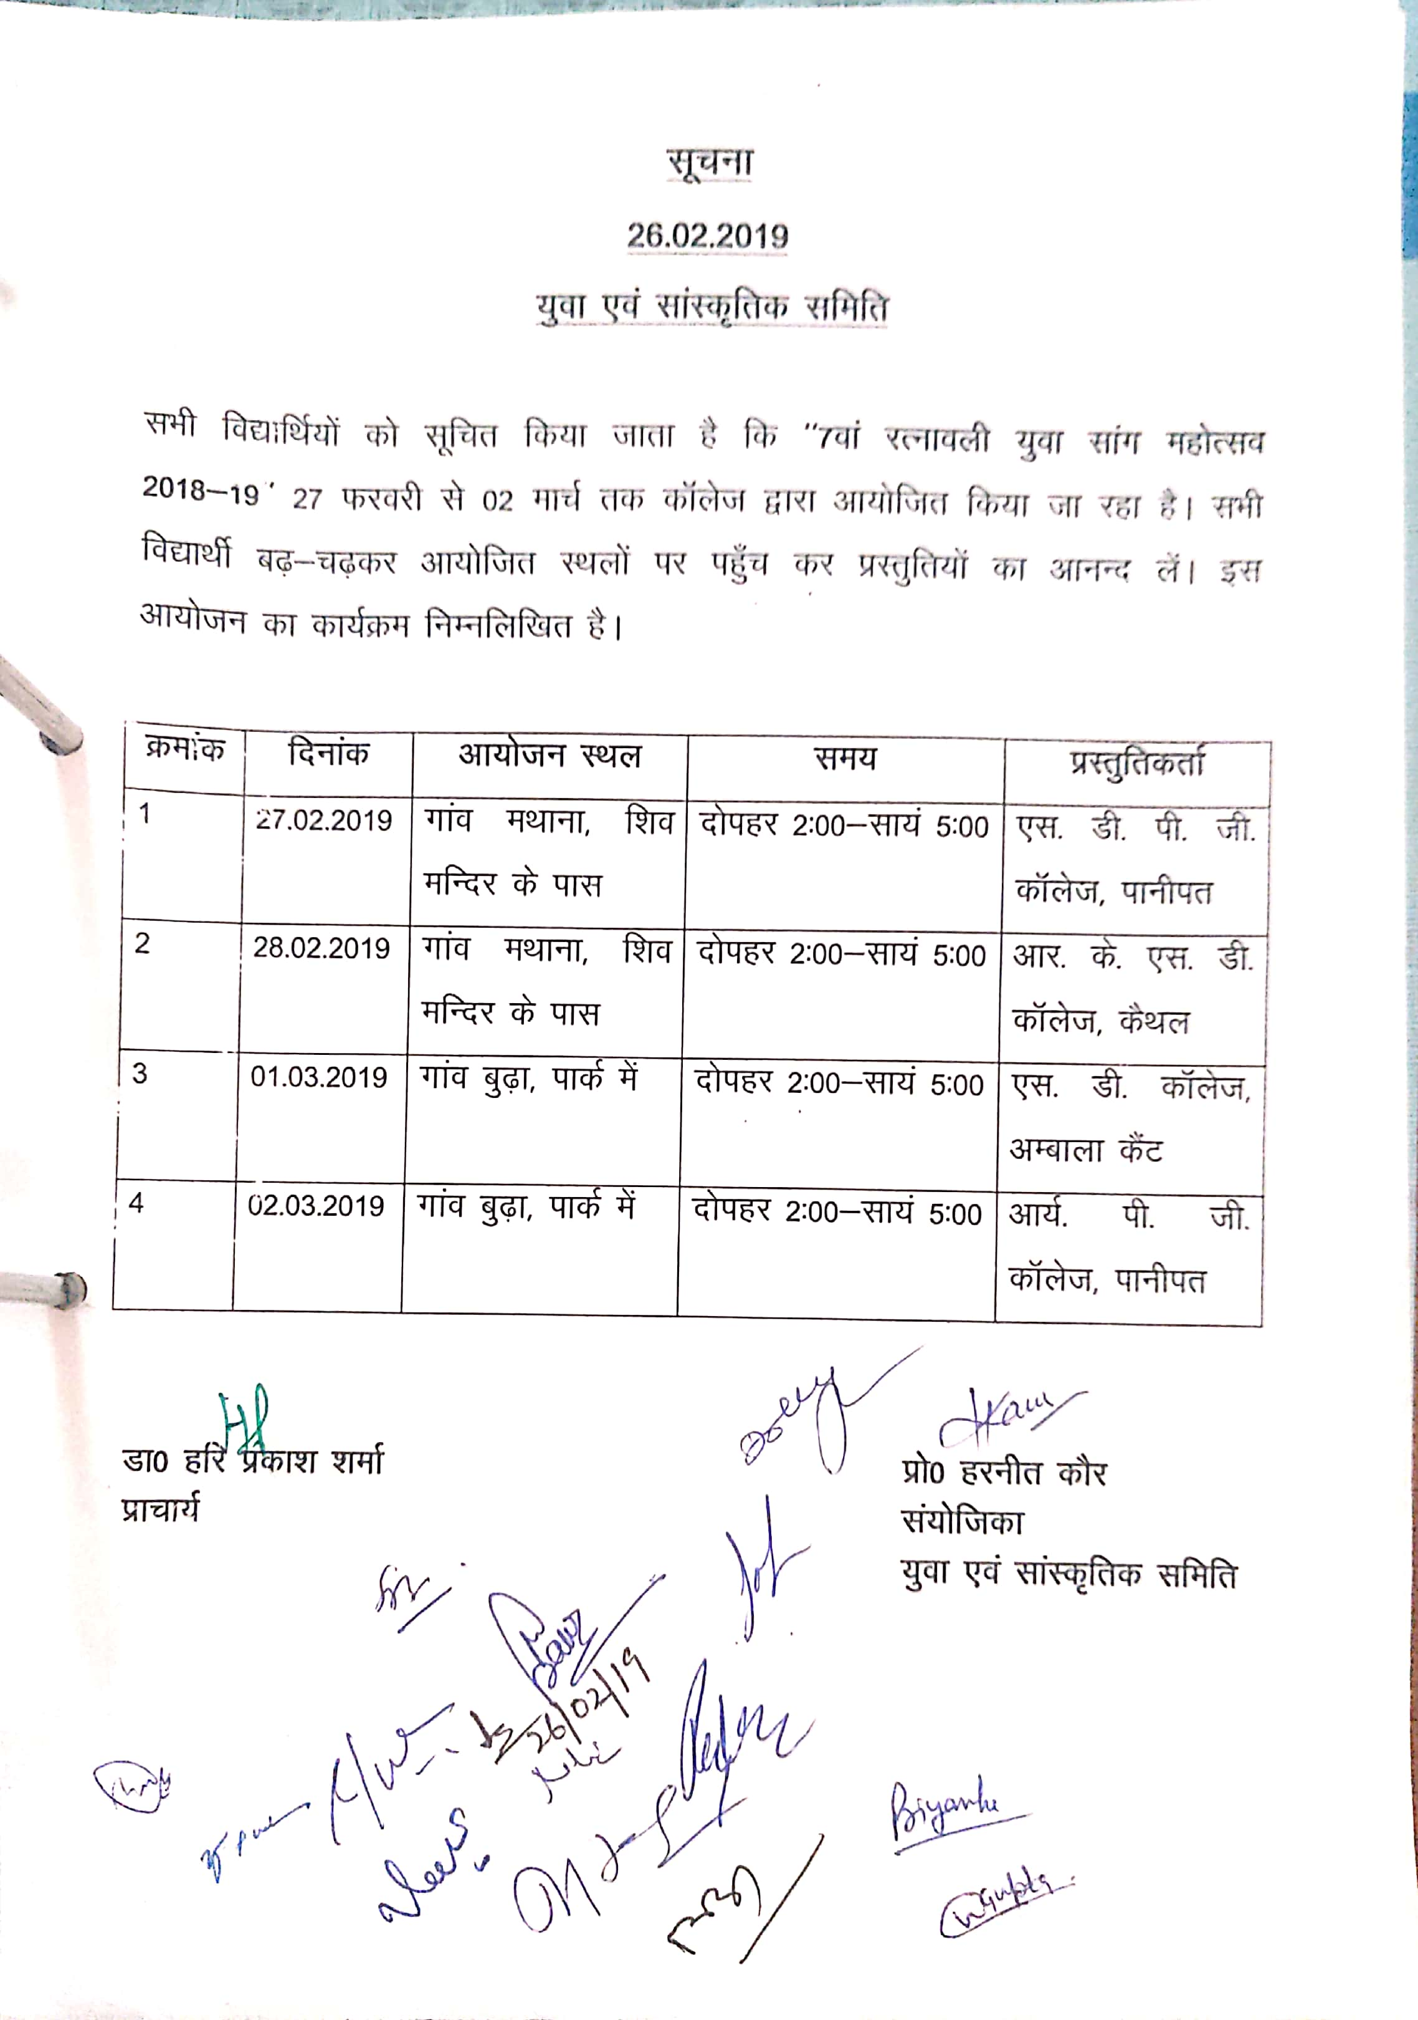
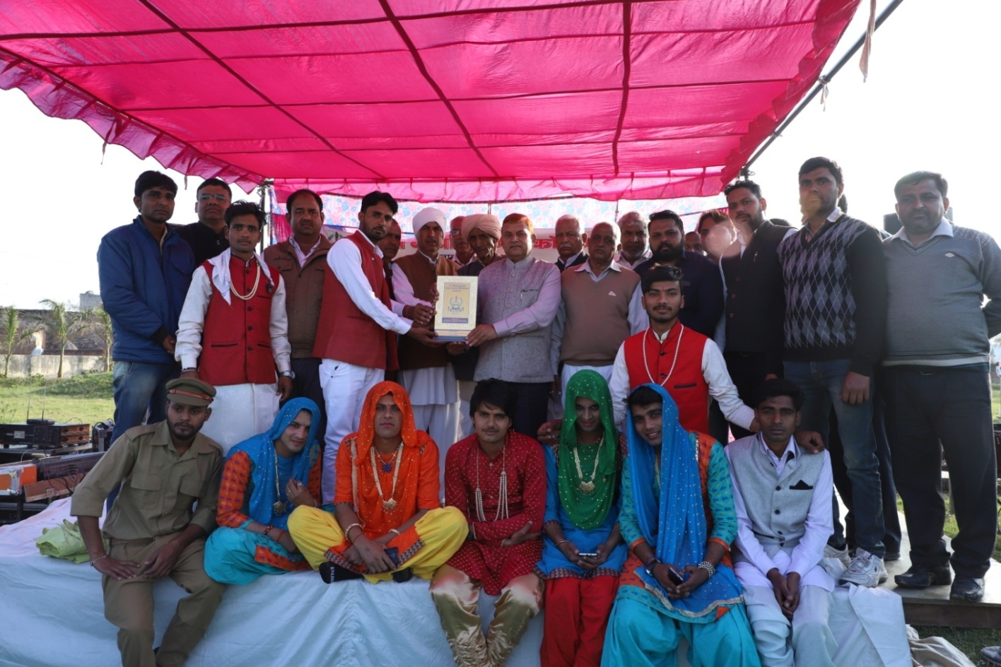
Principal and the staff, presenting memento to the participating team of Ratnawali Yuva Saang Mahotsava at village Budha on 01-03-2019

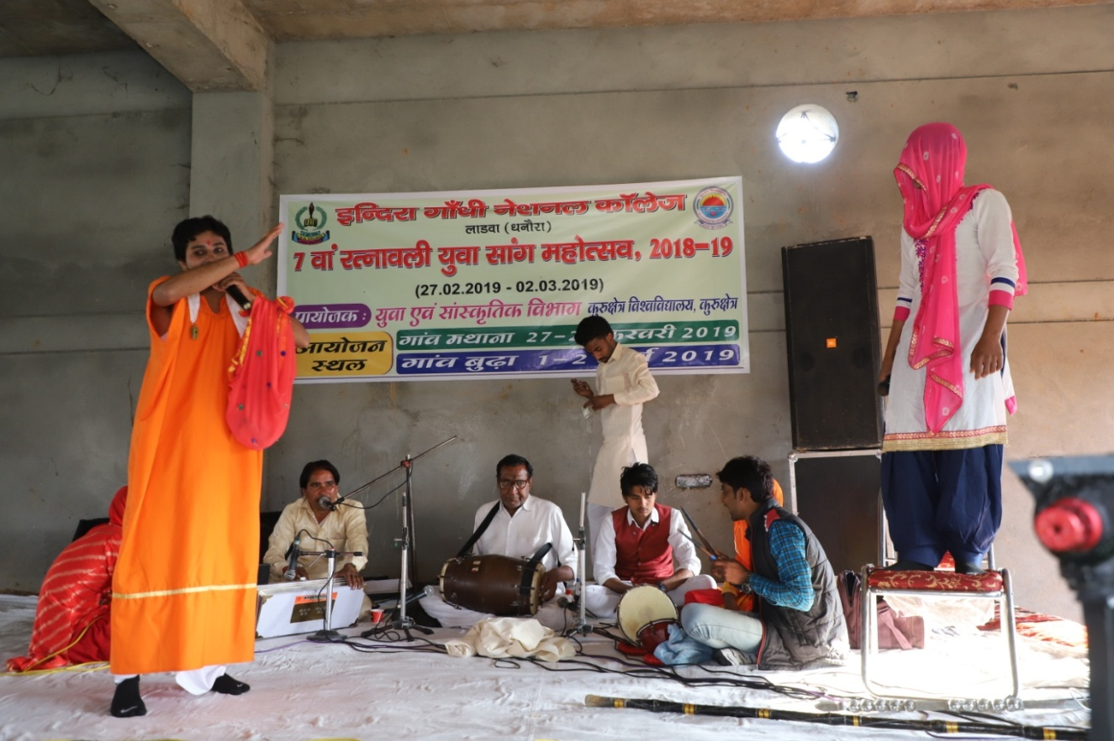
Ratnawali Yuva Saang Mahotsava at village Mathana on 27-02-2019
