One Day Camp 02-10-2019
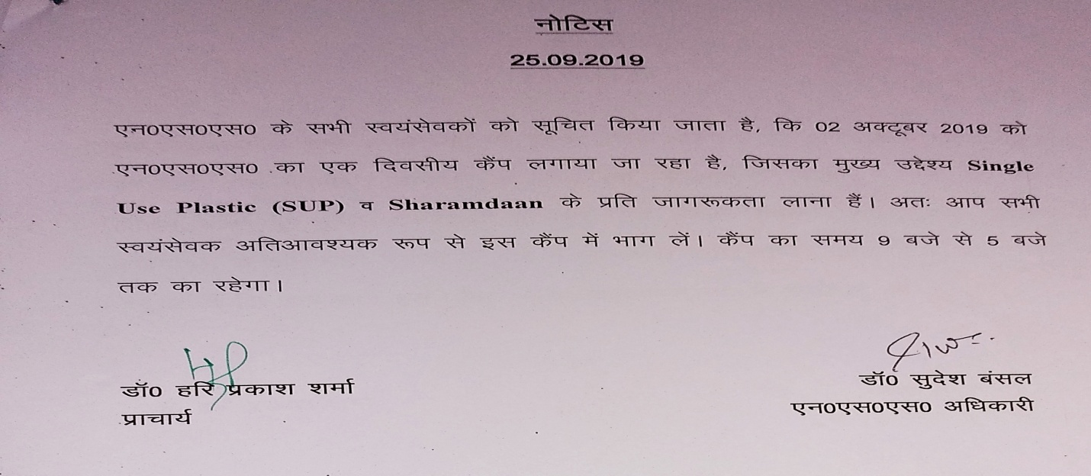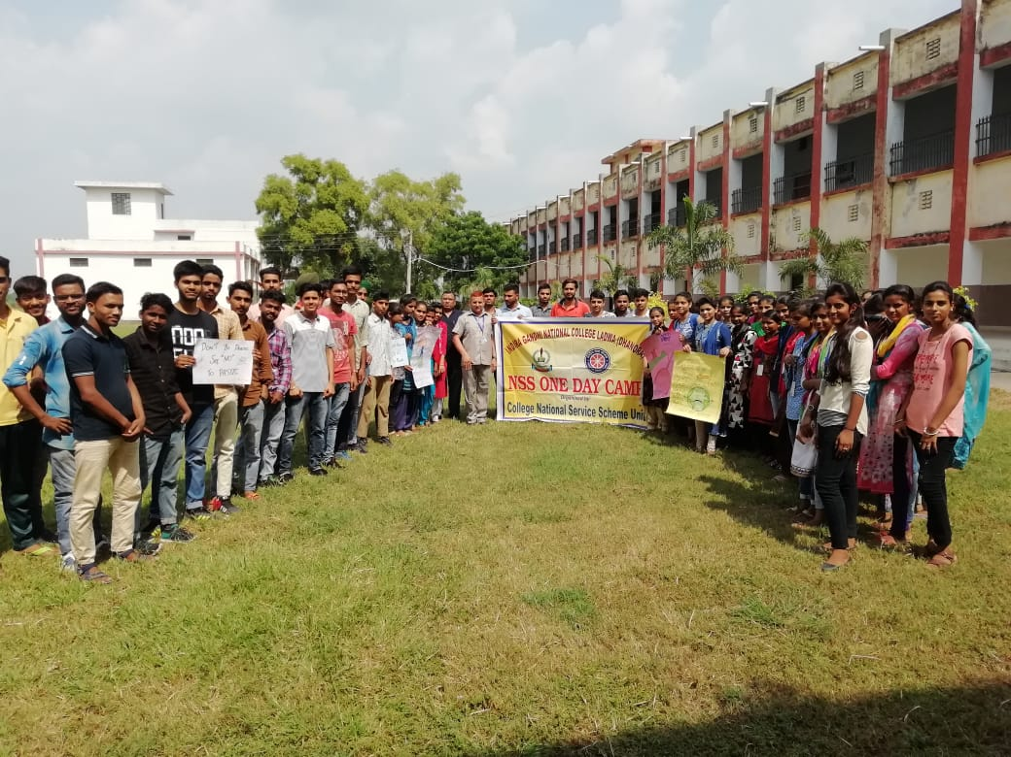
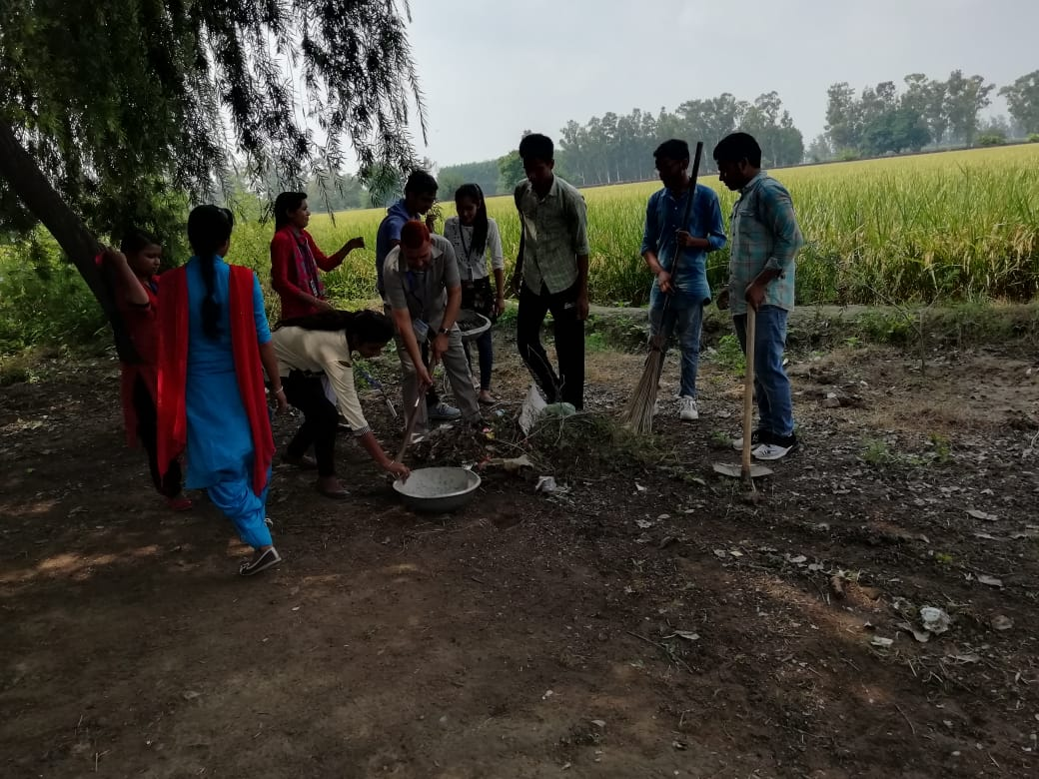
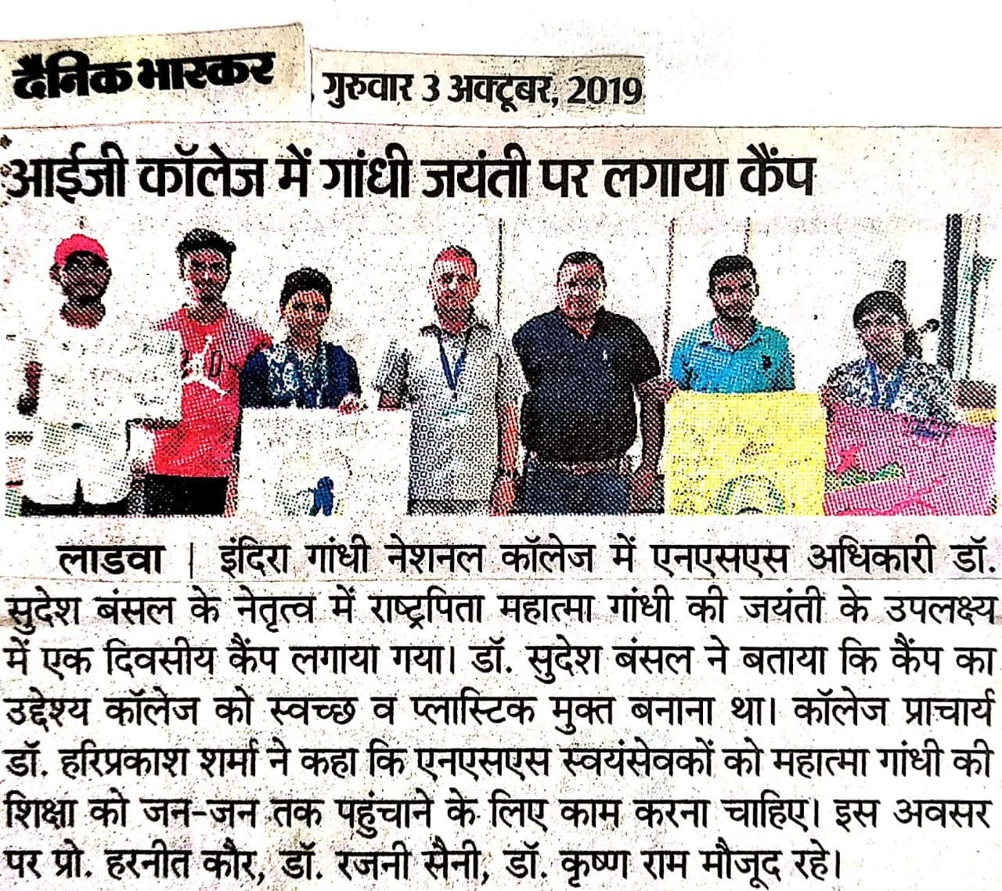
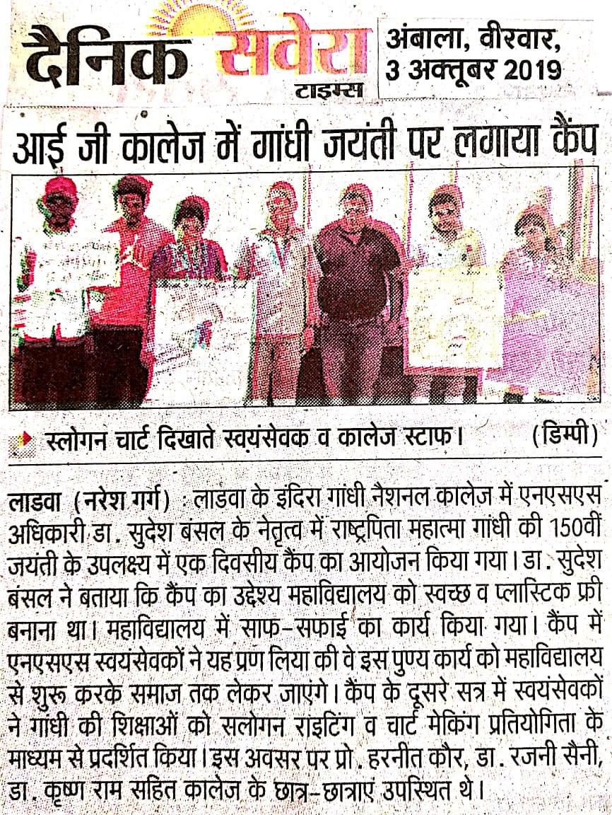
Report of One Day Camp
02-10-2019

One Day NSS camp was organized on the occasion of the 150th birth anniversary of Mahatama Gandhi by the NSS unit of the college with the objective of ‘Say No to Single Use Plastic’. Volunteers were indulge in cleanliness in the first half and in the second half volunteers took part in making chart and slogan writing competitions on the life of Mahatama Gandhi. On this occasion 60 NSS volunteers took part in this camp.

Principal Dr. Sudesh Kumar
NSS Programe Officer

