Special 7 Days ( Day & Night ) Camp : 18.03.2018-24.03.2018

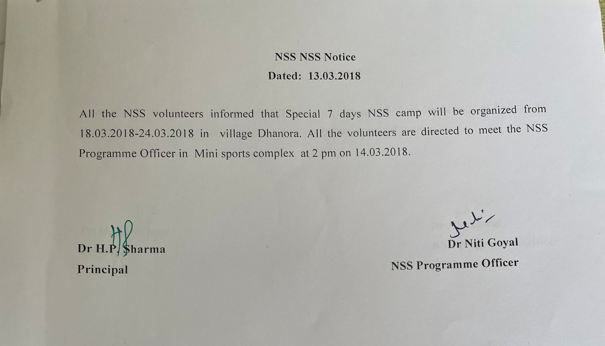

A report of 7 days Special NSS Camp
18/03/2017 | Vill. dhanora | Inauguration of camp by Dr DS Rana, NSS coordinator, Kurukshetra University, Sarpanch Babu Raam ji, college principal Dr Hari Parkash Sharma & school headmaster Om Prakash ji.  Cleaning of school campus
19/03/2017 | Vill. dhanora | Rally on road safety  Breaking the ice session for students, lecture on healthy living in modern lifestyle.
20/03/2017 | Vill. dhanora | Awareness drive on water & electricity conservation by door to door visit .  Lecture on Digital literacy by Mr Maharbir Singh Saini, Retd. senior manager, PNB & FLC Councillor, PNB RSETI, KKR
21/03/2017 | Vill. dhanora | Interactive session for the students. TREE Plantation( 80 trees planted)  Workshop on preliminary help after disaster by Dr. Kuldeep Singh, Asst. Prof. IGN, Ladwa.  Cultural Activities
22/03/2017 | Vill. dhanora | Awareness drive on polythene & plastic use & beti bachao beti bachao. Lecture on road safety by Dr Amit Vashisth , Asst. Prof. IGN, Ladwa.  Fencing & watering the trees planted. Personality Development Session
23/03/2017 | Vill. dhanora | Flag hoisting & Celebration of martyrs’ day.  Motivational session by Prof (Dr) Tejinder Sharma, director public Relations KUK. He explained the genesis of NSS, NOT ME BUT YOU. Cleanliness drive
24/03/2017 | Vill. dhanora | Valedictory session and Cultural Activities
19.3.18-24.3.18 | Vill. dhanora | First aid/home nursing training by lecturer from red cross society, Kurukshetra.

57 volunteers participated in the camp

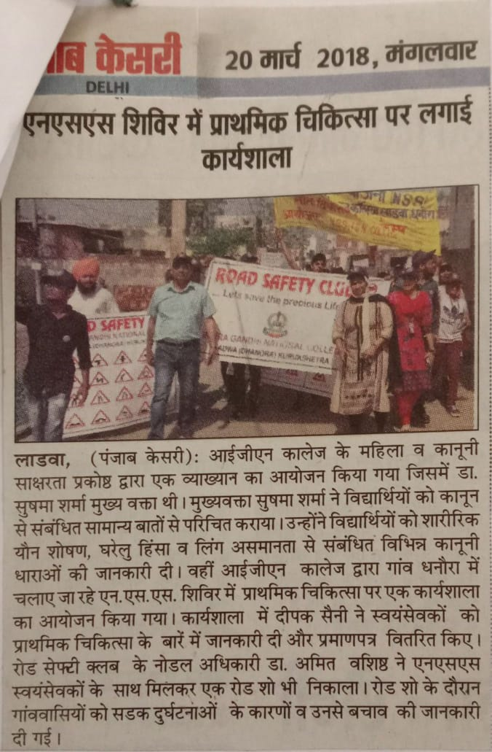

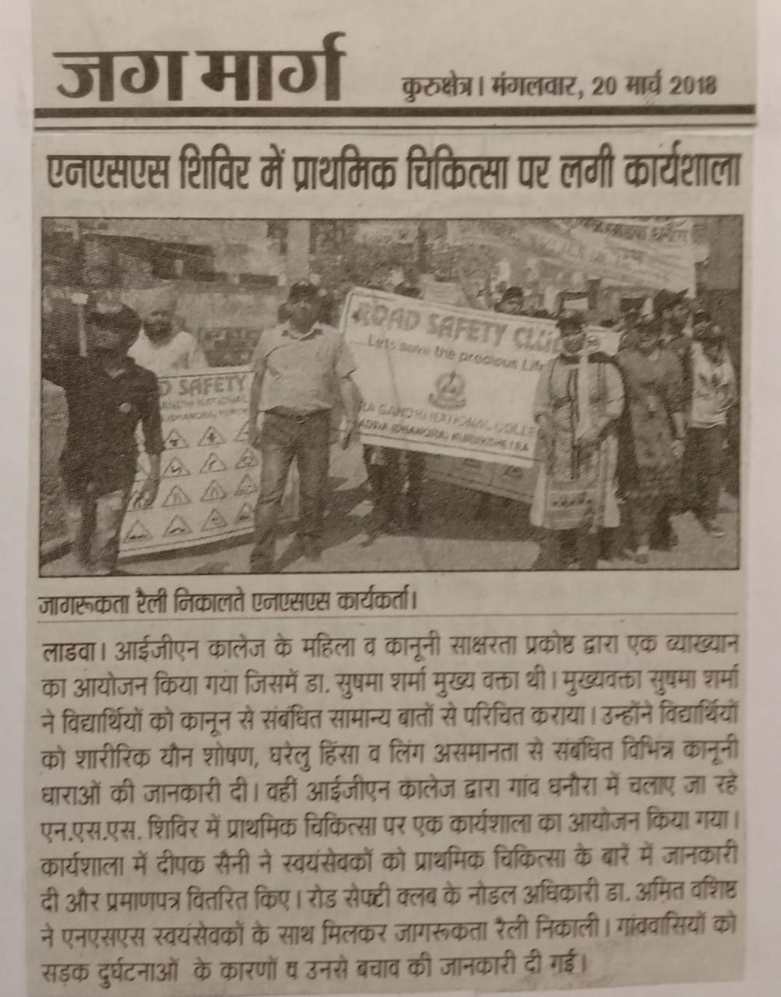
20.03.2018: LECTURE ON DIGITAL LITERACY BY MR MAHABIR SINGH SAINI, PNB RSETI, KURUKSHETRA

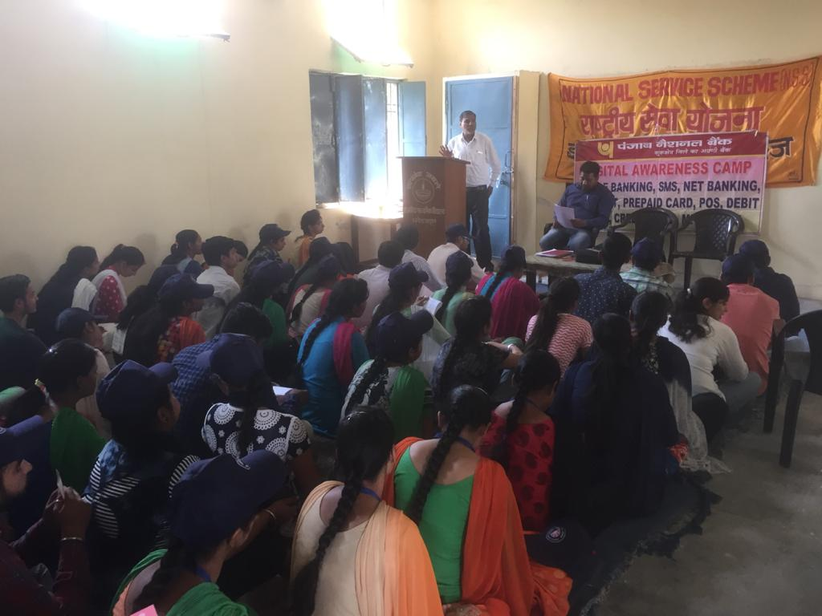

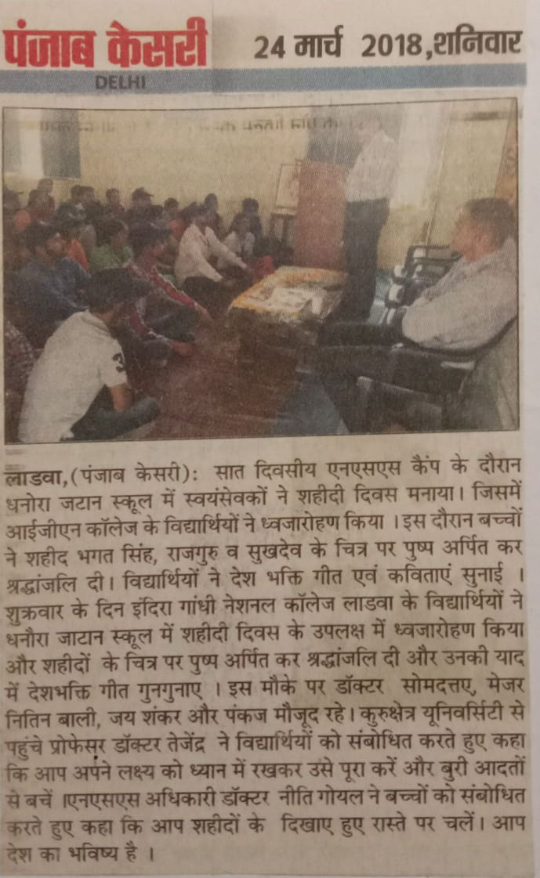

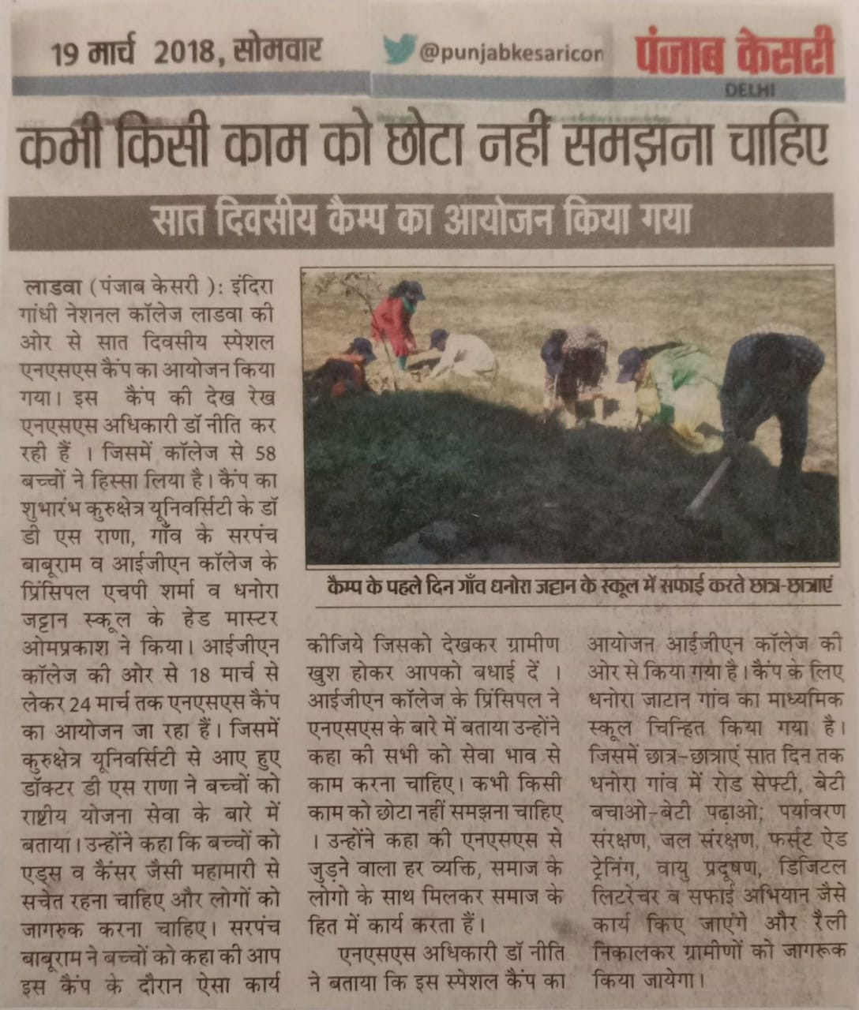

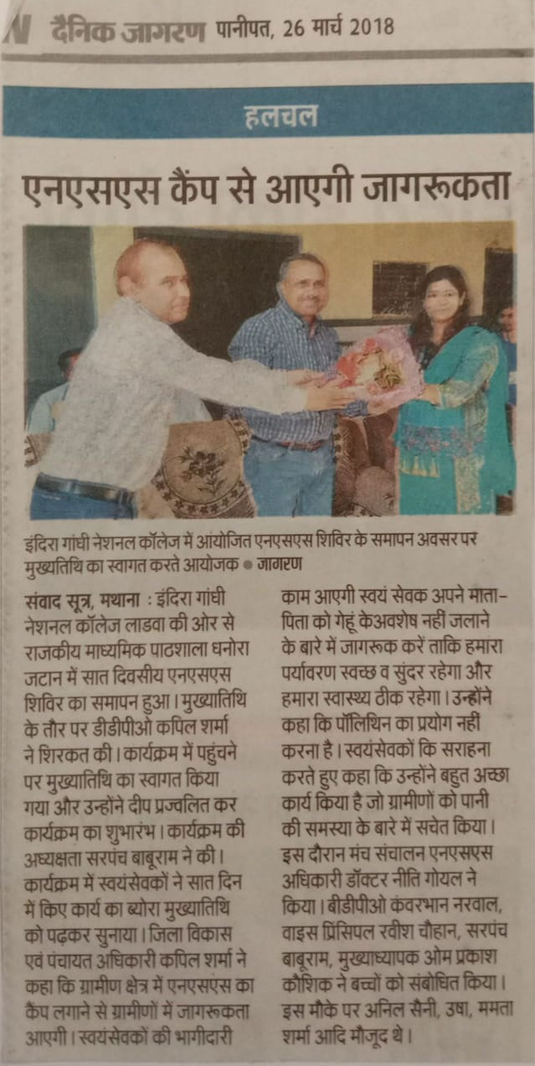

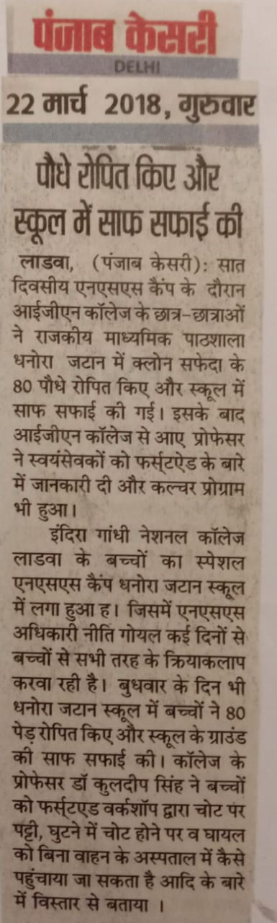

Attendance chart
