Special 7 Days ( Day & Night )Camp : 21.03.2017-27.03.2017

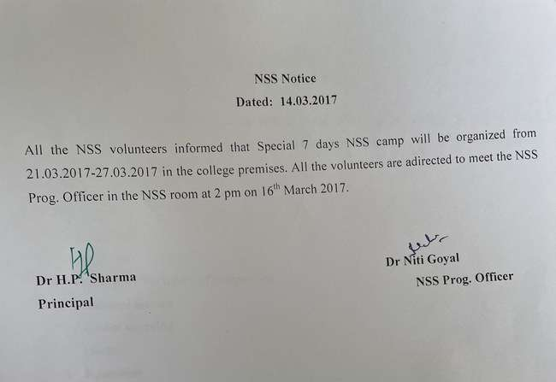
A report of the seven day activities:
21/03/2017 | IGN College | Inauguration by college principal Dr Hari Parkash Sharma. Extension lecture by Dr Rajesh.  Breaking the ice Session( interactive session for students)  Interactive session by Dr Mohan Lal  Cultural Session
22/03/2017 | IGN College | Lecture on the life of Shahid Bhagat Singh by a Mr Parveen (a learned scholar )  Workshop on Personality Development & Creativity.
23/03/2017 | IGN College | Celebration of Martyrs day, Interactive and a thought provoking session on the present state of India.  Cleanliness drive
24/03/2017 | IGN College | Workshop on Computer literacy, online banking and e payments.  Lecture by Dr. Ravish Chauhan on Social Service activities and positive attitude.
25/03/2017 | IGN College | Interactive session for the students.  Lecture by Dr Madhu Gupta on Health & nutrition.  Lecture by Dr KL Chugh on Vedas and Spirituality.  Motivational Session
26/03/2017 | IGN College | Quiz Competition  Cleanliness drive
27/03/2017 | IGN College | Lecture by Dr Santosh Chaudhry on beti bachao, beti padhao Valedictory session and Cultural Activities

The camp was attended by 60 volunteers. The following is the attendance of the students:

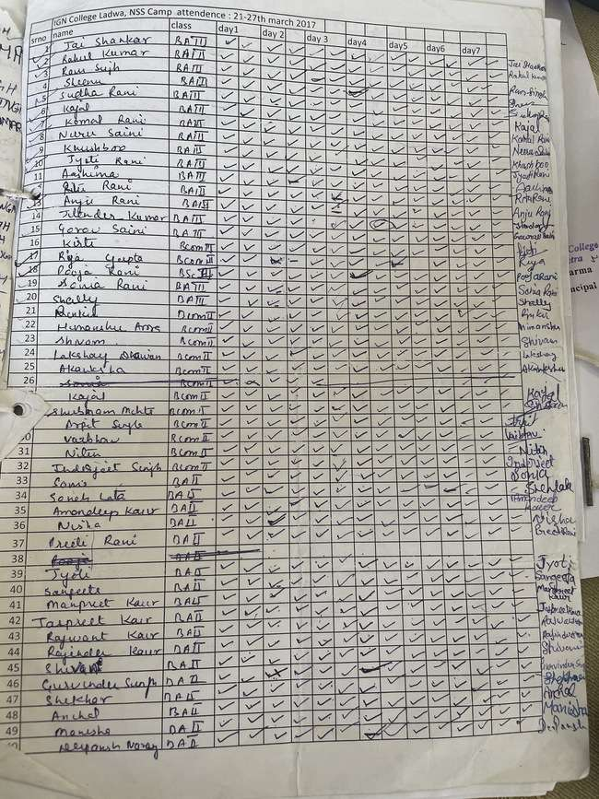

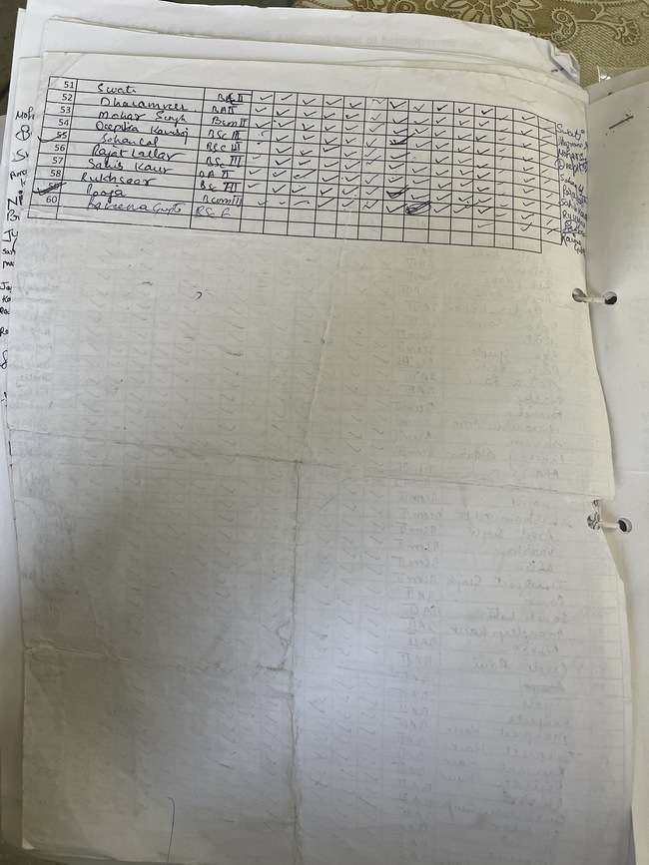

DIGITAL LITERACY TRAINING during 7 days special NSS camp 2016-17
In order to aware students about online banking, demonstration videos were shown to them. The videos demonstrated how to operate the bank account online and various functions available through online banking.
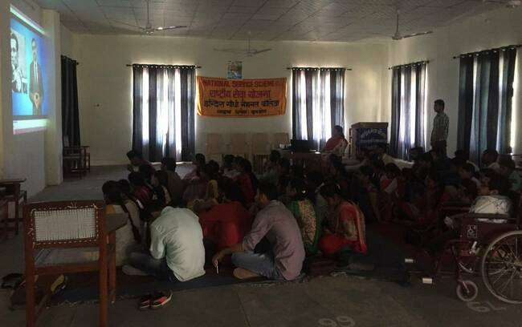

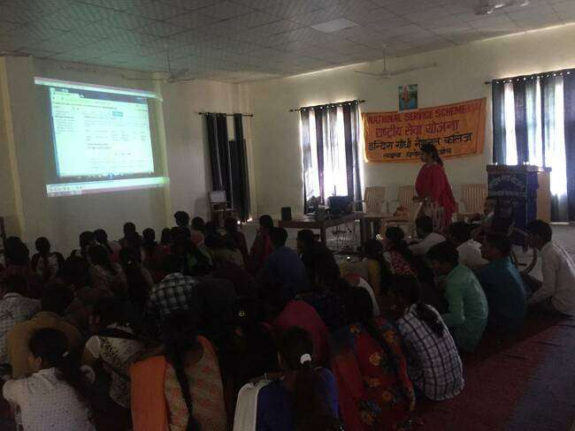

SEMINAR ON SOCIAL SERVICE AND POSITIVE ATTITUDE during 7 days special NSS camp 2016-17.
A seminar was conducted by Dr Ravish Chauhan, Associate Professor, IGN College, Ladwa, where he motivated students for social service and told them the benefits of holding a positive attitude in life. He also told students about various forms in which society can be served and contributed to by the NSS volunteers.

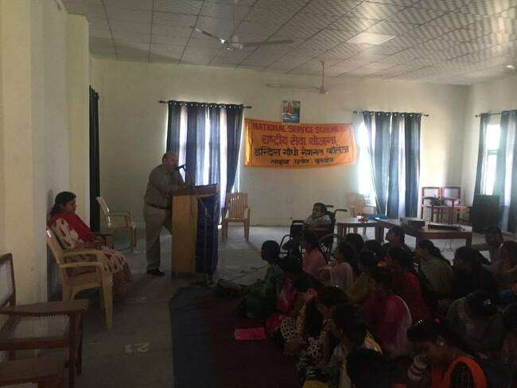

Interactive session on Health & Nutrition during 7 days Special NSS camp 2016-17
Dr Madhu Gupta, Associate Professor, department of home science, IGN College Ladwa, told students about balanced diet , its benefits and various foods which can be added to diet for better health . She also discussed various do’s and dont’s that must be followed for staying healthy.
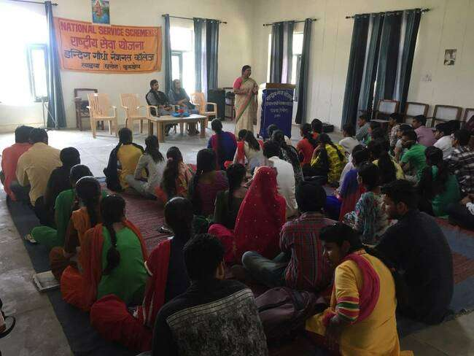

Pying tribute to Shaheed Bhagat Singh on Shaheedi Diwas
The fourth day of the camp ie. 23rd march, initiated by paying tribute to the Shaheed Bhagat Singh, Rajguru and Sukhdev . The volunteers said Slogans and gave speeches in hounour of the martyrs who sacrificed their lives in the struggle to set India free from the clutches of Britishers.

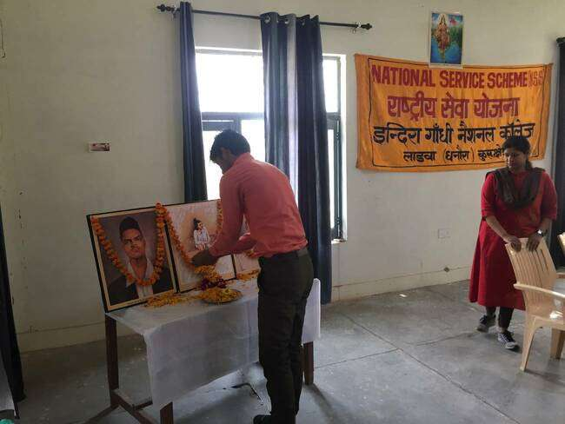

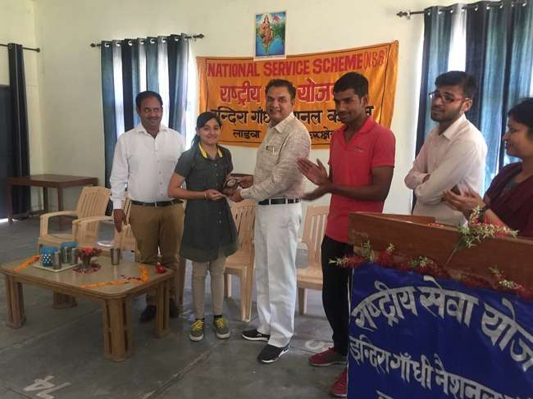

Chief Guest Dr Santosh Dahiya addressing volunteers on ‘Beti Bachao Beti Padhao’ on Valedictory Session of 7 days Special nss camp 2016-17
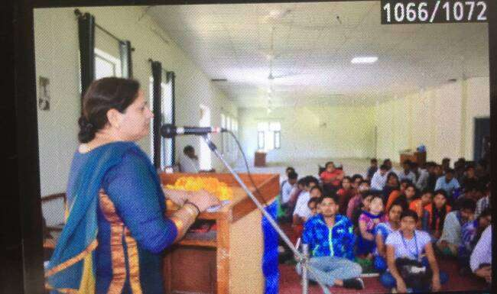

Honouring Chief Guest Dr Santosh Dahiya on Valedictory Session of 7 days Special nss camp 2016-

