12.03.2017: ONE DAY NSS CAMP

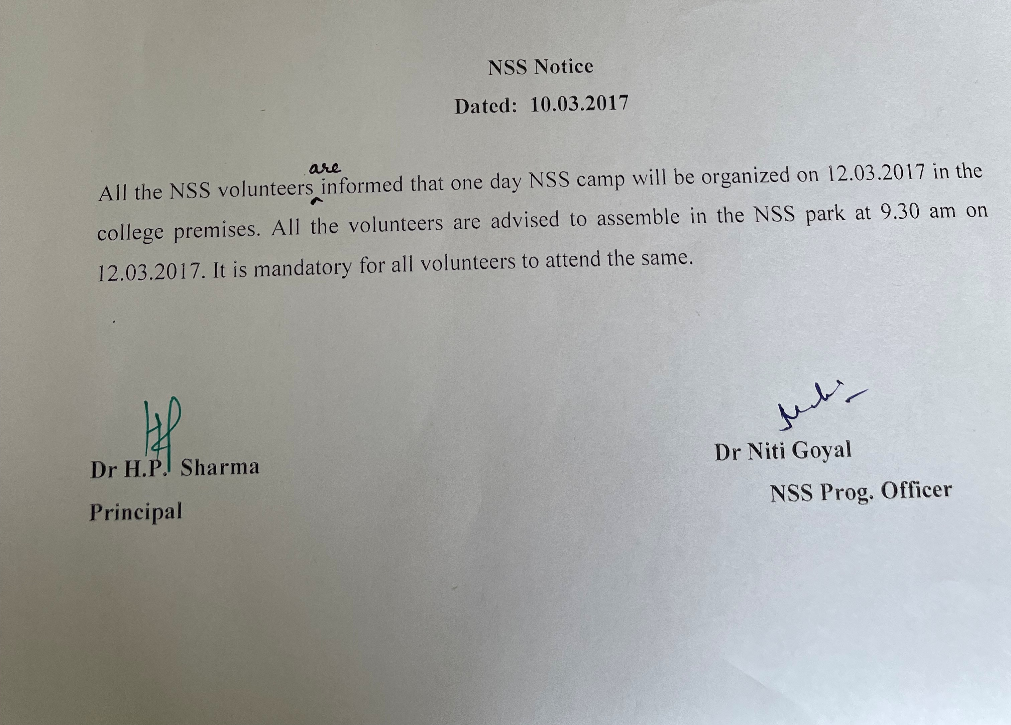

Second one day camp was organized on 12th March. Apart from cleaning the college ground and taking care of the trees and plants in the college premises, a cultural programme was also organized. Students played recreational games post refreshment session. Such games help develop personality and removes stage fear.

