INDIRA GANDHI NATIONAL COLLEGE, LADWA
(Affiliated to Kurukshetra University, Kurukshetra)
As notified by the Vice-Chancellor of Kurukshetra University Kurukshetra academic calendar for 2020-21(subject to the further directions from the state government if any) is as follows:
Admissions 15-07-2020 to 31-07-2020
(Odd Semester)
- First Teaching term 04-08-2020 to 30-11-2020
- Vacation I (Diwali) 13-11-2020 to 15-11-2020
- Examinations 01-12-2020 onwards
(Even Semester)
- First Teaching term 01-01-2021 to 26-03-2021
- Vacation I (Holi) 27-03-2021 to 31-03-2021
- Second Teaching term 01-04-2021 to 30-04-2021
- Examinations 01-05-2021 onwards
- Summer vacations 21-05-2021 to 30-06-2021
Due to COVID-19 above academic calendar issued by K.U.K was not executed and as per notification number ACR-2/9(vi) /20/13651-13731 dated 21-10-2020 the Vice-Chancellor of Kurukshetra University Kurukshetra approved the following schedule of academic calendar for 2020-21 as follows:
Admissions as per schedule issued by the Director, Higher Education, Haryana
(Odd Semester)
- Teaching term 02-11-2020 to 20-02-2021
- Examinations 22-02-2021 to 20-03-2021
(Even Semester)
- Teaching term 22-03-2021 to 12-07-2021
- Examinations 13-07-2021 onwards

Institutional Academic Calendar 2020-21
November 2020(Odd Semester)
- Screening of movies (English Department)
- Extension lecture (Economics Department)
- Extension lecture (Political Science Department)
- Extension lecture (Mathematics Department)
- Expert talk (Legal Literacy Cell and Anti Sexual Harassment Cell)
- First one day camp (NSS)
- Extension lecture (Women Cell)
December 2020
- World Aids Day celebration on 1st December (Red Ribbon Club)
- Book Exhibition (English Department)
- Assignment -I
- Outreach Activity (Legal Literacy Cell and Anti Sexual Harassment Cell)
- Seven days special camp (NSS)
January 2021
- Sessional test (first week)
- Collage making and Quiz Competition (Home Science Department)
- Extension lecture (Commerce Department)
- Field Study (Economics Department)
- National Youth Day Celebration on 12 January (Sports Department and Red Ribbon Club)
- Lohri celebration (13 Jan) (Youth and Cultural Affairs Committee)
- Sholoka Uchharan and Essay Writing Competition (Sanskrit Department)
- Essay Writing Competition (Political Science Department)
- Quiz Competition (Physics Department)
- Assignment -II (last week)
- Online Quiz Competition (Legal Literacy Cell and Anti Sexual Harassment Cell)
- Poster making and slogan writing competition on 23-24 January (Red Ribbon Club and Red Cross)
- Slogan writing (Women Cell)
February 2021
- Article Writing and Quiz Competition (Home Science Department)
- Quiz Competition (Commerce Department)
- Annual athletic meet (Sports Department)
- Rangoli and Quiz Competition (Sanskrit Department)
- Quiz Competition (Chemistry Department)
- Educational tour (Political Science Department)
- To enroll students as a club member (Road Safety Club)
- Poster making Competition (Physics Department)
- Expert talk/Outreach activity (Legal Literacy Cell and Anti Sexual Harassment Cell)
- Second one day camp (NSS)
- Quiz Competition (Red Ribbon Club)
March 2021
- Industrial tour (Economics Department)
- Outreach activity (Legal Literacy Cell and Anti Sexual Harassment Cell)
- Awareness camp (NSS)
- National Conference of Library Sc. in collaboration with the Haryana Library Association (Library Science)
- Extension Activity (Red Ribbon Club)
- Women’s day celebration on 8th march (Women Cell)
April 2021
- Essay Writing Competition (Commerce Department)
- Road Safety awareness Lecture during NSS Camp (Road Safety Club)
- Book Donation drive (Library Science)
- Quiz Competition (English Department)
- Awareness workshop/Lecture (NSS)
May 2021
- PowerPoint presentation (Commerce Department)
- Essay Writing Competition (English Department)
- Poster display competition and Quiz competition on Road Safety (Road Safety Club)
- Eidul Fitr celebration (Youth and Cultural Affairs Committee)
- Chart Making Competition (Physics Department)
- Books exhibition and Book review (Library Science)
- Quiz Competition (Mathematics Department)
- Multi-disciplinary Quiz contest (Library Science)
- Expert Lecture of a Resource Person from Academia and/or Industry, poster display competition (Chemistry Department)
- Community visit (Women cell)
June 2021
- Extension lecture (Physics Department)
- Road Safety awareness Lecture by a Police /RTA Official (Road Safety Club)
- Seminar / webinar on IPR / research methodology and IPR (Library Science)
- An Industrial Visit (Chemistry Department)
- Article Writing and Chart Making Competition (Mathematics Department)
July 2021
- Article writing competition (Physics Department)

INDIRA GANDHI NATIONAL COLLEGE, LADWA
(Affiliated to Kurukshetra University, Kurukshetra)
It is notified that IQAC Committee of the college has approved the following schedule of the academic calendar for the session 2019-20 (As notified by Kurukshetra University, Kurukshetra)
INSTITUTIONAL ACADEMIC CALENDAR 2019-20
July 2019(Odd Semester)
- Admissions 02-07-2019 to 15-07-2019
- First Teaching term 16-07-2019 to 23-10-2019
- Hawan Ceremony
- Seminar (Commerce Dept.)
August 2019
- Orientation Programme for newly admitted students
- Awareness Programme of NSS volunteers
- Seminar for Girls Students (Women Cell)
September 2019
- Teacher’s Day celebration (5-9-2019)
- Assignment -I
- Talent show competition
- One day NSS camp
- Quiz Competition (History Department)
- Extension lecture (Commerce Department)
- Extension lecture (Career Guidance Cell)
- Extension lecture (Chemistry Dept)
- Awareness lecture (NSS)
- Workshop on ‘Traffic rules’ (Road Safety Club)

October 2019
- Celebration of National Voluntary Blood Donation Day (1-10-2019)
- Gandhi Jayanti Celebration (2-10-2019)
- Sessional test
- Vacations I 24-10-2019 to 30-10-2019
- Outreach activity (Legal Cell and Sexual Harassment Cell)
- Competition for skill enhancement (Women Cell)
- Declamation Competition (Youth and Cultural cell)
- Departmental Activity (Mathematics Department)
- Celebration of birth anniversary of Sardar Vallabh Bhai Patel (31-10-2019)
- To commemorate the Death Anniversary of Smt. Indira Gandhi, Ex-Prime minister of India (31-10-2019)
November 2019
- Celebration of Birth anniversary of Smt. Indira Gandhi (19-11-2019)
- Assignment -II
- Examinations 19-11-2019 onwards
December 2019
- Winter Vacations 20-12-2019 to 31-12-2019
- Seven days special NSS champ
January 2020 (Even Semester)
- First Teaching term 01-01-2020 to 07-03-2020
- awareness program (Legal Literacy Cell)
- Mentor-Mentees Meeting
- Extension lecture and workshop (Career Guidance Cell)
- Celebration of Foundation Day (24-01-2021)
- Celebration of Voters' Day (25-01-2020)

February 2020
- Awareness program (Red Ribbon Club)
- Awareness Program on E-content (Librarian)
March 2020
- Annual Athletic Meet (Sports Department)
- Awareness lecture (Legal Literacy)
- Celebration of International Women’s Day (08-03-2020)
- Holi Vacations 08-03-2020 to 15-03-2020

Second Teaching term 16-03-2020 to 30-04-2020
Examinations 01-05-2020 onwards
Summer Vacations 20-05-2020 to 30-06-2020
Following instruction are given by Registrar, Kurukshetra University, Kurukshetra
1. The next academic Session 2020-21 will start from 01-07-2020.
2. If the number of teaching days falls less than 180 days (90 days in each semester) in the academic session 2019-20 due to some unforeseen reasons, it would be the responsibility of each Department/Institute/College to make good the loss by arranging extra classes.
3. In case results of the Even Semester are not declared in time, provisional admission in case of ongoing semesters will be made and classes may commence w.e.f. 16th July, 2019 of U.G. and 22th July, 2019 of P.G. courses.
4. The examinations of the 6th Semester of U.G. will start w.e.f. 20-04-2020 onwards.
5. The State Universities are authorized to make minor changes/adjustment according to their local condition at their own level, keeping in view the condition of minimum 90 teaching days in each semester.

INDIRA GANDHI NATIONAL COLLEGE, LADWA
(Affiliated to Kurukshetra University, Kurukshetra)
It is notified that IQAC Committee of the college has approved the following schedule of the academic calendar for the session 2018-19 (As notified by Kurukshetra University, Kurukshetra)
Academic Calendar 2018-19
For Under-Graduate Courses
Event | Duration
Admissions | 02.07.2018 to 12.07.2018
1stTeaching Term (Odd Semester) | 13.07.2018 to 05.11.2018
Vacations-I(Diwali) | 06.11.2018 to 13.11.2018
Examinations | 14.11.2018 onwards
Winter Vacations-II | 18.12.2018 to 31.12.2018
1st Teaching (Even Semester) | 01.01.2019 to 17.03.2019
Vacations-I | 18.03.2019 to 24.03.2019
2nd Teaching Term (Even Semester) | 25.03.2019 to 30.04.2019
Examinations | 01.05.2019 onwards
Summer Vacations-II (2018-19) | 23.05.2019 to 30.06.2019

For Post-Graduate Courses
Event | Duration
Admissions | 02.07.2018 to 12.07.2018
1stTeaching Term (Odd Semester) | 13.07.2018 to 05.11.2018
Vacations-I(Diwali) | 06.11.2018 to 13.11.2018
2nd Teaching Term (Odd Semester) | 14.11.2018 to 21.11.2018
Examinations | 22.11.2018 onwards
Winter Vacations-II | 18.12.2018 to 31.12.2018
1st Teaching (Even Semester) | 01.01.2019 to 17.03.2019
Vacations-I | 18.03.2019 to 24.03.2019
2nd Teaching Term (Even Semester) | 25.03.2019 to 30.04.2019
Examinations | 01.05.2019 onwards
Summer Vacations-II (2018-19) | 23.05.2019 to 30.06.2019

INDIRA GANDHI NATIONAL COLLEGE, LADWA
(Affiliated to Kurukshetra University, Kurukshetra)
It is notified that IQAC Committee of the college has approved the following schedule of the academic calendar for the session 2017-18 (As notified by Kurukshetra University, Kurukshetra)
Academic Calendar 2017-18 (For Under-Graduate Courses)
Event | Duration
Admissions | 01.07.2017 to 14.07.2017
1stTeaching Term (Odd Semester) | 15.07.2017 to 14.10.2017
Vacations-I | 15.10.2017 to 22.10.2017
2nd Teaching Term (Odd Semester) | 23.10.2017 to 13.11.2017
Examinations | 14.11.2017 onwards
Winter Vacations-II | 18.12.2017 to 31.12.2017
1st Teaching (Even Semester) | 01.01.2018 to 27.02.2018
Vacations-I | 28.02.2018 to 04.03.2018
2nd Teaching Term (Even Semester) | 05.03.2018 to 28.04.2018
Examinations | 30.04.2018 onwards
Summer Vacations-II (2017-18) | 19.05.2018 to 01.07.2018

For Post-Graduate Courses
Event | Duration
Admissions | 01.07.2017 to 19.07.2017
1stTeaching Term (Odd Semester) | 20.07.2017 to 14.10.2017
Vacations-I | 15.10.2017 to 22.10.2017
2nd Teaching Term (Odd Semester) | 23.10.2017 to 17.11.2017
Examinations | 18.11.2017 onwards
Winter Vacations-II | 18.12.2017 to 31.12.2017
1st Teaching (Even Semester) | 01.01.2018 to 27.02.2018
Vacations-I | 28.02.2018 to 04.03.2018
2nd Teaching Term (Even Semester) | 05.03.2018 to 28.04.2018
Examinations | 30.04.2018 onwards
Summer Vacations-II (2017-18) | 19.05.2018 to 01.07.2018

INDIRA GANDHI NATIONAL COLLEGE, LADWA
(Affiliated to Kurukshetra University, Kurukshetra)
It is notified that IQAC Committee of the college has approved the following schedule of the academic calendar for the session 2016-17 (As notified by Kurukshetra University, Kurukshetra)
Academic Calendar 2016-17
For Under-Graduate Courses
Event | Duration
Admissions | 1.07.2016 to 14.07.2016
Teaching (Odd Semester) | 15.07.2016 to 11.11.2016
Examinations | 12.11.2016 onwards
Winter Vacations | 19.12.2016 to 01.01.2017
Teaching (Even Semester) | 02.01.2017 to 25.04.2017
Examinations | 26.04.2017 onwards
Summer Vacations (2016-17) | 06.05.2017 to 30.06.2017

For Post-Graduate Courses
Event | Duration
Admissions | 1.07.2016 to 21.07.2016
Teaching (Odd Semester) | 22.07.2016 to 16.11.2016
Examinations | 17.11.2016 onwards
Winter Vacations | 19.12.2016 to 01.01.2017
Teaching (Even Semester) | 02.01.2017 to 25.04.2017
Examinations | 26.04.2017 onwards
Summer Vacations (2016-17) | 06.05.2017 to 30.06.2017

List of teachers delivering lecture through their own You-Tube channel/ Recorded Lectures

Sr. No. | Name of the teacher | Link of You-Tube Channel/ Recorded lectures
1 | Dr. Sandeep Bansal | https://youtu.be/Xbx8qFQGM5o
2 | Ms. Harneet Kaur | https://youtube.com/channel/UC4QA9rgewkK75YiRAG7bj3A
3 | Dr. Suman Siwach | https://youtube.com/channel/UCmm3xh2wIBaBzX4UzpOsJgg
4 | Dr. Amit Kumar | https://drive.google.com/file/d/14eDplRsLHobN324-GR_TlA_VPpzCufuy/view
5 | Ms. Priyanka | https://youtube.com/channel/UCtuDfpmuU-gTRLt8iiAvhog
6 | Dr. Navin kumari | https://youtu.be/Xbx8qFQGM5o

Screenshots of You-Tube channel/ Recorded Lectures

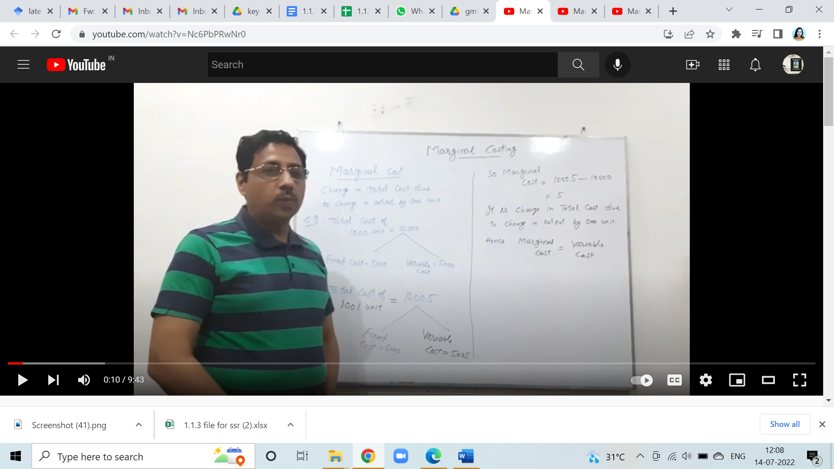

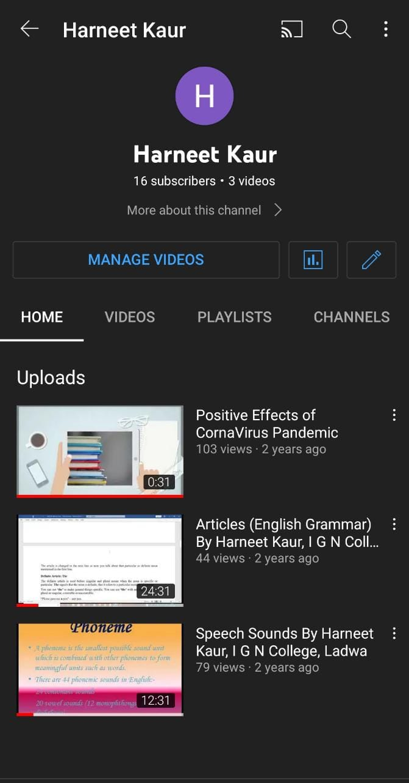

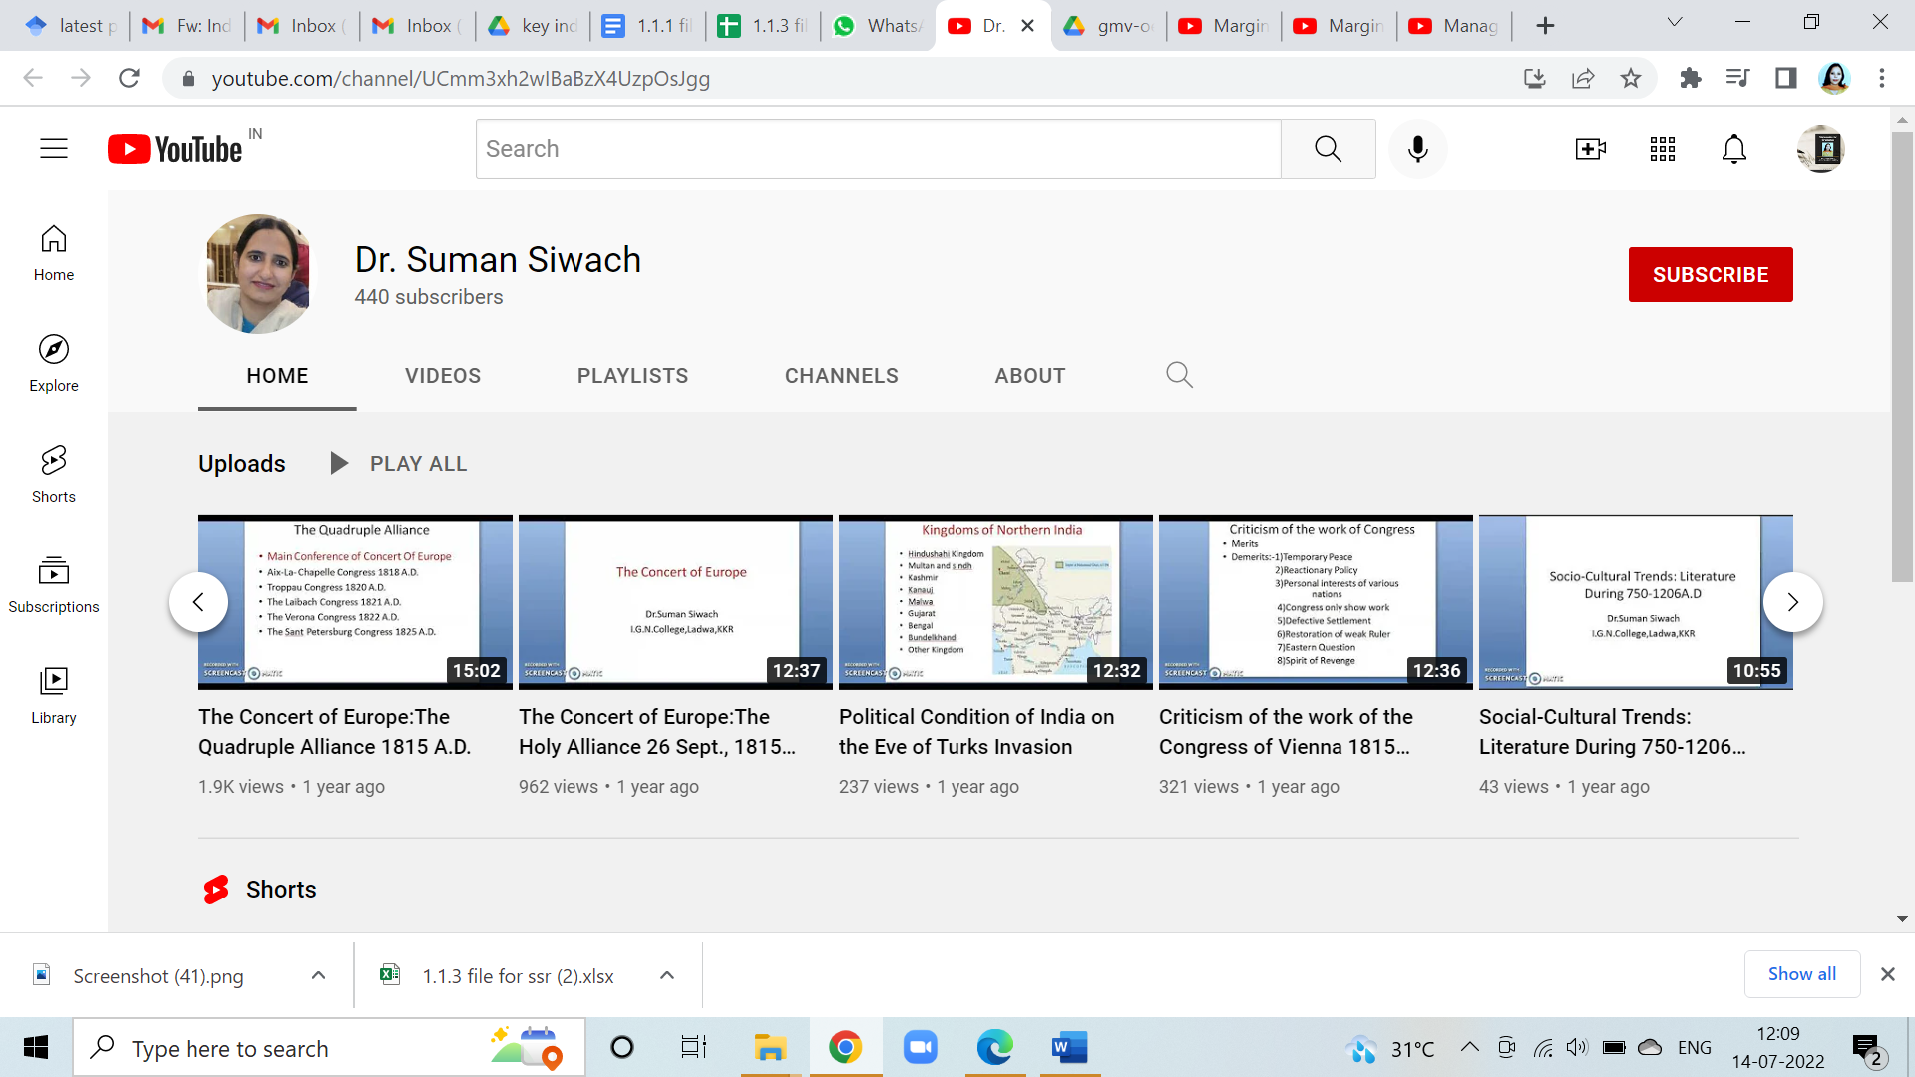

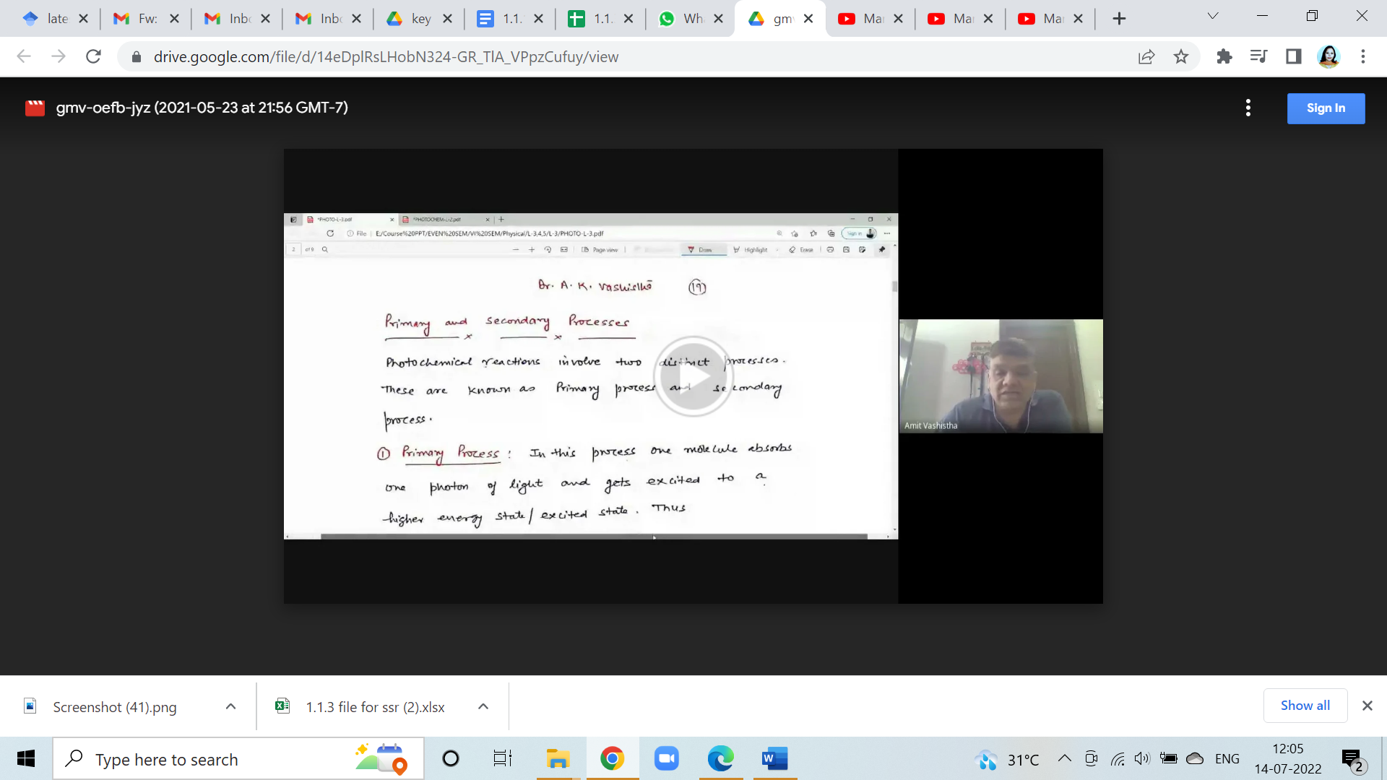

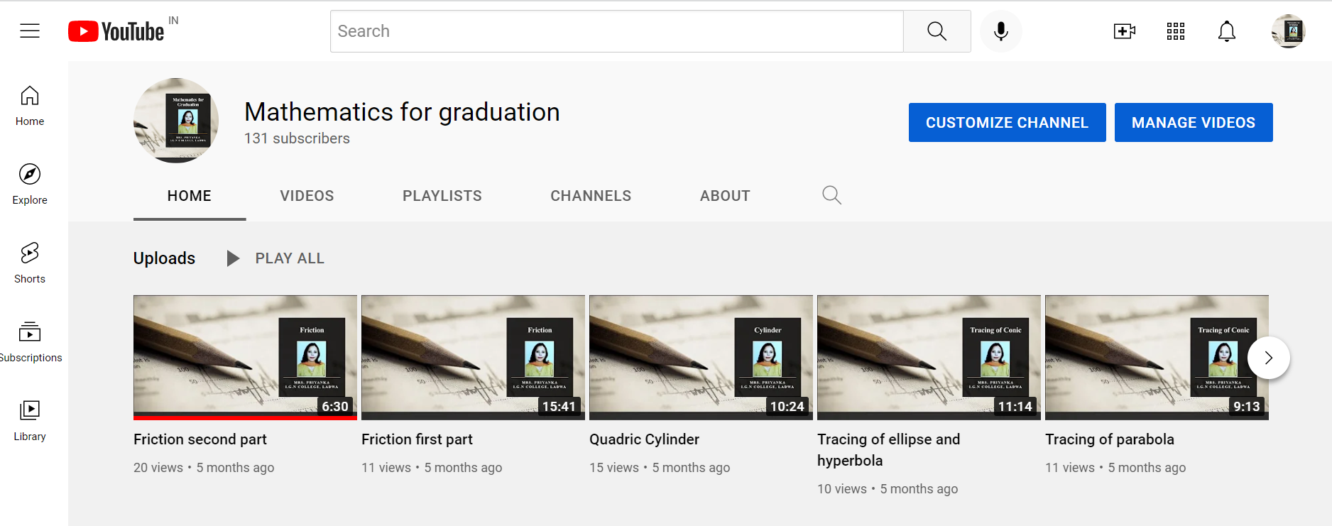

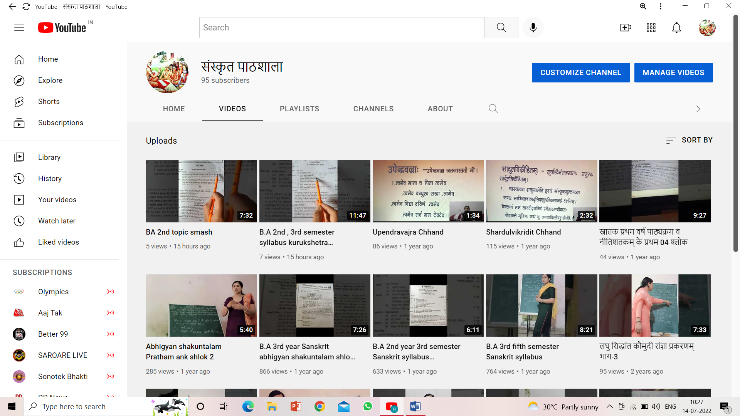

Notice for finding out slow learners and fast learners so that teachers can help them in the process of learning according to their level of understanding

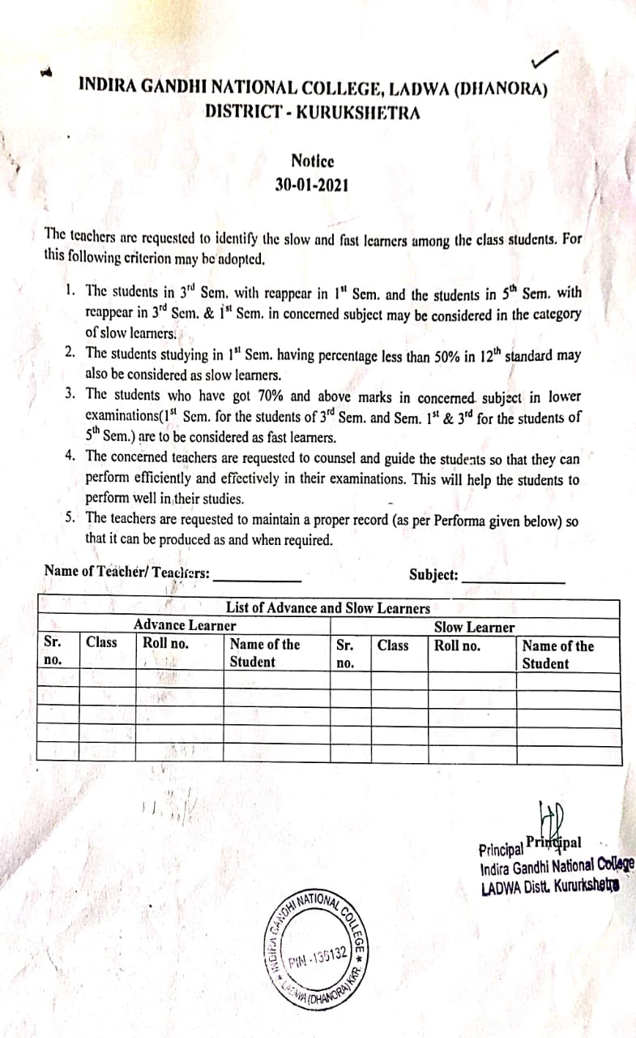

List of commencement of certificate courses
during the session (2020-21)

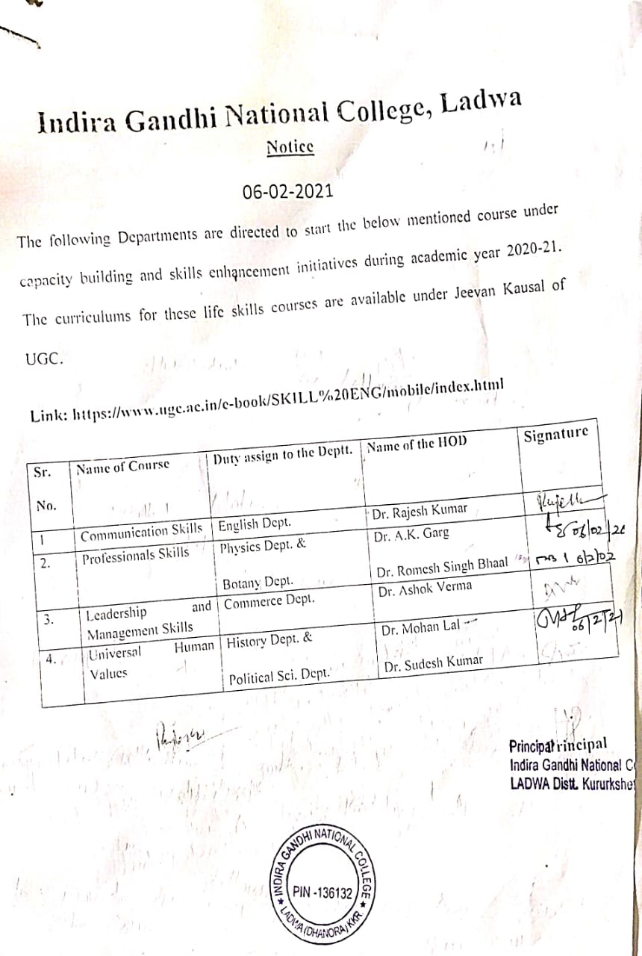

Notice for meetings of various Cells with IQAC

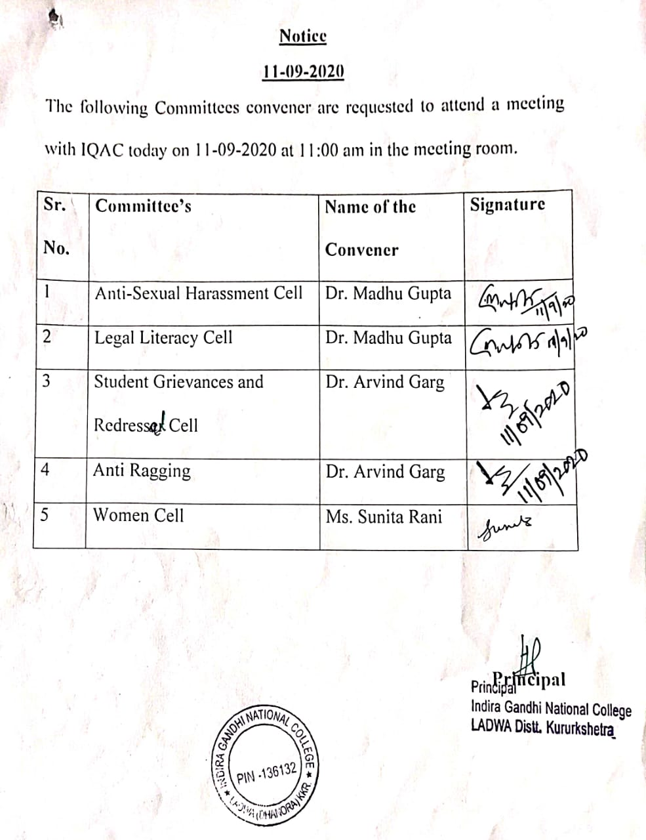

Notice related to organization of activities in collaboration with Govt. and Non-government organizations

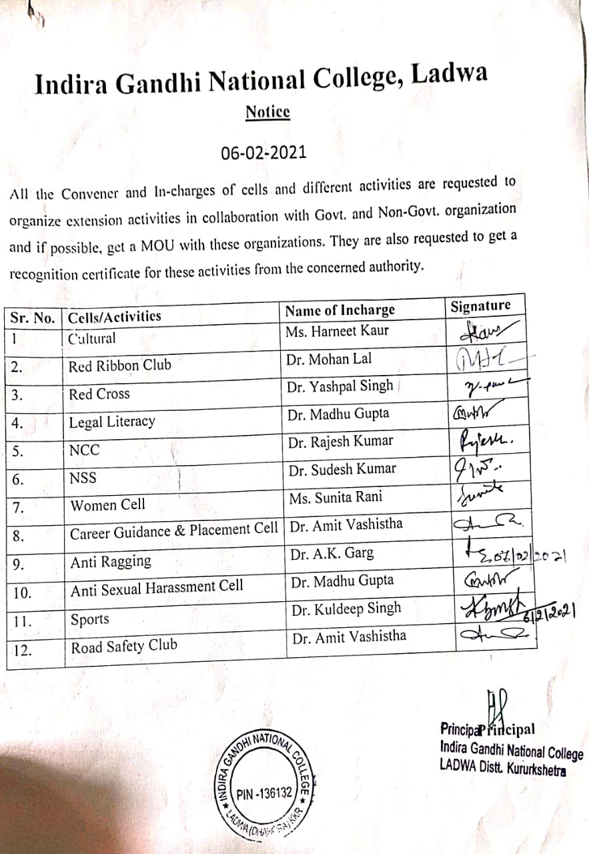

Notice related to celebration of important days

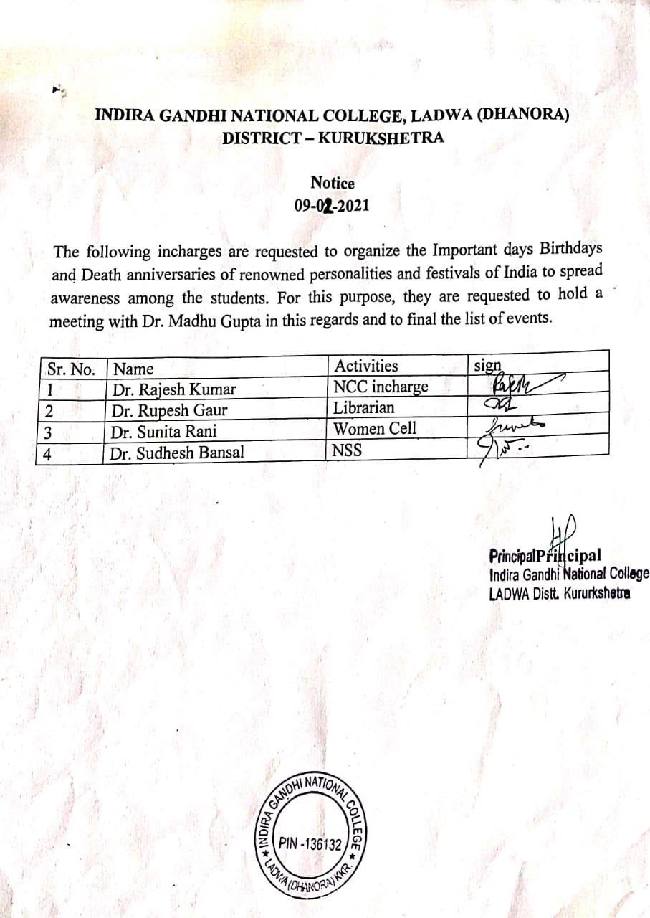

Notice regarding guidelines to be followed by teachers for curriculum delivery
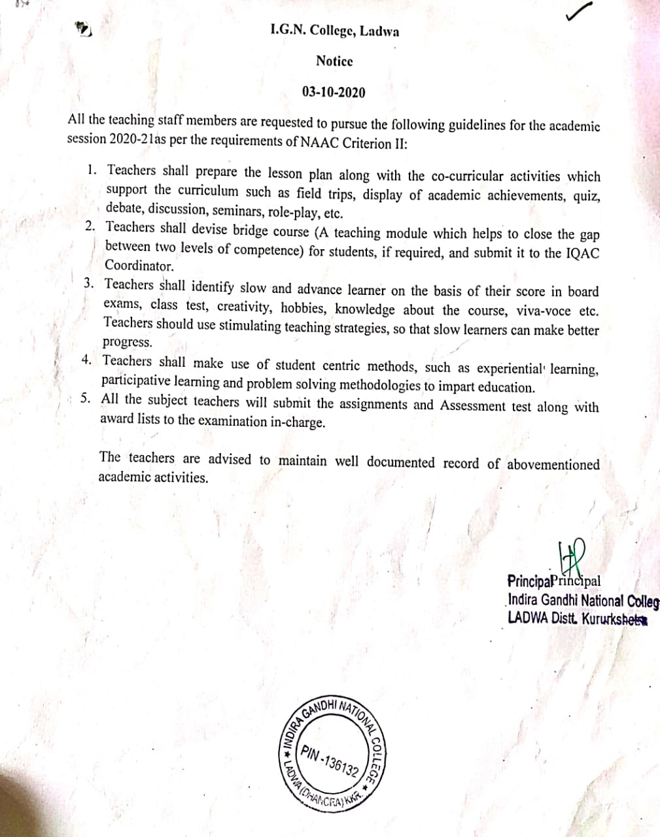

Statistics Related to Books and E-resources provided by Library

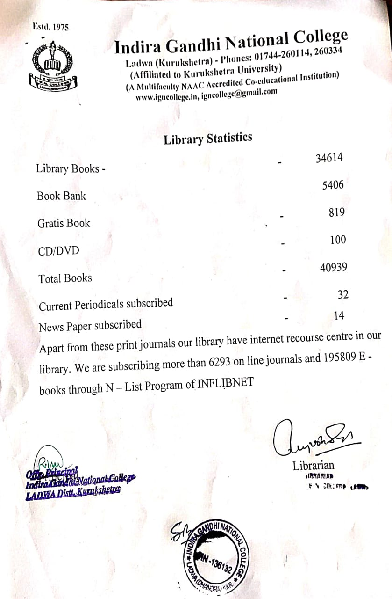

Time-table for the session 2020-21

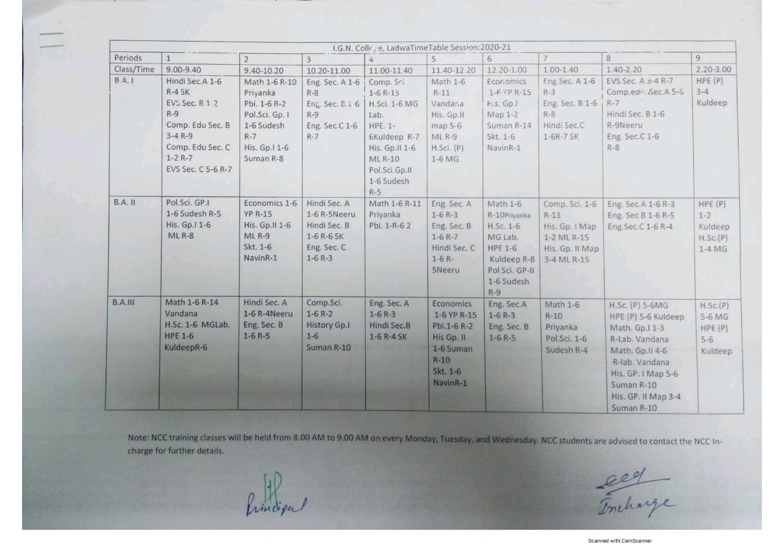

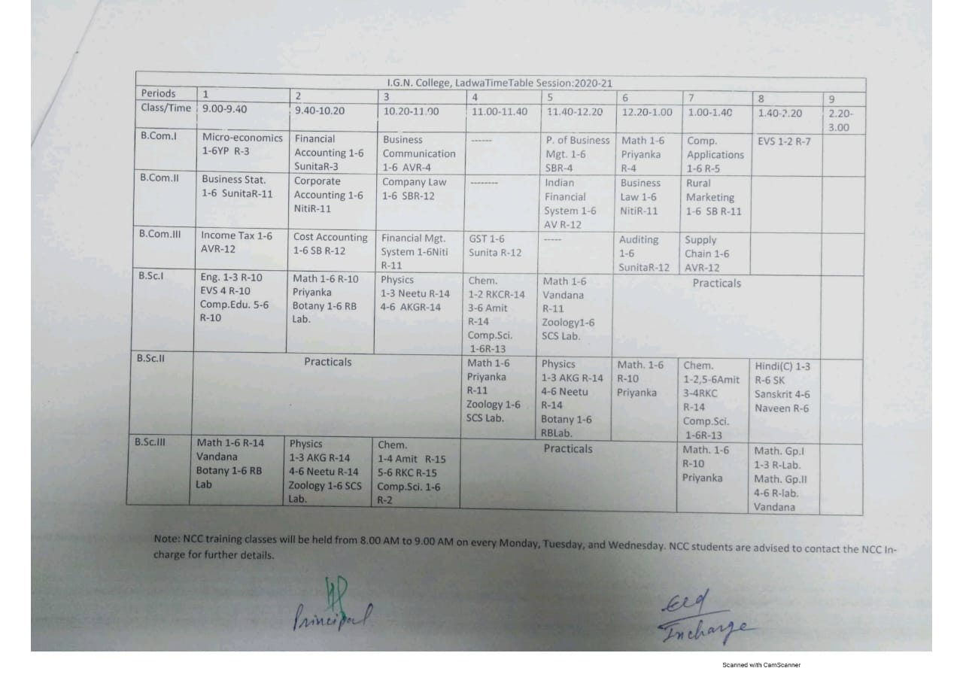

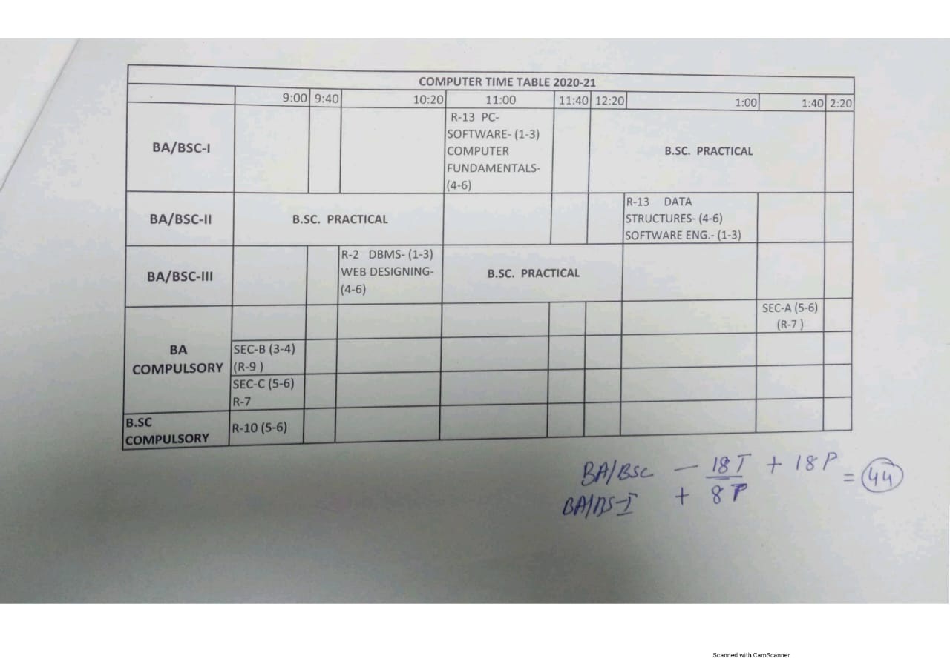

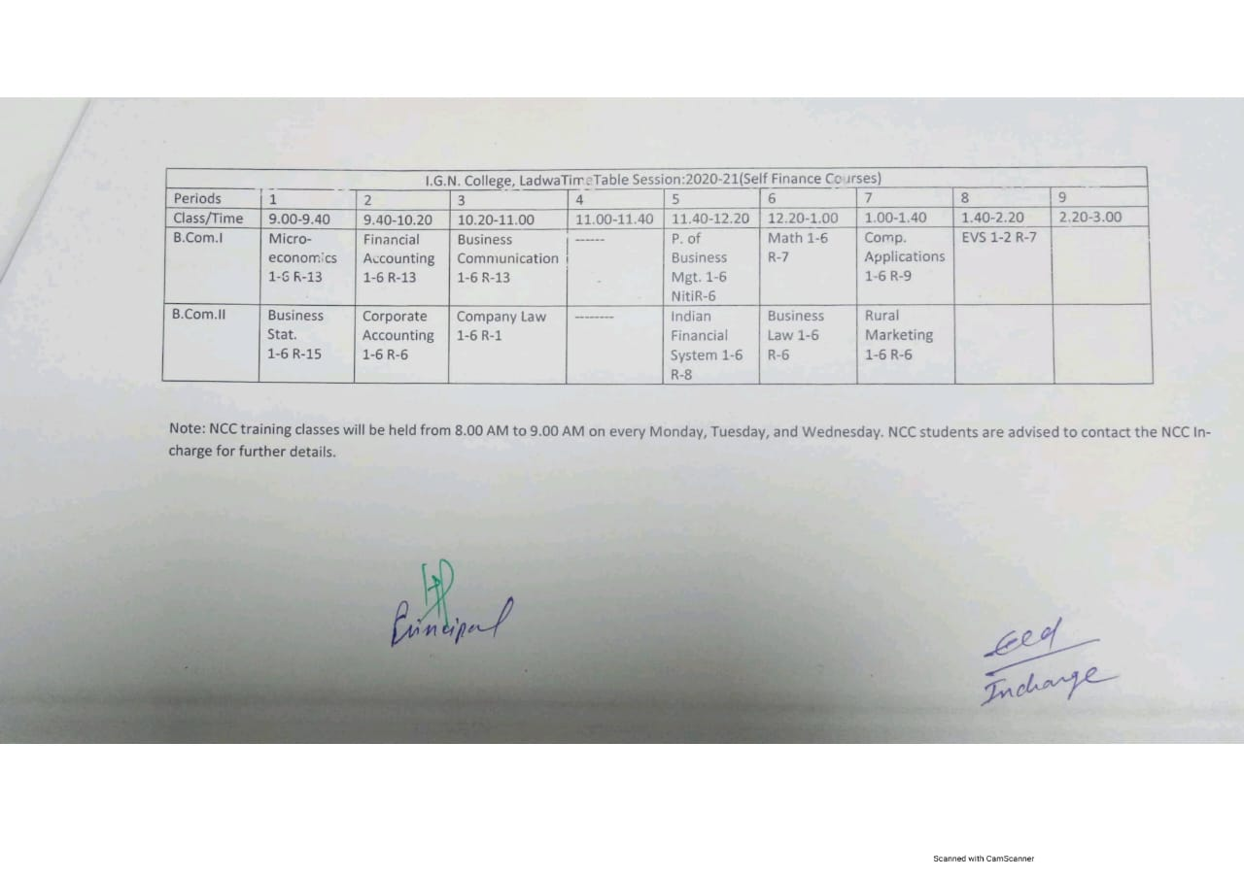

Time-table for the session 2019-20

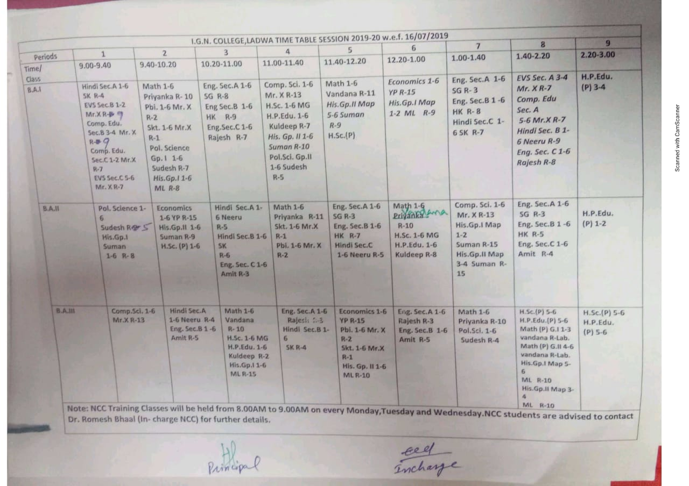

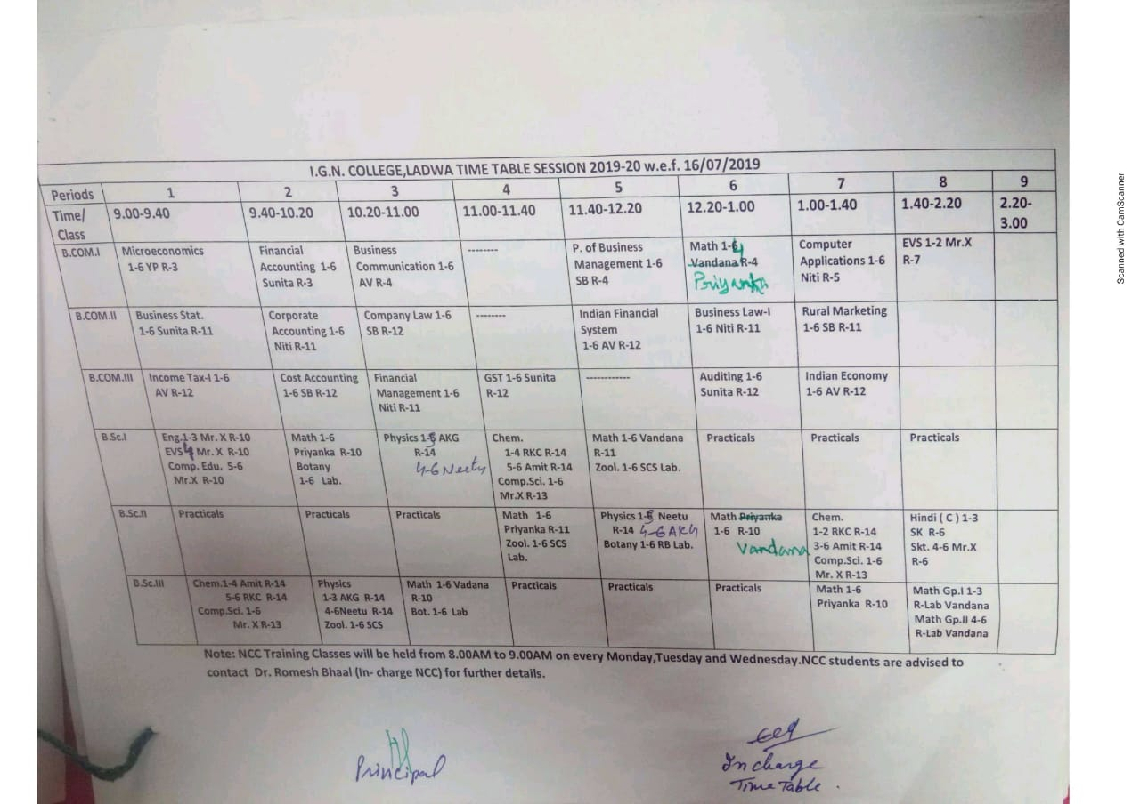

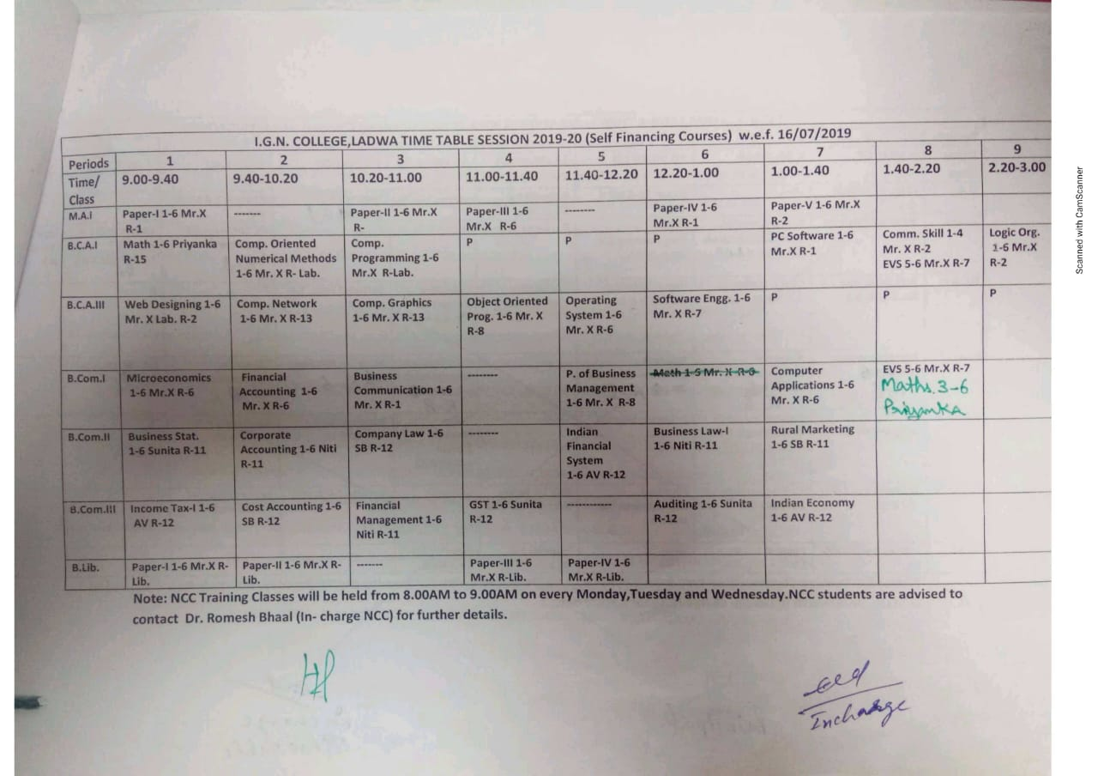

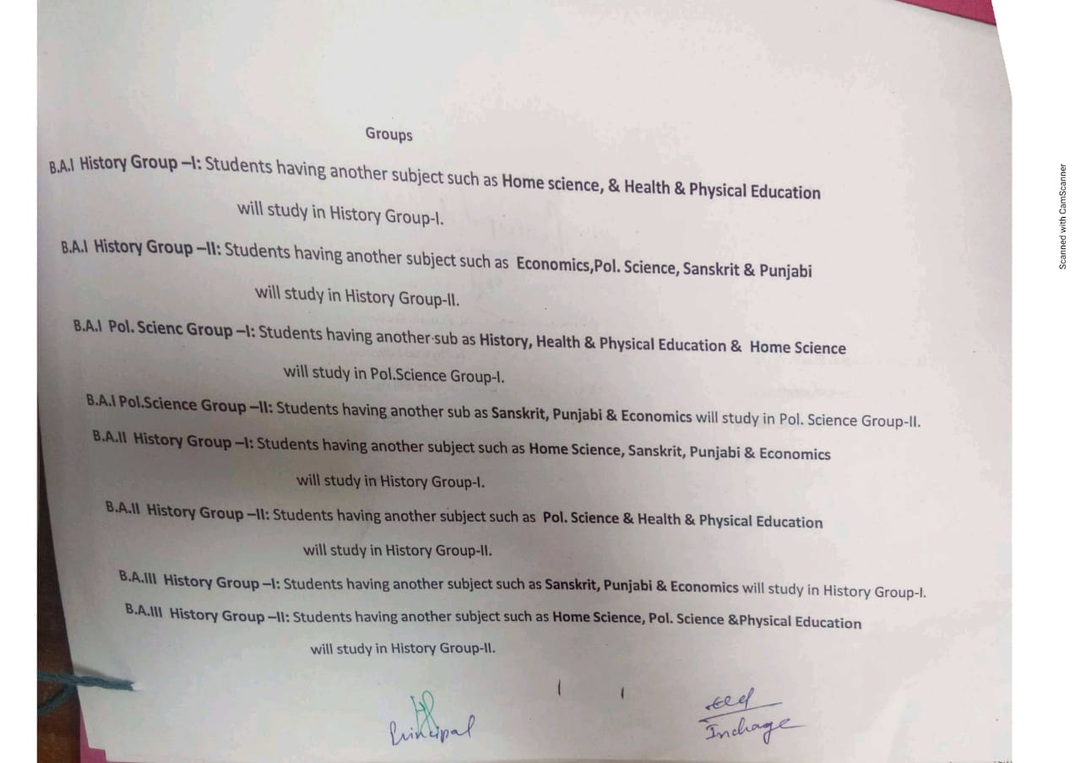

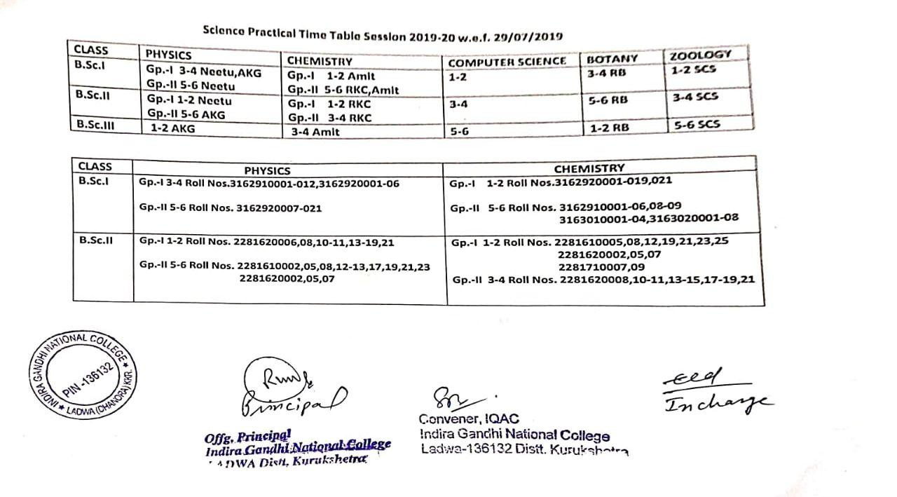

Time-table for the session 2018-19
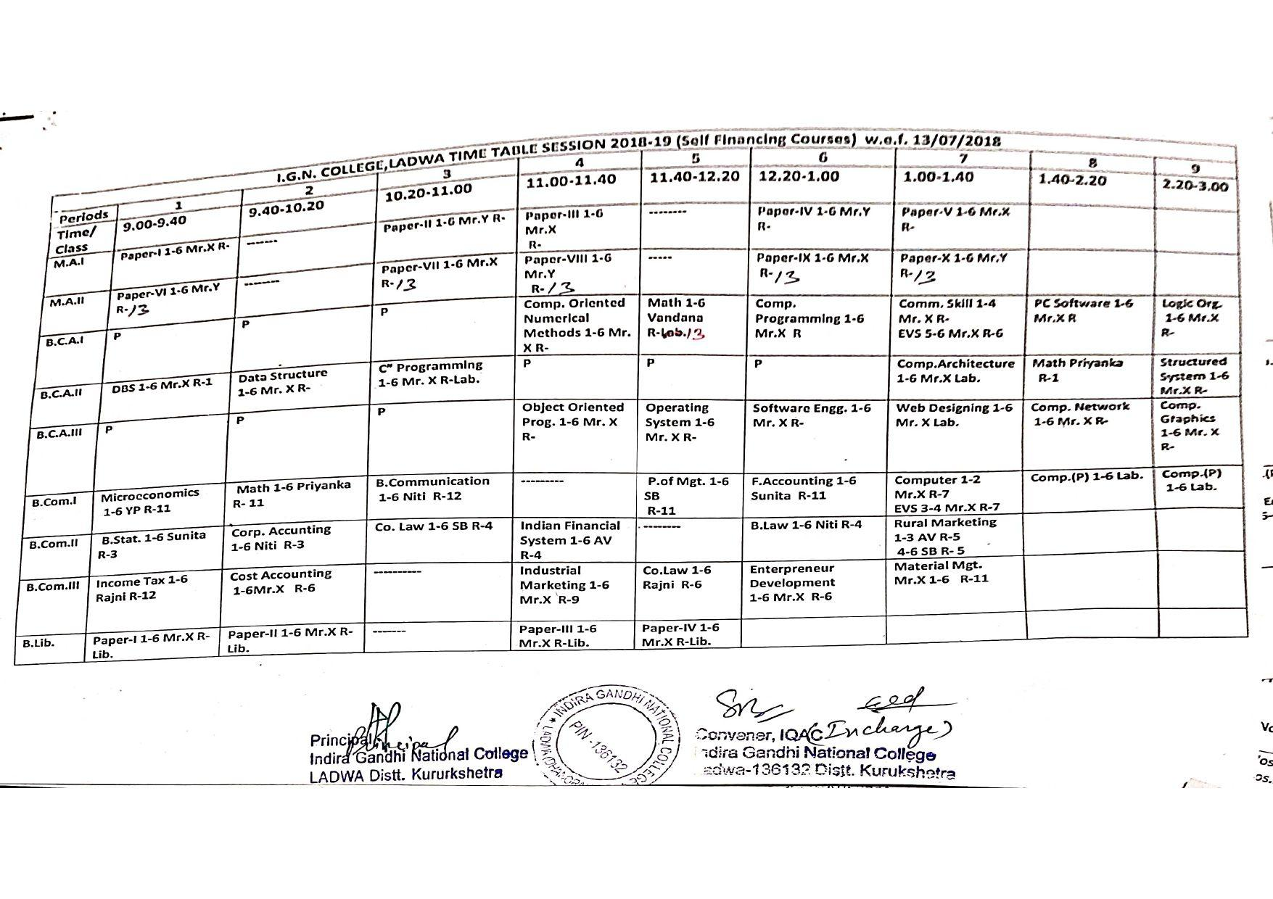
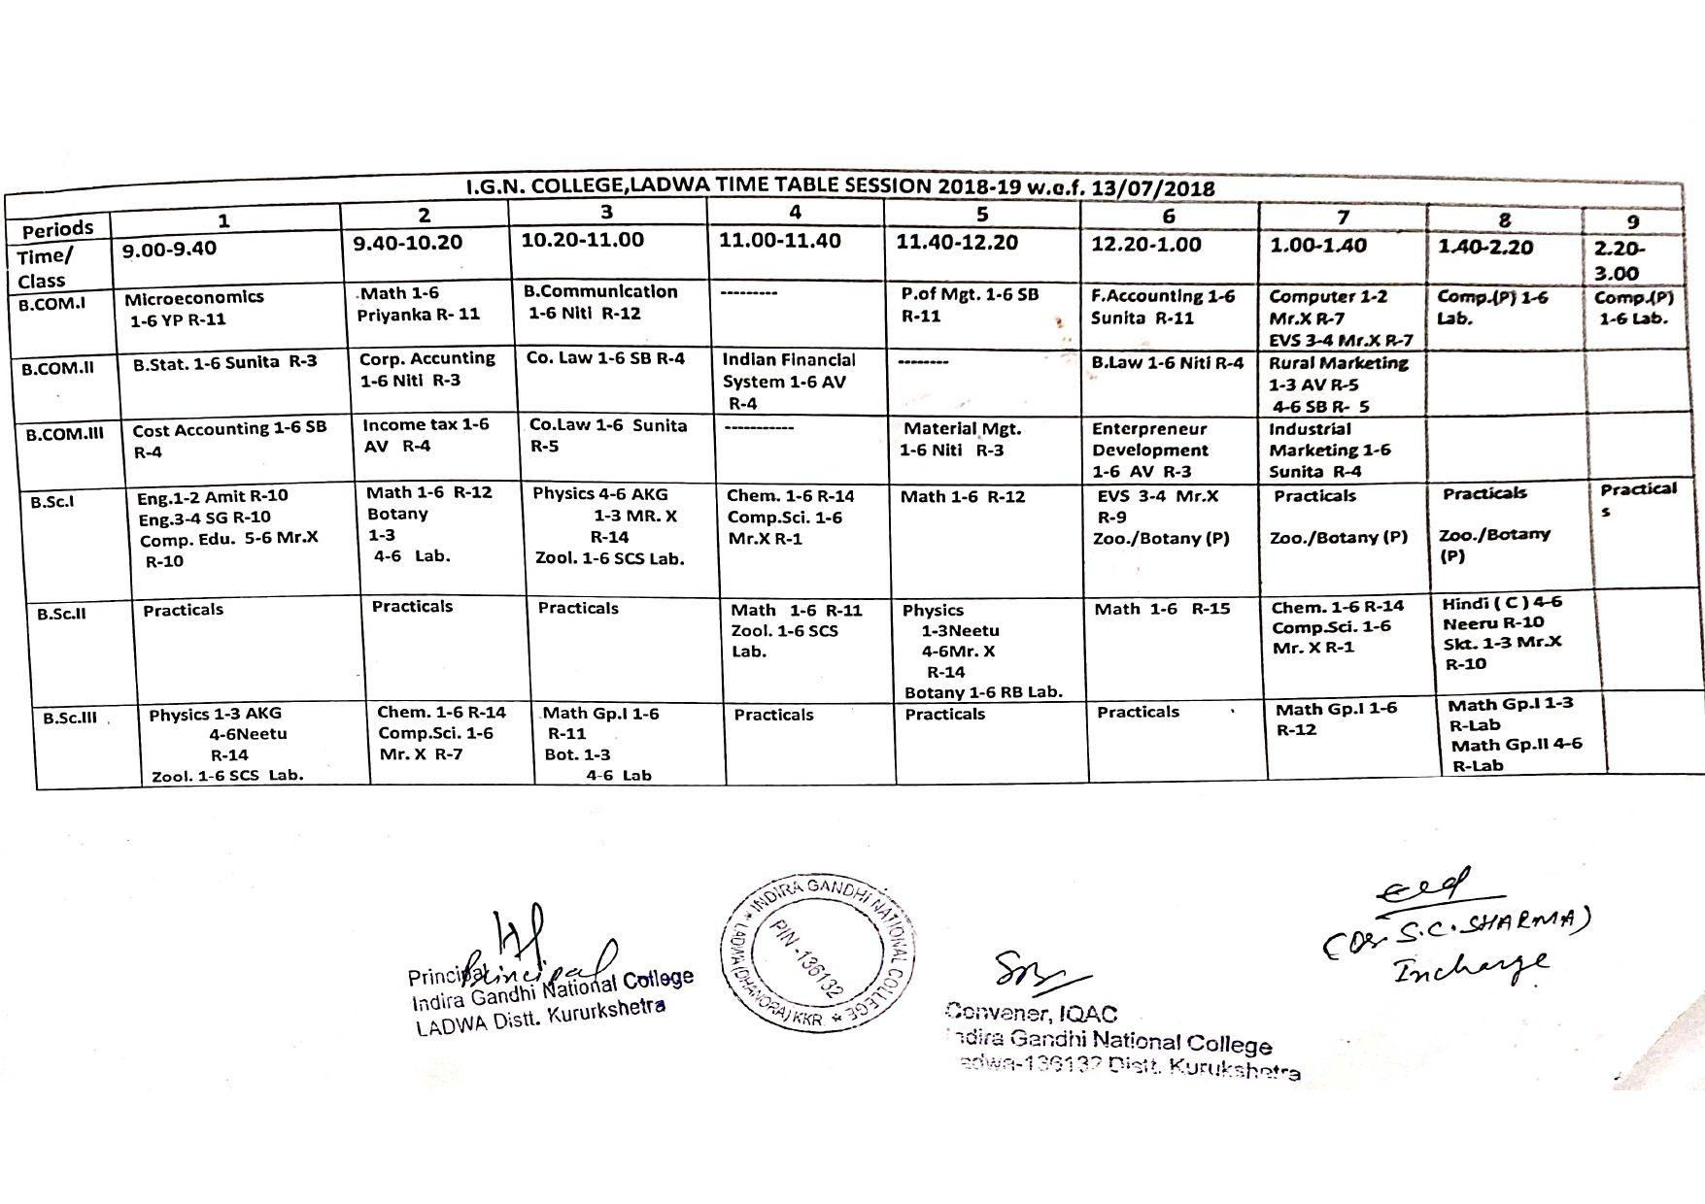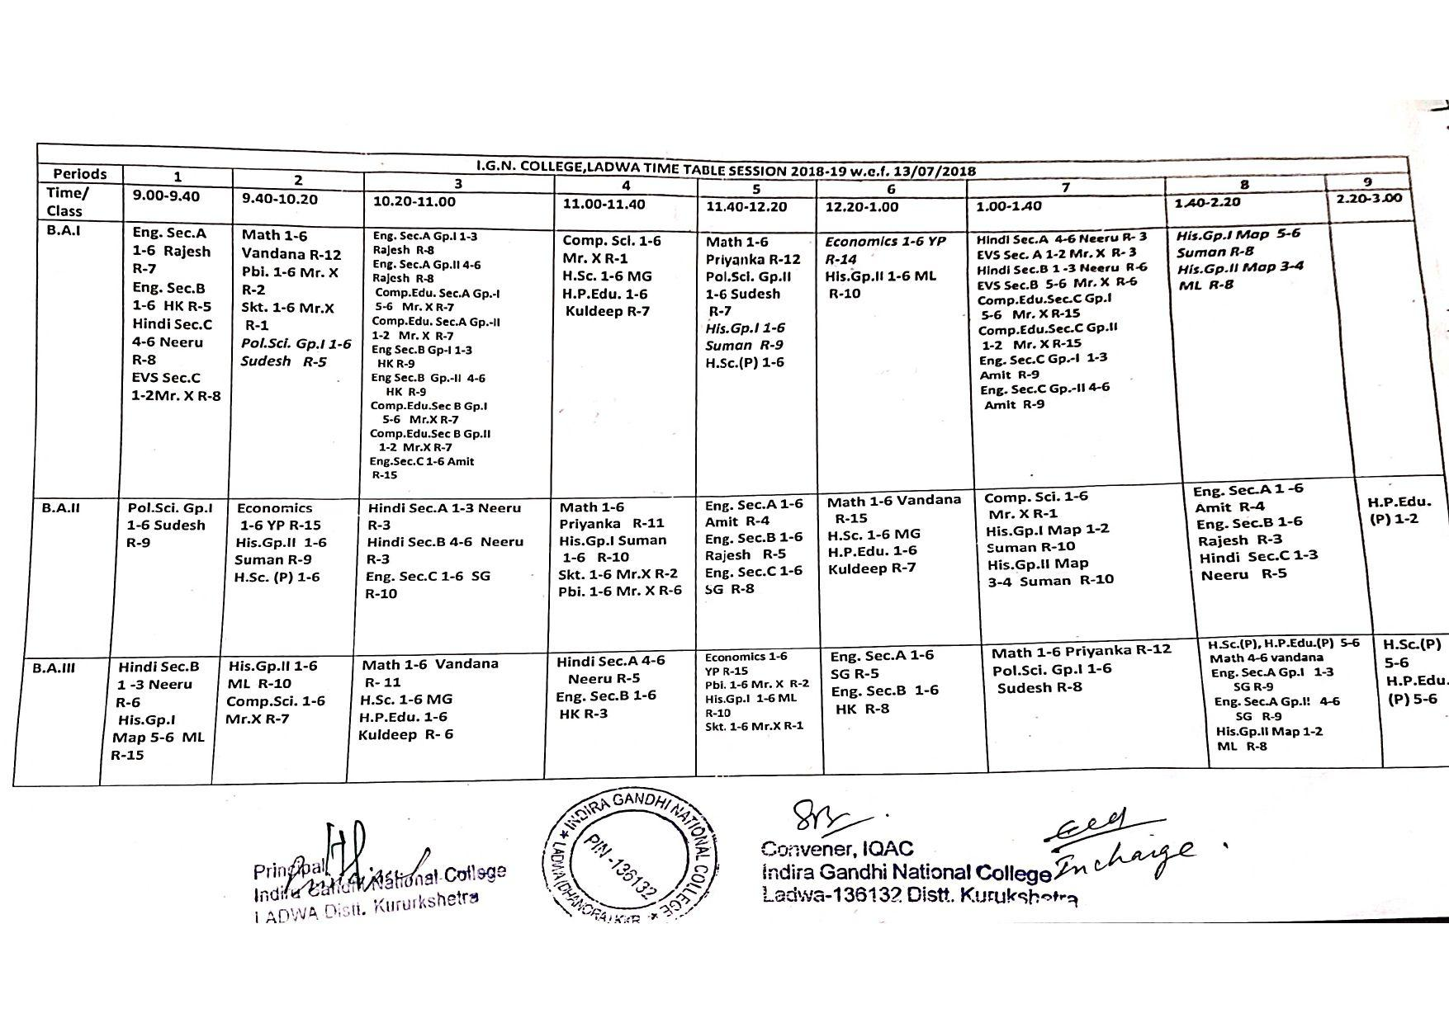

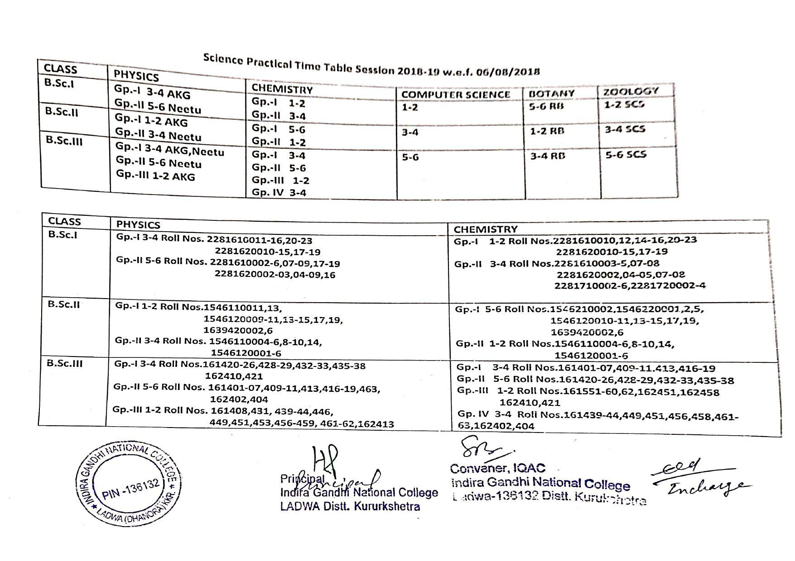

Time-table for the session 2017-18
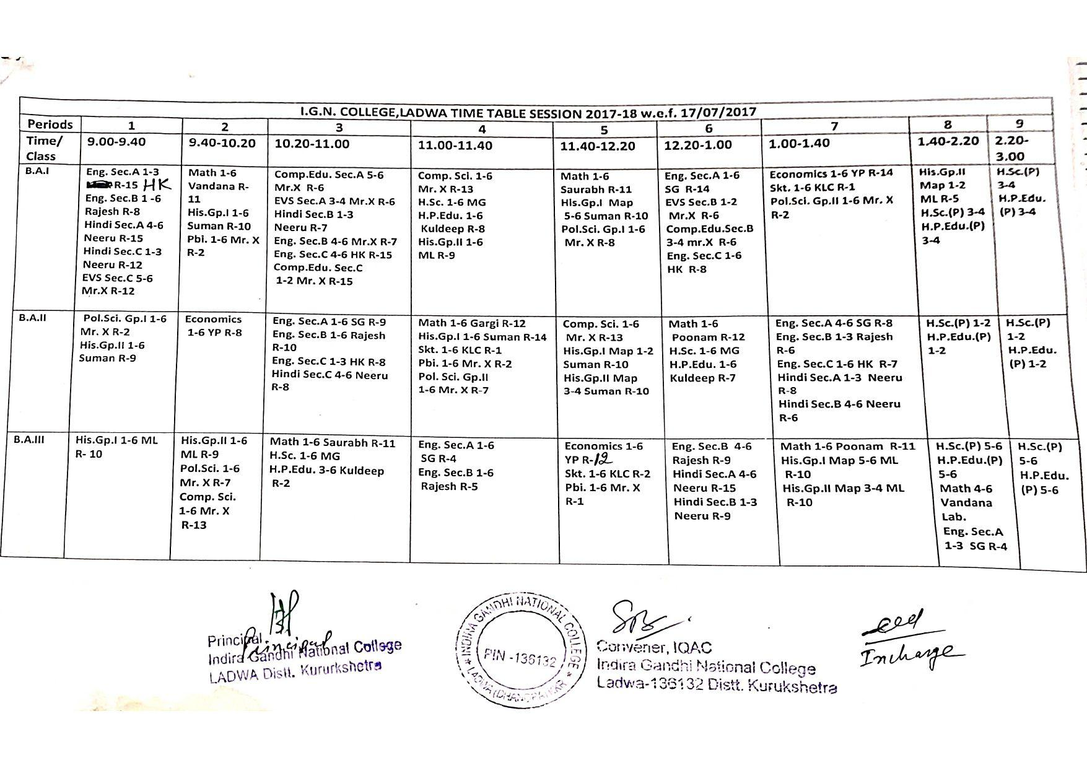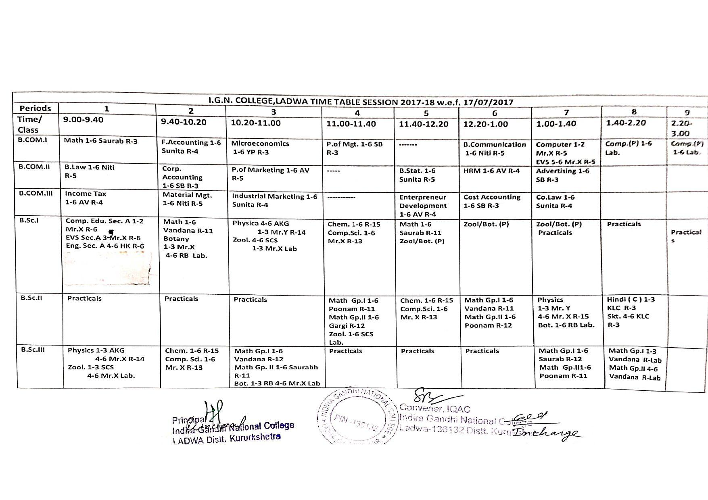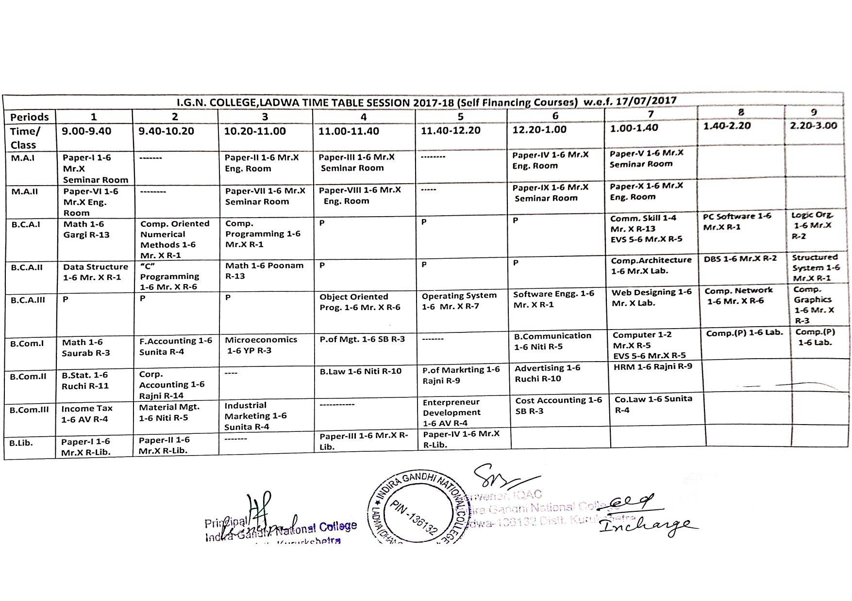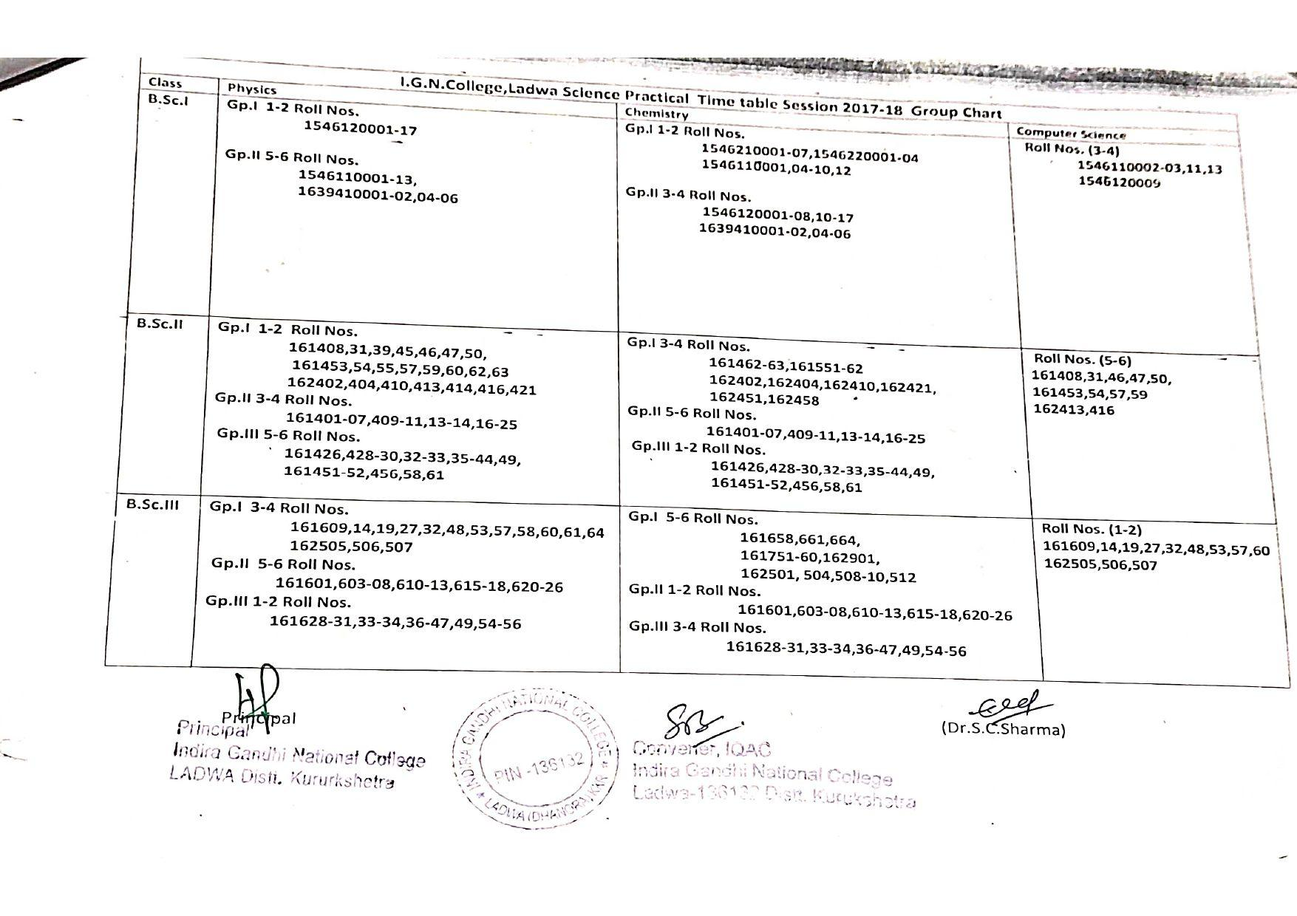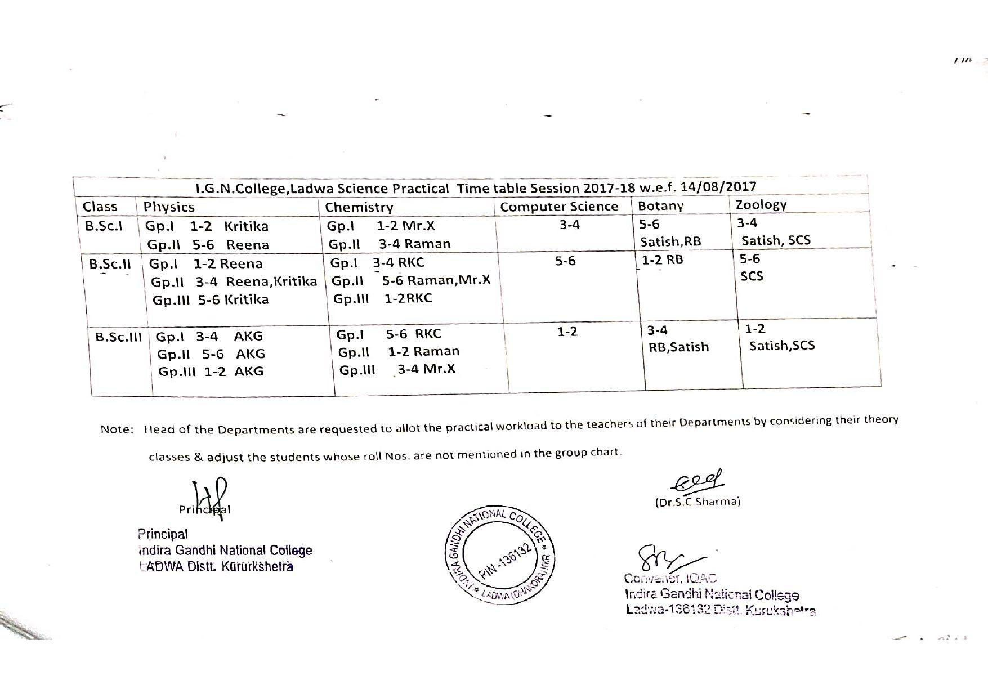

Time-table for the session 2016-17
