INDIRA GANDHI NATIONAL COLLEGE
LADWA (KURUKSHETRA)

REPORT ON AWARENESS COMPAIGN ON
SOCIAL SECURITY SCHEMES FOR UNORGANISED WORKERS ON 17 MAY 2022

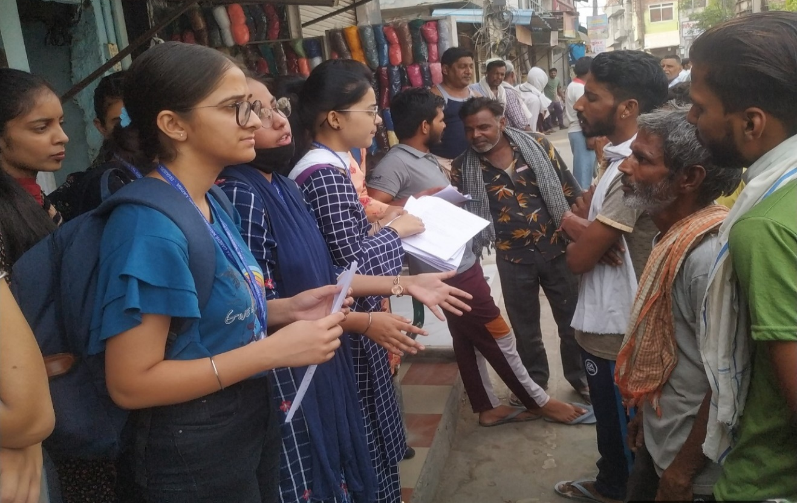
17 May 2022

REPORT
In India, more than 90 per cent of the total workforce falls under unorganised sector.These workers are compelled to spend out of their meagre incomes for all contingencies and remain helpless in their old age. The Centre Government has over the years taken a number of initiatives to extend social security cover to the workers in unorganised sector. As per government estimates,there are 38 crores unorganised workers in the country. Over 27.5 crores unorganised workers are registered on e-SHRAM portal.
To spread awareness among unorganised workers, a group of 10students of economics department, with their subject teacher Dr.Yashpal Singh,organised awareness campaign on ‘Social Security Schemes for Unorganised Workers’ on 17thMay, 2022 at Labour Chowk Ladwa. They briefed about the social security schemes which are being offered bythe government for the workers in unorganized sector. They shared the information regarding the registration process, annual charges/fees, required documents and benefits of the schemes with the workers.
List of social security scheme discussed with the unorganised workers
- e-SHRAM
- Pradhan Mantri Shram Yogi Maan-Dhan Yojana
- Pradhan Mantri Jeevan Jyoti Bima Yojana
- Pradhan Mantri Suraksha Bima Yojana
- Atal Pension Yojana
- Ayushman Bharat-Pradhan Mantri Jan Arogya Yojana
Programme Objectives:
- To create awareness among the unorganised workers about the social security schemes of the government.
- To motivate the workers of unorganised sector to register themselves on e-SHRAM portal.
Outcome of the Program:
The unorganised workers were awaked about the social security schemes of the government and motivated to enrol on e-SHRAM portal. The misconceptions about the schemes were cleared by the students. The students were encouraged to spread the information of social security schemes among the workers in their neighbourhood and village.

Dr. Ravish Kumar Chauhan Dr. Yashpal Singh
Principal Deptt. of Economics

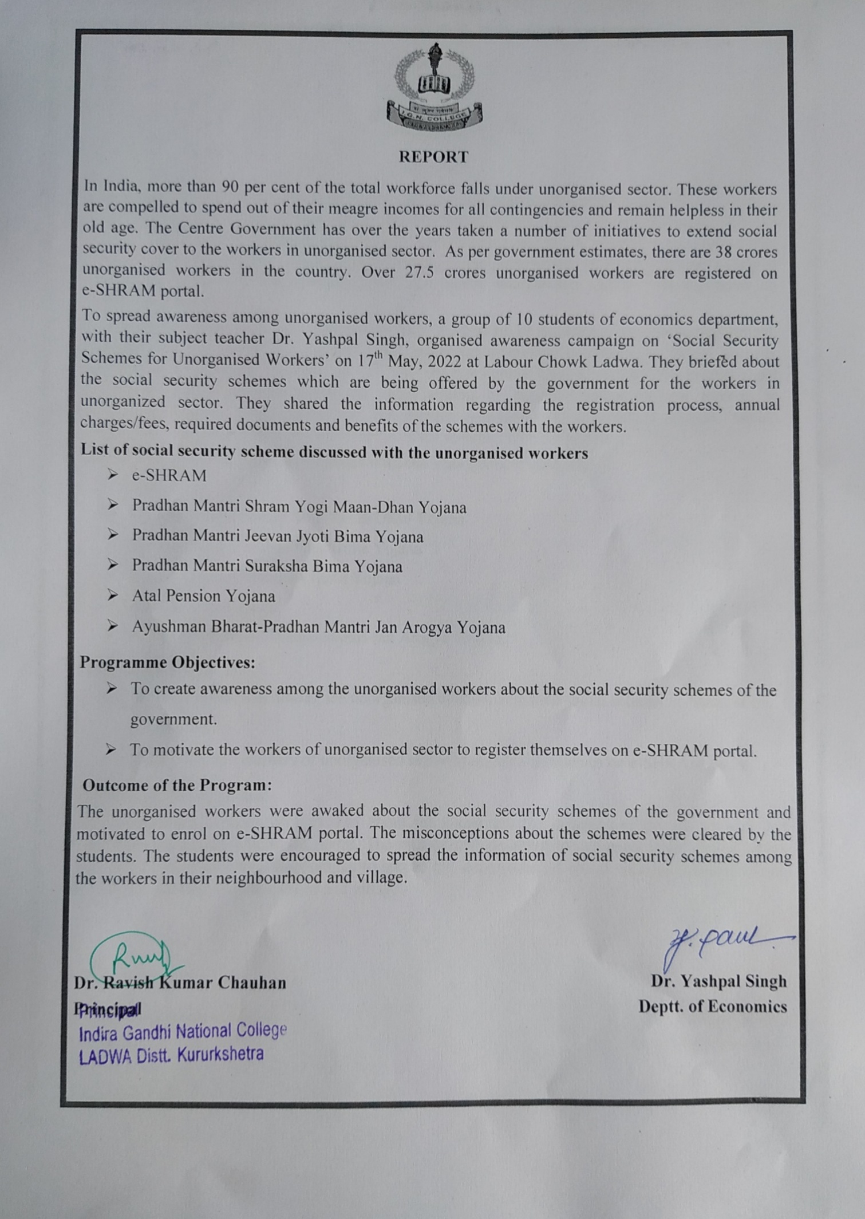

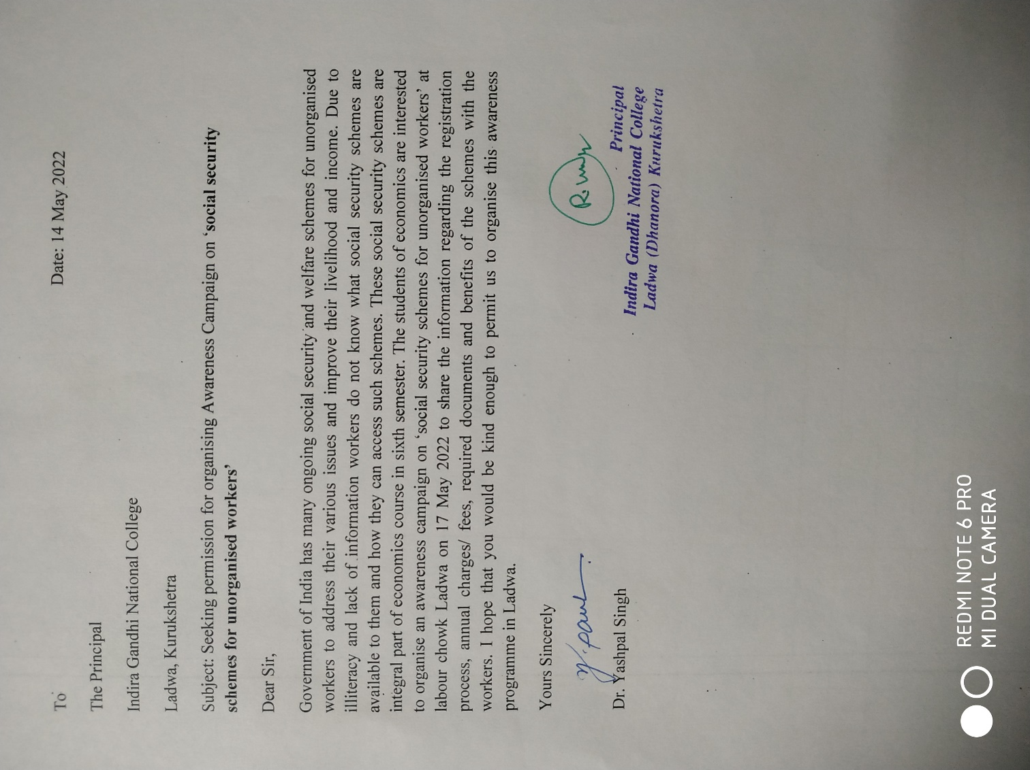

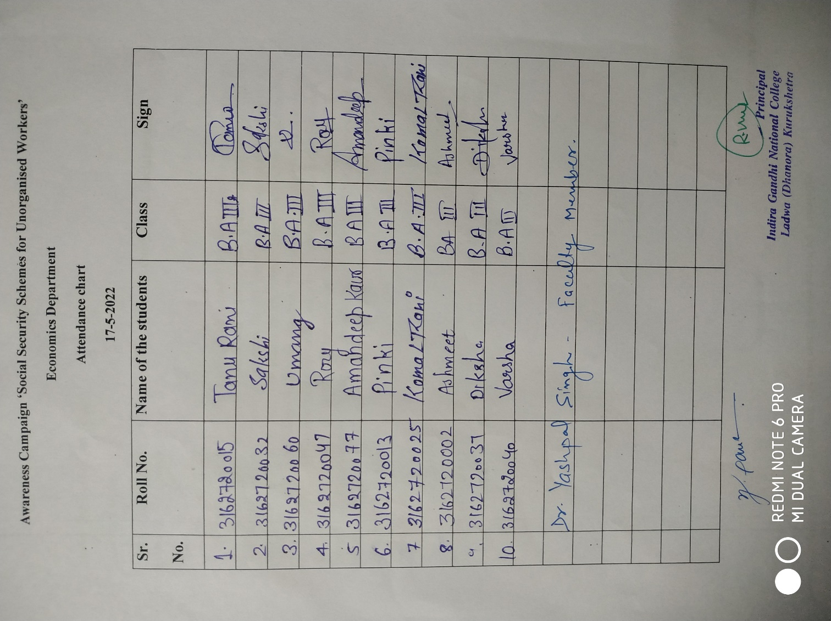

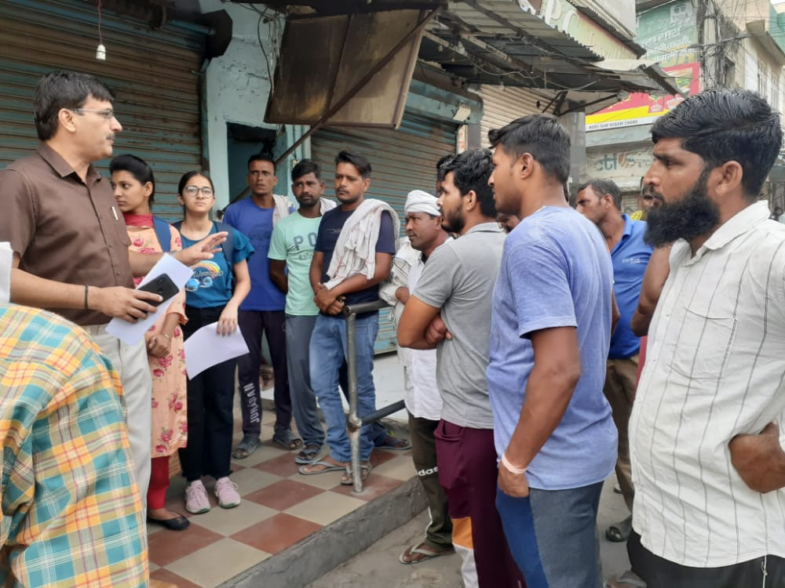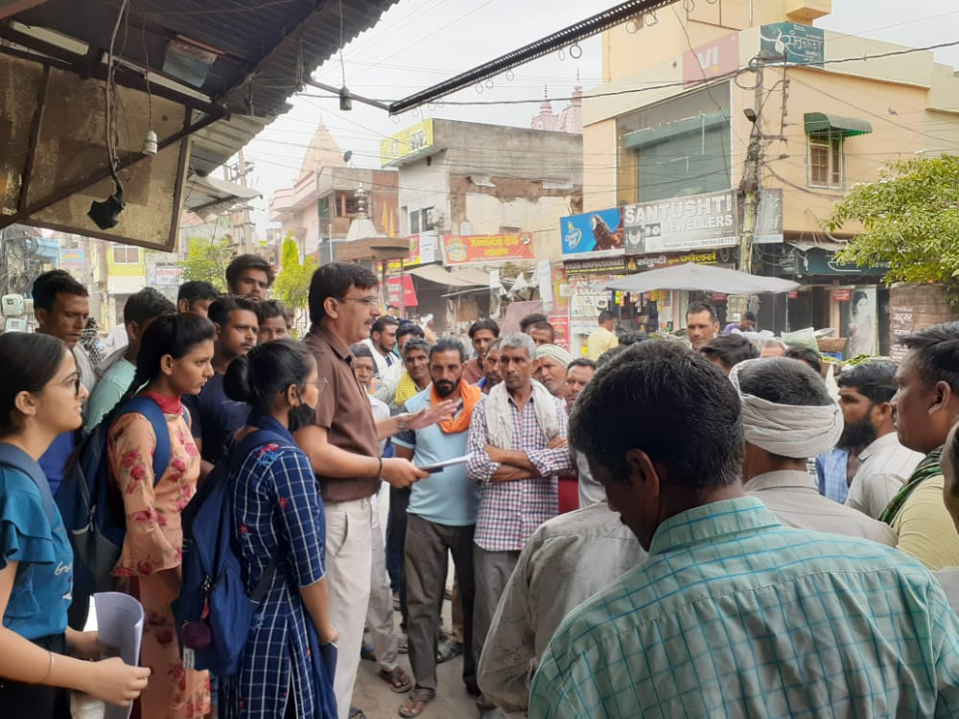
Dr. Yashpal Singh briefing about the awareness comparing to the workers

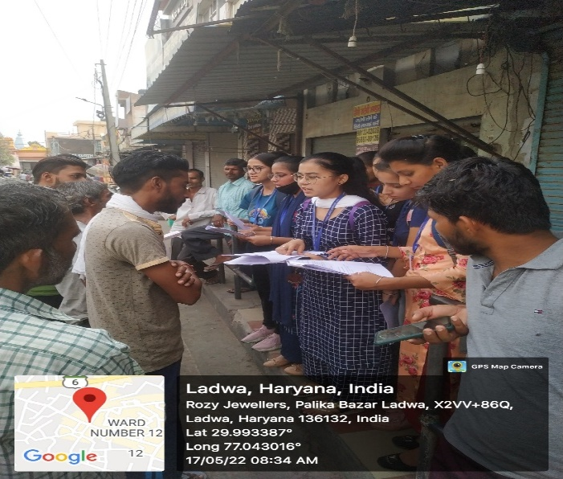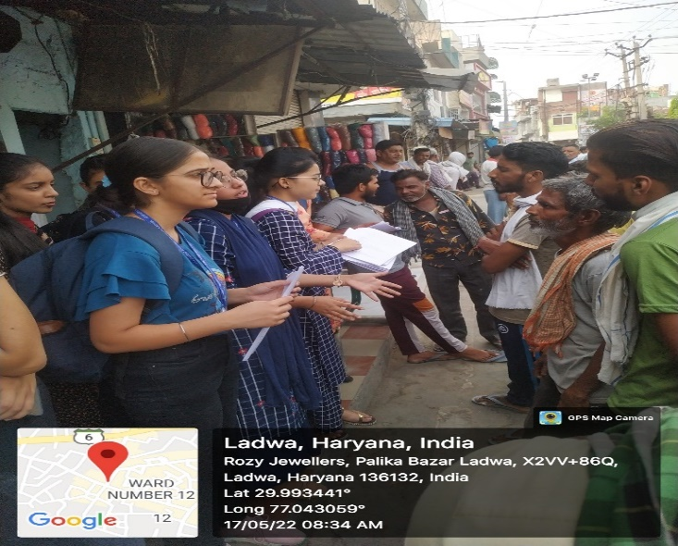
The students discussing about the social security schemes with the unorganised workers

