HAWAN AT THE BEGINNING OF NEW SESSION
(20-8-2020)
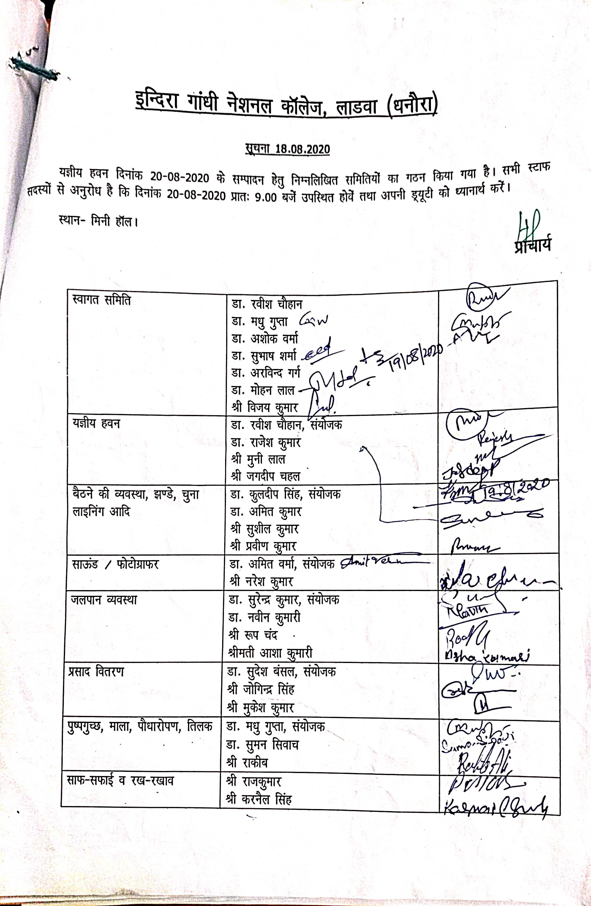
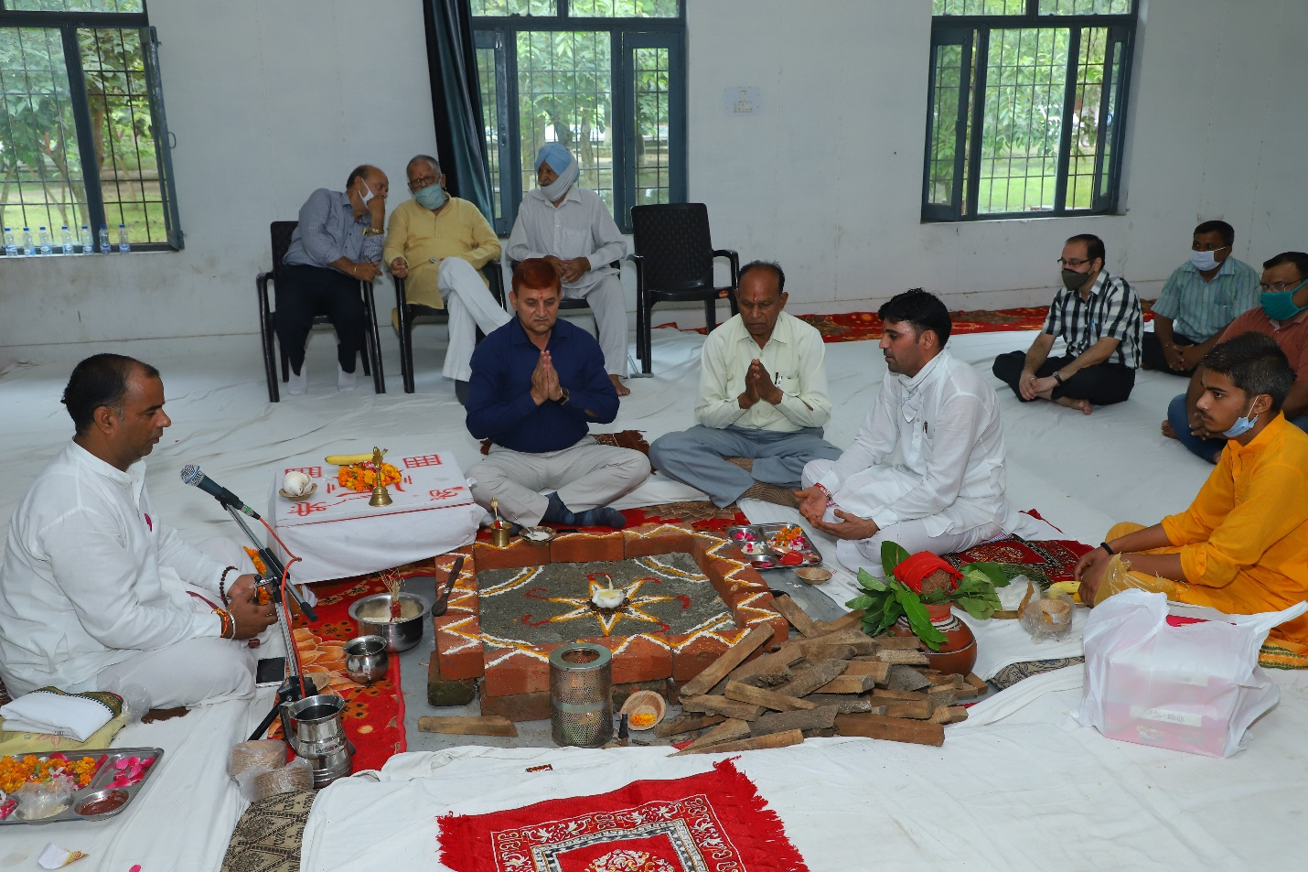

Press Report
Indira Gandhi National College, Ladwa started its new academic session 2020-21 today by performing Hawan Ceremony in the college on 20-08-2020. Venerable Maharaj, Shri Brahma Swaroop Brahmachari Ji, the Chairman and Convener, Jai Ram Institutes, graced the occasion with his benign presence as the chief guest of the programme. The programme was presided over by Chaudhary Meva Singh, MLA, Ladwa. Both the honourable guests paid tribute to Sh. Om Prakash Garg Ji, the founder of Indira Gandhi National College, Ladwa by offering flowers on his statue. Sh. Pawan Garg, President, Managing Committee, said that the auspicious presence of Pujya Maharaj Shri Brahmswaroop Brahmachari Ji has sanctified the aura of college campus. Pujya Maharaj ji has a great love for education and runs many institutes where poor children receive education and lead themselves on the path of success in life. Chaudhary Meva Singh emphasized the pivotal role of educated young men in the formation of a sound nation. Shri Brahmswaroop Brahmachari Ji, while blessing the students for a promising new academic year 2020-21, highlighted the value of students’ life as a period of creative contemplation and meditation.
Sh. Pawan Garg said that the college will soon begin the admission process of students. He further ensured the implementation of all requisite preventive measures in the college during the current phase of Corona epidemic. He informed that the college will adopt online teaching methods to avoid any kind of loss in the education of students and follow the government's guidelines for allowing the physical presence of students in the college.
College Principal, Dr. Hariprakash Sharma, extended his heartfelt greetings and gratitude to the worthy guests and said that the arrival of great people like Pujya Maharaj Ji in the college campus motivates the students to inculcate ethical values.
Former MLA Ramesh Gupta, S. Ujagar Singh, Vedprakash Singhal, Eng. Praveen Gupta, S. Mandeep Singh Toor, S. Jitendra Singh Gill, Ravindra Bansal, S. Harpreet Singh Cheema, Rohit Garg, Rajan Kansal, Babu Ram Sarpanch Dhanaura, Tejpal, Dharmendra Kheda School Principal, Kharaiti Lal Singhla, Ch. Shamsher Singh, Ramkumar Shastri, Ramswaroop, college staff etc. were among the other gracious persons present on this occasion.
Principal

