Indira Gandhi National College Ladwa
Youth Red Cross
Report on Awareness campaign against Drug Addiction in Bakali village on 18 February 2021
With the collaboration of District Red Cross Society,Kurukshetra 24volunteers of Youth Red Cross unit of Indira Gandhi National College Ladwa took out an Anti-Drug rally in Bakali Village. Randeep Singh Shokand, Secretary, District Red Cross Society Kurukshetra and husband of Sarpanch of village Bakali,Manjeet Singh, flagged off the rally. Principal Hari Parkash Sharma welcomed the guests and stated that the objective of Drug Awareness rally is to educate the villagers, and youths in particular, about the dangers and consequences of alcohol and substance abuse, which has reached unprecedented levels. The rally was conducted and led by the programme officer Dr.Yashpal Singh. The people of the village were told about the ill effects of the intoxicants by giving those messages through placards and slogans carried out by the volunteers. The volunteers marched in the streets of Bakali village chanting slogans and while telling residents to stay away from drugs and alcohol. Sh. Ramesh Choudhary, Joint Secretary, District Red Cross Society Kurukshetra, Dr.Vandna Gupta, Ms. Priyanka and Dr.Surinder Kumar member of YRC unit were present on the occasion.

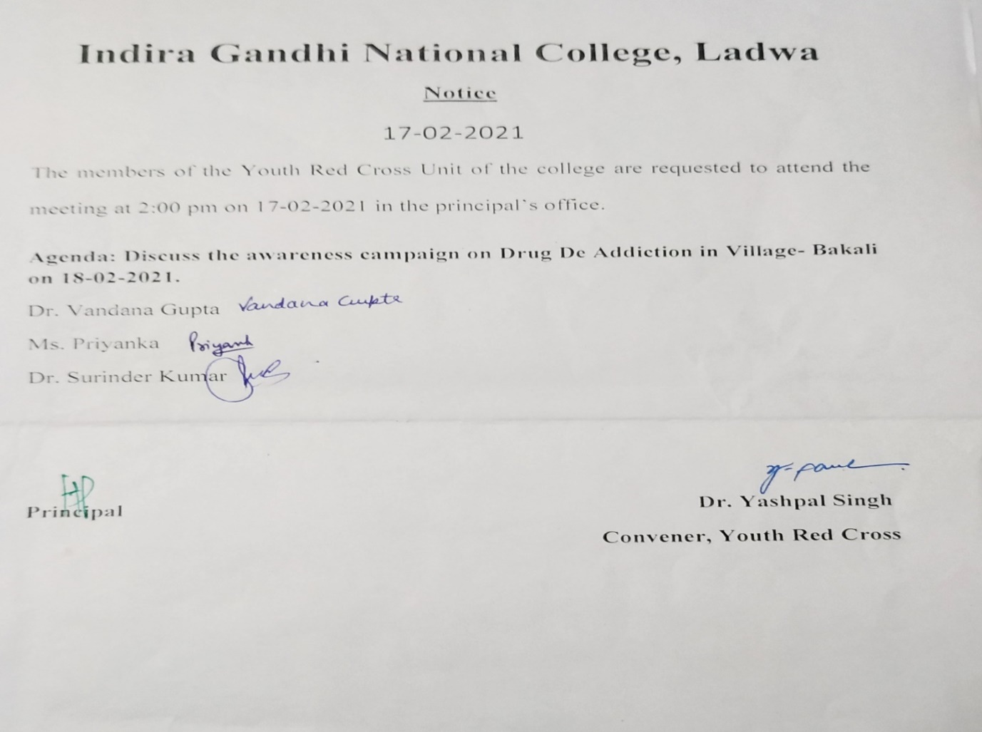

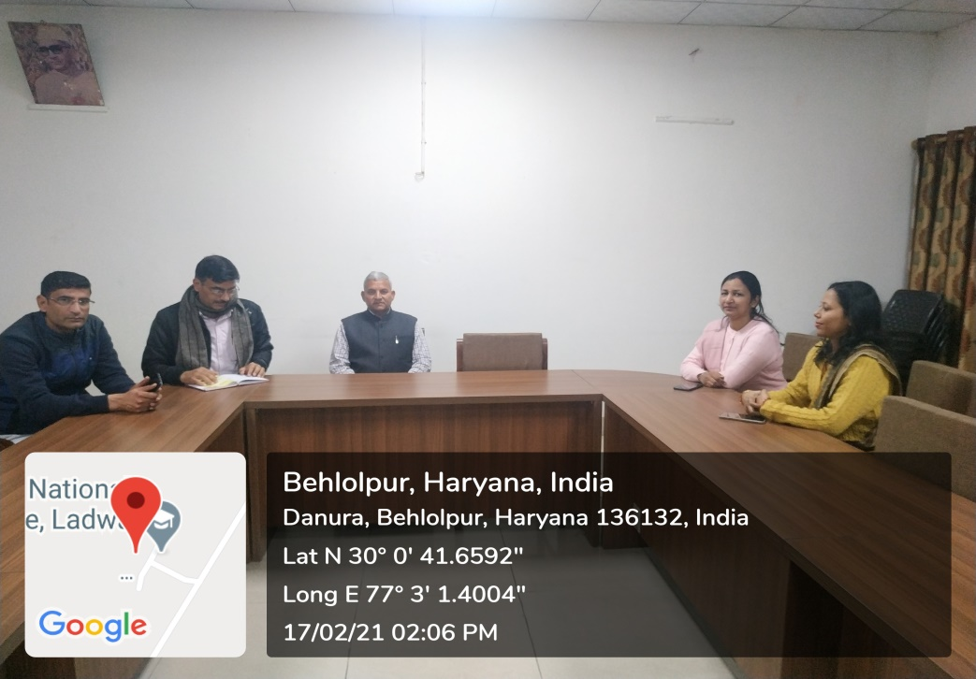
Meeting of YRC to chalk out the plan for ‘Drug De-addiction’ awareness rally
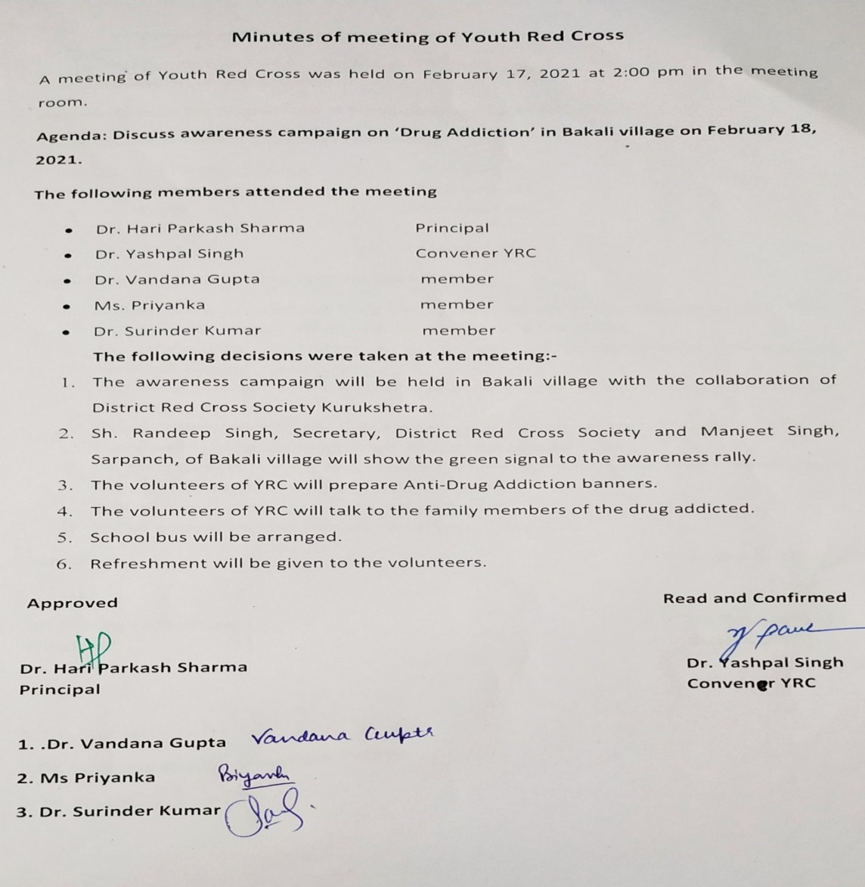
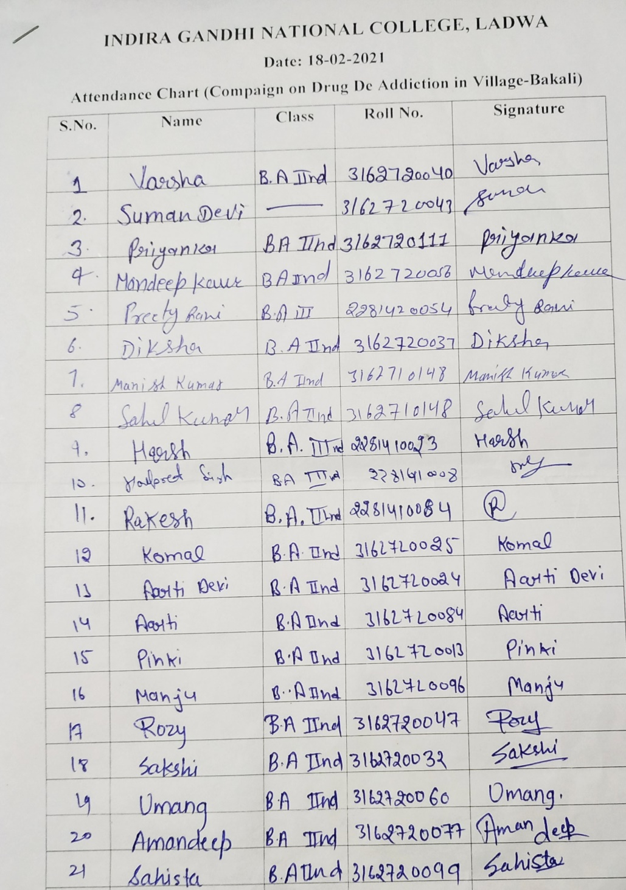

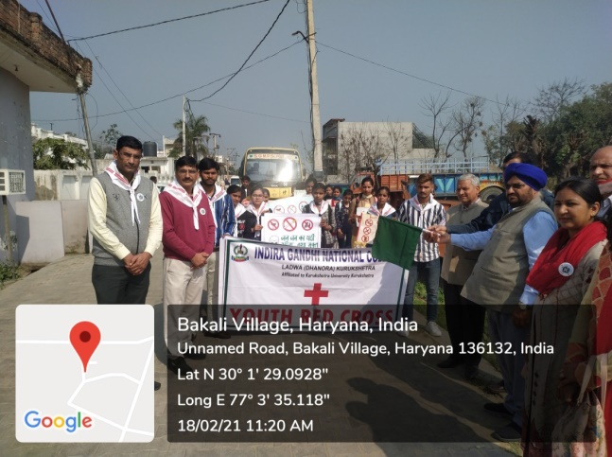
Manjeet Singh, Sarpanch of village Bakali, flagging off the Drug De-addiction awareness rally
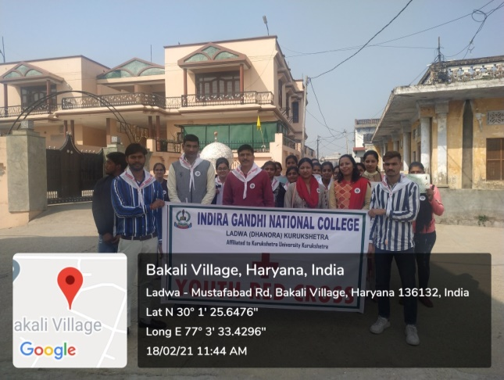
YRC volunteers marching in the streets chanting anti-drug addiction slogans
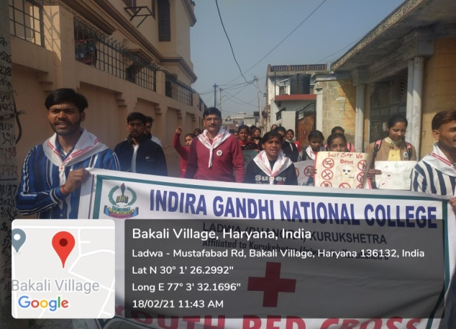
YRC volunteers marching in the streets with anti-drug addiction placards

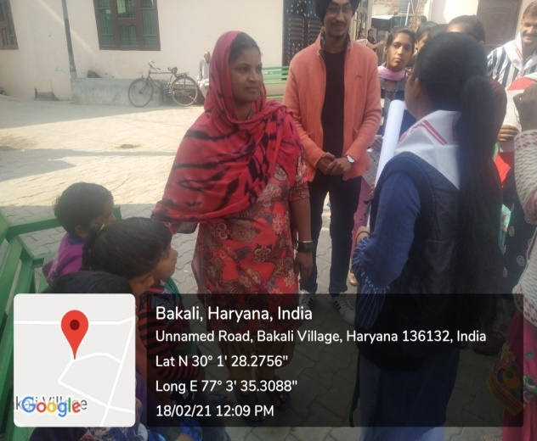
YRCvolunteers telling about the ill-effects of drugs to a village woman
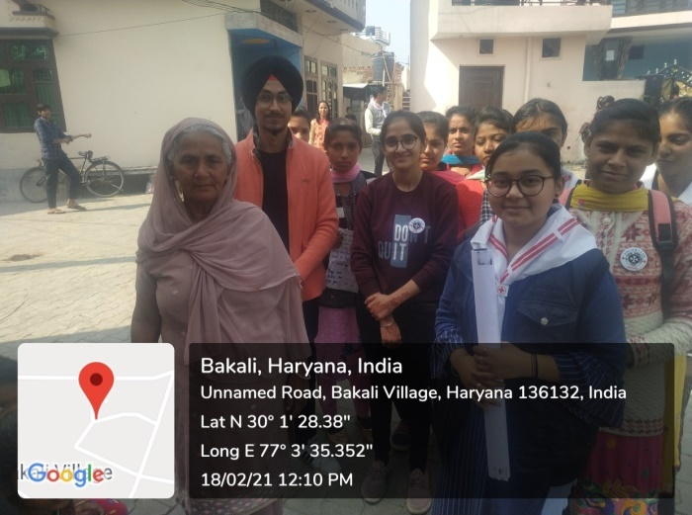
YRC volunteers with village woman
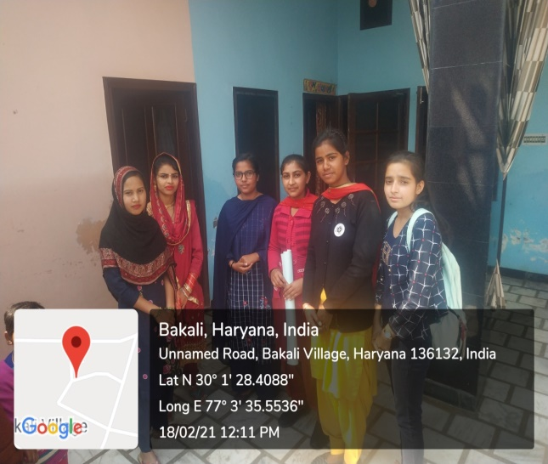
YRC volunteers talking about the ill effects of drugs with village young ladies
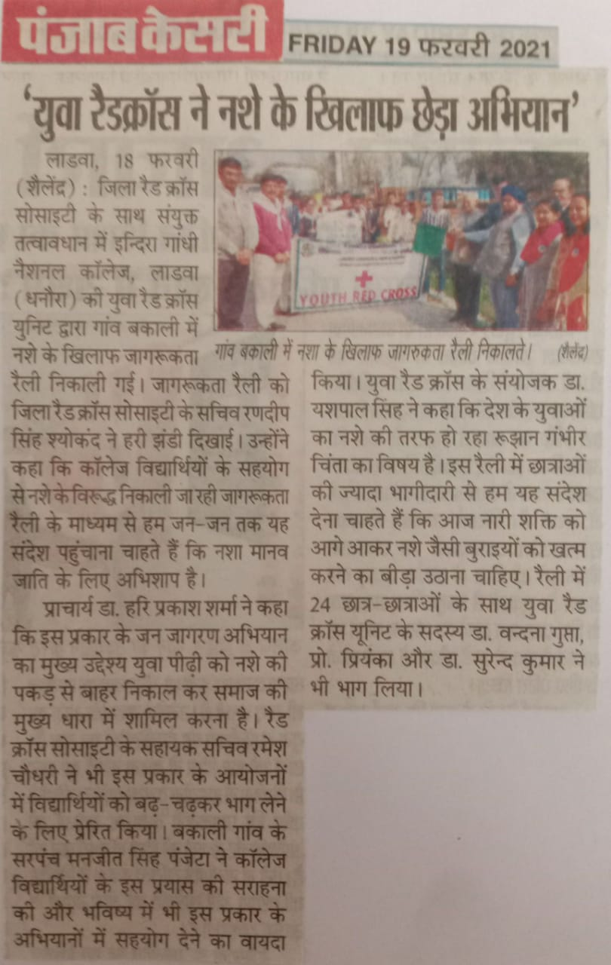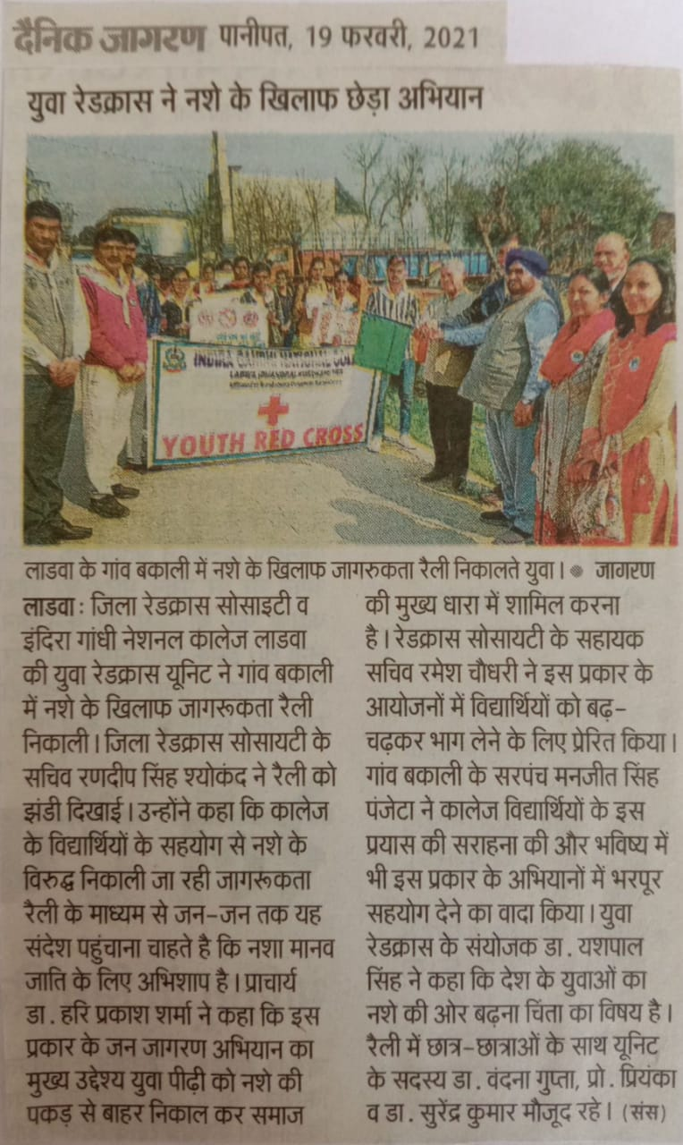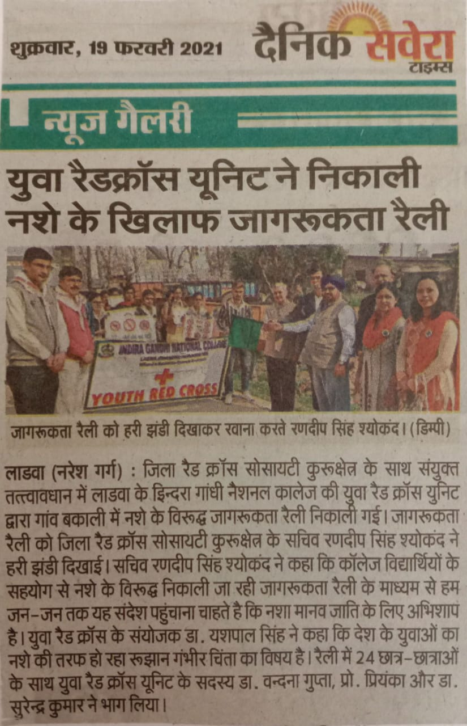

Video link :https://fb.watch/3KTEayV4Kp/

